First aid and emergency medical services in 2020

In 2020 emergency rescue teams provided health care benefits in the occurrence place to almost 2.8 million of persons. More than 3.2 million of persons received health care benefits in hospital emergency wards or admission rooms under the outpatient treatment while almost 1.4 million of persons received health care benefits in hospital emergency wards under the inpatient treatment.
5,7 pp
Increase of the share of calls to patient’s home in the structure of calls of the emergency rescue teams (including medical air rescue teams) to the occurrence places compared to 2019

Units of the State Emergency Medical Services System (denoted as PRM)
In 2020 the State Emergency Medical Services System covered: 1 581 emergency rescue teams, 21 medical air rescue teams and 239 hospital emergency wards
In 2020 the State Emergency Medical Services System covered functioning of the 1 581 of emergency rescue teams (4 more than in previous year). There were 1 238 basic emergency rescue teams and 343 specialist. On a yearly basis the number of specialist teams has been decreasing while the number of basic teams has been increasing.
The emergency medical treatment was also offered by 21 medical air rescue teams and 239 hospital emergency wards (denoted as SOR). The cooperating units role was played by 154 admission rooms, 17 trauma centers providing health care services to patients with multiple multi-organ injuries and 11 children trauma centers.
Map 1. Units of the State Emergency Medical Services System by voivodships in 2020
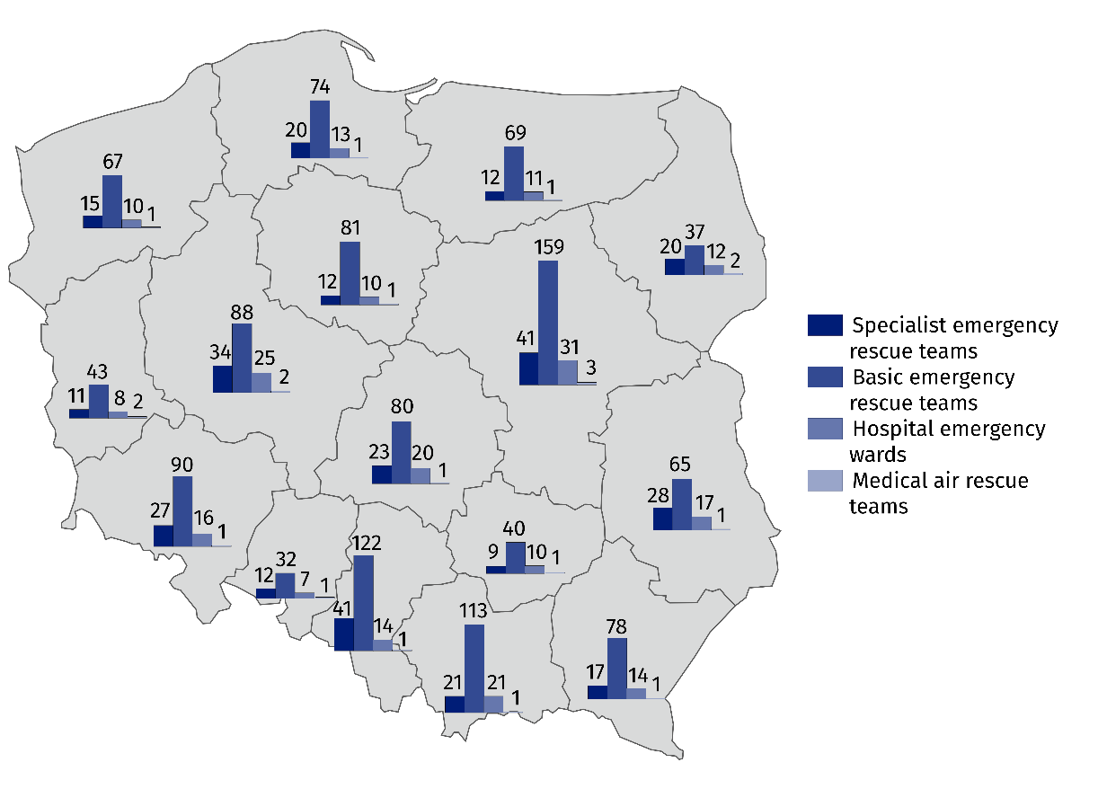
As of 31 December

Emergency rescue teams, medical air rescue teams
Almost 2.8 million of calls of the emergency rescue teams (including medical air rescue teams) to the occurrence places were recorded, of which 77.9% was at the patients’ home
The emergency rescue teams provided medical treatment for patients whose life is threatened. There were almost 2.8 million of calls of the emergency rescue teams (including medical air rescue teams) during which the emergency medical activities were provided. Compared to previous year the number of calls of the emergency rescue teams (including medical air rescue teams) to the occurrence places decreased by 341.1 thousand. The most common type of calls to the occurrence place was patient’ home (77.9% of the total calls – increase by 5.7 percentage points compared to 2019).

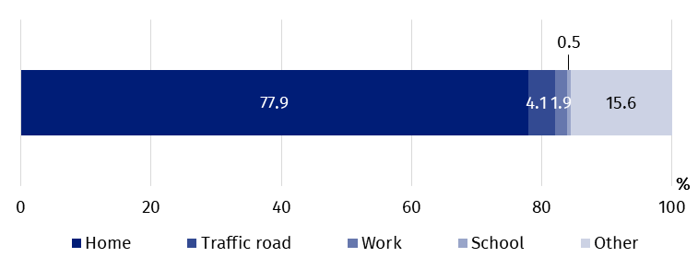
Chart 1. The structure of calls of the emergency rescue teams to the occurrence places by the type of occurrence place in 2020

The emergency rescue teams provided medical treatment to almost 2.8 million of persons (356.5 thousand less than in previous year). Among these persons 4.5% were children and youth up to age 18, and 48.5% – persons aged 65 and more (in 2019 6.0% and 45.4% respectively).

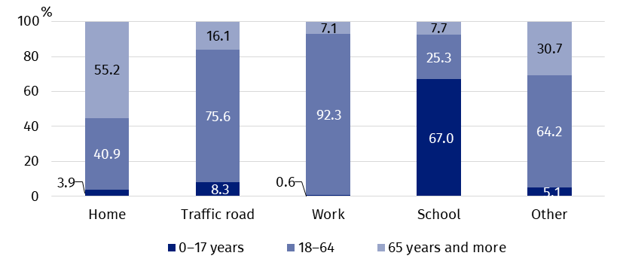
Chart 2. The structure of age of persons who received health care benefits in the place of occurrence by the type of occurrence place in 2020
In 2020 the emergency rescue teams provided medical treatment to 72 persons per 1 thousand population
In Poland, per 1 thousand population there were 72 persons to whom the emergency rescue teams provided medical treatment (compared to 81 persons in 2019). The maximum value (95) was observed in Zachodniopomorskie Voivodship and the minimum value (50) in Wielkopolskie Voivodship.

Map 2. Emergency rescue teams and persons who received health care benefits in the place of occurrence per 1 000 population by voivodships in 2020
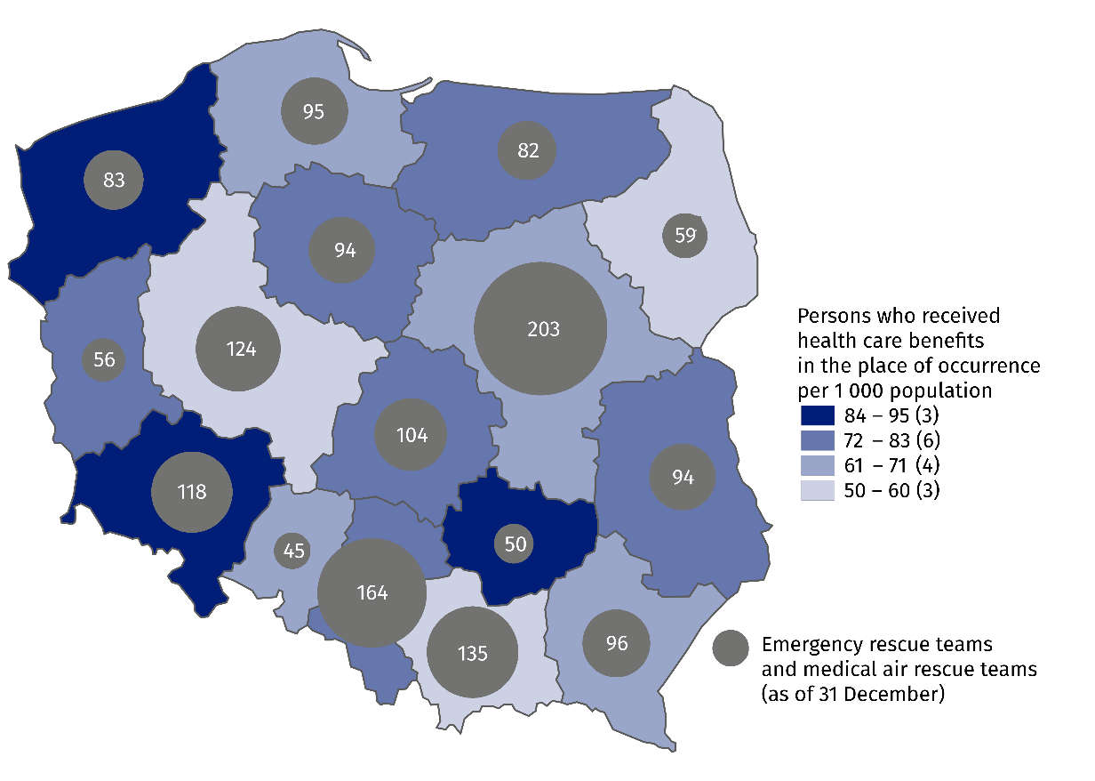
As of 31 of December 2020, the number of medical personnel of emergency rescue teams amounted to 13.0 thousand workers (0.2 thousand more compared to 2019). The largest group – almost 11.0 thousand – was constituted by emergency medical technicians. Moreover, there were over 1.1 thousand of nurses, almost 0.5 thousand of medical doctors and 0.4 thousand of other personnel. Compared to 2019 an increase in the number of emergency medical technicians was observed (by 0.6 thousand).
Chart 3. The structure of medical personnel of emergency rescue teams in 2020
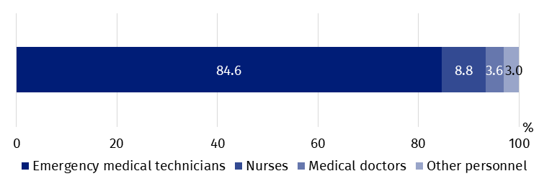
As of 31 December

Hospital emergency wards, admission rooms
In 2020 the number of persons who received health care benefits under outpatient treatment in both hospital emergency wards and admission rooms amounted to over 3.2 million
In hospital emergency wards the inpatient treatment was provided to almost 1.4 million persons
Hospital emergency wards (SOR) provide medical treatment of two distinct kind: outpatient treatment (with no subsequent hospitalization) and inpatient treatment. In both hospital emergency wards and admission rooms the largest number of services was provided under the outpatient treatment.
In 2020 the number of patients who received health care benefits in both hospital emergency wards and admission rooms under the outpatient treatment amounted to over 3.2 million persons (decrease by 29.0% as compared to 2019), while in the hospital emergency wards under the inpatient treatment – almost 1.4 million (decrease by 12.2% as compared to 2019). Children and youth up to age 18 stood for 15.6% of the total number of treated in hospital emergency wards or in admission rooms while persons aged 65 and more – 27.8% (in 2019 18.4% and 25.4% respectively).

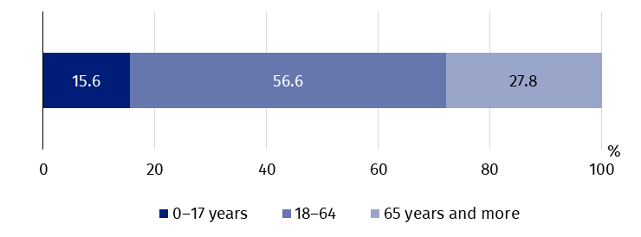
Chart 4. The structure of age of persons who received health care benefits in the hospital emergency wards or admission rooms in 2020

At the national level, there were 120 persons who received health care benefits in the hospital emergency wards or in admission rooms per 1 thousand population (160 persons in 2019). The maximum ratio of persons who received medical treatment in these places per 1 thousand population was observed in Lubelskie Voivodship (143) and the minimum value (85) in Śląskie Voivodship.

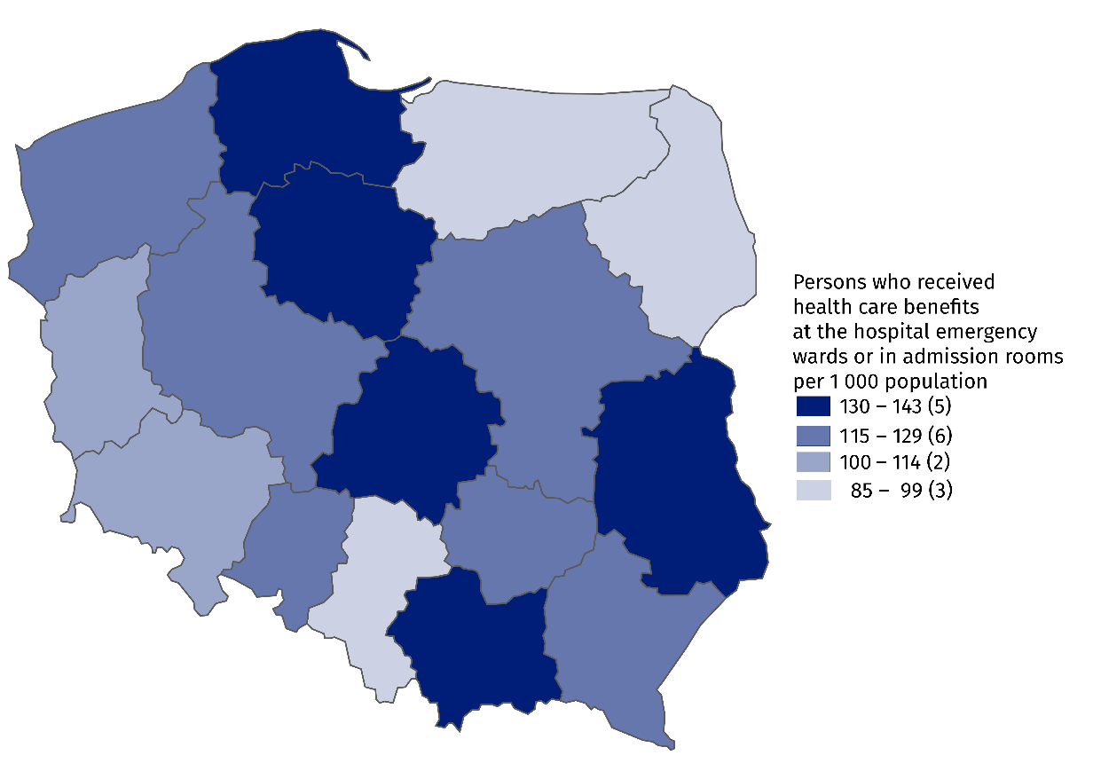
Map 3. Persons who received health care benefits in the hospital emergency wards or admission rooms per 1 000 population by voivodships in 2020

In the case of quoting data from the Statistics Poland, please provide information: "Statis-tics Poland data source", and in the case of publishing calculations made on data published by the Statistics Poland, please provide information: "Own study based on Statistics Poland data".
Prepared by:  Statistical Office in Kraków  Director Agnieszka Szlubowska  Office: tel. (+48 12) 420 40 50 | Issued by:  The Spokesperson for the President  of Statistics Poland  Karolina Banaszek  Mobile: (+48) 695 255 011

Press Office  Office: tel. (+48 22) 608 34 91, 608 38 04  e-mail: obslugaprasowa@stat.gov.pl |  | www.stat.gov.pl/en
 |  | @StatPoland
 |  | @GlownyUrzadStatystyczny

Related information
Health and health care in 2019
Methodological report. Health and health care statistics − Statistics Poland’s reports

Data available in databases
Local Data Bank -> Health care, social welfare and benefits to the family
Analytical Platform – SWAID – Knowledge Databases -> Health and Health care

Terms used in official statistics
Emergency medical services
Units of emergency medical service
Hospital emergency ward
The place of occurrence
Trauma center

Medical personnel for whom it was the main workplace, regardless of the form of employment contract.
Drivers and pilots.

