Pharmacies and pharmaceutical outlets in 2020

At the end of 2020, there were operating 12.1 thousand pharmacies (generally available and dispensaries) and 1.2 thousand pharmaceutical outlets in which 59.1 thousand pharmacists and pharmaceutical technicians were employed.
0.5%
Increase in the number of pharmacists employed in generally available pharmacies, dispensaries and pharmaceutical outlets compared to 2019

Pharmacies and pharmaceutical outlets
At the end of 2020, there were operating 12.1 thousand generally available pharmacies (decrease of 1.9% in comparison with the previous year), 24 dispensaries (as in 2019) and 1.2 thousand pharmaceutical outlets (by 3.2% less than a year earlier).
The night duties were fulfilled permanently by 2.8% generally available pharmacies, as well as temporarily by 19.3% pharmacies. The sales of medical products by mail order using the website (via e-pharmacies) were carried out by 223 pharmacies and 6 pharmaceutical outlets.
In Poland, there were on average 2 897 persons per 1 generally available pharmacy and pharmaceutical outlet (by 49 more than in the previous year). Like a year earlier, the highest number of inhabitants per 1 generally available pharmacy and pharmaceutical outlet was recorded in Pomorskie Voivodship (3 329), while the lowest – in Wielkopolskie Voivodship (2 558).
At the national level the number of population per 1 generally available pharmacy and pharmaceutical outlet amounted to 2 897 persons

Map 1. Generally available pharmacies and pharmaceutical outlets by voivodships in 2020
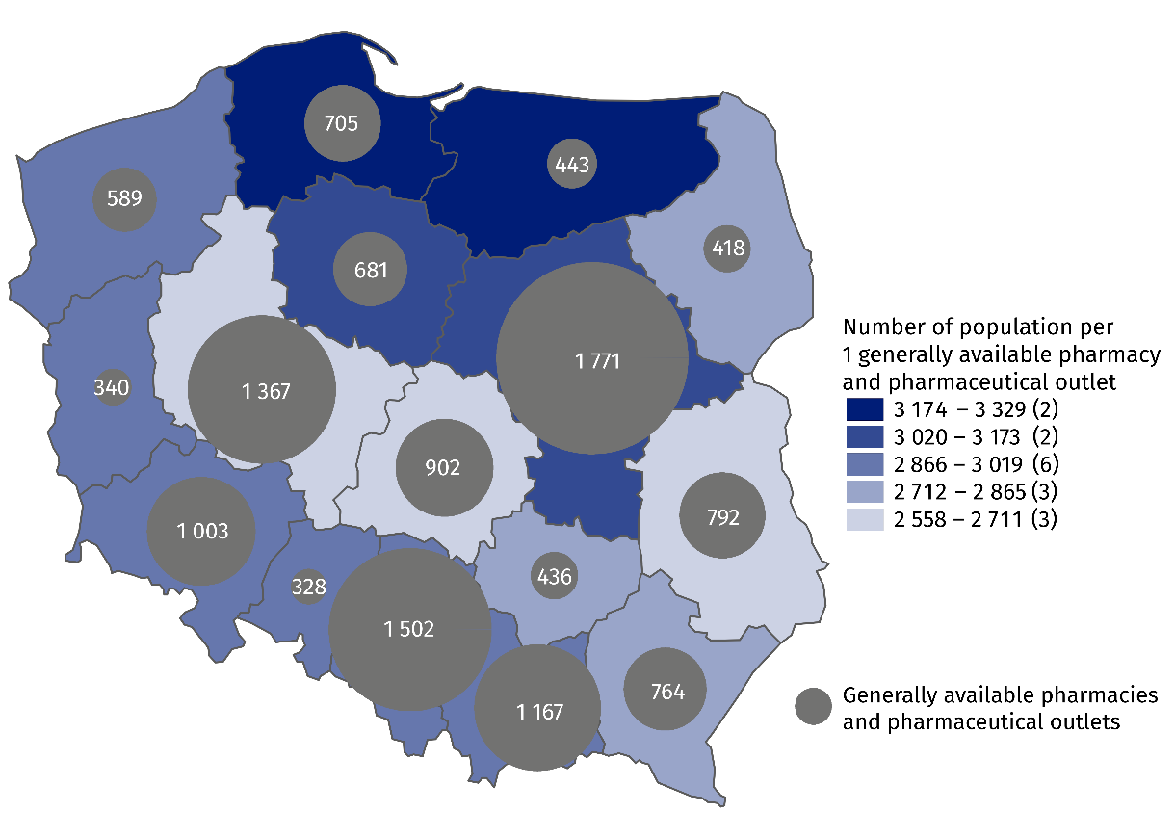
As of 31 December

Employed in pharmacies and pharmaceutical outlets
As of 31 December 2020, generally available pharmacies, dispensaries and pharmaceutical outlets employed 64.8 thousand employees, of which 26.2 thousand pharmacists (increase by 0.5% compared to 2019) and 32.9 thousand pharmaceutical technicians (by 1.3% less than a year earlier). Like a year earlier, the vast majority of employees were females (83.0% of pharmacists and 94.2% of pharmaceutical technicians).
Pharmacies and pharmaceutical outlets employed 26.2 thousand pharmacists and 32.9 thousand pharmaceutical technicians

Table 1. Employed in pharmacies and pharmaceutical outlets in 2020
As of 31 December
SPECIFICATION | Employees total | Of which
SPECIFICATION | Employees total | pharmacists | pharmaceutical  technicians
SPECIFICATION | in thousands
Generally available pharmacies | 63.0 | 26.0 | 31.4
Dispensaries | 0.2 | 0.1 | 0.1
Pharmaceutical outlets | 1.7 | 0.1 | 1.5

Map 2. Employed in generally available pharmacies and pharmaceutical outlets by voivodships in 2020
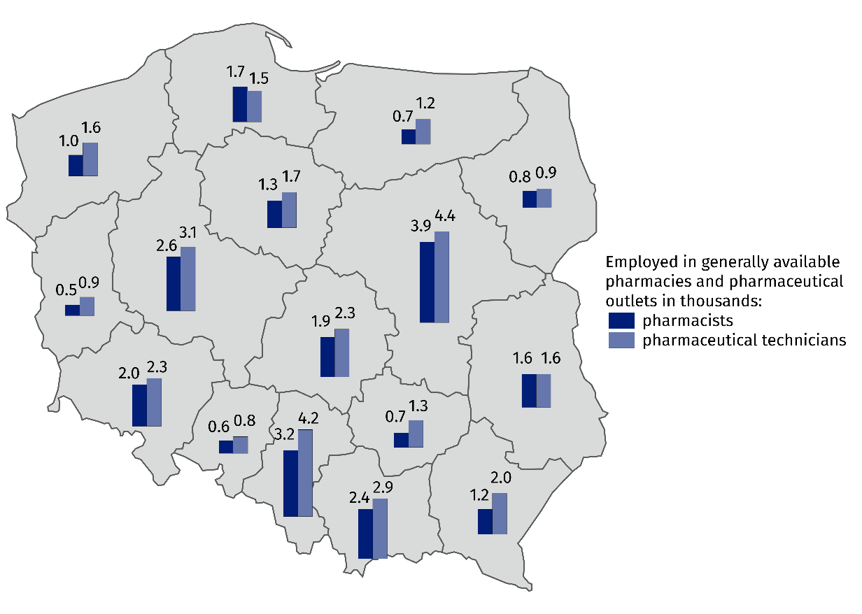
As of 31 December
In the case of quoting data from the Statistics Poland, please provide information: "Statis-tics Poland data source", and in the case of publishing calculations made on data published by the Statistics Poland, please provide information: "Own study based on Statistics Poland data".

Prepared by:  Statistical Office in Kraków  Director Agnieszka Szlubowska  Office: tel. (+48 12) 420 40 50 | Issued by:  The Spokesperson for the President  of Statistics Poland  Karolina Banaszek  Mobile: (+48) 695 255 011

Press Office  Office: tel. (+48 22) 608 34 91, 608 38 04  e-mail: obslugaprasowa@stat.gov.pl |  | www.stat.gov.pl/en/
 |  | @StatPoland
 |  | @GlownyUrzadStatystyczny

Related information
Health and health care in 2019
Methodological report. Health and health care statistics − Statistics Poland’s reports

Data available in databases
Local Data Bank -> Health care, social welfare and benefits to the family
Knowledge Databases -> Health and Health care

Terms used in official statistics
Generally available pharmacy
Dispensary
Pharmaceutical outlet
The main workplace

Concerns employed persons for whom this is the main workplace. Total number of employed covers all employees in an establishment, including non-medical staff (e.g. cashiers, manual workers) as well as owners and co-owners of pharmacies.

