Activity of centres of culture, cultural establishments, cultural centres, clubs and community centres in 2020

As of the end of 2020, there were 4040 operating centres of culture, cultural establishments, cultural centres, clubs and community centres. During the year entities organised 120.9 thousand events, in which took part 13.4 million participants.
50.4%
Decrease in the number of events organised by centres of culture, cultural establishments, cultural centres, clubs and community centres in comparison to 2019

Due to the announcement of the state of epidemic threat in Poland, from March 12, 2020, the possibility of conducting business activities was limited, among others, by cultural entities that had to close their facilities overnight. The introduced limitations resulted in changes in the functioning of cultural entities in terms of the implementation of cultural activities. At that time, some units did not undertake any activities related to the preparation and sharing of the cultural offer, and some tried to reach the recipient by making their offer available on the Internet. Restrictions on the activities of cultural entities in individual months had a different scope and forms, depending on the current epidemic situation in the country.
Most centres of culture, cultural establishments, cultural centres, clubs and community centres were operating in Małopolskie Voivodship (453), and the least in Lubuskie Voivodship (72). Taking into account the type of entities, most numerous group constituted community centres (32.6% of the total number of entities), whereas the least numerous were clubs (7.6%). Most of the entities (62.0%) were located in the countryside.
79
313
348
203
228
342
333
163
284
214
372
123
452
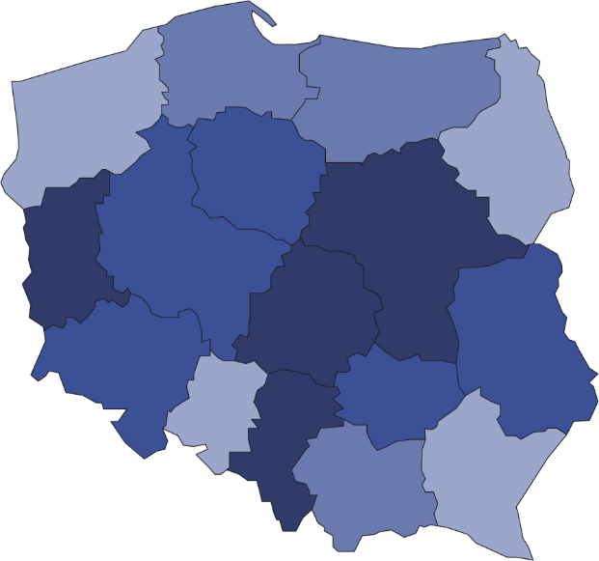

Map 1. Centres of culture, cultural establishments, cultural centres, clubs and community centres
in 2020
158
290
181
306
231
355
453
117
190
305
218
295
72
311

204

354
4040
Number of population
per 1 entity
12001–17729
9001–12000
7001– 9000
4788– 7000

Number of centres of culture, cultural establishments, cultural centres, clubs and community centres (as of 31 December)
11.2% of the total number of entities were operating in Małopolskie Voivodship

The prevalent part of centres of culture, cultural establishments, cultural centres, clubs and community centres (93.0%) belonged to the public sector. Local government units at the level of gmina played dominant role organising the activity of 90.5% of all public entities.

In 2020, the COVID-19 pandemic had a significant impact on the activities of centres of culture, cultural establishments, cultural centres, clubs and community centres. The number of entities that limited their cultural activities for this reason was 69.0%.

Centres of culture, cultural establishments, cultural centres, clubs and community centres organised a total of 120.9 thousand events, in which 13.4 million people took part. The largest number of events (37.8 thousand) was organized by cultural centres, and the least - clubs and community centres (7.4 thousand and 7.8 thousand events, respectively). In comparison to 2019 the number of organised events decreased by 50.4% and the number of participants – by 64.4%.

Workshops were most frequently organised (27.1% of the total number of events), whereas conferences were the least frequently organised (0.5% of the total number of events). On average 110 people took part in 1 event. Festivals and artistic reviews were the most numerous in this respect – on average 935 people attended 1 event.
In 2020, 43.9% of centres of culture, cultural establishments, cultural centres, clubs and community centres conducted online cultural activities, which provided 32.7 thousand events and 0.6 thousand courses.
As of the end of 2020, 24.1 thousand various types of groups (clubs/sections) were operating in centres of culture, cultural establishments, cultural centres, clubs and community centres, gathering 466.3 thousand members. In the form of groups (clubs/sections) mostly were organised art and technical classes (5.4 thousand). The largest number of participants gathered senior clubs and The Third Age Universities (93.4 thousand people).
In 2020 entities conducted a total of 4.8 thousand courses. 64.9 thousand people obtained the graduated status of the course (a decrease of 35.8% in comparison to 2019). Mostly were conducted courses related to learning to play the instruments (23.2% of the total number of courses) and foreign language courses (22.8%).

Chart 1. The structure of groups (clubs, sections) and their participants in centres of culture, cultural establishments, cultural centres, clubs and community centres in 2020

As of 31 December
%

As of the end of 2020, 14.2 thousand artistic groups were operating in centres of culture, cultural establishments, cultural centres, clubs and community centres, among which most numerous were dance groups (3.7 thousand). From the total number of 230.6 thousand artistic groups participants, 64.5% were school children and youth. Every fifth artistic groups participants was person above 60 years old.

Chart 2. The structure of artistic groups and their participants in centres of culture, cultural establish
ments, cultural centres, clubs and community centres in 2020
As of 31 December
%

In the case of quoting data from the Statistics Poland, please provide information: "Statistics Poland data source", and in the case of publishing calculations made on data published by the Statistics Poland, please provide information: "Own study based on Statistics Poland data".

Prepared by:  Statistical Office in Kraków  Director Agnieszka Szlubowska  Office: tel. (+48 12) 420 40 50 | Issued by:  The Spokesperson for the President  of Statistics Poland  Karolina Banaszek  Mobile: (+48) 695 255 011

Press Office  Office: tel. (+48 22) 608 34 91, 608 38 04  e-mail: obslugaprasowa@stat.gov.pl |  | www.stat.gov.pl/en/
 |  | @StatPoland
 |  | @GlownyUrzadStatystyczny

Related information
Culture in 2019
Activity of centres of culture, cultural centres and establishments, clubs and community centres in 2019

Terms used in official statistics
Cultural establishment
Show (event)
Club
Group in cultural institution
Unit’s organizer
Cultural centre
Performance hall
Community centre
Event participant

