Activity of art galleries in 2020

In 2020, there were 307 operating art galleries (6.1% less in comparison to 2019). In Poland, art galleries have organised 2,377 exhibitions, visited by 2.1 million people.
37.2%
Decrease in the number of organised exhibitions in Poland in comparison to 2019

Due to the announcement of the state of epidemic threat in Poland, from March 12, 2020, the possibility of conducting business activities was limited, among others, by cultural entities that had to close their facilities overnight. The introduced limitations resulted in changes in the functioning of cultural entities in terms of the implementation of cultural activities. At that time, some units did not undertake any activities related to the preparation and sharing of the cultural offer, and some tried to reach the recipient by making their offer available on the Internet. Restrictions on the activities of cultural entities in individual months had a different scope and forms depending on the current epidemic situation in the country.
People visiting art galleries in the Małopolskie and Mazowieckie Voivodships accounted for 56.6% of the total number of visitors
In 2020, 64.5% of art galleries limited their cultural activities due to COVID-19, i.e. did not prepare and did not make the cultural offer available to recipients. Most entities reduced their activity in March (59.9%), the least - in July and August (17.6% each). Most art galleries and salons (65.5%) have made their exhibitions available on the Internet - the recipients could view 896 virtual exhibitions via websites, social networks and video channels.
In 2020, most of units operated in Małopolskie Voivodship (57). The most visited art galleries were also located in Małopolskie (861.8 million visitors). Most people visited art galleries organised by public sector (90.7%). Outdoor exhibitions were visited by 47.3% of all visitors. On average there were 6.7 thousand visitors (in 2019 – 13.9 thousand) per one art gallery. One exhibition was visited by an average of 868 people (in 2019 1.2 thousand).
Map 1. Art galleries in 2020


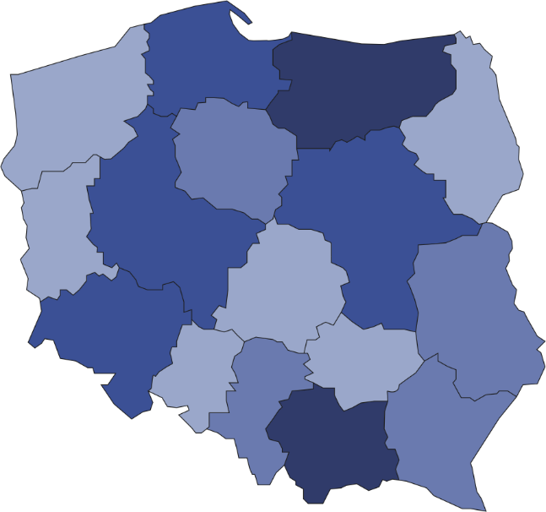
33.2% of art galleries were operating in Małopolskie and Mazowieckie Voivodships

6
20
8
45
9
7
57
9

35
18
15
13
4
21

2

38
307
Number of visitors per 1 art gallery
8001–15119
5501–8000
3501–5500
2191–3500
Number of art galleries

Art galleries organised 2,377 exhibitions (1,409 less than in 2019) including national exhibitions (2 132), international (142) and from abroad (103).
A significant part of art galleries belonged to the public sector (62.5%), in which the most of the units were organised by local government units. The remaining art galleries belonged to the private sector. The largest part of the collection of state and local government galleries was represented by painting collections (41.8%).
Chart 1. The structure of own collections of art galleries belonging to the state and self-government
units in 2020
As of 31 December
%

A significant part of art galleries belonged to the public sector (59.6%), within which the majority of units were organised by self-government units. Remaining art galleries were owned by the private sector. The largest part of the own collections of galleries belonging to the state and self-government units were collections in the domain of painting (43.0%).

Prepared by:  Statistical Office in Kraków  Director Agnieszka Szlubowska  Office: tel. (+48 12) 420 40 50 | Issued by:  The Spokesperson for the President  of Statistics Poland  Karolina Banaszek  Mobile: (+48) 695 255 011

Press Office  Office: tel. (+48 22) 608 34 91, 608 38 04  e-mail: obslugaprasowa@stat.gov.pl |  | www.stat.gov.pl/en/
 |  | @StatPoland
 |  | @GlownyUrzadStatystyczny

Related information
Culture in 2019
Activity of art galleries in 2019

Terms used in official statistics
Art gallery
Unit’s organiser
Exhibition
Open-air exhibition in the galleries
Exposition
Visitor

