Activity of museums in 2020

In 2020, there were 932 operating museums and museums branches visited by 16.6 million people. Museums in Poland organised 2.4 thousand regular exhibitions and 3.0 thousand temporary exhibitions (including 41 exhibitions from abroad).
58.7%
Decrease in the number of visitors in comparison to 2019

Due to the announcement of the state of epidemic threat in Poland, from March 12, 2020, the possibility of conducting business activities was limited, among others, by cultural entities that had to close their facilities overnight. The introduced limitations resulted in changes in the functioning of cultural entities in terms of the implementation of cultural activities. At that time, some units did not undertake any activities related to the preparation and sharing of the cultural offer, and some tried to reach the recipient by making their offer available on the Internet. Restrictions on the activities of cultural entities in individual months had a different scope and forms, depending on the current epidemic situation in the country.
In 2020, 50.9% of museum limited their cultural activities due to COVID-19, i.e. did not temporarily prepare and did not make the cultural offer available to recipients. Most entities reduced their activity in March (47.0%). From July to October over 80.0% operated without restrictions. Museums and museum branches made part of their offer available via the Internet, conducting cultural, scientific and educational activities. 1,367 exhibitions were made available via websites, social networks and video channels. In November and December, due to the worsening epidemic situation in the country, the number of museums and museum branches that limited the implementation of the cultural offer approached the March level.
Map 1. Museums and museum branches in 2020


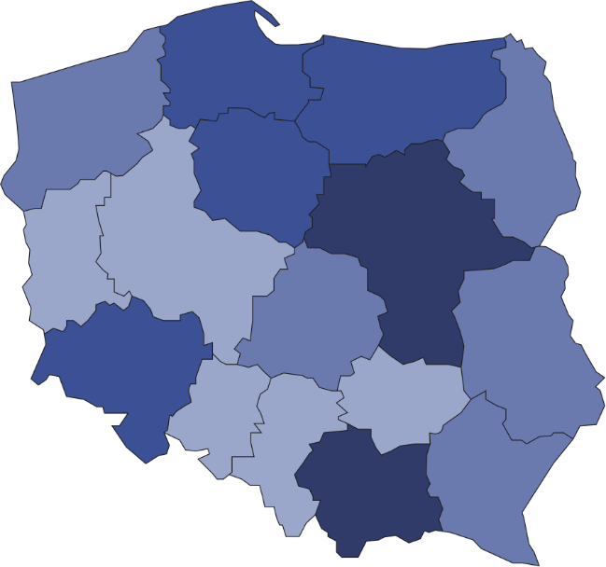
30
90
21
143
57
61
101
30
41
86
48
37
17
69
18
83
932
Number of visitors per 1 institutions
20001–48658
10001–20000
7001–10000
4858– 7000
Number of museums and museums branches (as of 31 December)
26.2% of the total number of museums operated in Mazowieckie and Małopolskie Voivodships

Compared to 2019, the number of temporary exhibitions in the country decreased by 40.0%, and the number of permanent exhibitions by 8.7%. The number of visitors was 23.6 million lower.
The greatest number of museums and visitors was recorded in Mazowieckie Voivodship. The number of museum visitors per 1,000 people amounted to 434 people (in 2019 - 1,082 people). In 2020, due to the COVID-19 pandemic, the "Night of Museums" took place mainly on the Internet. Only a few museums took part in this event in a traditional way (on a changed date). It was attended by 18.4 thousand visitors (in 2019 - 798.7 thousand).
In 2020, museums were visited by 16.6 million people, including 7.3 million for free.
Most museums belonged to the public sector (70.1%), in which the most of the units were organised by local government units (85.6%). In the private sector, most museums belonged to natural persons (57.3%).
Number of objects in museum collection amounted to 19.4 million pieces. The largest part of museum collection was represented by archaeological collections (26.0%).
Chart 1. The structure of museum collection by branch in 2020
As of 31 December

In addition to the primary activity of collecting and presenting collection, museums organised many educational and cultural events. Museum lessons and workshops were among most frequently organised (28.4 thousand).
Chart 2. The structure of cultural and educational activity of museums and museums branches in
2020
%

In the case of quoting data from the Statistics Poland, please provide information: "Statistics Poland data source", and in the case of publishing calculations made on data published by the Statistics Poland, please provide information: "Own study based on Statistics Poland data".

Prepared by:  Statistical Office in Kraków  Director Agnieszka Szlubowska  Office: tel. (+48 12) 420 40 50 | Issued by:  The Spokesperson for the President  of Statistics Poland  Karolina Banaszek  Mobile: (+48) 695 255 011

Press Office  Office: tel. (+48 22) 608 34 91, 608 38 04  e-mail: obslugaprasowa@stat.gov.pl |  | www.stat.gov.pl/en/
 |  | @StatPoland
 |  | @GlownyUrzadStatystyczny

Related information
Culture in 2019
Activity of museums in 2019

Terms used in official statistics
Museum
Museum branch
Unit’s organizer
Museum lesson
Exhibits
Temporary exhibitions
Permanent exhibitions
Visitor

Starting from 2020 data on museums include only those museums that operate on the basis of the statute or regulations agreed with the minister competent for culture and protection of national heritage, in accordance with Art. 6 of the Act of November 21, 1996 on museums (Journal of Laws of 2012, item 987, as amended).

