Activity of theatres and music institutions in 2020

In 2020, there were 194 theatres and music institutions operating in Poland. They presented 24.4 thousand performances with 4.5 million viewers. 389 premieres took place. Theatres and music institutions had 3.4 thousand performances in their repertoire.
68.7%
Decrease in the number of spectators and listeners in theatres and music institutions in comparison to 2019

Due to the announcement of the state of epidemic threat in Poland, from March 12, 2020, the possibility of conducting business activities was limited, among others, by cultural entities that had to close their facilities overnight. The introduced limitations resulted in changes in the functioning of cultural entities in terms of the implementation of cultural activities. At that time, some units did not undertake any activities related to the preparation and sharing of the cultural offer, and some tried to reach the recipient by making their offer available on the Internet. Restrictions on the activities of cultural entities in individual months had a different scope and forms, depending on the current epidemic situation in the country.
Out of 194 theatres and music institutions, 114 (58.8%) limited their cultural activities due to COVID-19, i.e. did not temporarily prepare and did not make the cultural offer available to recipients. More than half of the entities introduced restrictions in March, while from July to October, over 70% of theatres and musical institutions operated without restrictions. Almost 89% of entities made performances and concerts available via the Internet. Spectators and listeners could participate in 3,943 concerts and performances online.
In 2020, 194 theatres and music institutions with their own artistic ensemble conducted stage activity (3.2% more in comparison to 2019).
Map 1. Theatres and music institutions in 2020


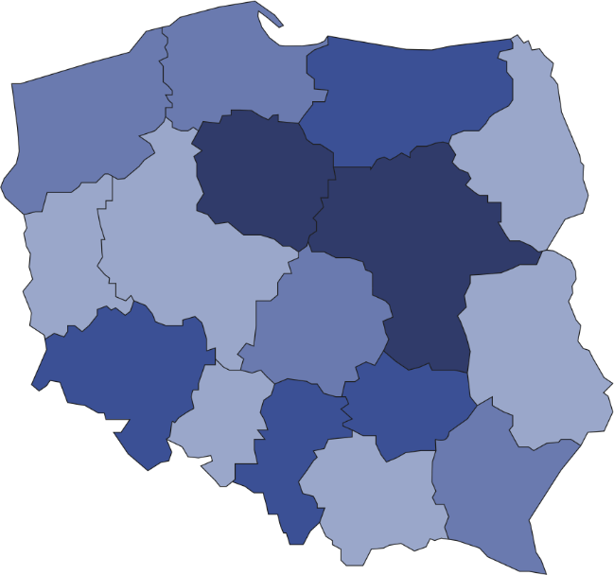
5
15
8
36
7
3
25
4
11
15
7
8
4
18
5
22

Number of spectators and listeners per 1 theatre/music institution
30001–43495
20001–30000
15001–20000
7814–15000
Number of theatres and music institutions (as of 31 December)
37.4% of total number of spectators and listeners took part in performances/concerts organised by theatres and music institutions from Mazowieckie Voivodship

194

The greatest number of theatres and music institutions with their own artistic ensemble operated in Mazowieckie Voivodship (36) and the least in Podkarpackie Voivodship (3). A total of 24.4 thousand performances/concerts were presented on 373 stages. Theatres and music institutions had 101.1 thousand seats in their audience.
In 2020, 85.1% of theatres and music institutions with their own artistic ensemble belonged to the public sector, in which 92.1% institutions were organised by local government units.
In 2020, 4.5 million spectators and listeners took part in performances/concerts organised by theatres and music institutions (a decrease of 68.7% in comparison to 2019). On average 185 people took part in one performance/concert. One institution organised on average 126 performances/concerts (in 2019 – 370).
Chart 1. The structure of theatres and music institutions by type in 2020
As of 31 December
%
19.0
39.7

In the case of quoting data from the Statistics Poland, please provide information: "Statistics Poland data source", and in the case of publishing calculations made on data published by the Statistics Poland, please provide information: "Own study based on Statistics Poland data".

Prepared by:  Statistical Office in Kraków  Director Agnieszka Szlubowska  Office: tel. (+48 12) 420 40 50 | Issued by:  The Spokesperson for the President  of Statistics Poland  Karolina Banaszek  Mobile: (+48) 695 255 011

Press Office  Office: tel. (+48 22) 608 34 91, 608 38 04  e-mail: obslugaprasowa@stat.gov.pl |  | www.stat.gov.pl/en/
 |  | @StatPoland
 |  | @GlownyUrzadStatystyczny

Related information
Culture in 2019
Activity of theatres and music institutions in 2019

Terms used in official statistics
Choir
Artistic activities and entertainment
Philharmonic
Musical institution
Concert
Orchestra
Premiere
Performance
Scene
Theatre
Spectators and listeners
Own artistic team
Song and dance ensemble

