Gross domestic product and gross value added
in the regions’ breakdown in 2019

In 2019, more than 1/2 of the national value of gross domestic product was generated in the 5 regions: Warszawski stołeczny, Śląskie, Wielkopolskie, Dolnośląskie and Małopolskie.
56.0%
Percentage of GDP value generated in the 5 regions
in 2019
r.

Gross domestic product
In 2019, value of the generated gross domestic product amounted to 2293199 million PLN.
In comparison to 2018, it grew by 8.1% at current prices.
Growth of gross domestic product at current prices in all regions in comparison with the previous year
In all regions, growth of GDP at current prices was observed in comparison with 2018, the highest in Warszawski stołeczny region – by 9.6% and the lowest in Kujawsko-pomorskie region – by 5.8%.
In 2019, the shares of individual regions in the generation of GDP ranged from 2.0% in Opolskie region to 17.6% in Warszawski stołeczny region. Value of GDP generated in Warszawski stołeczny region in 2019 was almost 9 times higher than in Opolskie
region (in 2018, more than 8 times higher).
In the group of regions with high shares in the generation of GDP in 2019, apart from Warszawski stołeczny region, there were also the following regions: Śląskie, Wielkopolskie, Dolnośląskie and Małopolskie. Entities acting in the 5 above-mentioned regions, in which 49.7% of total employed persons in the national economy worked, jointly generated 56.0%
of the national value of GDP.

Graph 1. Share of regions in the generation of gross domestic product in 2019 (current prices)

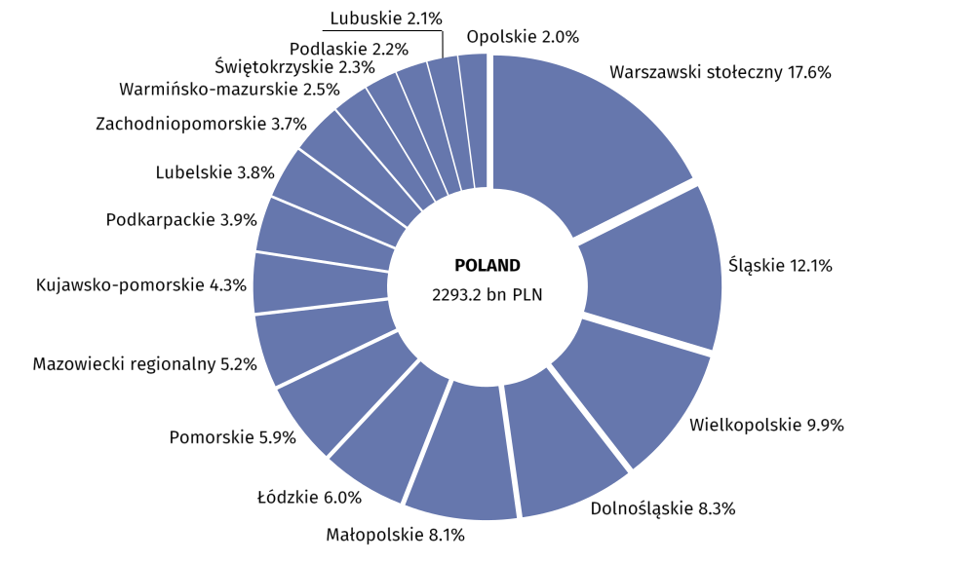

In 2019, the following regions were in the group of regions with low shares in the GDP generation (less than 3% each): Opolskie, Lubuskie, Podlaskie, Świetokrzyskie and Warmińsko-mazurskie. Their total share in the GDP generation amounted to 11.1% and employment in these regions constituted 13.2% of the total employed persons in the national economy.
In 2019, the average level of gross domestic product per capita in Poland amounted to
59741 PLN. In comparison with 2018, it was higher by 8.2% at current prices. In all regions growth of GDP per capita at current prices in comparison with 2018 was noted – from 6.0%
in Kujawsko-pomorskie region to 9.9% in Mazowiecki regionalny region.
In the regions’ breakdown, the level of GDP per capita in 2019 was considerably differentiated. Dispersion indicator of GDP per capita calculated at the regions’ level for Poland in 2019 amounted to 22.7%.
Value of GDP per capita exceeding the national average was obtained in
4 regions: Warszawski stołeczny, Dolnośląskie, Wielkopolskie and Śląskie
The highest level of GDP per capita in 2019 was noted for Warszawski stołeczny region – 131298 PLN, exceeding more than twice the national average (similarly as in 2018). In 2019 the level of GDP per capita above the national average was also observed in the following regions: Dolnośląskie – by 9.5%, Wielkopolskie – by 8.4% and Śląskie – by 2.5%.
The highest level of GDP per capita, obtained in 2019 in Warszawski stołeczny region, exceeded over 3-times the value of GDP per capita of Lubelskie region, in which the lowest level of GDP per capita was recorded.
Low level of GDP per capita (less than 75% of the national average) was noted in the
5 regions of Eastern Poland: Lubelskie, Warmińsko-
-mazurskie, Podkarpackie, Świętokrzyskie and Podlaskie
Low level of GDP per capita (less than 75% of the national average) in 2019 was observed
in the following regions: Lubelskie, Warmińsko-mazurskie, Podkarpackie, Świętokrzyskie and Podlaskie. In 2019 the value of GDP per capita in these regions varied from 68.2% to 72.2% of the national average.
The lowest level of GDP per capita in 2019, noted in Lubelskie region, represented 31.1%
of the level of this indicator for the best in this regard Warszawski stołeczny region.

Map 1. Gross domestic product per capita by regions in 2019 (current prices)

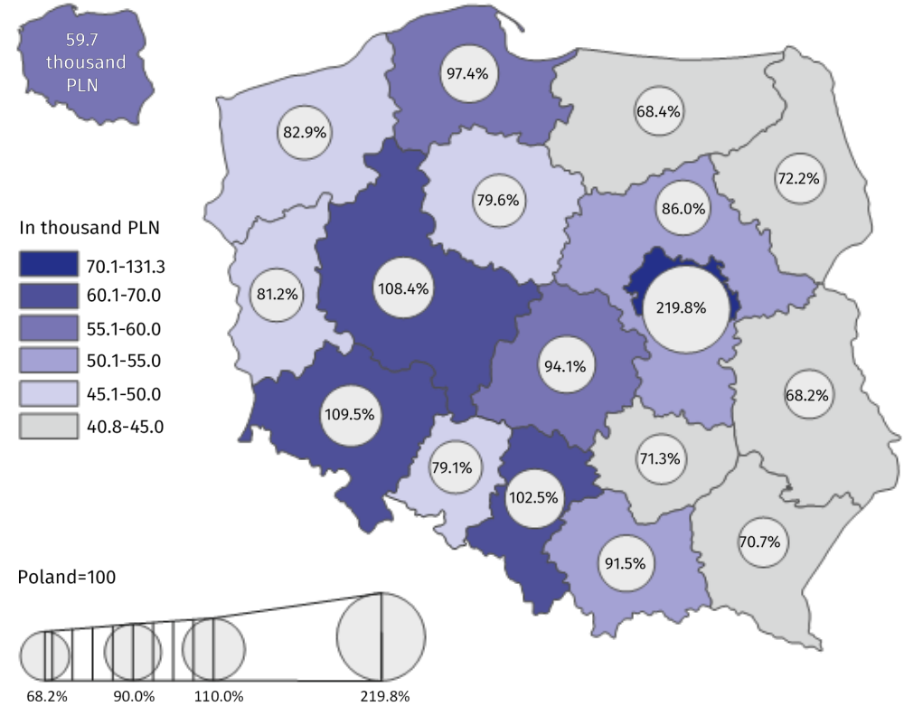

Table 1. Gross domestic product by regions in 2019 (current prices)
Regions | Total |  |  | Per capita
Regions | in million PLN | in percent | previous year=100 | in PLN | Poland=100 | previous year=100
POLAND | 2293199 | 100.0 | 108.1 | 59741 | 100.0 | 108.2
Dolnośląskie | 189637 | 8.3 | 107.9 | 65392 | 109.5 | 108.0
Kujawsko-pomorskie | 98660 | 4.3 | 105.8 | 47558 | 79.6 | 106.0
Lubelskie | 86116 | 3.8 | 108.4 | 40771 | 68.2 | 108.8
Lubuskie | 49131 | 2.1 | 106.5 | 48499 | 81.2 | 106.7
Łódzkie | 138283 | 6.0 | 108.9 | 56209 | 94.1 | 109.4
Małopolskie | 186170 | 8.1 | 107.8 | 54678 | 91.5 | 107.5
Mazowiecki regionalny | 120315 | 5.2 | 109.5 | 51388 | 86.0 | 109.9
Opolskie | 46532 | 2.0 | 107.3 | 47272 | 79.1 | 107.7
Podkarpackie | 89832 | 3.9 | 108.2 | 42225 | 70.7 | 108.2
Podlaskie | 50867 | 2.2 | 108.6 | 43128 | 72.2 | 108.8
Pomorskie | 136063 | 5.9 | 108.9 | 58202 | 97.4 | 108.4
Śląskie | 277029 | 12.1 | 106.3 | 61234 | 102.5 | 106.7
Świętokrzyskie | 52722 | 2.3 | 106.1 | 42608 | 71,.3 | 106.7
Warmińsko-mazurskie | 58298 | 2.5 | 106.9 | 40883 | 68.4 | 107.3
Warszawski stołeczny | 403106 | 17.6 | 109.6 | 131298 | 219.8 | 108.6
Wielkopolskie | 226378 | 9.9 | 108.7 | 64763 | 108.4 | 108.6
Zachodniopomorskie | 84061 | 3.7 | 107.4 | 49496 | 82.9 | 107.7
Gross value added by kind of activity
In 2019, 29.9% of the national gross value added was generated by the entities engaged in activities in the area of services covering trade; repair of motor vehicles; transportation and storage; accommodation and catering; information and communication. In the individual regions, the share of these entities in the generation of gross value added in 2019 ranged between 22.8% in Mazowiecki regionalny region and 38.2% in Warszawski stołeczny region.
In 2019, entities engaged in industry generated 25.3% of the national gross value added.
In the regions’ breakdown, in 2019 significant variation of the shares of industry was observed – from 12.0% in Warszawski stołeczny region to 35.2% in Mazowiecki regionalny region.
In 2019, entities engaged in other services (including public administration and defence; compulsory social security) generated 25.2% of the national gross value added. In 2019, Małopolskie region was characterised by the highest share of other services – 28.9% while Mazowiecki regionalny region was marked by the smallest share – 19.2%.

Entities engaged in financial and insurance activities; real estate activities in 2019 generated 9.3% of the national gross value added. In the individual regions, the share of entities acting in the field of financial and insurance activities; real estate activities in the generation of gross value added in 2019 ranged between 6.3% in Mazowiecki regionalny region and 14.5% in Warszawski stołeczny region.
In 2019, in all regions an increase of share of entities active in the field of financial and insurance activities; real estate activities in the gross value added generation was noted in comparison with 2018
In 2019, entities active in construction generated 7.7% of the national gross value added.
In the regions’ breakdown in 2019, the share of units engaged in construction in the generation of gross value added ranged from 6.2% in Łódzkie region to 9.4% in Małopolskie region.
The share of agriculture, forestry and fishing in the generation of the national gross value added in 2019 amounted to 2.6%. In the individual regions, in 2019 the shares of entities conducting activity in the range of agriculture, forestry and fishing were significantly differentiated – from 0.6% in Warszawski stołeczny region to 9.1% in Mazowiecki regionalny region.

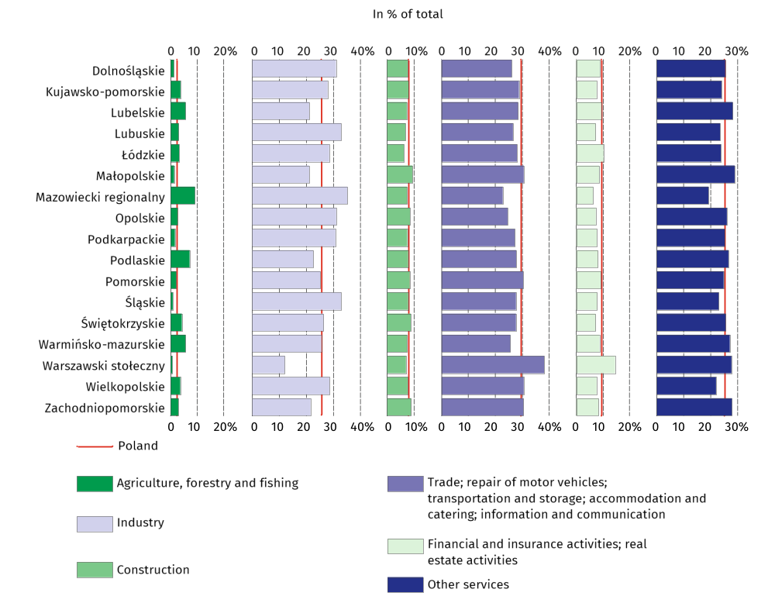
Graph 2. Gross value added by kind of activity and regions in 2019 (current prices)

Table 2. Gross value added by kind of activity and regions in 2019 (current prices)
REGIONS  a – in million PLN  b – in % of total  c – previous year=100 |  | Total | Agriculture, forestry  and fishing | Industry | Construction | Trade; repair of motor vehicles^{Δ};  transportation and storage; accommodation  and catering^{Δ}; information and communication | Financial  and insurance activities;  real estate activities^{Δ} | Other services
POLAND | a | 2016064 | 52538 | 510568 | 155022 | 602478 | 187819 | 507638
 | b | 100.0 | 2.6 | 25.3 | 7.7 | 29.9 | 9.3 | 25.2
 | c | 108.5 | 107.4 | 106.5 | 105.8 | 108.6 | 114.5 | 109.5
Dolnośląskie | a | 166719 | 2068 | 51601 | 12612 | 43490 | 14661 | 42286
 | b | 100.0 | 1.2 | 31.0 | 7.6 | 26.1 | 8.8 | 25.4
 | c | 108.4 | 97.4 | 107.4 | 107.5 | 108.1 | 111.4 | 109.7
Kujawsko-pomorskie | a | 86736 | 3244 | 24229 | 6848 | 25016 | 6585 | 20814
 | b | 100.0 | 3.7 | 27.9 | 7.9 | 28.8 | 7.6 | 24.0
 | c | 106.2 | 105.8 | 103.9 | 105.4 | 106.9 | 108.4 | 107.8
Lubelskie | a | 75709 | 4260 | 16011 | 5497 | 21598 | 7016 | 21327
 | b | 100.0 | 5.6 | 21.1 | 7.3 | 28.5 | 9.3 | 28.2
 | c | 108.8 | 110.3 | 111.2 | 106.0 | 107.3 | 111.0 | 108.4
Lubuskie | a | 43194 | 1276 | 14209 | 2917 | 11504 | 3128 | 10160
 | b | 100.0 | 3.0 | 32.9 | 6.8 | 26.6 | 7.2 | 23.5
 | c | 106.9 | 107.8 | 106.1 | 105.6 | 106.5 | 108.3 | 108.4
Łódzkie | a | 121571 | 3906 | 34634 | 7500 | 34158 | 12389 | 28983
 | b | 100.0 | 3.2 | 28.5 | 6.2 | 28.1 | 10.2 | 23.8
 | c | 109.4 | 111.9 | 107.7 | 107.2 | 109.9 | 114.6 | 108.9
Małopolskie | a | 163671 | 2121 | 34615 | 15350 | 50152 | 14087 | 47347
 | b | 100.0 | 1.3 | 21.1 | 9.4 | 30.6 | 8.6 | 28.9
 | c | 108.2 | 108.0 | 104.7 | 106.9 | 107.6 | 114.8 | 110.2
Mazowiecki regionalny | a | 105775 | 9611 | 37209 | 7784 | 24137 | 6707 | 20327
 | b | 100.0 | 9.1 | 35.2 | 7.4 | 22.8 | 6.3 | 19.2
 | c | 109.9 | 105.6 | 112.7 | 105.5 | 106.5 | 117.6 | 110.7
Opolskie | a | 40908 | 1060 | 12709 | 3490 | 10064 | 2968 | 10618
 | b | 100.0 | 2.6 | 31.1 | 8.5 | 24.6 | 7.3 | 26.0
 | c | 107.8 | 99.3 | 105.9 | 108.4 | 107.4 | 110.2 | 110.6
Podkarpackie | a | 78976 | 1262 | 24290 | 5886 | 21535 | 6109 | 19894
 | b | 100.0 | 1.6 | 30.8 | 7.5 | 27.3 | 7.7 | 25.2
 | c | 108.6 | 103.5 | 107.5 | 106.1 | 108.8 | 116.1 | 108.7
Podlaskie | a | 44720 | 3155 | 10116 | 3490 | 12448 | 3604 | 11906
 | b | 100.0 | 7.1 | 22.6 | 7.8 | 27.8 | 8.1 | 26.6
 | c | 109.0 | 112.3 | 109.1 | 111.1 | 107.6 | 110.0 | 108.6

Table 2. Gross value added by kind of activity and regions in 2019 (cont.)
REGIONS  a – in million PLN  b – in % of total  c – previous year=100 |  | Total | Agriculture. forestry  and fishing | Industry | Construction | Trade; repair of motor vehicles^{Δ};  transportation and storage; accommodation  and catering^{Δ}; information and communication | Financial  and insurance activities;  real estate activities^{Δ} | Other services
Pomorskie | a | 119620 | 2487 | 30142 | 10058 | 36379 | 10902 | 29652
 | b | 100.0 | 2.1 | 25.2 | 8.4 | 30.4 | 9.1 | 24.8
 | c | 109.3 | 106.6 | 107.0 | 107.8 | 110.1 | 117.3 | 108.9
Śląskie | a | 243550 | 1893 | 80109 | 19084 | 67415 | 19069 | 55980
 | b | 100.0 | 0.8 | 32.9 | 7.8 | 27.7 | 7.8 | 23.0
 | c | 106.8 | 114.0 | 102.5 | 104.4 | 108.0 | 116.2 | 109.4
Świętokrzyskie | a | 46350 | 1957 | 12258 | 4098 | 12837 | 3341 | 11859
 | b | 100.0 | 4.2 | 26.4 | 8.8 | 27.7 | 7.2 | 25.6
 | c | 106.6 | 105.2 | 105.9 | 104.8 | 105.3 | 110.7 | 108.3
Warmińsko-mazurskie | a | 51252 | 2851 | 13096 | 3785 | 13141 | 4473 | 13905
 | b | 100.0 | 5.6 | 25.6 | 7.4 | 25.6 | 8.7 | 27.1
 | c | 107.4 | 104.7 | 105.2 | 103.1 | 109.1 | 112.6 | 108.0
Warszawski stołeczny | a | 354391 | 2052 | 42548 | 24841 | 135233 | 51502 | 98215
 | b | 100.0 | 0.6 | 12.0 | 7.0 | 38.2 | 14.5 | 27.7
 | c | 110.0 | 101.8 | 105.1 | 104.5 | 109.6 | 116.9 | 111.0
Wielkopolskie | a | 199020 | 7199 | 56859 | 15190 | 60854 | 15155 | 43764
 | b | 100.0 | 3.6 | 28.6 | 7.6 | 30.6 | 7.6 | 22.0
 | c | 109.2 | 109.6 | 108.2 | 105.5 | 109.7 | 113.6 | 109.6
Zachodniopomorskie | a | 73902 | 2137 | 15932 | 6593 | 22516 | 6122 | 20602
 | b | 100.0 | 2.9 | 21.6 | 8.9 | 30.5 | 8.3 | 27.9
 | c | 107.9 | 113.8 | 106.7 | 103.6 | 108.7 | 110.9 | 107.8
Symbol (∆) — categories of applied classification are presented in abbreviated form; their full names are available on Statistics Poland’s website: Statistics Poland / Metainformation / Classifications

Data from regional accounts included in this note have been revised in relation to those published on 31 December 2020 and balanced with annual national accounts data included in the publication “National accounts by institutional sectors 2016-2019”, available at website Statistics Poland / Topics / National accounts / Annual national accounts. Complete range of data for the year 2019 will be available in November this year.
In case of quoting Statistics Poland data, please provide information: “Source of data: Statistics Poland”, and in case of publishing calculations made on data published by Statistics Poland, please include the following disclaimer: “Own study based on figures from Statistics Poland”.

Prepared by:  Statistical Office in Katowice  Director Aurelia Hetmańska  Office: tel: (+48 32) 779 12 48 | Issued by:  The Spokesperson for the President  of Statistics Poland  Karolina Banaszek  Mobile: (+48) 695 255 011

Press Office  Office: tel: (+48 22) 608 34 91, 608 38 04  e-mail: obslugaprasowa@stat.gov.pl |    | www.stat.gov.pl/en/
 |  | @StatPoland
 |  | @GlownyUrzadStatystyczny

Related information
GDP per capita in EU regions
Classification of Territorial Units for Statistics NUTS 2021
Gross Domestic Product – regional accounts in the years 2016-2018
National accounts by institutional sectors 2016-2019
Provisional estimates of gross domestic product in regional breakdown in 2019

Data available in databases
Local Data Bank ->Regional accounts

Terms used in official statistics
Regional accounts
Gross domestic product
Value added, gross

In accordance with the Classification of Territorial Units for Statistics (NUTS 2021), obligatory from 1 January 2021 https://eur-lex.europa.eu/legal-content/EN/TXT/PDF/?uri=CELEX:32019R1755&from=EN.

