
NEWS RELEASES

Activity of enterprises having foreign entities
31.03.2021
in 2019

At the end of 2019, 1 848 enterprises in Poland (a decrease as compared to 2018 by 0.6%) declared involvement in 3 979 foreign entities (an increase by 3.4% comparing to 2018) in the form of shares, branches or other forms. Majority of foreign entities were located in Germany, Czechia, Ukraine and Russia.
3.4%
Growth of the number of foreign entities y-o-y

Characteristics of enterprises in Poland having foreign entities
Micro and small enterprises (below 50 employed persons) constituted 42.8% of all enterprises in Poland having foreign entities

Engagement in foreign entities by the end of 2019 was confirmed by 1 848 surveyed enterprises (in 2018 – 1 859). In the surveyed population of enterprises having foreign entities dominated micro and small enterprises, i.e. with the number of persons employed below 50 people at the end of the year (42.8% of all enterprises), medium-sized enterprises (from 50 to 249 employed persons) accounted for 29.4% and large enterprises (250 and more employed persons) – 27.8%.
In 2019, enterprises belonging to enterprise groups (1 561 entities) accounted for 84.5% of the total of surveyed enterprises having foreign entities.

Chart 1. The number of enterprises in Poland and their foreign entities

The surveyed population of 1 848 enterprises declared involvement in 3 979 entities located abroad. Majority of foreign entities – 2 693 (67.7%) were entities with 100% share of the enterprise located in Poland in the capital of the foreign entity. Foreign entities, in which the share of the Polish enterprise was from 50.01% to 99.99% accounted for 18.3% of all foreign entities (730 entities) and entities for which the share of the enterprise located in Poland in their capital did not exceed 50% – 14.0% of foreign entities (556).
By legal forms, majority of enterprises having foreign entities constituted limited liability companies – 1 203 (65.1%) and joint stock companies – 505 enterprises (27.3%).
In Mazowieckie voivodship there were located 28.6% of all enterprises having foreign entities
At the end of 2019 the largest number of enterprises having foreign entities was located in the following voivodships: Mazowieckie (528 enterprises, which declared involvement in 1 175 foreign entities), Śląskie (228 and 356, respectively), Małopolskie (184 and 397) and Wielkopolskie (172 and 314).

Map 1. The number of enterprises in Poland and their foreign entities by voivodships in 2019

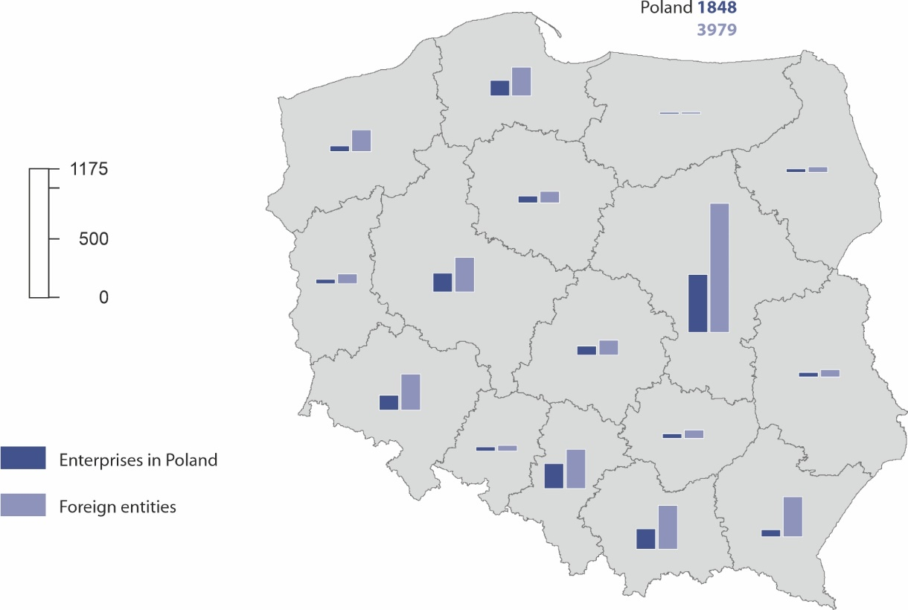
Manufacturing activity was conducted by 33.4% of enterprises having foreign entities
Enterprises located in Poland having foreign entities were mainly enterprises engaged in manufacturing (617 enterprises declared involvement in 1 181 foreign entities), trade; repair of motor vehicles (402 and 795, respectively), professional, scientific and technical activities (226 and 489) as well as construction (187 and 242).

Chart 2. The number of enterprises in Poland and their foreign entities by selected NACE section of enterprise in Poland in 2019

Countries of location of foreign entities
The largest number of foreign entities was located in the countries bordering with Poland: Germany, Czechia, Ukraine and Russia (1360 foreign entities – 34.2%)

Enterprises located in Poland engaged their capital in 115 countries. 1 701 foreign entities (42.7%) were located in seven countries which border with Poland. Majority of foreign entities were seated in Germany - 575, Czechia - 296, Ukraine - 279 and in Russia - 210. In 27 countries of the European Union there were 2 455 foreign entities (61.7% of all foreign entities).

Chart 3. The number of foreign entities by country of their location in 2019

Characteristics of foreign entities by main kind of activity of the enterprise in Poland
The number of persons employed in foreign entities amounted to 201.1 thousand persons

The number of persons employed in 3 979 foreign entities amounted to 201.1 thousand persons. In the foreign entities belonging to enterprises in Poland engaged in manufacturing worked 57.2 thousand persons, while in entities belonging to entities dealing with trade; repair of motor vehicles – 42.4 thousand persons.
The number of persons employed belonging to foreign entities of enterprises in Poland engaged in those two areas of activity amounted to 49.5% of the total number of persons employed in foreign entities.
Net revenues from sale of products, goods and materials (sales revenues) of foreign entities in total amounted to 260.2 bn PLN, of which the vast majority, i.e. 161.8 bn PLN (62.2%) were revenues of foreign entities belonging to the enterprises in Poland dealing with manufacturing. Sales revenues of entities belonging to the enterprises involved in trade; repair of motor vehicles amounted to 33.2 bn PLN (12.8% of the total sales revenues of foreign entities).
Net revenues from sale of products, goods and materials for export (export) of foreign entities amounted to 46.7 bn PLN and accounted for 18.0% of the total sales revenues. The largest share in export belonged to foreign entities owned by enterprises located in Poland conducting manufacturing activity – 68.5% (32.0 bn PLN).
Import purchases (import) made by foreign entities amounted to 76.5 bn PLN. Value of import of entities owned by enterprises conducting manufacturing activity amounted to 61.8 bn PLN and accounted for 80.8% of the total import of foreign entities.

Table 1. Characteristics of foreign entities by NACE section of the enterprise in Poland in 2019

NACE section | Number of foreign entities | Number of persons employed | Net revenues from sale of products, goods and materials | Export | Import | Outlays on tangible fixed assets
NACE section | Number of foreign entities | Number of persons employed | million PLN
Total | 3 979 | 201 092 | 260 206.6 | 46 743.6 | 76 511.9 | 12 578.2
including:
Manufacturing | 1 181 | 57 206 | 161 799.5 | 32 021.3 | 61 807.2 | 7 757.6
Electricity, gas, steam and air conditioning supply | 47 | 1 048 | 20 348.9 | 784.4 | 288.7 | 179.9
Construction | 242 | 10 390 | 3 181.5 | 92.1 | 125.6 | 19.4
Trade; repair of motor vehicles | 795 | 42 405 | 33 213.2 | 4 478.1 | 11 704.2 | 1 115.5
Information and communication | 567 | 30 140 | 12 189.8 | 1 586.0 | 559.8 | 172.4
Professional, scientific and technical activities | 489 | 16 728 | 9 794.1 | 2 228.3 | 870.8 | 921.9

Characteristics of foreign entities by their main kind of activity
In 2019, 60.5% of all foreign entities declared the same kind of activity as their parent enterprise located in Poland. The highest share of foreign entities with the same kind of activity as the enterprise in Poland was observed in transportation and storage (91.8%). It was also high in information and communication (81.0%).
30.2% of foreign entities were involved in trade; repair of motor vehicles

The largest number of foreign entities conducted their activity in trade; repair of motor vehicles (1 202), manufacturing (669), information and communication (519), professional, scientific and technical activities (416) and construction (279).
The number of persons employed in entities engaged in manufacturing amounted to 63.6 thousand persons in 2019, while in entities involved in trade; repair of motor vehicles – 37.3 thousand persons.
The highest net revenues from sale of products, goods and materials were achieved by foreign entities conducting trade; repair of motor vehicles activity – 105.1 bn PLN (40.4% of the total sales revenues) and manufacturing – 88.4 bn PLN (34.0% of the total sales revenues).
Foreign entities in Germany, Russia, Czechia and Hungary reported the largest number of employed persons
In 2019, the largest number of persons employed was declared in the foreign entities in Germany (31.8 thousand persons), Russia (22.1 thousand), in Czechia (19.0 thousand) and Hungary (14.4 thousand), which in total accounted for 43.5% of the number of persons employed in all foreign entities.
Taking into account the location of the surveyed foreign entities, the highest net revenues from sale of products, goods and materials in 2019 were achieved by foreign entities in Germany and Czechia, respectively 50.7 bn PLN (19.5% of the total sales revenues of foreign entities) and 32.6 bn PLN (12.5%).
Table 2. Characteristics of foreign entities by the selected countries of location in 2019
Countries | Number of foreign entities | Number of persons employed | Net revenues from sale of products, goods and materials | Export | Import | Outlays on tangible fixed assets
Countries | Number of foreign entities | Number of persons employed | million PLN
Total | 3 979 | 201 092 | 260 206.6 | 46 743.6 | 76 511.9 | 12 578.2
including:
Czechia | 296 | 19 018 | 32 551.1 | 8 627.3 | 26 529.2 | 1 641.2
Germany | 575 | 31 829 | 50 749.3 | 4 357.6 | 7 259.6 | 581.9
Russia | 210 | 22 116 | 9 835.3 | 338.8 | 2 542.7 | 449.3
Romania | 184 | 13 427 | 6 871.1 | 1 597.5 | 2 283.3 | 249.2
Ukraine | 279 | 13 515 | 4 887.1 | 1 160.5 | 1 566.6 | 471.7

The data on enterprises in Poland having foreign entities presented in this study do not include agriculture, forestry and fishing (section A), financial and insurance activities (section K), higher education institutions, independent public health care facilities, cultural institutions with legal personality and trade unions, religious and political organisations.
In case of quoting Statistics Poland data, please provide information: “Source of data: Statistics Poland”, and in case of publishing calculations made on data published by Statistics Poland, please include the following disclaimer: “Own study based on figures from Statistics Poland”.

Prepared by:  Enterprises Department  Director Katarzyna Walkowska  Office: tel: (+48 22) 608 31 25 | Issued by:  The Spokesperson for the President  of Statistics Poland  Karolina Banaszek  Mobile: (+48) 695 255 011

Press Office  Office: tel. (+48 22) 608 3491, 608 3804  e-mail: obslugaprasowa@stat.gov.pl |  | www.stat.gov.pl/en/
 |  | @StatPoland
 |  | @GlownyUrzadStatystyczny

Related information
News release: Activity of enterprises having foreign entities in 2018
Publication: Activity of enterprises having foreign entities in 2018
Methodological report. Non-financial enterprises surveys 2019

Terms used in official statistics
Net revenues from sale of products, goods and materials

Since the reference year 2018 there has been collected the variable ‘average number of persons employed’ calculated as annual mean on the basis of daily, weekly, monthly or quarterly basis

