Production of industrial products in 2020
The value of sold production of own products by producers in 2020 r. decreased in relation to 2019 by 5.3% and amounted to 1 147 427.1 million PLN.
94.7
Index of value of sold production of own products by manufacturers

Sold production of industrial products
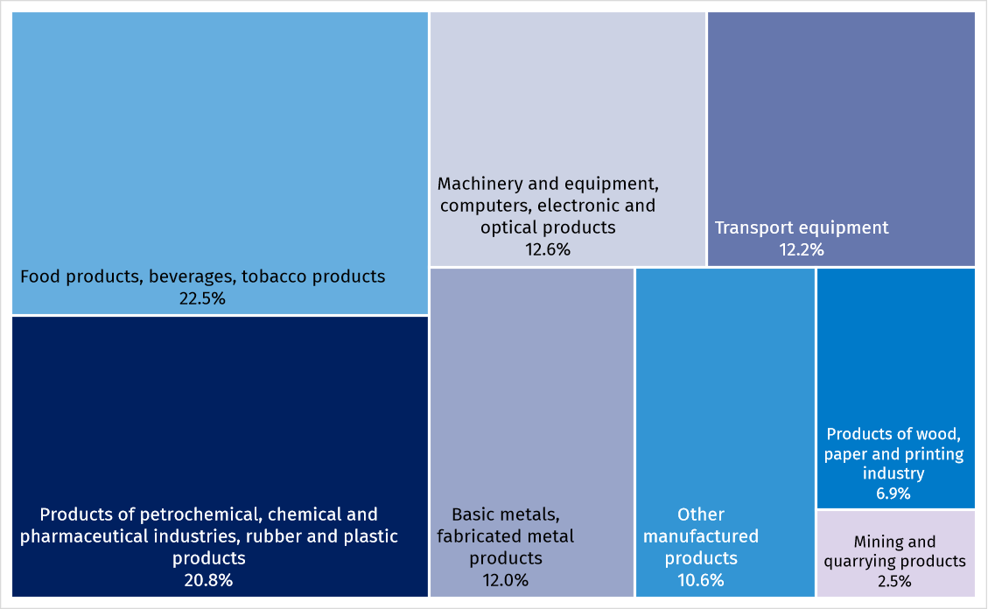
Chart 1. Share in the value of sold production in 2020, by groupings of divisions of the Polish Classification of Goods and Services (PKWiU)

Compared to 2019, the total value of sold production of goods increased in the following divisions: Computers, electronic and optical products (by 5.8%), Basic pharmaceutical products, medicaments and pharmaceutical preparations (by 5.4%), Textiles (by 3.1%), Food products (by 1.8%). The decrease of the value of sold production was recorded e.g. for divisions Coke, briquette and similar solid fuels from coal or peat and refined petroleum products (by 24.8%), Hard coal and lignite (by 18.9%), Motor vehicles, trailers and semi-trailers (by 14.2%), Electrical equipment (by 9.4%). The value of sold production of Wood and cork products, articles of straw and plaiting materials remained unchanged.

Table 1. Value of sold production of products in 2019 by PKWiU sections and divisions
The largest share in the value of sold production was recorded for Food products (18.1%)

SECTIONS AND DIVISIONS | 2020
SECTIONS AND DIVISIONS | in thousand PLN | 2019=100 | share in total value
TOTAL | 1 147 427 117.3 | 94.7 | 100.0
PRODUCTS OF MINING AND QUARRYING | 28 608 993.9 | 82.8 | 2.5
of which Hard coal and lignite | 17 341 719.9 | 81.1 | 1.5
MANUFACTURED PRODUCTS | 1 118 818 123.4 | 94.8 | 97.5
of which:
Food products | 207 226 520.1 | 101.8 | 18.1
Beverages | 33 169 184.4 | 99.4 | 2.9
Textiles | 9 658 442.7 | 103.1 | 0.8
Wearing apparel | 4 309 545.8 | 81.6 | 0.4
Leather and leather products | 2 892 149.0 | 81.4 | 0.3
Wood and products of wood and cork, except furniture; articles of straw and plaiting materials | 28 337 095.5 | 100.0 | 2.5
Paper and paper products | 43 350 299.4 | 99.6 | 3.8
Coke, briquette and similar solid fuels from coal and peat, refined petroleum products | 74 946 850.6 | 75.2 | 6.5
Chemicals and chemical products | 68 112 807.1 | 97.4 | 5.9
Basic pharmaceutical products, medicaments and pharmaceutical preparations | 11 455 121.5 | 105.4 | 1.0
Rubber and plastic products | 84 644 891.1 | 99.8 | 7.4
Other non-metallic mineral products | 52 565 067.3 | 99.1 | 4.6
Basic metals | 68 750 484.7 | 95.3 | 6.0
Fabricated metal products, except machinery and equipment | 68 795 969.0 | 99.7 | 6.0

SECTIONS AND DIVISIONS | 2020
SECTIONS AND DIVISIONS | in thousand PLN | 2019=100 | share in total value
Computer, electronic and optical products | 36 225 176.4 | 105.8 | 3.2
Electrical equipment | 64 654 868.9 | 90.6 | 5.6
Machinery and equipment n.e.c. | 43 326 528.1 | 91.1 | 3.8
Motor vehicles, trailers and semi-trailers | 121 244 518.6 | 85.8 | 10.6
Other transport equipment | 18 601 051.8 | 91.7 | 1.6
Furniture | 41 833 418.8 | 95.8 | 3.6

The following were among the products with largest value of sold production: gas oils for high-speed compression ignition engines (diesel fuel); parts and accessories for motor vehicles; hard coal; hot rolled products (excluding semi-finished products); motor gasoline, unleaded; television receivers with built-in digital TV tuner; cigarettes; pig meat, fresh or chilled; beer excluding non-alcoholic beer; vehicle compression-ignition internal combustion piston engines (excluding for railway or tramway rolling stock and wheeled agricultural or forestry tractors).

Out of 4455 products and assortment groups of products covered by observation in physical units of measure according to the PRODPOL nomenclature, entities of the national economy reported sold production for 3567 headings. Increase in sold production was noted in 1431 products and decrease was noted in 1940.

Manufactured production of industrial products
Out of 4455 products and assortment groups of products covered by observation in physical units of measure according to the PRODPOL nomenclature, entities of the national economy reported manufactured production for 3601 items.

Table 2. Manufactured production of industrial products in 2020
SPECIFICATION | Volume  unit | Volume | 2019=100
Hard coal | thousand  tonnes | 54 741 | 88.1
Lignite | thousand  tonnes | 45 983 | 91.3
Natural gas | cubic  hectometres | 5 302 | 98.7
Slaughter products of cattle and calves and pigs included in slaughter capacity | tonnes | 1 367 404 | 88.9
Poultry meat | tonnes | 3 187 475 | 103.5
Milk | hectolitres | 37 091 277 | 107.6
Butter | tonnes | 254 625 | 107.3
Fresh bread | tonnes | 1 377 336 | 93.7
Sugar in terms of white sugar | tonnes | 1 992 269 | 90.6
Vodka in terms of 100% | hectolitres | 983 974 | 93.1
Beer from malt | hectolitres | 39 065 757 | 96.7
Cigarettes | million items | 223 219 | 104.6
Footwear (including rubber footwear) | thousand pair | 28 848 | 78.2
Sawnwood | cubic  decametres | 4 625 | 93.5
Fibreboard | thousand m² | 681 890 | 93.3
Paper and paperboard | thousand  tonnes | 5 129 | 105.1
Motor gasoline (including aviation gasoline) | tonnes | 4 314 687 | 94.3
Diesel oils | tonnes | 13 491 457 | 100.6
Ethylene | tonnes | 486 940 | 102.6

SPECIFICATION | Volume  unit | Volume | 2019=100
Mineral or chemical fertilizers. in terms of pure component, including multi-ingredient fertilizers | tonnes | 2 928 570 | 100.4
Plastics in primary forms | tonnes | 3 681 124 | 101.5
Tires (excluding retreaded) | thousand  items | 42 424 | 84.8
Builders’ ware of plastic | tonnes | 1 049 152 | 105.9
Cement | thousand  tonnes | 19 049 | 100.5
Bricks | thousand  bricks | 576 632 | 86.4
Crude steel | tonnes | 7 958 219 | 87.2
Hot rolled products (excluding semi-finished products) | tonnes | 8 490 285 | 91.5
Steel tubes | tonnes | 807 545 | 102.0
Unwrought, unalloyed refined copper | tonnes | 562 006 | 96.5
Computers | thousand  items | 3 361 | 80.8
Television receivers | thousand  items | 16 707 | 98.5
Refrigerators and freezers, including combined refrigerators-freezers | thousand  items | 3 518 | 101.6
Washing machines (including machines which both wash and dry) | thousand  items | 6 773 | 103.3
Domestic electric cookers with at least an oven and a hob (including combined gas-electric appliances) | thousand  items | 1 411 | 101.4
Agricultural tractors | items | 1 760 | 85.0
Machinery and equipment for construction, road and drainage work | tonnes | 12 494 | 86.1
Passenger cars | items | 278 788 | 64.1
Public transport vehicles | items | 6 037 | 82.0
Lorries and road tractors for semi-trailers | items | 166 445 | 80.1
Wooden furniture for dining and living room | thousand  items | 32 073 | 97.7
Table 3. Manufactured production of products related to the prevention of spreading / combating COVID-19

Product name | Measurement unit | III-XII 2020
Protective clothing (overalls, aprons) | items | 14 710 683
Face masks used in medicine | items | 50 341 695
Other protective face masks | items | 221 974 502
Disposable plastic film gloves | items | 3 537 320
Protective head caps | items | 7 844 189
Protective face shields | items | 12 080 271
Safety googles | items | 70 421
Protective shoe covers | pair | 4 245 180
Disinfectant liquids and gels | kilograms | 88 057 511
Disinfectant wipes | kilograms | 13 054 814
Soap with disinfectant properties | kilograms | 33 596
Swab test kits⁵ | items | 370 900
Acrylic sneeze guards /workplace shields⁵ | items | 384 177

In the case of quoting data from the Statistics Poland, please provide information: "Statistics Poland data source", and in the case of publishing calculations made on data published by the Statistics Poland, please provide information: "Own study based on Statistics Poland data".

Prepared by:  Enterprises Department  Director Katarzyna Walkowska  Office: tel. (+48 22) 608 31 25 |  | Issued by:  The Spokesperson for the President  of Statistics Poland  Karolina Banaszek  Mobile: (+48) 695 255 011
Press Office  Office: tel. (+48 22) 608 34 91, 608 38 04  e-mail: obslugaprasowa@stat.gov.pl |  |  | www.stat.gov.pl/en/
 |  |  | @StatPoland
 |  |  | @GlownyUrzadStatystyczny
Powiązane opracowania
Production of industrial products
Production of major industrial products
Production of industrial products in 2015–2019
Production of industrial products related to prevention of spreading / combating COVID-19 in December 2020

Data available in databases
Knowledge databases - Industrial production

Terms used in official statistics
Sold production of industry products
Manufactured production
Finished products

Data refer to enterprises in which the number of persons employed is 10 and more
Data refer to enterprises in which the number of persons employed is 10 and more
Data refer to enterprises in which the number of persons employed is 10 and more.
The data covers the period from March 2020, i.e. the month in which the epidemic threat and the state of the epidemic were announced
Data for the period I-XII 2020

