Non-financial enterprises established in 2020

Among the non-financial enterprises declaring the start of operations in 2020, 161 048 units remained active by 2021 i.e. 67.1%. The highest survival rate after the first year of activity was recorded for entities in professional, scientific and technical activities section (79.6%).
67.1%
Survival rate of non-financial enterprises after the first year of activity

In the one-year non-financial enterprises there were employed 261.8 thousand persons

In non-financial enterprises established in 2020 and active until 2021 there were employed 261 812 persons of which 67.2% worked in enterprises that were natural persons and 32.8% legal persons.

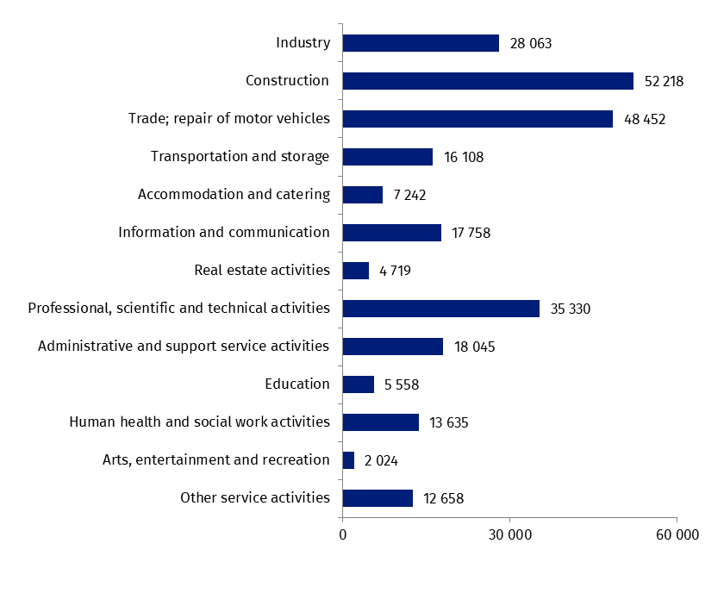
Chart 1. Number of persons employed in enterprises established in 2020 and active until 2021
According to the predominant kind of activity, the highest number of persons employed was in enterprises that conducted activity in sections: construction (52 218 persons), trade; repair of motor vehicles (48 452 persons) and professional, scientific and technical activities (35 330 persons).
In terms of the territorial division, the highest number of persons employed in one-year enterprises was in the enterprises which had their registered offices in the Mazowieckie Voivodship (59 572 persons) and the lowest in the Warmińsko-Mazurskie Voivodship (4 637 persons).

Enterprises established in 2020 and active until 2021 achieved total revenues of 44 212.3 million PLN.
One-year non-financial enterprises generated total revenues of 44 212.3 million PLN
The share of total revenues generated in the first year of activity by entities in the area of trade; repair of motor vehicles comprised 44.7% of all one-year enterprises' total revenues.
Total costs in one-year enterprises amounted to 36 652.2 million PLN of which 50.4% were incurred by entities conducting trade; repair of motor vehicles activity.

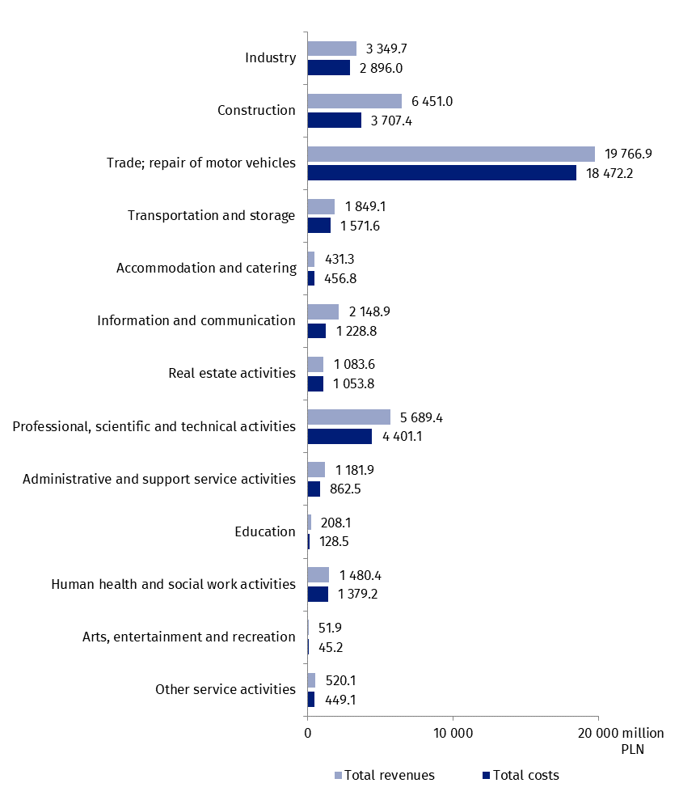
Chart 2. Total revenues and total costs of enterprises established in 2020 and active until 2021 according to the NACE sections
Chart 3. Cost level indicator for enterprises established in 2020 and active until 2021 by the
Cost level indicator for one-year non-financial enterprises was 82.9%
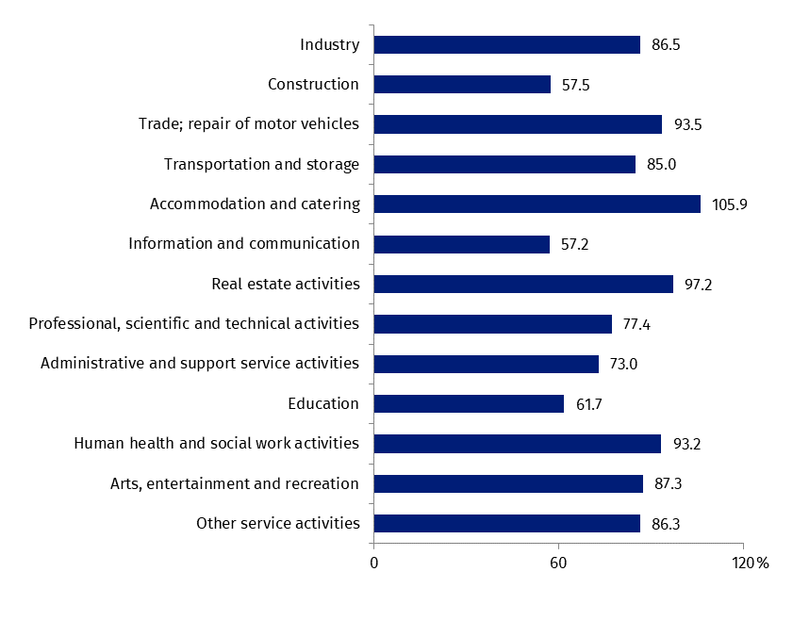
NACE sections

Amongst the enterprises established in 2020 and still active in 2021, the lowest cost level indicator was observed in information and communication section (57.2%). This indicator exceeded 100% for units in accommodation and catering section (105.9%).
In terms of the territorial division, the lowest value of the cost level indicator was recorded for the Pomorskie voivodship (63.9%), and the highest for the Mazowieckie voivodship (90.7%).
Data presented herein concern non-financial enterprises established in 2020 and active until 2021, irrespective of the number of persons employed. Data do not cover agriculture, forestry and fishing (section A of NACE Rev. 2); financial and insurance activities (section K of NACE Rev. 2); higher education; independent public health care units; cultural institutions with legal personality and trade unions, religious and political organizations.
The results of newly-born non-financial enterprises survey will be present in publication titled „Non-financial enterprises established in 2016-2020”.
In terms of the data roundings, in some cases the sums of ingredients may differ slightly from presented totals.
In the case of quoting Statistics Poland data, please provide information: „Source of data: Statistics Poland” and in the case of publishing calculations made on data published by Statistics Poland, please include the following disclaimer: „Own study based on figures from Statistics Poland”.

Tabular appendix
Table 1. Basic data on enterprises established in 2020 and active until 2021 by kind of activity
SPECIFICATION | Number of enterprises | Number of persons  employed | Average paid employment | Total  revenues | Total  costs
 |  |  |  | in thousand PLN
TOTAL | 161 048 | 261 812 | 46 518 | 44 212 297 | 36 652 197
Section B + C + D + E  Industry | 13 920 | 28 063 | 8 275 | 3 349 682 | 2 896 008
of which Section C  Manufacturing | 12 731 | 26 111 | 7 905 | 3 045 798 | 2 636 581
Section F  Construction | 33 493 | 52 218 | 8 088 | 6 451 031 | 3 707 404
Section G  Trade; repair of motor vehicles | 28 090 | 48 452 | 10 498 | 19 766 892 | 18 472 243
Section H  Transportation and storage | 8 872 | 16 108 | 2 381 | 1 849 095 | 1 571 553
Section I  Accommodation and catering | 4 333 | 7 242 | 848 | 431 277 | 456 797
Section J  Information and communication | 12 873 | 17 758 | 2 207 | 2 148 924 | 1 228 816
Section L  Real estate activities | 3 527 | 4 719 | 880 | 1 083 608 | 1 053 789
Section M  Professional, scientific and technical activities | 23 287 | 35 330 | 4 865 | 5 689 404 | 4 401 091
Section N  Administrative and support  service activities | 8 278 | 18 045 | 4 094 | 1 181 925 | 862 526
Section P  Education | 4 327 | 5 558 | 1 079 | 208 129 | 128 472
Section Q  Human health and social work activities | 9 025 | 13 635 | 1 560 | 1 480 401 | 1 379 198
Section R  Arts, entertainment and  recreation | 1 708 | 2 024 | 102 | 51 851 | 45 244
Section S  Other service activities | 9 315 | 12 658 | 1 640 | 520 078 | 449 056

Table 2. Basic data on enterprises established in 2020 and active until 2021 by voivodship
SPECIFICATION | Number of enterprises | Number of persons  employed | Average paid employment | Total  revenues | Total  costs
 |  |  |  | in thousand PLN
POLAND | 161 048 | 261 812 | 46 518 | 44 212 297 | 36 652 197
Dolnośląskie | 14 720 | 26 747 | 4 012 | 3 452 003 | 2 372 425
Kujawsko-pomorskie | 5 603 | 8 084 | 1 551 | 1 000 389 | 704 479
Lubelskie | 5 778 | 8 951 | 1 495 | 942 616 | 797 684
Lubuskie | 3 839 | 5 173 | 556 | 894 514 | 748 302
Łódzkie | 9 863 | 13 990 | 1 817 | 1 682 455 | 1 356 882
Małopolskie | 14 776 | 24 088 | 4 812 | 3 501 603 | 2 558 258
Mazowieckie | 33 879 | 59 572 | 11 541 | 20 245 594 | 18 367 012
Opolskie | 2 977 | 4 933 | 1 030 | 381 698 | 327 644
Podkarpackie | 6 666 | 11 930 | 1 979 | 770 014 | 646 362
Podlaskie | 4 241 | 7 714 | 1 683 | 1 447 596 | 1 217 165
Pomorskie | 11 230 | 15 005 | 2 154 | 1 561 958 | 997 310
Śląskie | 16 166 | 27 822 | 5 391 | 3 022 202 | 2 342 987
Świętokrzyskie | 4 414 | 7 683 | 2 192 | 700 267 | 557 928
Warmińsko-mazurskie | 3 055 | 4 637 | 972 | 307 431 | 257 871
Wielkopolskie | 16 867 | 25 937 | 4 163 | 3 539 028 | 2 908 959
Zachodniopomorskie | 6 976 | 9 546 | 1 170 | 762 930 | 490 928

Prepared by:  Enterprises Department  Director Katarzyna Walkowska  Office: tel. (+48 22) 608 31 25 | Issued by:  The Spokesperson for the President of Statistics Poland  Karolina Banaszek  Office: tel. (+48) 695 255 011

Press Office  Office: tel. (+48 22) 608 34 91, 608 38 04  e-mail: obslugaprasowa@stat.gov.pl |  | http://www.stat.gov.pl/en/
 |  | @StatPoland
 |  | @GlownyUrzadStatystyczny
Powiązane opracowania
Methodological report. Non-financial enterprises surveys

Ważniejsze pojęcia dostępne w słowniku
Total revenues
Total costs
Cost level indicator

