Financial results of non-financial enterprises
in the 1st half of 2021

In the 1st half of 2021 financial results of the surveyed non-financial enterprises were higher than those obtained a year earlier. Also, the economic and financial indicators have significantly improved. Investment outlays were higher by 7.9% than those recorded in the 1st half of 2020 (when there was a decrease by 6.1%).
19.7%
Increase in total revenues y/y

Total revenues were higher by 19.7% comparing to the previous year and total costs of obtaining the revenues increased by 16.2%. The cost level indicator improved from 95.8% in the previous year to 93.0%. Net revenues from sale of products, goods and materials increased by 19.3% and the costs of obtaining them increased by 17.5%.
The financial result from the sale of products, goods and materials amounted to 99.5 bn PLN and was by 57.2% higher than in the 1st half of 2020. The financial results from other operating activity amounted to 16.4 bn PLN and was higher by 9.6 bn PLN over the previous year. There was an improvement observed in the result on financial activities (8.1 bn PLN compared to minus 7.5 bn PLN in the 1st half of 2020).
In the 1st half of 2021 net financial result of non-financial enterprises was 106.1% higher than the year before

Gross financial result amounted to 124.0 bn PLN compared to 62.6 bn PLN a year ago and its obligatory encumbrances amounted to 20.1 bn PLN (compared to 12.2 bn PLN). Net financial result amounted to 103.9 bn PLN and was 106.1% higher than the year before. Net profit amounted to 119.8 bn PLN and was higher by 41.4 bn PLN than in the 1st half of 2020 while net loss was 16.0 bn PLN and decreased by 12.0 bn PLN over the year. Net profit was recorded by 76.9% of all enterprises (compared to 72.3% a year ago) and the revenues obtained by them constituted 87.3% of total revenues of the surveyed enterprises (compared to 75.4% of the previous year). In manufacturing, net profit was recorded by 80.7% of all enterprises (it was 76.7% a year ago) and the share of the total revenues generated by these enterprises in the total revenues of all enterprises in this section was 88.4% (compared to 71.3% a year ago).
Chart 1. Profitability indicators in the 1st half from 2002 to 2021
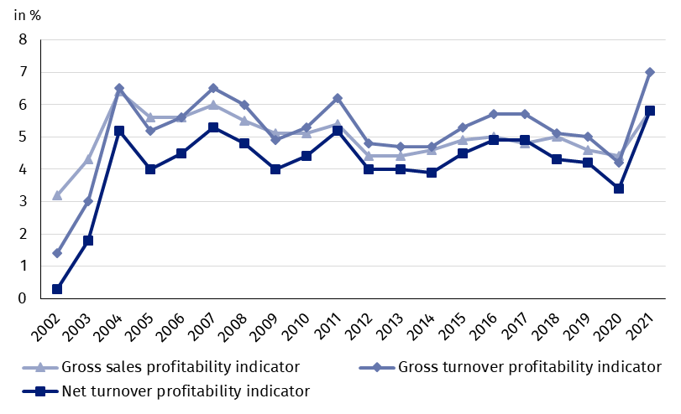

Table 1. Basic financial data of surveyed enterprises
SPECIFICATION | Jan.-June 2020 | Jan.-June 2021 | Jan.-June 2020  = 100
SPECIFICATION | in mln PLN |  | Jan.-June 2020  = 100
Total revenues | 1489641.6 | 1782459.8 | 119.7
of which net revenues from sale  of products, goods and materials | 1444923.6 | 1723494.9 | 119.3
Total costs | 1427029.3 | 1658446.8 | 116.2
of which cost of products,  goods and materials sold | 1381605.6 | 1623965.9 | 117.5
Financial result from the sale of products,  goods and materials | 63317.9 | 99 529.0 | 157.2
Financial result from other  operating activity | 6789.8 | 16 428.0 | 242,0
Result on financial activity | -7495.5 | 8 056.0 | x
Gross financial result | 62612.3 | 124 013.0 | 198.1
Net financial result | 50391.1 | 103868.8 | 206.1
Net profit | 78363.6 | 119831.4 | 152.9
Net loss | 27972.5 | 15962.6 | 57.1
 | %
Cost level indicator | 95.8 | 93.0 | x
Gross sales profitability indicator | 4.4 | 5.8 | x
Gross turnover profitability indicator | 4.2 | 7.0 | x
Net turnover profitability indicator | 3.4 | 5.8 | x
First degree financial liquidity indicator | 42.6 | 44.1 | x
Second degree financial liquidity indicator | 102.9 | 107.6 | x
Cost level indicator for all enterprises was 93.0% (compared to 95.8% a year ago). Gross sales profitability indicator increased from 4.4% to 5.8% and gross turnover profitability indicator increased from 4.2% to 7.0% as well as net turnover profitability indicator increased from 3.4% to 5.8%.
In the 1st half of 2021 an increase in net turnover profitability indicator was recorded in majority of sections

The most significant increase in net turnover profitability indicator was recorded i.a. in information and communication (from 7.5% to 15.9%), professional, scientific and technical activities (from 6.2% to 10.4%), transportation and storage (from 0.6% to 4.1%), mining and quarrying (from minus 2.9% to 0.5%), manufacturing (from 3.2% to 6.3%), other service activities (from minus 0.9% to 2.0%), administrative and support service activities (from 3.1% to 5.9%), water supply; sewerage, waste management and remediation activities (from 7.7% to 10.0%), as well as construction (from 4.0% to 6.3%). Despite a significant improvement in net turnover profitability indicator for accommodation and catering (from minus 11.7% to minus 2.4%), this section still records negative value of the indicator. A decrease in net turnover profitability indicator was recorded in electricity, gas, steam and air conditioning supply (from 10.6% to 9.5%) and activities related to real estate activities (from 7.2% to 6.5%).
First degree financial liquidity indicator was 44.1% (compared to 42.6% a year ago) and second degree financial liquidity indicator was 107.6% (compared to 102.9% in the previous year). First degree financial liquidity indicator at the level over 20% was achieved by 59.3% of the surveyed enterprises (compared to 61.9% a year ago). Second degree financial liquidity indicator, which ranged from 100% to 130%, was recorded by 12.8% of the surveyed enterprises (compared to 12.3% a year ago).
Chart 2. Net turnover profitability indicator
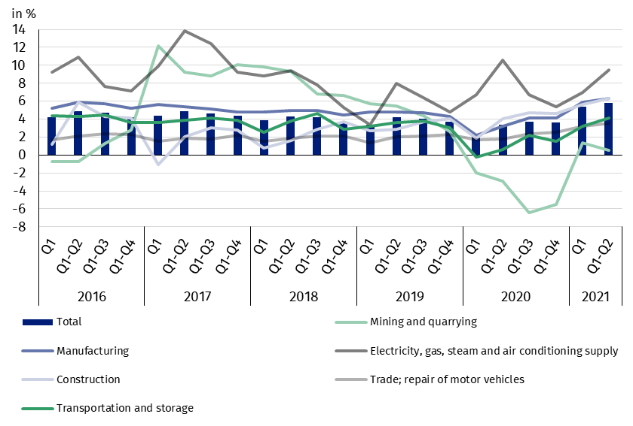

In the structure of total costs, there was an increase in the share of consumption of materials (by 3.3 pp.). There was a decrease in the share of wages and salaries (by 1.1 pp.), external services (by 0.9 pp.), depreciation (by 0.7 pp.), social insurances and other benefits (by 0.4 pp.) as well as comsumption of energy and taxes and fees (by 0.1 pp. each). The share of other costs by kind remained unchanged.

Chart 3. Structure of costs by type in the 1st half of 2021
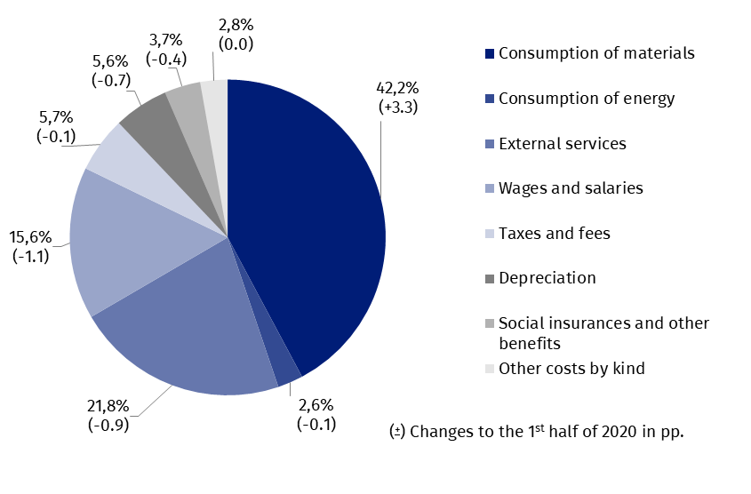

53.4% of the surveyed enterprises reported net revenues from sale of products, goods and materials for export in the 1st half of 2021 (compared to 52.4% in the previous year). The revenues from export sales were by 29.0% higher than a year earlier. The share of export in total sales revenues for all surveyed enterprises increased from 24.2% to 26.2%. 81.8% of the exporting enterprises reported net profit (compared to 76.5% in the previous year). There was an improvement of basic economic and financial relations among the exporting enterprises and were better than in all surveyed enterprises in total.
There was an increase in investment outlays of the surveyed enterprises by 7.9% compared to the 1st half of 2020
In the 1st half of 2021 investment outlays of the surveyed enterprises amounted to 67.6 bn PLN and were (in constant prices) by 7.9% higher than in the previous year when an decrease by 6.1% was recorded. In the 1st quarter of 2021 the increse amounted to 4.6% compared to a responding period of last year. Expenditures on purchases increased (by 15.6%), including outlays on machinery, technical equipment and tools – by 8.3% (in comparison to the decrease in the previous year – 5.4%) and on transport equipment – by 42.9% (in comparison to the decrease in the previous year – 24.6%). The expenditures on buildings and structures fell by 3.4% (in the previous year they increased by 1.6%).
The most significant increase in investment outlays (in current prices) was recorded i.a. in administrative and support service activities (by 58.2% compared to the decrease by 21.3% the year before), transportation and storage (by 39.1% compared to the decrease by 2.1% in the previous year), real estate activities (by 33.9% compared to the increase by 18.0% in the previous year), trade; repair of motor vehicles (by 15.0% compared to the decrease by 10.3% in the previous year), water supply; sewerage, waste management and remediation activities (by 12.9% compared to the increase by 9.5% a year earlier), construction (by 12.7% compared to the increase by 17.9% the year earlier), information and communication (by 9.1% compared to the decrease by 9.0% the year before). The decrease in investment outlays was noticed i.a. in mining and quarrying (by 8.0% compared to the decrease of 2.3% in the previous year), manufacturing (by 3.6% compared to the decrease by 1.7% the year before), electricity, gas, steam and air conditioning supply (by 2.2% compared to the decrease of 8.4% in the previous year).
Chart 4. Dynamics of investment outlays - increase/decrease compared to the corresponding period of the previous year
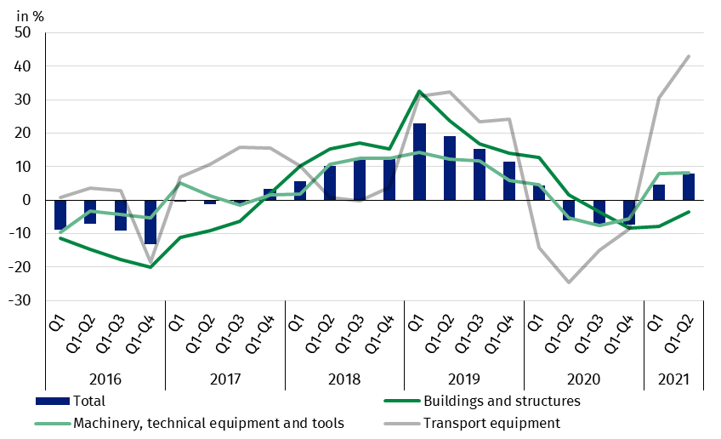

The data refer to 16 646 non-financial enterprises (legal entities) with 50 and more persons employed and which keep accounting ledgers. The data do not include agriculture, forestry, hunting and fishing (section A according to NACE rev. 2); financial and insurance activities (section K according to NACE rev. 2); higher education institutions; independent public health care facilities; cultural institutions with legal personality; trade unions, religious and political organisations.
In the case of quoting Statistics Poland data, please provide information: “Source of data: Statistics Poland” and in the case of publishing calculations made on data published by Statistics Poland, please include the following disclaimer: “Own study based on figures from Statistics Poland”.

Prepared by:  Enterprises Department  Director Katarzyna Walkowska  Office: tel. (+48 22) 608 31 25 | Issued by:  The Spokesperson for the President of Statistics Poland  Karolina Banaszek  Office: tel. (+48 22) 608 34 75, 608 30 09

Press Office  Office: tel. (+48 22) 608 34 91, 608 38 04  e-mail: obslugaprasowa@stat.gov.pl |  | www.stat.gov.pl
 |  | @GUS_STAT
 |  | @GlownyUrzadStatystyczny
Related information
Statistical Bulletin
Information on the socio-economic situation of the country
News releases. Financial results of non-financial enterprises
Methodological report. Non-financial enterprises surveys

The information is available in databases
Local Data Bank
Knowledge Database Non-financial Enterprises
Macroeconomic Data Bank

Most important terms
Total revenues
Total costs
Gross financial result
Net financial result
Cost level indicator
Gross turnover profitability indicator
Net turnover profitability indicator
First degree financial liquidity indicator
Second degree financial liquidity indicator
Investment outlays

