Financial results of non-financial enterprises
in the 1st quarter of 2021

In the 1st quarter of 2021 financial results of the surveyed non-financial enterprises were higher than those obtained a year earlier. Also, the economic and financial indicators have significantly improved. Investment outlays were higher by 4.6% than those recorded in the 1st quarter of 2020 (when there was an increase by 4.3%).
10.4%
Increase in total revenues y-o-y

Total revenues were higher by 10.4% comparing to the previous year and total costs of obtaining the revenues increased by 6.3%. The cost level indicator improved from 97.0% in the previous year to 93.4%. Net revenues from sale of products, goods and materials increased by 10.1% and the costs of those activities increased by 7.7%.
The financial result from the sale of products, goods and materials amounted to 50.9 bn PLN and was by 69.2% higher than in the 1st quarter of 2020. The financial result from other operating activity amounted to 9.0 bn PLN and was higher by 4.8 bn PLN over the previous year. There was an improvement in the result on financial activity (minus 2.4 bn PLN compared to minus 10.3 bn PLN in the 1st quarter of 2020).
In the 1st quarter of 2021 net financial result of non-financial enterprises was 153.7% higher than the year before

Gross financial result amounted to 57.5 bn PLN compared to 23.9 bn PLN a year ago and its obligatory encumbrances amounted to 10.4 bn PLN (compared to 5.3 bn PLN). Net financial result amounted to 47.1 bn PLN and was 153.7% higher than the year before. Net profit amounted to 61.2 bn PLN and was higher by 22.2 bn PLN than in the 1st quarter of 2020 while net loss was 14.1 bn PLN and decreased by 6.4 bn PLN over the year. Net profit was recorded by 69.4% of all enterprises (compared to 67.6% a year ago) and the revenues obtained by them constituted 81.8% of total revenues of the surveyed enterprises (compared to 72.7% of the previous year). In manufacturing, net profit was recorded by 75.5% of all enterprises (it was 73.4% a year ago) and the share of the total revenues generated by these enterprises in the total revenues of all enterprises in this section was 84.8% (compared to 70.3% a year ago).
Chart 1. Profitability indicators in the 1st quarter from 2002 to 2021
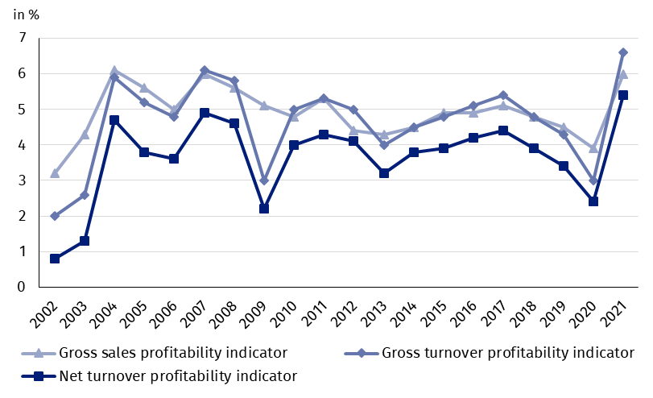

Table 1. Basic financial data of surveyed enterprises
SPECIFICATION | Jan.-Mar. 2020 | Jan.-Mar. 2021 | Jan.-Mar. 2020  = 100
SPECIFICATION | in mln PLN |  | Jan.-Mar. 2020  = 100
Total revenues | 786 700.6 | 868 242.6 | 110.4
of which net revenues from sale  of products, goods and materials | 763 844.1 | 841 057.8 | 110.1
Total costs | 762 799.7 | 810 731.1 | 106.3
of which cost of products,  goods and materials sold | 733 780.4 | 790 190.2 | 107.7
Financial result from the sale of products,  goods and materials | 30 063.7 | 50 867.6 | 169.2
Financial result from other  operating activity | 4 150.3 | 9 009.2 | 217.1
Result on financial activity | -10 313.1 | -2 365.3 | x
Gross financial result | 23 900.9 | 57 511.5 | 240.6
Net financial result | 18 562.5 | 47 098.6 | 253.7
Net profit | 39 044.0 | 61 236.3 | 156.8
Net loss | 20 481.5 | 14 137.8 | 69.0
 | %
Cost level indicator | 97.0 | 93.4 | x
Gross sales profitability indicator | 3.9 | 6.0 | x
Gross turnover profitability indicator | 3.0 | 6.6 | x
Net turnover profitability indicator | 2.4 | 5.4 | x
First degree financial liquidity indicator | 38.9 | 43.0 | x
Second degree financial liquidity indicator | 100.3 | 104.4 | x
Cost level indicator for all enterprises was 93.4% (compared to 97.0% a year ago). Gross sales profitability indicator increased from 3.9% to 6.0% and gross turnover profitability indicator increased from 3.0% to 6.6% as well as net turnover profitability indicator increased from 2.4% to 5.4%.
An increase in net turnover profitability indicator was recorded for i.a. information and communication (from 4.3% to 20.9%), activities related to real estate activities (from 4.3% to 8.6%), water supply; sewerage, waste management and remediation activities (from 4.8% to 8.6%), manufacturing (from 2.2% to 5.9%), construction (from 1.9% to 5.6%), mining and quarrying (from minus 2.0% to 1.4%), transportation and storage (from minus 0.2% to 3.2%), administrative and support service activities (from 1.8% to 4.2%), professional, scientific and technical activities (from 5.4% to 7.4%) as well as trade; repair of motor vehicles (from 1.7% to 3.2%). A decrease in net turnover profitability indicator was recorded for accommodation and catering (from minus 7.9% to minus 18.9%) and other service activities (from minus 2.1% to minus 5.0%).
In the 1st quarter of 2021 an increase in net turnover profitability indicator was recorded in majority of sections

First degree financial liquidity indicator was 43.0% (compared to 38.9% a year ago) and second degree financial liquidity indicator was 104.4% (compared to 100.3% in the previous year). First degree financial liquidity indicator at the level over 20% was achieved by 60.7% enterprises (compared to 53.9% a year ago). Second degree financial liquidity indicator, which ranged from 100% to 130%, was recorded by 12.4% of the surveyed enterprises (compared to 12.0% a year ago).
Chart 2. Net turnover profitability indicator
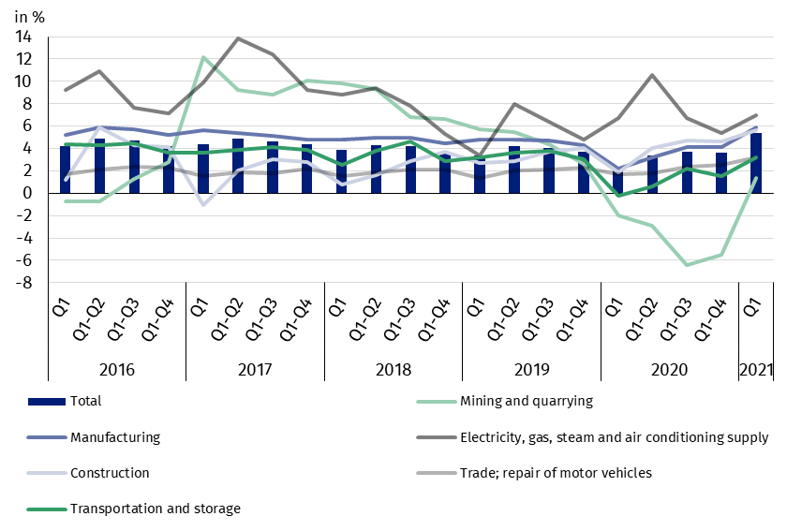

In the structure of total costs, there was an increase in the share of consumption of materials (by 0.8 p.p.). There was a decrease in the share of wages and salaries (by 0.3 p.p.), social insurances and other benefits (by 0.2 p.p.) as well as external services, depreciation and other costs by kind (by 0.1 p.p. each). The share of comsumption of energy and taxes and fees remained unchanged.

Chart 3. Structure of costs by type in the 1st quarter of 2021

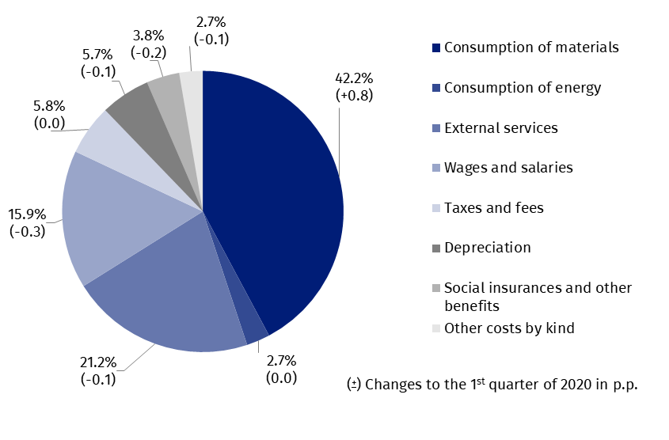

52.2% of the surveyed enterprises reported net revenues from sale of products, goods and materials for export in the 1st quarter of 2021 (compared to 51.0% in the previous year). The revenues from export sales were by 15.9% higher than a year earlier. The share of export in total sales revenues for all surveyed enterprises increased from 25.0% to 26.3%. 76.4% of the exporting enterprises reported net profit (compared to 72.7% in the previous year). There was an improvement of basic economic and financial relations among the exporting enterprises and the relations were better than in the case of all surveyed enterprises in total.
There was an increase in investment outlays of the surveyed enterprises by 4.6% compared to the 1st quarter of 2020
In the 1st quarter of 2021 investment outlays of the surveyed enterprises amounted to 31.2 bn PLN and were (in constant prices) by 4.6% higher than in the previous year when an increase by 4.3% was recorded). Expenditures on purchases increased by 13.1%, including outlays on machinery, technical equipment and tools – by 8.0% (in comparison to the increase in the previous year by 4.6%) and on transport equipment – by 30.6% (in comparison to the decrease in the previous year by 14.2%). The expenditures on buildings and structures fell by 7.9% (in the previous year they increased by 12.8%).
The most significant increase in investment outlays (in current prices) was recorded for real estate activities (by 107.8% compared to the increase by 25,4% the year before), transportation and storage (by 66.6% compared to the decrease by 0.5% in the previous year), administrative and support service activities (by 37.0% compared to the decrease by 13.8% in the previous year), construction (by 24.2% compared to the increase by 7.0% the year earlier), information and communication (by 12.1% compared to the decrease by 9.4% the year before). The decrease in investment outlays was noticed for mining and quarrying (by 12.2% compared to the increase of 11.5% in the previous year), electricity, gas, steam and air conditioning supply (by 10.7% compared to the decrease of 4.9% in the previous year), manufacturing (by 10.0% compared to the increase by 14.1% the year before), water supply; sewerage, waste management and remediation activities (by 4.8% compared to the increase by 22.8% a year earlier), trade; repair of motor vehicles (by 0.2% compared to the increase by 10.2% in the previous year).
Chart 4. Dynamics of investment outlays - increase/decrease compared to the corresponding period of the previous year
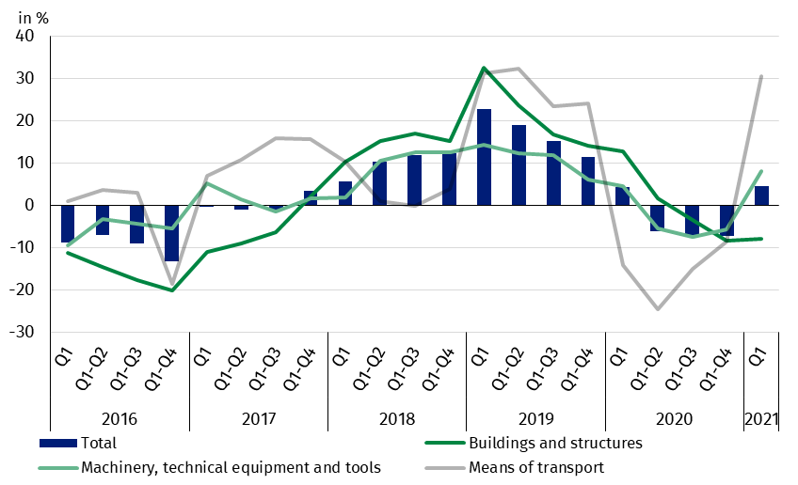

The data refer to 16 065 non-financial enterprises in which the number of persons employed is 50 and more and which keep accounting ledgers. The data do not include agriculture, forestry, hunting and fishing (section A according to NACE rev. 2); financial and insurance activities (section K according to NACE rev. 2); higher education institutions; independent public health care facilities; cultural institutions with legal personality; trade unions, religious and political organisations.
In the case of quoting Statistics Poland data, please provide information: “Source of data: Statistics Poland” and in the case of publishing calculations made on data published by Statistics Poland, please include the following disclaimer: “Own study based on figures from Statistics Poland”.

Prepared by:  Enterprises Department  Director Katarzyna Walkowska  Office: tel. (+48 22) 608 31 25 | Issued by:  The Spokesperson for the President of Statistics Poland  Karolina Banaszek  Office: tel. (+48 22) 608 34 75, 608 30 09

Press Office  Office: tel. (+48 22) 608 34 91, 608 38 04  e-mail: obslugaprasowa@stat.gov.pl |  | www.stat.gov.pl
 |  | @GUS_STAT
 |  | @GlownyUrzadStatystyczny
Related information
Statistical Bulletin
Information on the socio-economic situation of the country
News releases. Financial results of non-financial enterprises
Methodological report. Non-financial enterprises surveys

The information is available in databases
Local Data Bank
Knowledge Database Non-financial Enterprises
Macroeconomic Data Bank

Most important terms
Total revenues
Total costs
Gross financial result
Net financial result
Cost level indicator
Gross turnover profitability indicator
Net turnover profitability indicator
First degree financial liquidity indicator
Second degree financial liquidity indicator
Investment outlays

