Index numbers of sold production of industry in November 2021^{a)}

In November 2021, sold production of industry was by 15.2% higher than in November 2020, when an increase was recorded by 5.4% as compared to the previous year, whereas in comparison with October 2021, it increased by 5.3%. In the period January-November of 2021, sold production of industry was by 15.0% higher than in the corresponding period of 2020, which saw a decrease by 2.1%.
15.2%
Increase in sold production of industry as compared to November 2020

After seasonal adjustment, an increase in sold industrial production in November 2021 amounted to 15.2% per year

After eliminating the seasonal factors, in November 2021 sold production of industry reached the level higher by 15.2% than in the corresponding month of 2020 and by 6.5% higher as compared to October 2021.
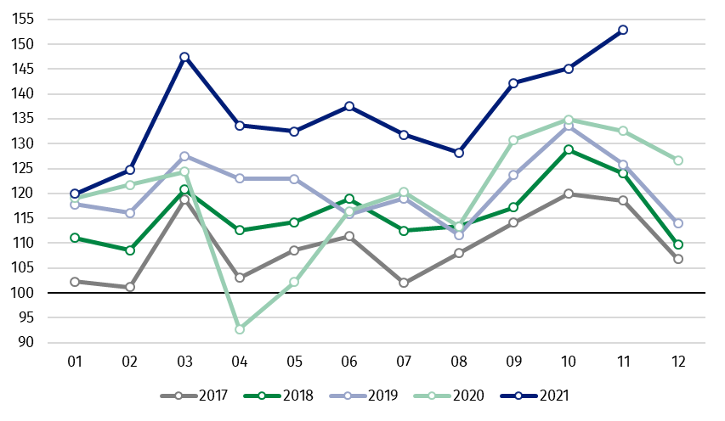
Chart 1. Sold production of industry (average monthly level in 2015=100)

In November 2021, an increase of production, as compared to previous year, was recorded in all main industrial groupings. The highest growth was observed in production of energy – by 31.3% and intermediate goods – by 17.0%. The lower increase was observed in production of durable consumer goods – by 9.7%, capital goods – by 9.5% and non-durable consumer goods – by 8.3%.

^{a)} Reported data; comprise enterprises with 10 or more persons employed.
Table 1. Index numbers of sold production of industry (constant prices)
SPECIFICATION | 11 2021 |  |  | 01-11 2021^{a)}
SPECIFICATION | 10 2021=100 | 11 2020=100 | monthly average  of 2015=100 | 01-11 2020=100
INDUSTRY | 105.3 | 115.2 | 152.9 | 115.0
Mining and quarrying | 104.0 | 104.0 | 94.9 | 101.9
Manufacturing | 104.7 | 113.0 | 153.6 | 114.4
Electricity, gas, steam and air  conditioning supply | 114.2 | 147.7 | 173.2 | 127.9
Water supply; sewerage waste  management and remediation  activities | 99.0 | 112.5 | 149.2 | 111.0

^{a)} Data including final information on production and prices in October and reported data – in November.
Share of production value of industry divisions, which saw an increase in comparison to November 2020, stood at 98.5%

According to the preliminary data, in November 2021, as compared to November 2020, an increase in sold production (in constant prices) was reported in 31 (out of 34) industry divisions, among others, in repair and installation of machinery and equipment – by 47.6%, in manufacture of chemicals and chemical products – by 28.6%, manufacture of basic metals – by 26.7%, manufacture of machinery and equipment – by 20.4%, manufacture of paper and paper products – by 19.9%, manufacture of metal products – by 17.4%.
A decrease in sold production of industry, as compared to November 2020, was recorded in 3 divisions, including manufacture of leather and related products – by 8.5%.

Chart 2. Index numbers of sold production of industry by selected NACE divisions (constant prices;
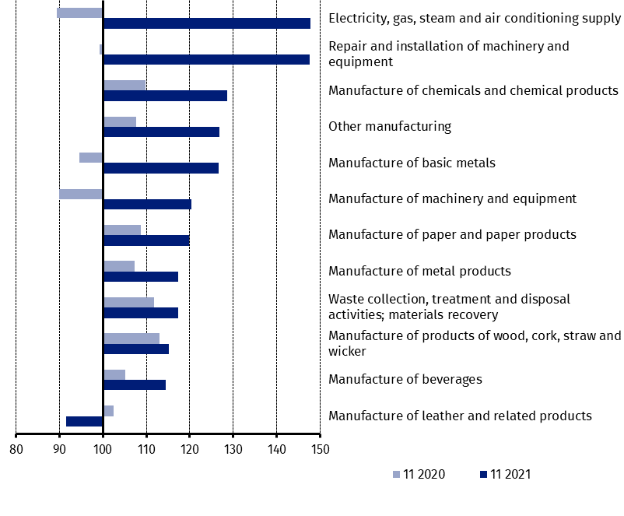
previous year =100)

As compared to October 2021, an increase in sold production (in constant prices) in November 2021 was recorded in 22 industry divisions, among others, in manufacture of motor vehicles, trailers and semi-trailers – by 32.9%, manufacture of other transport equipment – by 24.7%, in repair and installation of machinery and equipment – by 16.2%, in electricity, gas, steam and air conditioning supply – by 14.2%, in manufacture of electrical equipment – by 10.1%, manufacture of beverages – by 9.4%.
A decrease in sold production of industry, as compared to October 2021, was recorded in 11 divisions, among others, in manufacture of coke and refined petroleum products – by 8.7%, in waste collection, treatment and disposal activities; materials recovery – by 3.2%, in manufacture of other non-metallic mineral products – by 2.4%.

Chart 3. Index numbers of sold production of industry by selected NACE divisions (constant prices;
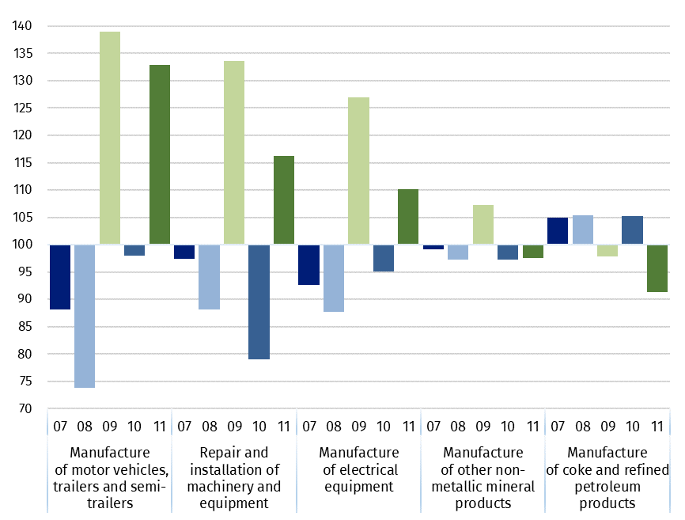
previous month =100)

In case of quoting Statistics Poland data, please provide information: “Source of data: Statistics Poland”, and in case of publishing calculations made on data published by Statistics Poland, please include the following disclaimer: “Own study based on figures from Statistics Poland”.

Prepared by:  Enterprises Department  Director Katarzyna Walkowska  Office: tel. (+48 22) 608 31 25 | Issued by:  The Spokesperson for the President of Statistics Poland  Karolina Banaszek  Mobile: (+48) 695 255 011

Press Office  Office: tel. (+48 22) 608 34 91, 608 38 04  e-mail: obslugaprasowa@stat.gov.pl |  | www.stat.gov.pl/en/
 |  | @StatPoland
 |  | @GlownyUrzadStatystyczny

Related information
Statistical Bulletin
Socio-economic situation of the country

Data available in databases
Knowledge Database - Industrial Production
Macroeconomic Data Bank
Macroeconomic indicators
Local Data Bank

Terms used in official statistics
Sold production of industry
Seasonally un-adjustedindex of sold production of industry
Seasonally adjustedindex of sold production of industry
Production of capital goods
Production of non-durable consumer goods
Production of durable consumer goods
Production of intermediate goods
Production of goods related to energy

