Price indices of sold production of industry in February 2021

According to preliminary data, in February 2021 the prices of sold production of industry increased compared to January 2021 by 0.8 % and compared to that recorded in the corresponding month of the previous year - by 2.0%.
2.0%
producer prices in industry increased compared to February 2020

Table 1. Price indices of sold production of industry in February 2021

 | I 2021 |  | II 2021 |  |  | I-II 2021
SPECIFICATION | XII 2020=100 | corresponding period 2020=100 |  | I 2021=100 | XII 2020=100 | I-II 2020=100
TOTAL | 101.0* | 101.0* | 102.0 | 100.8 | 101.8 | 101.5
Mining and quarrying | 103.0* | 111.3* | 115.5 | 102.7 | 105.8 | 113.4
Manufacturing | 101.1* | 100.4* | 101.5 | 100.8 | 101.9 | 100.9
Electricity, gas, steam and air conditioning supply | 100.2* | 101.8* | 101.2 | 100.1 | 100.3 | 101.5
Water supply; sewerage, waste management and remediation activities | 100.3* | 103.4* | 103.1 | 100.1 | 100.4 | 103.2

* Data revised.

According to preliminary data, the prices of sold production of industry in February 2021 increased by 0.8% compared to January 2021. The highest growth of prices was recorded in the section mining and quarrying - by 2.7%, of which in mining of metal ores- by 4.6% and in mining of coal and lignite - by 0.7%. The prices increased in the section manufacturing by 0.8%, with multidirectional price changes in individual divisions. The prices the most increased in manufacture of coke and refined petroleum products (by 8.0%). The prices growth was recorded also, among others, in manufacture: of basic metals (by 2.7%), of textiles as well as of chemicals and chemical products (by 0.8% each), of food products (by 0.7%), of leather and related products as well as of computer, electronic and optical products (by 0.6% each), of products of wood, cork, straw and wicker (by 0.5%), of beverages as well as of printing and reproduction of recorded media (by 0.4% each), of rubber and plastic products as well as of furniture (by 0.3% each), of paper and paper products as well as of other non-metallic mineral products (by 0.2% each), of electrical equipment and of motor vehicles, trailers and semi-trailers (by 0.1% each). The prices in manufacture of metal products remained at a level similar to that recorded in the previous month. However, the prices decreased, among other things, in manufacture: of pharmaceutical products, of machinery and equipment as well as of other transport equipment (by 0.1% each), of tobacco products and of wearing apparel (by 0.3% each). The prices in sections electricity, gas, steam and air conditioning supply as well as water supply; sewerage, waste management and remediation activities increased by 0.1% each.
Among divisions of manufacturing in February 2021 in comparison with the previous month, the prices the most increased in manufacture of coke and refined petroleum products

In February 2021 the prices of sold production of industry compared to February 2020 increased by 2.0%. Prices growth was recorded in all sections of the industry. The prices the most increased in the section mining and quarrying - by 15.5%, of which in mining of metal ores - by 40.1%, with the prices drop in mining of coal and lignite - by 0.6%. The prices in the section water supply; sewerage, waste management and remediation activities increased - by 3.1% The prices in manufacturing increased by 1.5%, with multidirectional prices movements in individual divisions. The prices the most increased in manufacture of basic metals (by 9.8%). The prices were also higher than in the year before, among other things, in manufacture: of coke and refined petroleum products (by 6.9%), of products of wood, cork, straw and wicker (by 3.9%), of motor vehicles, trailers and semi-trailers (by 3.4%), of pharmaceutical products (by 3.1%), of chemicals and chemical products (by 2.9%), of other transport equipment (by 2.8%), of leather and related products as well as of metal products (by 2.1% each), of computer, electronic and optical products (by 1.6%), of electrical equipment (by 1.5%), of machinery and equipment (by 1.1%), of tobacco products (by 0.8%), of beverages as well as of other non-metallic mineral products (by 0.4% each) and of furniture (by 0.3%). However, the prices decreased, among other things, in manufacture: of textiles as well as of paper and paper products (by 0.1% each), of food products as well as of rubber and plastic products (by 0.2% each) and of wearing apparel (by 0.5%). The deepest drop of prices compared to February 2020 was recorded in printing and reproduction of recorded media (by 2.9%). Prices in the section electricity, gas, steam and air conditioning supply increased by 1.2%.
Among divisions of manufacturing in February 2021, compared to the same month of the previous year, the most increased prices in manufacture of basic metals

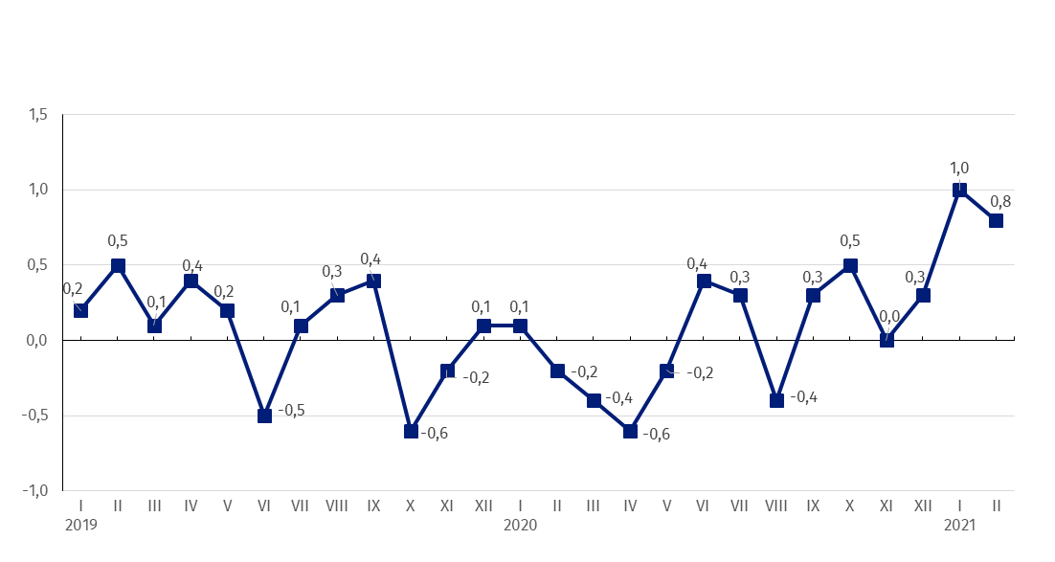
Chart 1. Prices changes of sold production of industry in 2019-2021 in relation to the previous period (in %)

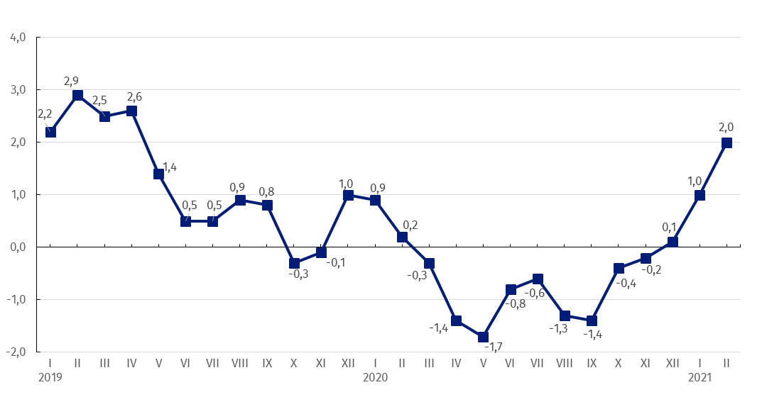
Chart 2. Prices changes of sold production of industry in 2019-2021 in relation to the same period of the previous year (in %)

Chart 3. Prices changes of sold production of industry by sections NACE in 2019-2021 in relation to December 2018 (in %)

In case of quoting Statistics Poland data, please provide information: “Source of data: Statistics Poland”, and in case of publishing calculations made on data published by Statistics Poland, please include the following disclaimer: “Own study based on figures from Statistics Poland”.

Prepared by:  The Trade and Services Department  Director Ewa Adach-Stankiewicz  Office: tel. (+48 22) 608 31 24 | Issued by:  The Spokesperson for the President  of Statistics Poland  Karolina Banaszek  Mobile: (+48) 695 255 011

Press Office  Office: tel. (+48 22) 608 34 91, 608 38 04  e-mail: obslugaprasowa@stat.gov.pl |  | www.stat.gov.pl/en/
 |  | @StatPoland
 |  | @GlownyUrzadStatystyczny

Related information
Statistical Bulletin
News Releases

Data available in databases
Analytical Platform - Knowledge Databases
Macroeconomic Data Bank
Prices indices (Topics: Prices, Trade)

Terms used in official statistics
Price index of sold production of industry

