Physical education in 2019

In 2019, there were 70 sports associations in Poland. Compared to 2018, the number of coaches and judges registered in the Polish sports associations increased, whereas the number of Polish representatives decreased. Physical education organisations associated 2.2 thousand units. In relation to the previous year, both the number of units as well as the number of members and persons practising sports in these organizations decreased.
171.7 thousand

The number of persons practising sports in physical education organisations

Polish sports associations
In 2019, Polish sports associations (PZS) selected 8839 members of the national team
In 2019, a total of 70 Polish sports associations and 535 regional sports associations were active. This year, the Polish Association of Wheelchair Rugby started its activity. The Polish sports associations selected 8.8 thousand members of the national team, 39.7% of whom were women. There were 47.0% of Polish representatives in junior categories.
Table 1. Basic information on Polish sports associations in 2019
SPECIFICATION | Total | Of total number - women
Polish representatives | 8839 | 3505
of which:
juniors | 4150 | 1789
Competitorª | 757023 | 140889
of which:
junior competitors^{b} | 487303 | 108469
Coaching staff^{c}
coaches | 29323 | 2253
instructors | 12039 | 2853
Judges | 40490 | 8998
of which:
with international class | 1734 | 398
a Including foreign competitors performing in Poland. The competitors can be shown several times if they are licensed in several sports supervised by one sports association. b Total juniors, younger junior "cadets", sub-juniors and children. c Members of the coaching staff and judges can be shown several times if they are licensed in several sports supervised by one sports association.

Compared to 2018, there was a 16.4% decrease in the number of Polish representatives. The number of both women (by 14.3%) and juniors (by 21.7%) decreased. The number of representatives who are members of foreign clubs increased slightly (from 256 in 2018 to 304 in 2019).
In 2019, the largest number of members of the national team was in the Polish Swimming Federation (567 representatives), followed by the Polish Basketball Association (397) and the Polish Ice Hockey Federation (373). In 2018, the most numerous was the Polish Volleyball Federation (790 representatives).
Chart 1. Polish representatives in 2019

In 2019, 757 thousand competitors had licenses of the Polish sports associations. Seniors constituted 30.4% of the competitors, and women - 18.6% (10.9% in the senior category). Due to the change in the methodology of showing competitors by the Polish Football Association, it is not possible to compare the data with previous years.
Most persons trained in Mazowieckie and Śląskie Voivodships (14.8% and 11.5% respectively). The majority were competitors licensed by the Polish Football Association - over 50%, followed by the Polish Volleyball Federation - 5.5% and the Polish Sport Shooting Federation - 4.5%.
The number of competitors with disabilities holding licenses in the Polish sports associations was 2,642 in 2019, of which almost 74% were men. The largest percentage of competitors with disabilities (in relation to the total number of competitors in the voivodship) was in the following voivodships: Lubelskie, Zachodniopomorskie and Mazowieckie - 0.3% each. In the country this indicator was 0.2%.
Map 1. Competitors registered in Polish sports associations in 2019
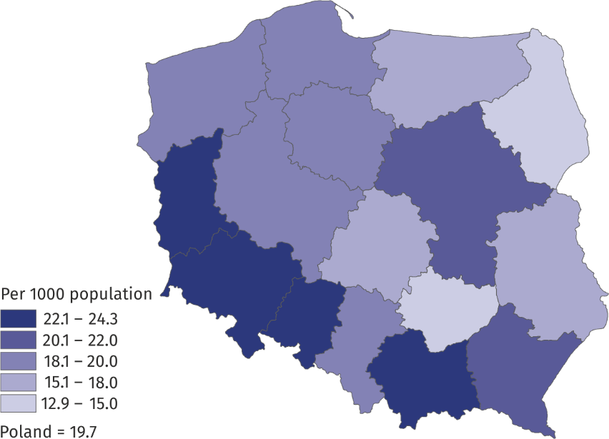
Foreign competitors holding licenses of the Polish sports association constituted 0.6% of all competitors. The highest percentage of these competitors was recorded in Mazowieckie Voivodship (1.4%) and Opolskie Voivodship (0.8%). The most popular sports they practiced in Poland were football, squash, basketball and ice hockey.
In 2019, the number of coaches holding licences of the Polish sports association increased by nearly 7% in relation to 2018, whereas the number of instructors remained at the same level
The coaching staff employed in the Polish sports associations amounted to 646 persons. This number has slightly decreased in relation to 2018 (by 20 persons). A minimal increase in was recorded in the employment of medical staff (230 persons in 2019 and 224 persons in 2018). In 2019, 29.3 thousand coaches and 12.0 thousand instructors held current licenses of the Polish sports associations. Compared to the previous year, the number of coaches increased by almost 2 thousand, whereas the number of instructors remained at the same level.
Chart 2. Coaching staff in Polish sports associations in 2019

In 2019, 40.5 thousand sports judges were registered in the Polish sports associations (an increase of 1.6% compared to 2018). Of these, 22.2% were women. The percentage of judges with international class was 4.3%. The highest number of judges was in the most popular type of sport – football (21.7%). A significant group were judges of sports shooting (16.7%) and swimming sports (9.5%). Women as judges prevailed mainly in artistic gymnastics and softball – 100% each and synchronous swimming – 97.3%. A significant part of them also judged wheelchair rugby (71.4%) and horse riding (68.1%), whereas few air sports (1.9%) and squash (3.1%).

Chart 3. Sports judges by class in 2019

Chart 4. Sports judges in 2019

In 2019, the Polish representatives won 1,106 medals of the World and European Championships and 164 medals of events of the same rank for persons with disabilities
In the World Championships in 2019, a total of 2,262 Polish competitors participated (in 2018 – 2,370), who won medal places 432 times (in 2018 - 431). They won 130 gold, 137 silver and 165 bronze medals (39 medals in the Olympic disciplines including: 6 gold, 15 silver and 18 bronze medals). Poles won the most medal places in the following disciplines: dancesport (78 medals), ju-jitsu and traditional karate (39 medals each) and taekwon-do ITF (30 medals).
Significantly more competitors represented Poland at sports events of European Championships rank - the Polish team consisted of 2,918 persons (in 2018 – 3,001 persons). Poles won a total of 674 European Championships medals (603 in 2018), including 223 gold, 205 silver and 246 bronze (87 medals in Olympic disciplines: 24 gold, 29 silver and 34 bronze). The most medals of the European Championships were won in the following disciplines: traditional karate (81 medals), karate (74 medals) and sumo (49 medals). Competitors with disabilities won a total of 101 World Championships medals (25 gold, 34 silver, 42 bronze) and 63 European Championships medals (24 gold, 17 silver and 22 bronze).
Table 2. Medals won by Polish competitors in the international arena in 2019
SPECIFICATION | Medals
SPECIFICATION | total | gold | silver | bronze
World Championships | 432 | 130 | 137 | 165
of which juniorsª | 218 | 75 | 65 | 78
of which in Olympic disciplines | 39 | 6 | 15 | 18
European Championships | 674 | 223 | 205 | 246
of which juniorsª | 375 | 125 | 117 | 133
of which in Olympic disciplines | 87 | 24 | 29 | 34
World Championships for persons with disabilities | 101 | 25 | 34 | 42
European Championships for persons with disabilities | 63 | 24 | 17 | 22
a Total juniors and young competitors.
Physical education organisations
In 2019, physical education organisations such as: Academic Sports Association, „Rural Sports Teams” Association, The Polish Sports Association for the Disabled ’’Start’’ and the Society for the Promotion of Physical Education showed a total of 2.2 thousand organisational units, 177.6 thousand members and 171.7 thousand persons practising sports. Compared to the previous year, the number of organisational units decreased (by 9.6%) as well as the number of members (by 7.4%) and persons practising sports (by 13.1%). In terms of the number of members and persons actively practising sports, the Society for Promotion of Physical Education was the most numerous one (95.4 thousand members, 100.8 thousand persons practising sports), followed by the „Rural Sports Teams” Association " (39.6 thousand members, 35.3 thousand persons practising sports), the Academic Sports Association (40.9 thousand members and 34.4 thousand persons practising sports), and the Polish Sports Association for the Disabled "Start" - 1.7 thousand members and 1.2 thousand persons practising sports.

When quoting Statistics Poland data, please provide information: “Source of data: Statistics Poland”, and when publishing calculations made on data published by Statistics Poland, please provide information: “Own study based on Statistics Poland data”.

Prepared by:  Statistical Office in Rzeszów  Director Marek Cierpiał-Wolan  Office: tel. (+48 17) 853 52 10 | Issued by:  The Spokeperson for the President  of Statistics Poland  Karolina Banaszek  Mobile: (+48) 695 255 011

Press Office  Office: tel. (+48 22) 608 34 91, 608 38 04  e-mail: obslugaprasowa@stat.gov.pl |  | www.stat.gov.pl/en/
 |  | @StatPoland
 |  | @GlownyUrzadStatystyczny

Related information
Physical education in the years 2017 and 2018

Data available in databases
Local Data Bank

Terms used in official statistics
Sports instructor
Regional sports association
Physical education organisation
Sports judge
Sport
Sports
Sports coach
Competitor
Sports association

According to the list of Polish sports associations announced by the Minister of Sport - Communiqué of August 2, 2019, the release does not include the Polish Amp Football Association, which in 2019 did not start activity.
Until 2018, all persons who received a licence regardless of whether they still actively participated in the competition were regarded as competitors by the Polish Football Association. Since 2019, after consultation with the survey originator, only active competitors are included in statistics.
Coaching staff members may be shown several times if they are licensed in several sports supervised by one sports association.
Judges may be shown several times if they are licensed in several sports.
The study included: in AZS - clubs, in LZS - teams, in PZSN "Start" - organizational units, in TKKF - centres and clubs.

