Outpatient health care in 2019

At the end of 2019, outpatient health care was carried out by 21.8 thousand outpatient departments and 4.4 thousand doctors and dentists practices providing services funded by public sources. During the year, 291.5 milllion doctors consultations and 34.3 million dentists consultations were provided.
1.2%
Increase in the number of specialized doctors consultations compared to 2018

Outpatient departments and doctors practices
At the end of 2019, outpatient consultations were provided by 21.8 thousand outpatient departments and 4.4 thousand doctors and dentists practices providing services funded by public sources
At the end of 2019, 26.3 thousand providers of ambulatory health care were operating, of whom 21.8 thousand outpatient departments and 0.8 thousand doctors practices and 3.6 thousand dentists practices providing services funded by public sources. 20.4 thousand providers of ambulatory health care were located in urban areas, and 5.9 thousand in rural areas.
The most outpatient departments were operating in Mazowieckie Voivodship (3 096), and the lowest – in Opolskie Voivodship (548). The highest number of doctors and dentists practices providing health services funded by National Health Fund was recorded in Wielkopolskie Voivodship (589), while the lowest – in Małopolskie Voivodship (141).

Chart 1. Outpatient departments by class of locality and voivodships in 2019
As of 31st December
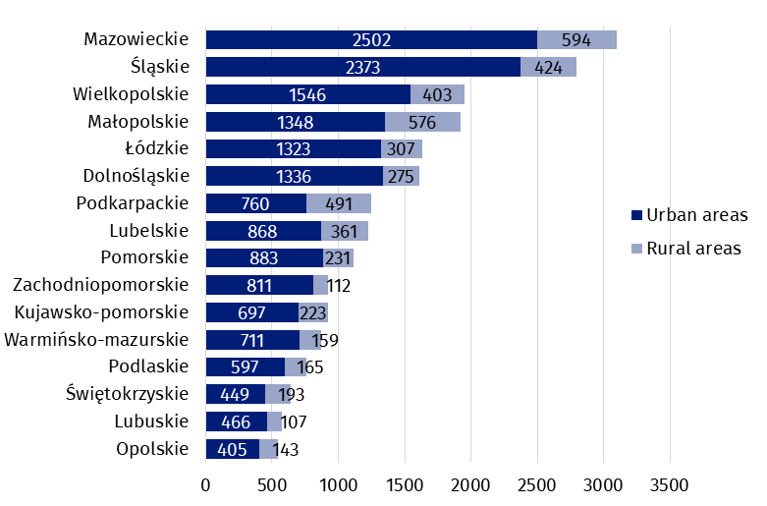

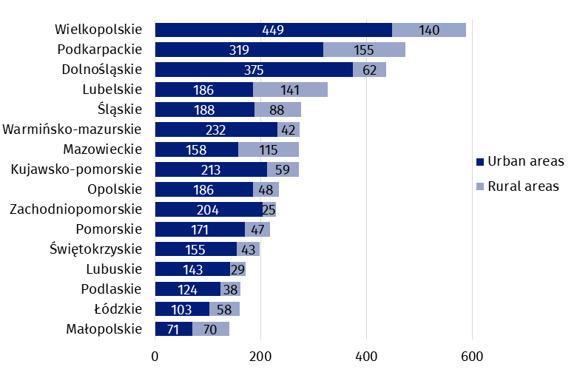
Chart 2. Doctors and dentists practices providing health services funded by public sources by class of locality and voivodships in 2019
As of 31st December

In Poland, the number of population per 1 provider of ambulatory health care amounted to 1 461 persons (by 22 more than in the previous year). The highest value was recorded in Pomorskie Voivodship (1 760), while the lowest – in Podkarpackie Voivodship (1 233).

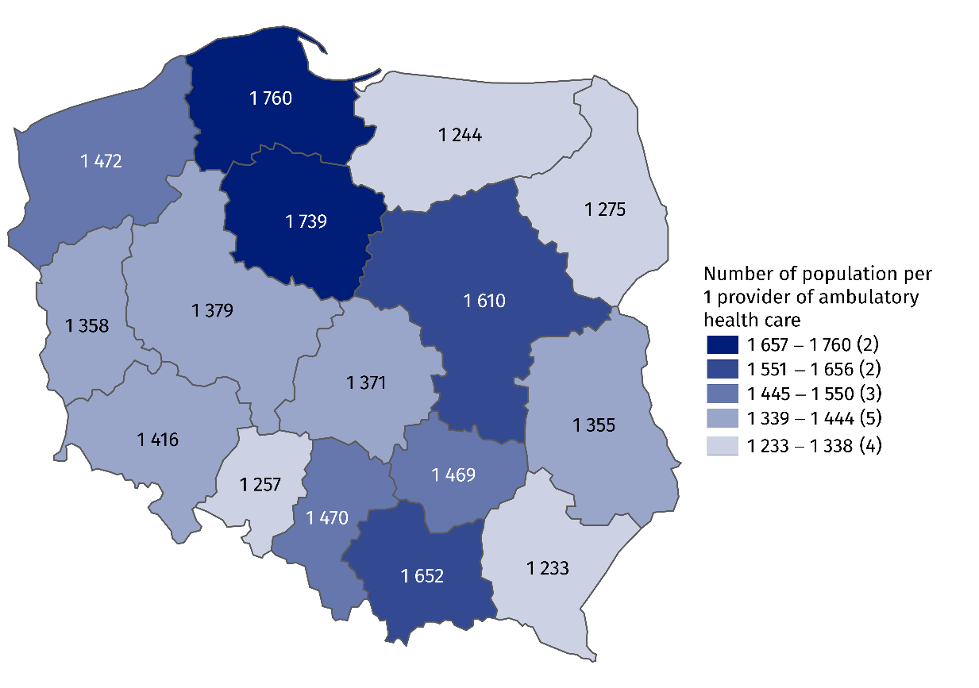
Map 1. The number of population per 1 provider of ambulatory health care by voivodships in 2019
As of 31st December

Outpatient consultations
In 2019, there were provided 291.5 million doctors consultations and 34.3 million dentists consultations in outpatient health care
In 2019, there were provided 325.8 million outpatient consultations – 291.5 doctors consultations (increase of 1.1% compared to the previous year) and 34.3 million dentists consultations (by 0.1% less than a year earlier). Of doctors consultations, 173.8 million outpatient consultations were in primary health care (by 1.0% more than in 2018.), and 117.7 million – were specialized consultations (increase of 1.2% compared to the previous year).
In primary health care children and youth in age up to 18 years had 35.6 million consultations (decrease of 3.1% compared with the previous year), while people aged 65 years and more – 58.8 million (by 4.1% more than a year earlier). There were 14.5 million specialized consultations provided to children and youth in age up to 18 years (by 0.8% less than in 2018) and 34.6 million consultations provided to people aged 65 years and more (by 2.7% more than in the previous year).

Chart 3. Outpatient consultations by type of consultation and patients’ age in 2019
In specialised doctors care, the highest share of consultations was in surgical clinic (17.9%). Consultations were also often provided in gynecological and obstetrical clinics (11.2%) and ophthalmology clinics (9.6%).
Most doctors consultations in specialised outpatient health care were provided in surgical clinics
(approx. 21 million)

Chart 4. Specialized doctors consultations by type of clinic in 2019
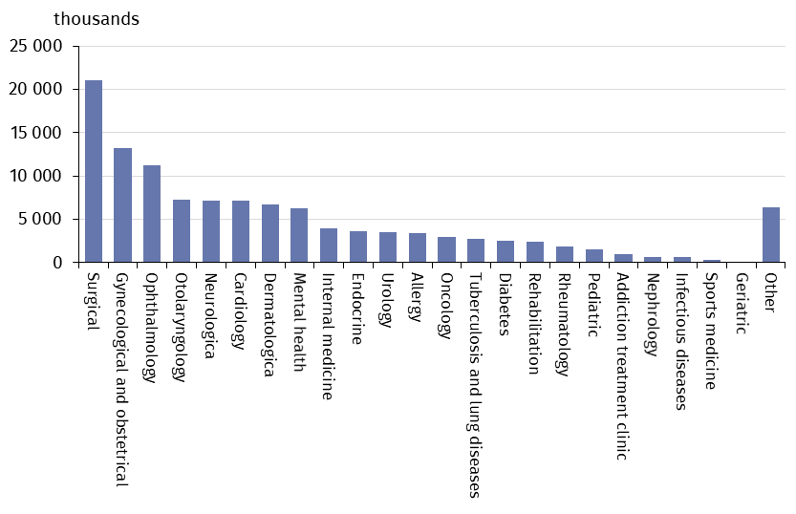
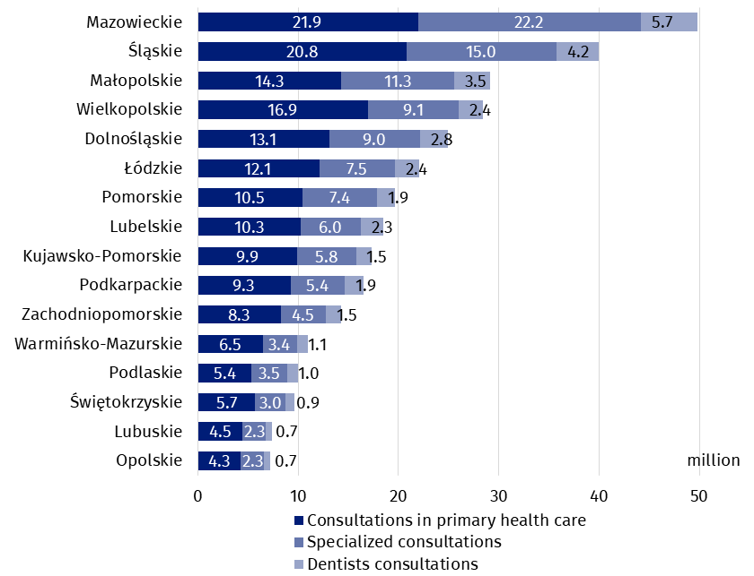
Chart 5. Outpatient consultations by voivodships and type of consultations in 2019

In 2019, the average number of outpatient consultations per capita was 8.5. The highest value was recorded in Mazowieckie Voivodship (9.2), while the lowest – in Lubuskie Voivodship (7.3).
In 2019, the average number of outpatient consultations per capita was 8.5
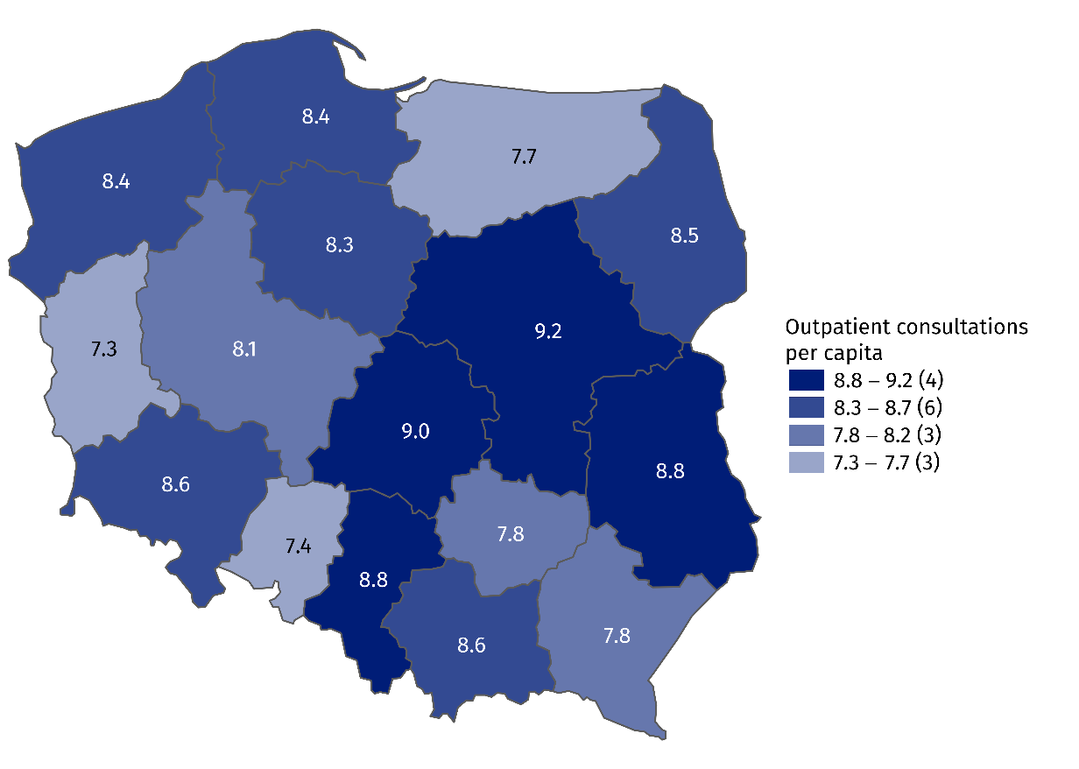
Map 2. Outpatient consultations per capita by voivodships in 2019
In the case of quoting data from the Statistics Poland, please provide information: "Statis-tics Poland data source", and in the case of publishing calculations made on data published by the Statistics Poland, please provide information: "Own study based on Statistics Poland data".

Prepared by:  Statistical Office in Kraków  Director Agnieszka Szlubowska  Office: tel. (+48 12) 420 40 50 | Issued by:  The Spokeperson for the President  of Statistics Poland  Karolina Banaszek  Mobile: (+48) 695 255 011

Press Office  Office: tel. (+48 22) 608 34 91, 608 38 04  e-mail: obslugaprasowa@stat.gov.pl |  | www.stat.gov.pl/en/
 |  | @StatPoland
 |  | @GlownyUrzadStatystyczny

Related information
Health and health care in 2018
Methodological report. Health and health care statistics − Statistics Poland’s reports

Data available in databases
Local Data Bank -> Health care, social welfare and benefits to the family
Knowladge Databases ->Health and Health care

Terms used in official statistics
Specialised out-patient services
Out-patient health care services
Primary health care
Consultation
Medical practice
An out-patient department

Including outpatient departments of Ministry of National Defence and Ministry of the Interior and Administration.
Including information on holiday and nighttime medical service. There are health care benefits in primary health care, provided from 6 pm to 8 pm on the following day and 24 hours on public holidays. Including also information on holiday and nighttime medical service given as a subcontract with a hospital .

