Activity of centres of culture, cultural centres
and establishments, clubs and community centres
in 2019

As of the end of 2019, 4255 centres of culture, cultural establishments, cultural centres, clubs and community centres were operating. During the year entities organised 243.8 thousand events, in which took part
37.5 million participants.
5.0%
Decrease in the number of participants of events in comparison to 2018

Most centres of culture, cultural establishments, cultural centres, clubs and community centres were operating in Małopolskie Voivodship (459), and the least in Lubuskie Voivodship (84). Taking into account the type of entities, most numerous group constituted community centres (32.2% of the total number of entities), whereas the least numerous were clubs (7.9%). Most of the entities (63.2%) were located in the countryside.
79
313
348
203
228
342
333
163
284
214
372
123
452

Map 1. Centres of culture, cultural establishments, cultural centres, clubs and community centres
in 2019
4255
Number of population
per 1 entity
12001–17271
9001–12000
7001– 9000
4657– 7000
Number of centres of culture, cultural establishments, cultural centres, clubs and community centres (as of 31st December)
163
329
184
314
229
366
459
121
204
314
226
336
84
342

211

373
10.8% of the total number of entities were operating in Małopolskie Voivodship

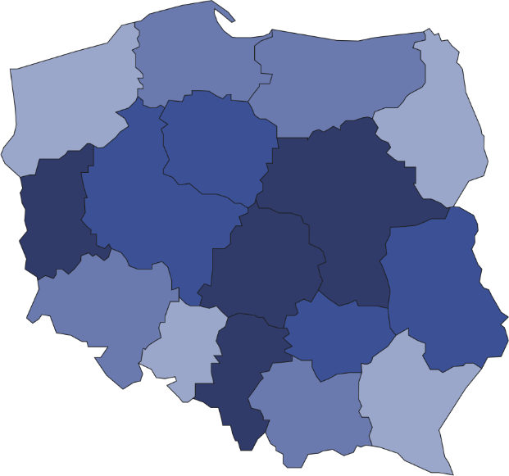
The prevalent part of centres of culture, cultural establishments, cultural centres, clubs and community centres (92.8%) belonged to the public sector. Local government units at the level of gmina played dominant role organising the activity of 90.7% of all public entities.

In 2019 centres of culture, cultural establishments, cultural centres, clubs and community centres organised a total of 243.8 thousand events, in which 37.5 million people took part. In comparison to 2018 the number of organised events increased by 0.6%, whereas number of participants decreased by 5.0%. Workshops were most frequently organised (21.1% of the total number of events). On average 154 people took part in 1 event. Festivals and artistic reviews were the most numerous in this respect – on average 640 people attended 1 event.
As of the end of 2019, 27.4 thousand various types of groups (clubs/sections) were operating in centres of culture, cultural establishments, cultural centres, clubs and community centres, gathering 575.5 thousand members. In the form of groups (clubs/sections) mostly were organised art and technical classes (6.0 thousand). The largest number of participants gathered senior clubs and The Third Age Universities (122.4 thousand people).
In 2019 entities conducted a total of 6.6 thousand courses. 101.0 thousand people obtained the graduated status of the course. Mostly were conducted dance courses (20.4% of the total number of courses) and language courses (19.0%).

Chart 1. The structure of groups (clubs, sections) and their participants in centres of culture, cultural establishments, cultural centres, clubs and community centres in 2019

As of 31st December
%

As of the end of 2019, 16.2 thousand artistic groups were operating in centres of culture, cultural establishments, cultural centres, clubs and community centres, among which most numerous were dance groups (4.3 thousand). From the total number of 276.0 thousand artistic groups participants, 64.9% were school children and youth. Every fifth artistic groups participants was person above 60 years old.
Chart 2. The structure of artistic groups and their participants in centres of culture, cultural establish
ments, cultural centres, clubs and community centres in 2019
As of 31st December
%

In the case of quoting data from the Statistics Poland, please provide information: "Statistics Poland data source", and in the case of publishing calculations made on data published by the Statistics Poland, please provide information: "Own study based on Statistics Poland data".

Prepared by:  Statistical Office in Kraków  Director Agnieszka Szlubowska  Office: tel. (+48 12) 420 40 50 | Issued by:  The Spokeperson for the President  of Statistics Poland  Karolina Banaszek  Mobile: (+48) 695 255 011

Press Office  Office: tel. (+48 22) 608 34 91, 608 38 04  e-mail: obslugaprasowa@stat.gov.pl |  | www.stat.gov.pl/en/
 |  | @StatPoland
 |  | @GlownyUrzadStatystyczny

Related information
Culture in 2018

Terms used in official statistics
Cultural establishment
Show (event)
Club
Group in cultural institution
Unit’s organizer
Cultural centre
Performance hall
Community centre
Event participant

