Activity of art galleries in 2019

In 2019, 327 art galleries were operating (0,6% more in comparison to 2018). Art galleries organised
3.9 thousand exhibitions in Poland, which were visited by 4.5 million people.
2.8%
Decrease in the number of organised exhibitions in comparison to 2018

Visitors in art galleries in Małopolskie and Mazowieckie consisted 55.1% of total number of visitors

In 2019, the majority of units were operating in Małopolskie (61) and Mazowieckie (53) Voivodships. The most visited art galleries were located in Małopolskie (1.3 million) and Mazowieckie (1.2 million) Voivodships. Most people visited art galleries organised by public sector (88.4%). Open-air exhibitions were visited by 28.8% of total number of visitors. On average there were 13.9 thousand visitors per one art gallery, one exhibition was visited by an average of 1.2 thousand people.
Map 1. Art galleries in 2019

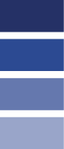
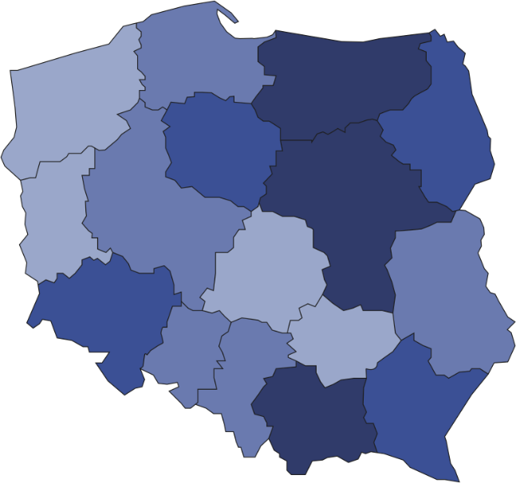
34.9% of art galleries were operating in Małopolskie and Mazowieckie Voivodships

327
Number of visitors per 1 art gallery
20001–24213
12001–20000
6001–12000
3121–6000
Number of art galleries
6
23
7
53
10
7
61
9

36
21
16
12
4
21

2

39
Art galleries organised 3.9 thousand exhibitions. Most exhibitions were national (87.3% of total number of exhibitions), which were visited by 82.3% of all visitors.
Chart 1. The structure of own collections of art galleries belonging to the state and self-government
units in 2019
As of 31st December
%

A significant part of art galleries belonged to the public sector (59.6%), within which the majority of units were organised by self-government units. Remaining art galleries were owned by the private sector. The largest part of the own collections of galleries belonging to the state and self-government units were collections in the domain of painting (43.0%).

Prepared by:  Statistical Office in Kraków  Director Agnieszka Szlubowska  Office: tel. (+48 12) 420 40 50 | Issued by:  The Spokeperson for the President  of Statistics Poland  Karolina Banaszek  Mobile: (+48) 695 255 011

Press Office  Office: tel. (+48 22) 608 34 91, 608 38 04  e-mail: obslugaprasowa@stat.gov.pl |  | www.stat.gov.pl/en/
 |  | @StatPoland
 |  | @GlownyUrzadStatystyczny

Related information
Culture in 2018

Terms used in official statistics
Art gallery
Unit’s organiser
Exhibition
Open-air exhibition in the galleries
Exposition
Visitor

