Activity of museums in 2019

In 2019, 959 museums and museums branches were operating (1.5% more in comparison to 2018), which were visited by 40.2 million people. Museums organised
2.7 thousand regular exhibitions and 5.0 thousand temporary exhibitions in Poland (including 100 exhibitions from abroad).
5.5%
Increase in the number of visitors in comparison to 2018

In 2019 40.2 million people visited museums, of which 14.3 million free of charge
The largest number of museums and visitors were in Mazowieckie and Małopolskie voivodships. Number of visitors in museums per 1000 people amounted to 1048 people. In ”Night of Museums” took part 798.7 thousand visitors.
The largest number of museums belonged to the public sector (77.1%), within which most of the units were organised by self-government units (81.7%). In private sector the largest number of museums were organised by natural persons (38.6%).

Map 1. Museums and museum branches in 2019


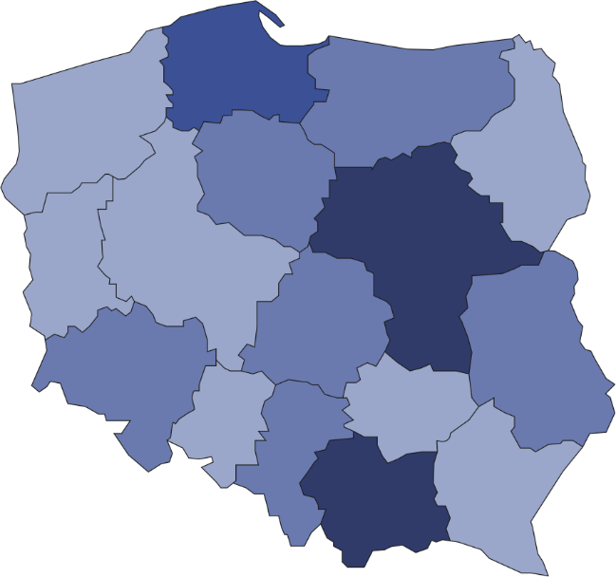
959
Number of visitors per 1 institutions
70001–91740
40001–70000
20001–40000
12494–20000
Number of museums and museums branches (as of 31st December)
29.0% of the total number of museums conducted activity in Mazowieckie and Małopolskie voivodships
32
83
29
143
51
57
135
34
46
89
41
32
20
73
20
74

Number of objects in museum collection amounted to 22.6 million pieces. The largest part of museum objects were from the archaeology domain (22.3%).

Chart 1. The structure of museum collection by branch in 2019
As of 31st December

In addition to the primary activity of collecting and presenting collection, museums organised many educational and cultural events. Museums lessons were most frequently organised (80.9 thousand).

Chart 2. The structure of cultural and educational activity of museums and museums branches in
2019
%

Prepared by:  Statistical Office in Kraków  Director Agnieszka Szlubowska  Office: tel. (+48 12) 420 40 50 | Issued by:  The Spokeperson for the President  of Statistics Poland  Karolina Banaszek  Mobile: (+48) 695 255 011

Press Office  Office: tel. (+48 22) 608 34 91, 608 38 04  e-mail: obslugaprasowa@stat.gov.pl |  | www.stat.gov.pl/en/
 |  | @StatPoland
 |  | @GlownyUrzadStatystyczny

Related information
Culture in 2018

Terms used in official statistics
Museum
Museum branch
Unit’s organizer
Museum lesson
Exhibits
Temporary exhibitions
Permanent exhibitions
Visitor

