Activity of theatres and music institutions in 2019

In 2019, 188 theatres and music institutions were operating in Poland. They presented 69.5 thousand performances with 14.4 million viewers. 730 premieres took place. Theatres and music institutions had 8.2 thousand performances in their repertoire.
3.6%
Decrease in the number of spectators and listeners in theatres and music institutions in comparison to 2018

In 2019, 188 theatres and music institutions with their own artistic ensemble conducted stage activity (0.5% less in comparison to 2018).
The largest number of theatres and music institutions with their own artistic ensemble operated in Mazowieckie Voivodship (35) and the least in Podkarpackie Voivodship (3). A total of 69.5 thousand performances/concerts were presented on 374 stages. Theatres and music institutions had 101.0 thousand seats in their audience.
In 2019, 86.7% of theatres and music institutions belonged to the public sector, within which 92.0% institutions were organised by self-government units.
Map 1. Theatres and music institutions in 2019


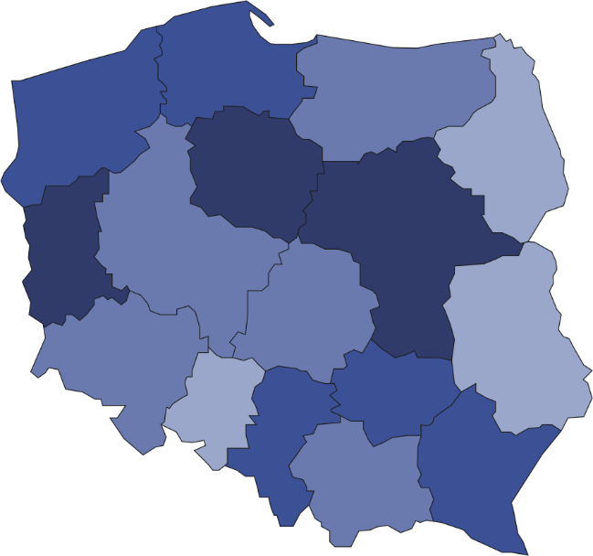
Number of spectators and listeners per 1 theatre/music institution
80001–148308
65001–80000
45001–65000
38522–45000
Number of theatres and music institutions (as of 31st December)
36.1% of total number of spectators and listeners took part in performances/concerts organised by theatres and music institutions in Mazowieckie Voivodship

5
15
8
35
7
3
22
4
11
15
7
8
4
17
5
22
188
In 2019, 14.4 million spectators and listeners took part in performances/concerts organised by theatres and music institutions (a decrease of 3.6% in comparison to 2018). On average 207 people took part in one performance/concert. On average one institution organised 370 performances/concerts.
Chart 1. The structure of theatres and music institutions by type in 2019
As of 31st December
%
1.6
2.6
6.4
9.0
9.0
12.7
19.0
39.7

Prepared by:  Statistical Office in Kraków  Director Agnieszka Szlubowska  Office: tel. (+48 12) 420 40 50 | Issued by:  The Spokeperson for the President  of Statistics Poland  Karolina Banaszek  Mobile: (+48) 695 255 011

Press Office  Office: tel. (+48 22) 608 34 91, 608 38 04  e-mail: obslugaprasowa@stat.gov.pl |  | www.stat.gov.pl/en/
 |  | @StatPoland
 |  | @GlownyUrzadStatystyczny

Related information
Culture in 2018

Terms used in official statistics
Choir
Artistic activities and entertainment
Philharmonic hall
Musical institution
Concert
Orchestra
Premiere
Performance
Scene
Theatre
Spectators and audience
Own artistic team
Song and dance ensemble

