Financial results of cultural institutions in 2019
(preliminary data)

In 2019 financial results of surveyed cultural institutions were higher in comparison to those achieved a year before. Assets (liabilities) as of 31 December 2019 amounted to PLN 18,615.7 million. Total revenues increased by 5.5% and total costs by 4.9%.
5.5%
Increase of total revenues in comparison to previous year

Assets (liabilities) of cultural institutions at the end of 2019 were 7.4% higher than at the end of 2018

In 2019 assets amounted to PLN 18,615.7 million. Taking into account the size of cultural institution measured by the number of employees, 47.2% of the total value of assets belonged to entities employing between 50 to 249 people, 24.9% of total assets belonged to entities employing between 10 to 49 people, 23.6% – entities employing 250 and more people and 4.3% – entities employing less than 10 people.
The highest value of assets was recorded in libraries, archives, museums and in entities conducting other activity in the field of culture – PLN 11,216.7 million (60.3% of the total value of assets).
Table 1. Basic data on the finances of cultural institutions
SPECIFICATION | 2018 | 2019 | 2018 = 100
SPECIFICATION | in PLN million |  | 2018 = 100
Assets (liabilities) | 17,330.2 | 18,615.7 | 107.4
Total revenues | 9,687.6 | 10,215.9 | 105.5
Total costs | 9,647.8 | 10,123.6 | 104.9
Gross financial result | 39.9 | 92.4 | 231.7
Net financial result | 38.5 | 90.5 | 234.8
At the end of 2019 fixed assest of cultural institutions amounted to PLN 17,069.6 million and were 7.3% higher in comparison to the previous year. Tangible fixed assets (98.3%) had the largest share in their structure, within which fixed assets constituted 89.0% and fixed assets under construction 10.5%.
Chart 1. The structure of fixed assets
As of 31st December 2019

Current assets of cultural institutions were 8.8% higher in comparison to the end of 2018 and amounted to PLN 1,546.1 million. In their structure short-term investmenst constituted 68.5% (a decrease of 0.6 percentage point).
Chart 2. The structure of current assets
As of 31st December 2019

(+) changes compared to 31.12.2018 in percentage points

In the structure of liabilities 33.1% constituted equities, which increased by 4.9%
in comparison to the end of 2018 and amounted to PLN 6,160.0 million, while the share of liabilities and provisions for liabilities constituted 66.9%.
Liabilities and provisions for liabilities at the end of 2019 amounted to PLN 12,455.7 million (an increase of 8.7% in comparison to the end of 2018), in which prepayments and accruals constituted 92.5%, short-term liabilities 4.9%, reserves for liabilities 2.1% and long-term liabilities 0.5%.

Chart 3. The structure of liabilities
As of 31st December 2019

The total revenue generated by cultural institutions amounted to PLN 10,215.9 million and increased by 5.5% in comparison to 2018. The highest value of revenues was reported in cultural institutions employing between 50 to 249 people (38.9% of the total value of revenues). In the structure of total revenues the largest share had subsidies to basic activity (75.5%). The remaining part constituted net revenues from sales of products (14.6%), other operating revenues 8.8%, net revenues from sales of goods and materials (1.0%) and financial revenues (0.1%).
Total revenues in 2019 were 5.5% higher than in previous year and total costs increased by 4.9%
The highest total revenues were achieved by cultural institutions in Mazowieckie Voivodship (25.6% of the total value of revenues) followed by Małopolskie (12.1%) and Śląskie (10.3%) Voivodships.

In 2019, total costs amounted to PLN 10,123.6 million and were 4.9% higher than a year ago.
The own costs of products, goods and materials sold (98.9%) had the largest share in their structure.
In the structure of operating costs by type remuneration accounted for 47.7% (an increase of 0.4 percentage points compared to 2018), 21.4% (as in the previous year) external services, and 9.2% social insurance and other benefits (increase by 0.2 percentage points).
As in the case of total revenues, the highest total costs were generated by units from the Mazowieckie voivodship (25.5% of the total value of costs).
The gross financial result was PLN 92.4 million (profit PLN 189.6 million, loss PLN 97.2 million).
Obligatory encumbrances on gross financial result due to income taxes increased in relation to 2018 by 43.8% and amounted to PLN 1.9 million.
The net financial result was at the level of PLN 90.5 million (compared to PLN 38.5 million in 2018), with an increase in net profit (by 29.7%) and a decrease in net loss (by 8.4%).
From the total number of cultural institutions examined, 42.5% achieved a net profit, and 37.6% recorded a net loss.
Chart 4. The structure of total revenues and total costs in 2019
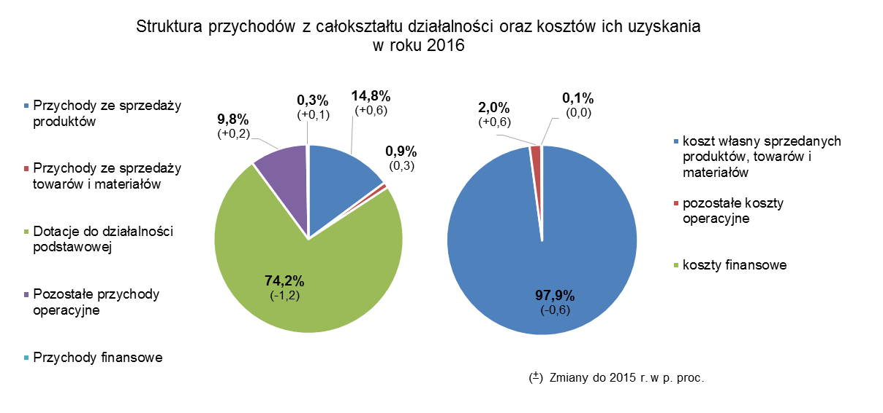
As of 31 December 2019, 86.2 thousand people worked in cultural institutions, of which 11.2% in state-owned units and 88.8% in local government organisational units. Among the cultural institutions surveyed, entities employing less than 10 people predominated, constituting 58.1% of the total number of units.
Most people worked in cultural institutions conducting creative activities related to culture and entertainment (54.7% of the total number of entities).

Table 2. Total revenues and total costs according to selected divisions and groups of PKD
classification in 2019

SPECIFICATION | Total | Of which
SPECIFICATION | Total | creative, arts and entertainment activities | of which |  | libraries, archives, museums and other cultural activities | of which
SPECIFICATION | Total | creative, arts and entertainment activities | performing arts | operation of arts  facilities | libraries, archives, museums and other cultural activities | library and  archives activities | museums activities
Number of cultural institutions | 4,685 | 2,286 | 150 | 2,124 | 2,393 | 2,006 | 378
Total revenues in PLN mln | 10,215.9 | 6,179.4 | 1,957.1 | 4,060.2 | 3,877.1 | 1,740.3 | 2,030.2
of which:
net revenues from the  sale of products | 1,491.7 | 1,077.7 | 423.2 | 619.7 | 367.6 | 20.5 | 341.5
subsidies for the basic  activity | 7,713.0 | 4,567.6 | 1,376.9 | 3,072.3 | 3,059.8 | 1,606.7 | 1,394.2
of which:
state budget | 1,614.0 | 782.2 | 362.3 | 413.7 | 765.4 | 173.7 | 555.9
local government  units | 5,936.6 | 3,722.6 | 996.9 | 2,620.2 | 2,210.3 | 1,386.1 | 801.6
Total costs in PLN million | 10,123.6 | 6,146.5 | 1,951.4 | 4,033.8 | 3,822.3 | 1,740.2 | 1,976.4
of which:
depreciation | 780.3 | 378.7 | 148.7 | 224.4 | 385.0 | 123.0 | 243.4
usage of materials and  energy | 857.3 | 523.9 | 103.2 | 411.0 | 326.1 | 175.3 | 144.3
extrernal services | 2,141.6 | 1,454.7 | 310.2 | 1,095.9 | 619.7 | 181.3 | 414.4
remunaration | 4,776.9 | 2,844.4 | 1,061.9 | 1,726.5 | 1,892.5 | 979.0 | 879.6
social insurance and  other benefits | 916.7 | 522.5 | 194.6 | 318.7 | 387.5 | 200.3 | 180.2
The balance sheet and profit and loss account for 2019 were obtained from 4,685 cultural institutions with legal personality: 64 state organisational units and 4,621 self-government units - municipal, poviat and voivodship.
The data presented in this study were prepared on the basis of the form with the symbol
F-02/dk Annual report on the finances of cultural institutions.
In the case of quoting data from the Statistics Poland, please provide information: "Statistics Poland data source", and in the case of publishing calculations made on data published by the Statistics Poland, please provide information: "Own study based on Statistics Poland data".

Prepared by:  Statistical Office in Kraków  Director Agnieszka Szlubowska  Office: tel. (+48 12) 420 40 50 | Issued by:  The Spokeperson for the President  of Statistics Poland  Karolina Banaszek  Mobile: (+48) 695 255 011

Press Office  Office: tel. (+48 22) 608 34 91, 608 38 04  e-mail: obslugaprasowa@stat.gov.pl |  | www.stat.gov.pl/en/
 |  | @StatPoland
 |  | @GlownyUrzadStatystyczny

Related information
Financial results of cultural institutions in period January-December 2019
Methodological report. Non-financial enterprises surveys 2019

Terms used in official statistics
Total revenues
Total costs
Gross financial result
Net financial result
Investment outlays
Outlays on intangible fixed assets
Cultural institution

