Gross domestic product and gross value added
in the regions’ breakdown in 2018

In 2018, more than 1/2 of the national value of gross domestic product was generated in the 5 regions: Warszawski stołeczny, Śląskie, Wielkopolskie, Dolnośląskie and Małopolskie.
55.9%
Percentage of GDP value generated in the 5 regions
in 2018
r.

Gross domestic product
In 2018, value of the generated gross domestic product amounted to 2120480 million PLN.
In comparison to 2017, it grew by 6.6% at current prices.
Growth of gross domestic product at current prices in all regions in comparison with the previous year
In all regions, growth of GDP at current prices was observed in comparison with 2017, the highest in Podkarpackie region – by 8.0% and the lowest in Lubelskie region – by 4.1%.
In 2018, the shares of individual regions in the generation of GDP ranged from 2.0% in Opolskie region to 17.4% in Warszawski stołeczny region. Value of GDP generated in Warszawski stołeczny region in 2018 was more than 8 times higher than in Opolskie
region (similarly as in 2017).
In the group of regions with high shares in the generation of GDP in 2018, apart from Warszawski stołeczny region, there were also the following regions: Śląskie, Wielkopolskie, Dolnośląskie and Małopolskie. Entities acting in the 5 above-mentioned regions, in which 49.5% of total employed persons in the national economy worked, jointly generated 55.9%
of the national value of GDP.

Graph 1. Share of regions in the generation of gross domestic product in 2018 (current prices)
Świętokrzyskie 2.3%
Opolskie 2.0%
Podlaskie 2.2%
Warszawski stołeczny 17.4%
Lubuskie 2.2%
Warmińsko-mazurskie 2.6%
Zachodniopomorskie 3.7%
Lubelskie 3.7%
Podkarpackie 3.9%
Kujawsko-pomorskie 4.4%
Pomorskie 5.9%
Łódzkie 6.0%
Mazowiecki regionalny 5.2%
Wielkopolskie 9.8%
Dolnośląskie 8.3%
Małopolskie 8.1%
POLAND
2120.5 bn PLN
Śląskie 12.3%

In 2018, the following regions: Opolskie, Lubuskie, Podlaskie, Świetokrzyskie and Warmińsko--mazurskie were in the group of regions with low shares in the GDP generation (less than 3% each). Their total share in the GDP generation amounted to 11.3% and employment in these regions constituted 13.3% of the total employed persons in the national economy.
In 2018, the average level of gross domestic product per capita in Poland amounted to
55202 PLN. In comparison with 2017, it was higher by 6.6% at current prices. In all regions growth of GDP per capita at current prices in comparison with 2017 was noted – from 4.5%
in Lubelskie region to 7.9% in Podkarpackie region.
In the regions’ breakdown, the level of GDP per capita in 2018 was considerably differentiated. Dispersion indicator of GDP per capita calculated at the regions’ level for Poland in 2018 amounted to 22.8%.
Value of GDP per capita exceeding the national average was obtained in
4 regions: Warszawski stołeczny, Dolnośląskie, Wielkopolskie and Śląskie
The highest level of GDP per capita in 2018 was noted for Warszawski stołeczny region – 121310 PLN, exceeding more than twice the national average (similarly as in 2017). In 2018 the level of GDP per capita above the national average was also observed in the following regions: Dolnośląskie – by 9.6%, Wielkopolskie – by 8.0% and Śląskie – by 3.9%.
The highest level of GDP per capita, obtained in 2018 in Warszawski stołeczny region, exceeded over 3-times the value of GDP per capita of Lubelskie region, in which the lowest level of GDP per capita was recorded.
Low level of GDP per capita (less than 75% of the national average) was noted in the
5 regions of Eastern Poland: Lubelskie, Warmińsko-
-mazurskie, Podkarpackie, Podlaskie and Świętokrzyskie
Low level of GDP per capita (less than 75% of the national average) in 2018 was observed
in the following regions: Lubelskie, Warmińsko-mazurskie, Podkarpackie, Podlaskie and Świętokrzyskie. In 2018 the value of GDP per capita in these regions varied from 67.6% to 72.2% of the national average.
The lowest level of GDP per capita in 2018, noted in Lubelskie region, represented 30.8%
of the level of this indicator for the best in this regard Warszawski stołeczny region.

Map 1. Gross domestic product per capita by regions in 2018 (current prices)

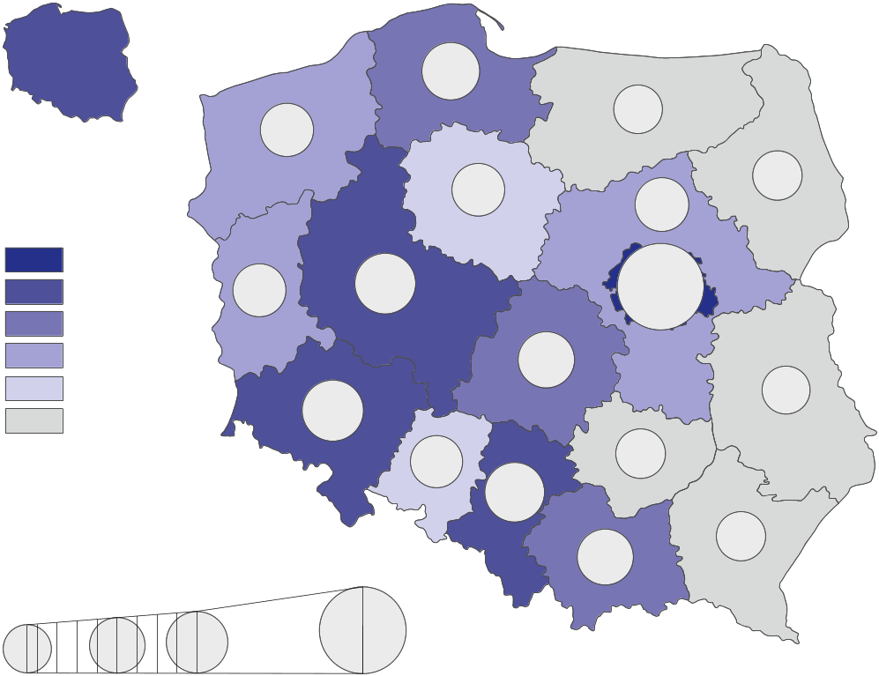
Poland=100
In thousand PLN
67.6%
90.0%
110.0%
219.8%
81.2%
82.3%
219.8%
97.2%
68.9%
83.2%
71.4%
84.6%
108.0%
92.9%
109.6%
72.2%
55.2
thousand
PLN

55.1-65.0
45.1-50.0
65.1-121.3
50.1-55.0
92.0%
37.3-40.0
67.6%
40.1-45.0
70.5%
79.5%
103.9%

Table 1. Gross domestic product by regions in 2018 (current prices)
Regions | Total |  |  | Per capita
Regions | in million PLN | in percent | previous year=100 | in PLN | Poland=100 | previous year=100
POLAND | 2120480 | 100.0 | 106.6 | 55202 | 100.0 | 106.6
Dolnośląskie | 175498 | 8.3 | 105.7 | 60496 | 109.6 | 105.7
Kujawsko-pomorskie | 93248 | 4.4 | 106.9 | 44833 | 81.2 | 107.1
Lubelskie | 79187 | 3.7 | 104.1 | 37324 | 67.6 | 104.5
Lubuskie | 46146 | 2.2 | 106.2 | 45445 | 82.3 | 106.3
Łódzkie | 126757 | 6.0 | 106.2 | 51306 | 92.9 | 106.6
Małopolskie | 172368 | 8.1 | 107.7 | 50761 | 92.0 | 107.4
Mazowiecki regionalny | 109660 | 5.2 | 105.4 | 46678 | 84.6 | 105.6
Opolskie | 43371 | 2.0 | 106.5 | 43897 | 79.5 | 106.9
Podkarpackie | 82903 | 3.9 | 108.0 | 38944 | 70.5 | 107.9
Podlaskie | 46645 | 2.2 | 106.2 | 39441 | 71.4 | 106.4
Pomorskie | 124882 | 5.9 | 107.7 | 53639 | 97.2 | 107.3
Śląskie | 260429 | 12.3 | 106.6 | 57362 | 103.9 | 106.9
Świętokrzyskie | 49601 | 2.3 | 107.4 | 39860 | 72.2 | 107.8
Warmińsko-mazurskie | 54451 | 2.6 | 104.5 | 38043 | 68.9 | 104.8
Warszawski stołeczny | 369090 | 17.4 | 107.8 | 121310 | 219.8 | 106.9
Wielkopolskie | 208023 | 9.8 | 105.7 | 59595 | 108.0 | 105.5
Zachodniopomorskie | 78217 | 3.7 | 106.2 | 45929 | 83.2 | 106.4
Gross value added by kind of activity
In 2018, 29.8% of the national gross value added was generated by the entities engaged in activities in the area of services covering trade; repair of motor vehicles; transportation and storage; accommodation and catering; information and communication. In the individual regions, the share of these entities in the generation of gross value added in 2018 ranged between 23.6% in Mazowiecki regionalny region and 38.0% in Warszawski stołeczny region.
In 2018, entities engaged in industry generated 25.9% of the national gross value added.
In the regions’ breakdown, in 2018 significant variation of the shares of industry was observed – from 12.5% in Warszawski stołeczny region to 34.5% in Mazowiecki regionalny region.
In 2018, entities engaged in other services (including public administration and defence; compulsory social security) generated 25.0% of the national gross value added. In 2018, Małopolskie region was characterized by the highest share of other services – 28.5% while Mazowiecki regionalny region was marked by the smallest share – 19.2%.

Entities engaged in financial and insurance activities; real estate activities in 2018 generated 9.0% of the national gross value added. In the individual regions, the share of entities acting in the field of financial and insurance activities; real estate activities in the generation of gross value added in 2018 ranged between 6.0% in Mazowiecki regionalny region and 14.3% in Warszawski stołeczny region.
In 2018, in all regions an increase of share of entities active in construction in the gross value added generation was noted in comparison with 2017
In 2018, entities active in construction generated 7.9% of the national gross value added.
In the regions’ breakdown in 2018, the share of units engaged in construction in the generation of gross value added ranged from 6.3% in Łódzkie region to 9.5% in Małopolskie region.
The share of agriculture, forestry and fishing in the generation of the national gross value added in 2018 amounted to 2.5%. In the individual regions, in 2018 the shares of entities conducting activity in the range of agriculture, forestry and fishing were significantly differentiated – from 0.6% in Warszawski stołeczny region to 9.2% in Mazowiecki regionalny region.

Graph 2. Gross value added by kind of activity and regions in 2018 (current prices)
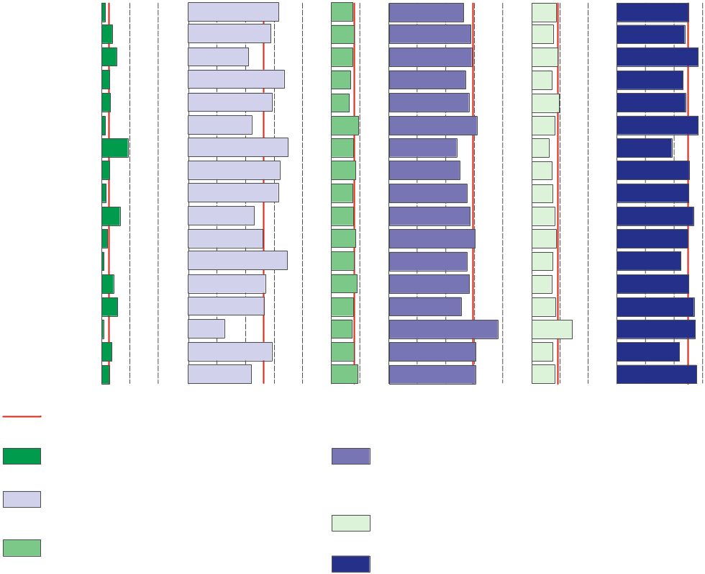
In % of total
0 10 20% 0 10 20 30 40% 0 10% 0 10 20 30 40% 0 10 20% 0 10 20 30%
Dolnośląskie
Kujawsko-pomorskie
Lubelskie
Lubuskie
Łódzkie
Małopolskie
Mazowiecki regionalny
Opolskie
Podkarpackie
Podlaskie
Pomorskie
Śląskie
Świętokrzyskie
Warmińsko-mazurskie
Warszawski stołeczny
Wielkopolskie
Zachodniopomorskie
Poland
Agriculture, forestry and fishing
Trade; repair of motor vehicles;
transportation and storage; accommodation and catering; information and communication
Industry
Construction
Financial and insurance activities; real estate activities
Other services
0 10 20% 0 10 20 30 40% 0 10% 0 10 20 30 40% 0 10 20% 0 10 20 30%

Table 2. Gross value added by kind of activity and regions in 2018 (current prices)
REGIONS  a – in million PLN  b – in % of total  c – previous year=100 |  | Total | Agriculture, forestry  and fishing | Industry | Construction | Trade; repair of motor vehicles^{Δ};  transportation and storage; accommodation  and catering^{Δ}; information and communication | Financial  and insurance activities;  real estate activities | Other services
POLAND | a | 1856461 | 46785 | 480619 | 145830 | 552757 | 167137 | 463333
 | b | 100.0 | 2.5 | 25.9 | 7.9 | 29.8 | 9.0 | 25.0
 | c | 106.3 | 87.7 | 104.7 | 115.4 | 107.8 | 104.7 | 106.2
Dolnośląskie | a | 153647 | 2049 | 48158 | 11734 | 40023 | 13210 | 38473
 | b | 100.0 | 1.3 | 31.3 | 7.6 | 26.0 | 8.6 | 25.0
 | c | 105.3 | 93.3 | 101.7 | 115.9 | 108.2 | 104.9 | 105.1
Kujawsko-pomorskie | a | 81638 | 2987 | 23381 | 6499 | 23354 | 6103 | 19314
 | b | 100.0 | 3.7 | 28.6 | 8.0 | 28.6 | 7.5 | 23.7
 | c | 106.6 | 85.7 | 109.2 | 114.2 | 106.6 | 105.4 | 105.5
Lubelskie | a | 69328 | 3639 | 14437 | 5187 | 20032 | 6348 | 19685
 | b | 100.0 | 5.2 | 20.8 | 7.5 | 28.9 | 9.2 | 28.4
 | c | 103.8 | 85.4 | 102.0 | 114.7 | 106.1 | 102.0 | 105.0
Lubuskie | a | 40401 | 1140 | 13424 | 2763 | 10802 | 2900 | 9372
 | b | 100.0 | 2.8 | 33.2 | 6.8 | 26.7 | 7.2 | 23.2
 | c | 105.8 | 84.8 | 104.2 | 116.5 | 109.4 | 104.0 | 105.2
Łódzkie | a | 110974 | 3347 | 32231 | 6995 | 30993 | 10789 | 26620
 | b | 100.0 | 3.0 | 29.0 | 6.3 | 27.9 | 9.7 | 24.0
 | c | 105.9 | 81.9 | 102.9 | 113.2 | 108.1 | 114.4 | 105.9
Małopolskie | a | 150907 | 1755 | 33143 | 14348 | 46347 | 12364 | 42949
 | b | 100.0 | 1.2 | 22.0 | 9.5 | 30.7 | 8.2 | 28.5
 | c | 107.3 | 88.6 | 104.4 | 115.5 | 109.1 | 108.6 | 106.0
Mazowiecki regionalny | a | 96007 | 8818 | 33078 | 7383 | 22619 | 5722 | 18387
 | b | 100.0 | 9.2 | 34.5 | 7.7 | 23.6 | 6.0 | 19.2
 | c | 105.0 | 92.1 | 106.6 | 113.3 | 106.8 | 101.6 | 105.2
Opolskie | a | 37971 | 1037 | 12036 | 3219 | 9365 | 2710 | 9604
 | b | 100.0 | 2.7 | 31.7 | 8.5 | 24.7 | 7.1 | 25.3
 | c | 106.2 | 85.9 | 107.4 | 116.0 | 106.2 | 103.0 | 105.4
Podkarpackie | a | 72580 | 1055 | 22647 | 5549 | 19735 | 5295 | 18300
 | b | 100.0 | 1.5 | 31.2 | 7.6 | 27.2 | 7.3 | 25.2
 | c | 107.6 | 87.1 | 108.2 | 118.7 | 107.5 | 103.4 | 106.7
Podlaskie | a | 40838 | 2626 | 9291 | 3145 | 11540 | 3285 | 10951
 | b | 100.0 | 6.4 | 22.8 | 7.7 | 28.3 | 8.0 | 26.8
 | c | 105.8 | 85.9 | 107.3 | 113.3 | 107.5 | 103.7 | 107.4

Table 2. Gross value added by kind of activity and regions in 2018 (cont.)
REGIONS  a – in million PLN  b – in % of total  c – previous year=100 |  | Total | Agriculture, forestry  and fishing | Industry | Construction | Trade; repair of motor vehicles^{Δ};  transportation and storage; accommodation  and catering^{Δ}; information and communication | Financial  and insurance activities;  real estate activities | Other services
Pomorskie | a | 109333 | 2224 | 28240 | 9327 | 32959 | 9359 | 27223
 | b | 100.0 | 2.0 | 25.8 | 8.5 | 30.1 | 8.6 | 24.9
 | c | 107.3 | 85.7 | 104.7 | 112.5 | 109.1 | 111.0 | 107.3
Śląskie | a | 228004 | 1534 | 78278 | 18235 | 62101 | 16680 | 51175
 | b | 100.0 | 0.7 | 34.3 | 8.0 | 27.2 | 7.3 | 22.4
 | c | 106.3 | 90.3 | 104.1 | 115.5 | 108.0 | 103.4 | 106.1
Świętokrzyskie | a | 43426 | 1763 | 11597 | 3911 | 12168 | 3038 | 10950
 | b | 100.0 | 4.1 | 26.7 | 9.0 | 28.0 | 7.0 | 25.2
 | c | 107.0 | 90.6 | 109.6 | 117.4 | 106.7 | 102.3 | 105.9
Warmińsko-mazurskie | a | 47672 | 2634 | 12487 | 3673 | 12027 | 3982 | 12869
 | b | 100.0 | 5.5 | 26.2 | 7.7 | 25.2 | 8.4 | 27.0
 | c | 104.2 | 87.8 | 101.3 | 115.5 | 108.3 | 104.8 | 104.3
Warszawski stołeczny | a | 323135 | 1935 | 40544 | 23111 | 122788 | 46337 | 88420
 | b | 100.0 | 0.6 | 12.5 | 7.2 | 38.0 | 14.3 | 27.4
 | c | 107.4 | 94.3 | 106.2 | 116.0 | 108.5 | 102.1 | 107.7
Wielkopolskie | a | 182123 | 6433 | 52681 | 14384 | 55213 | 13479 | 39933
 | b | 100.0 | 3.5 | 28.9 | 7.9 | 30.3 | 7.4 | 21.9
 | c | 105.3 | 84.4 | 104.6 | 118.3 | 105.9 | 105.4 | 105.6
Zachodniopomorskie | a | 68479 | 1811 | 14965 | 6368 | 20690 | 5537 | 19107
 | b | 100.0 | 2.6 | 21.9 | 9.3 | 30.2 | 8.1 | 27.9
 | c | 105.9 | 90.2 | 102.7 | 112.8 | 107.5 | 104.0 | 106.9
Symbol (∆) — categories of applied classification are presented in abbreviated form; their full names are
available on Statistics Poland’s website: https://stat.gov.pl/Klasyfikacje/doc/pkd_07/pkd_07.htm

Data from regional accounts included in this note have been revised in relation to the published on 31 December 2019. They will be subject to further revision, accordingly to the revision policy applied in the national and regional accounts. Final data for 2018 will be available in November this year.

In case of quoting Statistics Poland data, please provide information: “Source of data: Statistics Poland”, and in case of publishing calculations made on data published by Statistics Poland, please include the following disclaimer: “Own study based on figures from Statistics Poland”.

Prepared by:  Statistical Office in Katowice  Director Aurelia Hetmańska  Office: tel: (+48 32) 779 12 48 | Issued by:  The Spokesperson for the President  of Statistics Poland  Karolina Banaszek  Mobile: (+48) 695 255 011

Press Office  Office: tel: (+48 22) 608 34 91, 608 38 04  e-mail: obslugaprasowa@stat.gov.pl |    | www.stat.gov.pl/en/
 |  | @StatPoland
 |  | @GlownyUrzadStatystyczny

Related information
GDP per capita in EU regions
Gross Domestic Product - regional accounts in the years 2015-2017
NUTS 2016 revision (binding since 1 January 2018 to 31 December 2020)
National accounts by institutional sectors 2015–2018

Data available in databases
Statistic Poland -> Local Data Bank ->Regional accounts

Terms used in official statistics
Regional accounts
Gross domestic product
Value added, gross

In accordance with the Classification of Territorial Units for Statistics (NUTS 2016), obligatory from 1 January 2018. https://eur-lex.europa.eu/legal-content/EN/TXT/PDF/?uri=CELEX:32016R2066&qid=1600686365854&from=EN

