Price indices of construction and assembly production in November 2020

According to preliminary data, in November 2020 the prices of construction and assembly production in comparison with the corresponding month of the previous year increased by 2.4%, and in comparison with October 2020 - by 0.2%.
2.4%
the growth of producer prices in construction in comparison with November 2019

In comparison with the previous month the growth of prices was recorded in civil engineering by 0.2% as well as in construction of buildings and in specialised construction activities - by 0.1% each.
In comparison with November 2019 the increase of prices was noticed in construction of buildings as well as in civil engineering by 2.5% each and in specialised construction activities- by 2.0%.

Table 1. Price indices of construction and assembly production in November 2020

 | X 2020 |  | XI 2020 |  |  | I-XI 2020
SPECIFICATION | IX 2020=100 | corresponding period 2019=100 |  | X 2020=100 | XII 2019=100 | I-XI 2019
TOTAL | 100.2* | 102.4* | 102.4 | 100.2 | 102.5 | 102.7
Construction of buildings | 100.2* | 102.6* | 102.5 | 100.1 | 102.4 | 103.0
Civil engineering | 100.2* | 102.5* | 102.5 | 100.2 | 102.4 | 102.6
Specialised construction activities | 100.2 | 102.1 | 102.0 | 100.1 | 101.9 | 102.4

* Data revised.

In November 2020, as in October this year, the prices of construction and assembly production increased compared to the previous month by 0.2%
Chart 1. Prices changes of construction and assembly production in 2019-2020 in relation
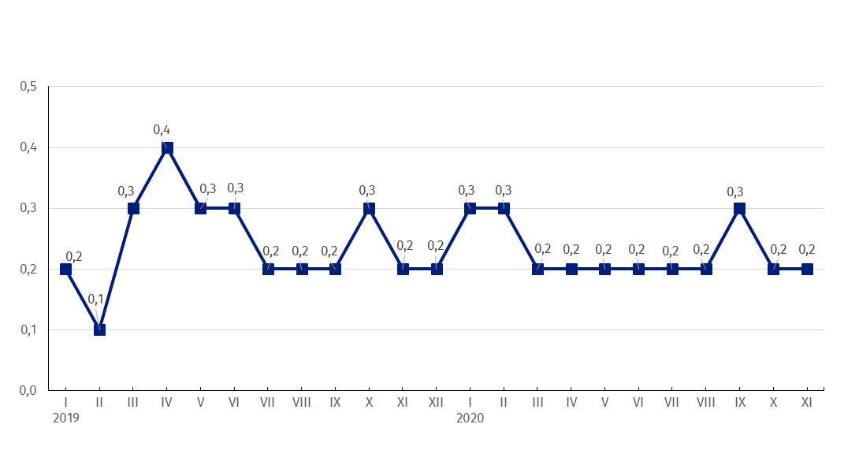
to the previous period ( in %)

Chart 2. Prices changes of construction and assembly production in 2019-2020 in relation
In November 2020 the prices growth of construction and assembly production in annual term remained at the level observed in the previous month and amounted to 2.4%
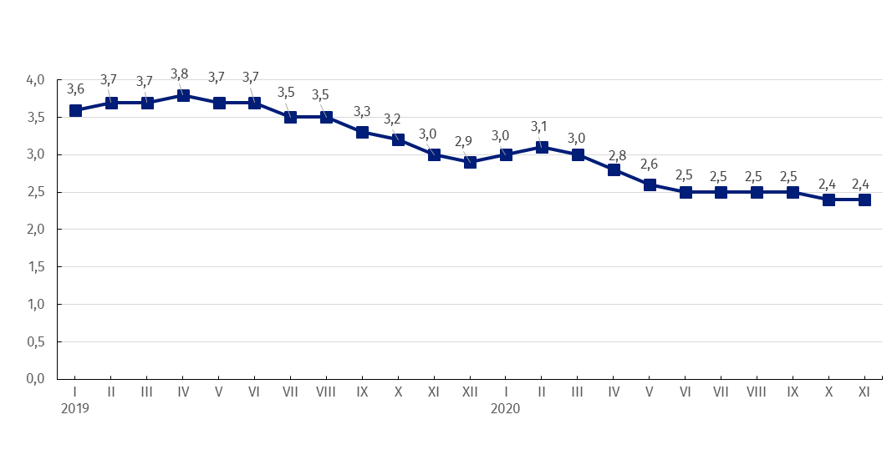
to the same period of the previous year (in %)

Chart 3. Prices changes of production and assembly construction by divisions NACE in 2019-2020
Starting from January 2019 the highest prices growth is recorded in construction of buildings
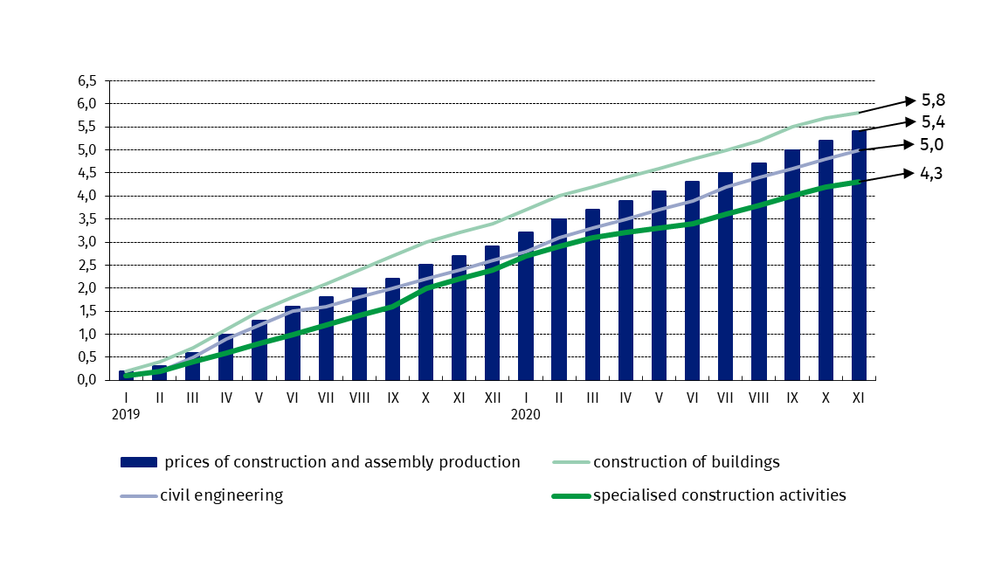
in relation to December 2018 (in %)

In case of quoting Statistics Poland data, please provide information: “Source of data: Statistics Poland”, and in case of publishing calculations made on data published by Statistics Poland, please include the following disclaimer: “Own study based on figures from Statistics Poland”.

Prepared by:  The Trade and Services Department  Director Ewa Adach-Stankiewicz  Office: tel. (+48 22) 608 31 24 | Issued by:  The Spokesperson for the President  of Statistics Poland  Karolina Banaszek  Mobile: (+48) 695 255 011

Press Office  Office: tel. (+48 22) 608 34 91, 608 38 04  e-mail: obslugaprasowa@stat.gov.pl |  | www.stat.gov.pl/en/
 |  | @StatPoland
 |  | @GlownyUrzadStatystyczny

Related information
Statistical Bulletin
News Releases

Data available in databases
Analytical Platform - Knowledge Databases
Macroeconomic Data Bank
Prices indices (Topics: Prices, Trade)

Terms used in official statistics
Price index of construction and assembly production

