Price indices of construction and assembly production in January 2020

According to preliminary data in January 2020 the prices of construction and assembly production were higher by 2.9% in comparison with the corresponding month of the previous year and by 0.2% in comparison with December 2019.
2.9%
the growth of producer prices in construction in comparison with January 2019

In comparison with the previous month the growth of prices was recorded in construction of buildings as well as in civil engineering (by 0.2% each). The prices in specialised construction activities increased (by 0.1%).
In comparison with January 2019 the increase of prices was noticed in construction of buildings (by 3.4%), in civil engineering (by 2.7%) as well as in specialised construction activities (by 2.4%).

Table 1. Price indices of construction and assembly production in January 2020

 | XII 2019 |  | I-XII 2019 | I 2020
SPECIFICATION | XI 2019=100 | corresponding period 2018=100 |  | I 2019=100 | XII 2019=100
TOTAL | 100.2 | 102.9 | 103.5 | 102.9 | 100.2
Construction of buildings | 100.2 | 103.4 | 104.1 | 103.4 | 100.2
Civil engineering | 100.2 | 102.6 | 103.3 | 102.7 | 100.2
Specialised construction activities | 100.2* | 102.4* | 102.8 | 102.4 | 100.1

* Data revised.

In January 2020, same as in November and in December last year, the prices of construction and assembly production were by 0.2% higher compared to the previous month
Chart 1. Prices changes of construction and assembly production in 2018-2020 in relation
to the previous period (in %)
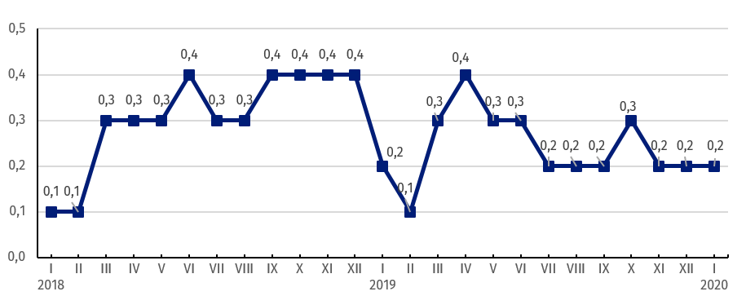
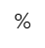

In the second consecutive month, the prices of construction and assembly production in annual term increased by 2.9%
Chart 2. Prices changes of construction and assembly production in 2018-2020 in relation
to the same period of the previous year (in %)
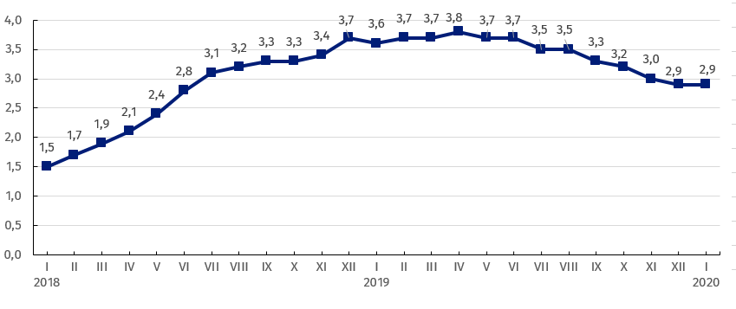

Chart 3. Prices changes of production and assembly construction in 2018-2020
in relation to XII 2017 (in %)
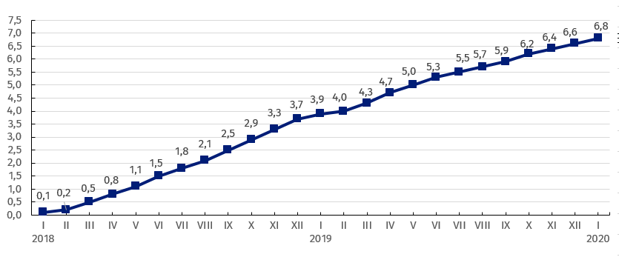

Chart 4. Prices changes of production and assembly construction by divisions NACE in 2018-2020
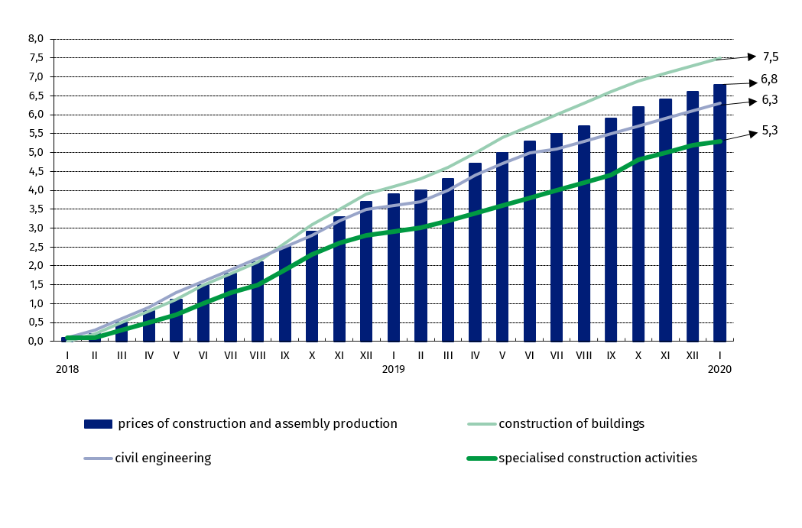
in relation to XII 2017 (in %)

Prepared by:  The Trade and Services Department  Director Ewa Adach-Stankiewicz  Office: tel. (+48 22) 608 31 24 | Issued by:  The Spokeperson for the President  of Statistics Poland  Karolina Banaszek  Mobile: (+48) 695 255 011

Press Office  Office: tel. (+48 22) 608 34 91, 608 38 04  e-mail: obslugaprasowa@stat.gov.pl |  | www.stat.gov.pl/en/
 |  | @StatPoland
 |  | @GlownyUrzadStatystyczny

Related information
Statistical Bulletin
News Releases

Data available in databases
Analytical Platform - Knowledge Databases
Macroeconomic Data Bank
Prices indices (Topics: Prices, Trade)

Terms used in official statistics
Price index of construction and assembly production

