Business tendency in manufacturing, construction, trade and services – February 2020
General business climate indicator and its components in the last six months
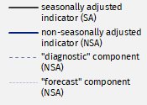
Entities from sections: manufacturing, accommodation and food services as well as financial and insurance activities evaluate general business climate indicator in February worse than one month ago. Entrepreneurs of the other scrutinised kinds of activities evaluate it similarly as in January. In most of the areas “diagnostic” component is getting worse and “forecast” component is getting better in comparison with the previous month.
1,6
General business climate indicator for manufacturing (NSA)


Manufacturing – general business climate indicator (graph 1)
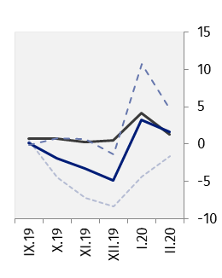
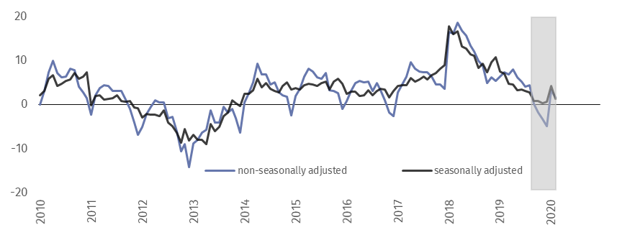
In February general business climate indicator (NSA) takes the value plus 1.6 that is lower than in January (plus 3.2) and in February of the last six years.


Construction – general business climate indicator (graph 2)
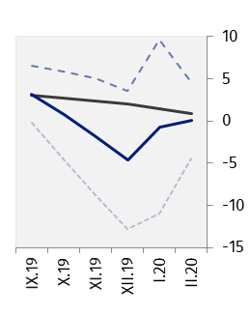
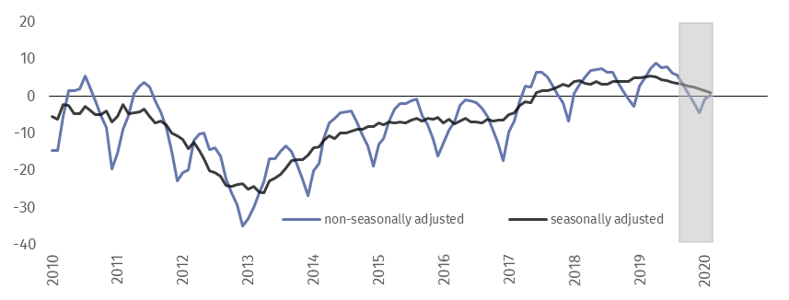
In the current month general business climate indicator (NSA) takes the value plus 0.1 that is higher than in the previous 3 months but lower than in February of the last two years.


Wholesale trade – general business climate indicator (graph 3)
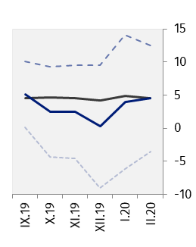
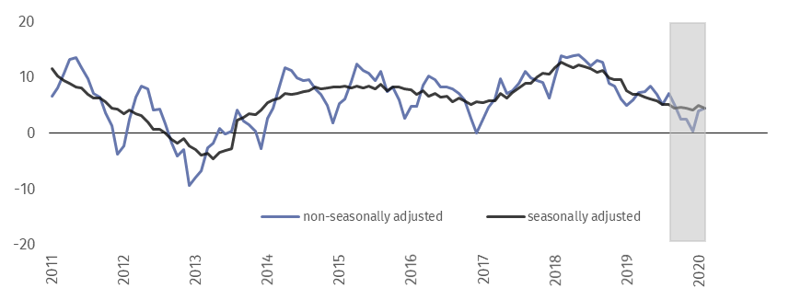
In the current month general business climate indicator (NSA) takes the value plus 4.5 – similarly to January (plus 4.0) but lower than in February of the last two years.


Retail trade – general business climate indicator (graph 4)
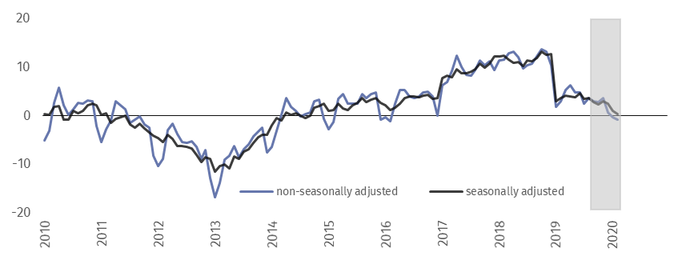
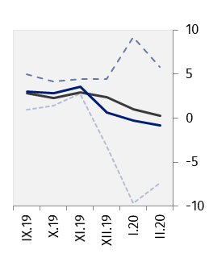
In the current month general business climate indicator (NSA) takes the value minus 0.8 – similarly to January (minus 0.3) but lower than in analogous month of the last three years when it took positive values.


Transportation and storage – general business climate indicator (graph 5)
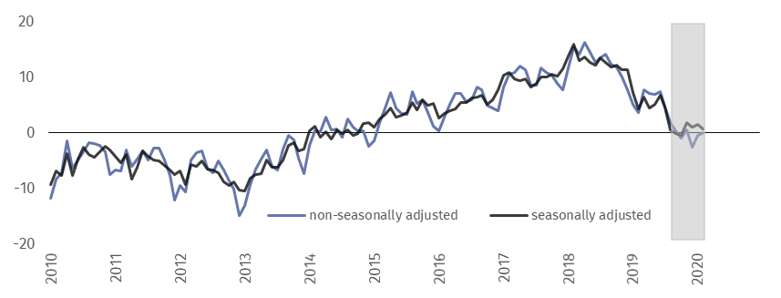
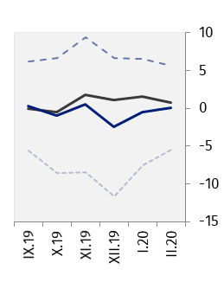
In the current month general business climate indicator (NSA) takes the value plus 0.1 – close to its value in January (minus 0.5) but lower than in February of the last five years.


Accommodation and food service activities – general business climate indicator (graph 6)
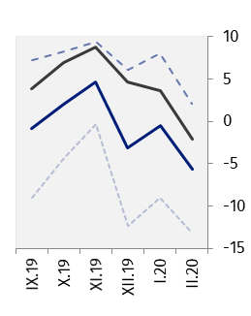
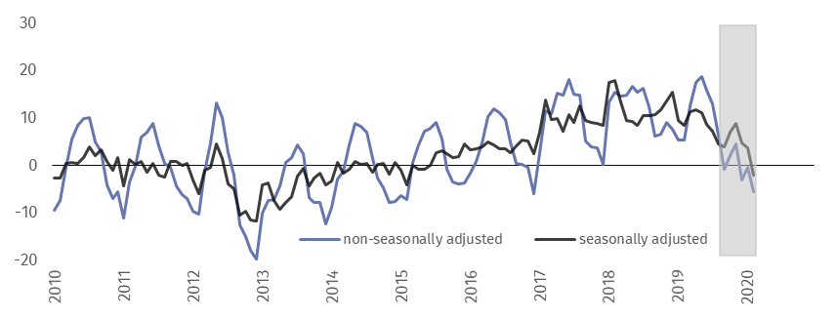
In the current month general business climate indicator (NSA) takes the value minus 5.6 that is lower than in January (minus 0.5) and in analogous month of the last four years when it took positive values.


Information and communication – general business climate indicator (graph 7)
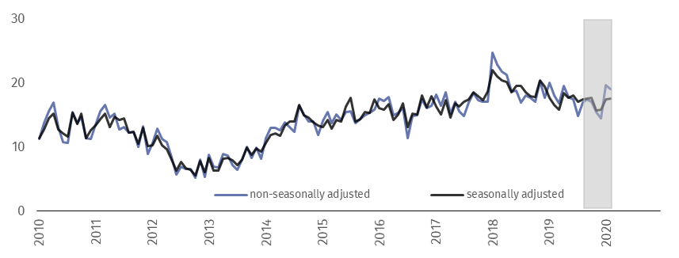
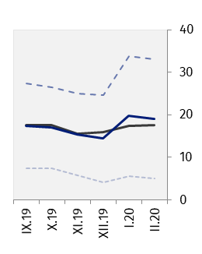
In February general business climate indicator (NSA) takes the value plus 19.0 that is close to its value one month ago (plus 19.7) and one year ago (plus 18.0).


Financial and insurance activities – general business climate indicator (graph 8)
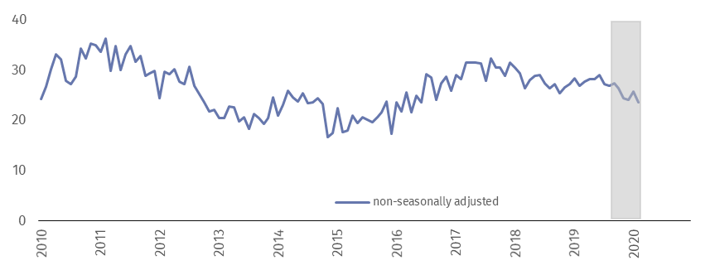
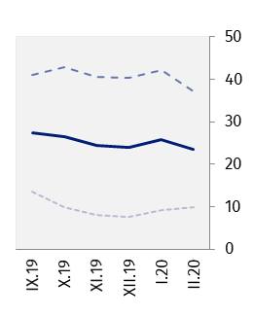
In February general business climate indicator (NSA) takes the value plus 23.6 that is lower than one month ago (plus 25.7) and in February of the last three years.

Table 1. Business climate indicators by kind of activity
SPECIFICATION |  | Analogous month of the previous year | Previous month | Current month | Long-term average
Manufacturing | seasonally adjusted indicator (SA) | 7,1 4,2 1,3 3,8  7,3 3,2 1,6 3,8  8,4 10,7 4,7 -0,6  6,1 -4,3 -1,6 8,2  5,2 1,4 0,9 -1,1  4,9 -0,7 0,1 -1,1  6,5 9,6 4,6 -5,3  3,3 -11,0 -4,5 3,1  7,0 4,9 4,6 6,1  5,9 4,0 4,5 6,0  11,5 14,1 12,5 10,2  0,3 -6,2 -3,5 1,8  3,7 1,0 0,3 -3,4  3,0 -0,3 -0,8 -3,4  8,4 9,2 5,8 -3,3  -2,4 -9,7 -7,4 -3,5  4,3 1,5 0,7 0,7  3,7 -0,5 0,1 0,6  9,0 6,5 5,6 1,1  -1,7 -7,5 -5,5 0,2  8,3 3,6 -2,1 3,1  5,3 -0,5 -5,6 3,0  8,9 8,0 2,1 1,3  1,7 -9,0 -13,2 4,8  16,6 17,4 17,5 19,9  18,0 19,7 19,0 19,9  30,2 33,7 33,0 26,3  5,8 5,6 5,0 13,5  . . . .  26,8 25,7 23,6 29,3  40,4 42,1 37,2 34,5  13,2 9,2 10,0 24,07,8 | 0,8 | 4,5 | 3,9
 | non-seasonally adjusted indicator (NSA) | 6,4 | -4,9 | 3,2 | 3,9
 | “diagnostic” component (NSA) | 11,8 | -1,4 | 10,7 | -0,6
 | “forecasting” component (NSA) | 1,0 | -8,4 | -4,3 | 8,3
Construction | seasonally adjusted indicator (SA) | 5,0 | 2,2 | 1,7 | -1,1
 | non-seasonally adjusted indicator (NSA) | 2,7 | -4,6 | -0,7 | -1,1
 | “diagnostic” component (NSA) | 10,4 | 3,6 | 9,6 | -5,4
 | “forecasting” component (NSA) | -5,0 | -12,8 | -11,0 | 3,1
Wholesale trade | seasonally adjusted indicator (SA) | 7,6 | 4,2 | 4,9 | 6,1
 | non-seasonally adjusted indicator (NSA) | 5,0 | 0,3 | 4,0 | 6,1
 | “diagnostic” component (NSA) | 13,4 | 9,5 | 14,1 | 10,2
 | “forecasting” component (NSA) | -3,5 | -9,0 | -6,2 | 1,9
Retail trade | seasonally adjusted indicator (SA) | 3,0 | 2,6 | 1,3 | -3,4
 | non-seasonally adjusted indicator (NSA) | 1,8 | 0,6 | -0,3 | -3,4
 | “diagnostic” component (NSA) | 11,0 | 4,4 | 9,2 | -3,4
 | “forecasting” component (NSA) | -7,4 | -3,2 | -9,7 | -3,5
Transportation and storage | seasonally adjusted indicator (SA) | 7,2 | 1,1 | 1,6 | 0,7
 | non-seasonally adjusted indicator (NSA) | 5,1 | -2,5 | -0,5 | 0,6
 | “diagnostic” component (NSA) | 13,5 | 6,7 | 6,5 | 1,0
 | “forecasting” component (NSA) | -3,3 | -11,7 | -7,5 | 0,2
Accommodation and food service activities | seasonally adjusted indicator (SA) | 9,9 | 5,1 | 4,2 | 3,1
 | non-seasonally adjusted indicator (NSA) | 5,4 | -3,1 | -0,5 | 3,1
 | “diagnostic” component (NSA) | 9,7 | 6,1 | 8,0 | 1,3
 | “forecasting” component (NSA) | 1,1 | -12,3 | -9,0 | 4,9
Information and communication | seasonally adjusted indicator (SA) | 17,6 | 15,8 | 17,3 | 19,9
 | non-seasonally adjusted indicator (NSA) | 20,0 | 14,4 | 19,7 | 19,9
 | “diagnostic” component (NSA) | 33,1 | 24,6 | 33,7 | 26,3
 | “forecasting” component (NSA) | 6,8 | 4,2 | 5,6 | 13,5
Financial and insurance activities | seasonally adjusted indicator (SA) | . | . | . | .
 | non-seasonally adjusted indicator (NSA) | 28,4 | 24,0 | 25,7 | 29,3
 | “diagnostic” component (NSA) | 43,0 | 40,3 | 42,1 | 34,5
 | “forecasting” component (NSA) | 13,7 | 7,6 | 9,2 | 24,1

Prepared by:  Macroeconomic Studies and Finance Statistics Department  Director Mirosław Błażej  Office: tel. (+48 22) 608 37 73 | Issued by:  The Spokesperson for the President  of Statistics Poland  Karolina Banaszek  Mobile: (+48) 695 255 011
Press Office  Office: tel. (+48 22) 608 34 91, 608 38 04  e-mail: obslugaprasowa@stat.gov.pl |  | www.stat.gov.pl/en/
 |  | @StatPoland
 |  | @GlownyUrzadStatystyczny



This document was prepared with European Commission financial contribution. Ideas presented here are Statistics Poland notions, so they should not be seen in any cases as European Commission official opinions reflections.

Related information
Business tendency in manufacturing, construction, trade and services

Data available in databases
Knowledge Database Business Tendency
Macroeconomic Data Bank

Terms used in official statistics
Business tendency

Time series does not require to be seasonally adjusted. Non-seasonally adjusted data can be analyzed and interpreted in the same way as seasonally adjusted data.
Time series does not require to be seasonally adjusted. Non-seasonally adjusted data can be analyzed and interpreted in the same way as seasonally adjusted data.

