Cooperation of non-profit organizations with other entities in 2019

In 2019, 78.5 thousand out of 89.4 thousand of active non-profit organizations cooperated with other entities, i.e. 0.6 ppt more compared to 2017. These organizations most frequently cooperated with public institutions (81.2%).
87.8%
of organizations cooperated with other entities
As many as 71.2% of the cooperating organizations declared the absence of barriers to cooperation (73.8% in 2017).

Number of active organizations
In 2019, 89.4 thousand of associations and similar social organizations, foundations, business and professional associations (3.3 thousand fewer compared to 2017) were active.

In Poland, 89.4 thousand of associations and similar social organizations, foundations, social faith-based charities, business and professional associations were active in 2019. Compared to 2017, the number dropped by 3.3 thousand (3.6%), and increased by 1.3 thousand (1,5%) until 2018.
In 2019, the most numerous group were associations and similar social organizations (69.9 thousand; 78.2%), followed by foundations (15.3 thousand; 17.1%). There were clearly fewer business and professional associations (2.4 thousand; 2.7%) and social faith-based charities (1.8 thousand; 2.0%).

Chart 1. The number of associations and similar social organizations, foundations, social faith-based charities, business and professional associations in 2019

Intra-sectoral and inter-sectoral cooperation
Non-profit organizations most frequently cooperated with public institutions (81.2%).

In 2019, public institutions were the main cooperation partner for non-profit organizations. As many as 81.2% of organizations cooperated with the central and local government administration or its subordinate entities. The second most frequently indicated group of entities with which the cooperation was established by organizations were other non-profit entities (54.8%). On the other hand, established cooperation with enterprises was most rare form (34.0%).

Figure 1. Establishment of cooperation with other entities by non-profit organizations in 2019

Non-profit organizations (NPOs) can cooperate in parallel with partners from different sectors. As few as 24.1% of non-profit organizations decided to cooperate with all groups at the same time. The cooperation with public institutions and other non-profit organizations was established by 25.6% of organizations. It was the most numerous group in terms of total cooperation. Only 1.7% of entities did indicate cooperation with non-profit organizations and enterprises, while 12.2% of organizations did not establish any cooperation.

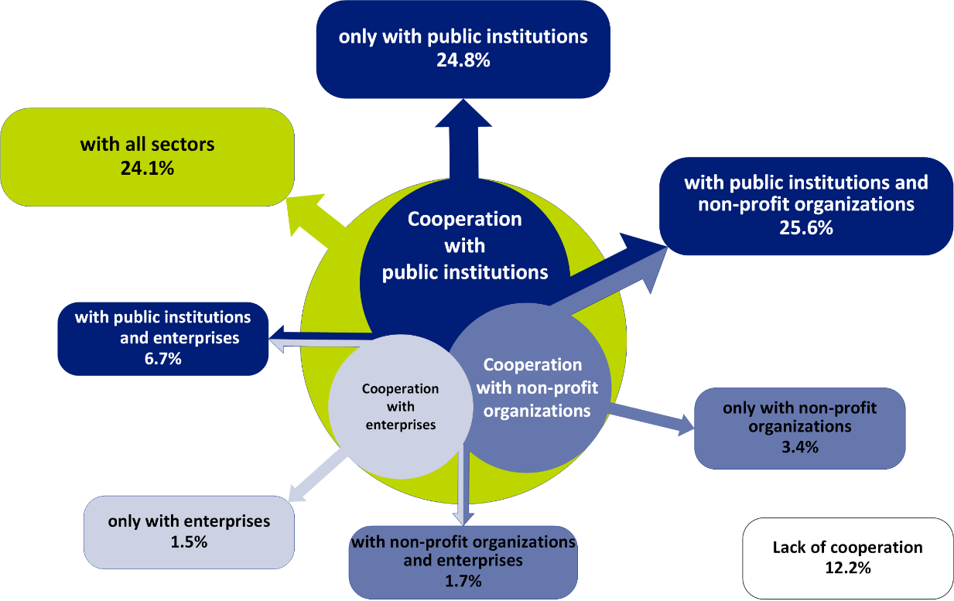
Figure 2. Cooperation of non-profit organizations in 2019 by the type of partner - in total

Compared to 2017, there were no significant differences in the cooperation established. Changes exceeding 1.0 ppt only occurred in three groups. An increase of 1.6 ppt (from 22.5% in 2017 to 24.1% in 2019) was observed in terms of cooperation with all sectors. The share of units among entities cooperating with public institutions and non-profit organizations increased as well – 1.4 ppt (from 24.2 in 2017 to 25.6% in 2019). On the other hand, the percentage of organizations cooperating only with public institutions decreased by 1.9 ppt (from 26.7% in 2017 to 24.8% in 2019).

Objectives of cooperation
In 2019, for organizations cooperating with public administration, the main goal of cooperation was to raise funds (74.5%).

Among the entities cooperating with the public sector, the most frequently indicated target in 2019 was to raise funds (74.5%). 47.2% of organizations having partner relations with this sector could count on material support (40.4% of which used the premises free of charge or on preferential policies).
Nearly half (49.6%) of the entities cooperating with the commercial sector indicated a target of raising funds, and 43.2% - material support (14.9% of which indicated using the premises).

Chart 2. The percentage of non-profit organizations in 2019 by the purpose of cooperation and the type of partner ª
Immaterial things
Material things
ª The values refer to all organizations declaring cooperation with a given type of partner.

The main goal of intra-sectoral cooperation was to obtain intangible resources. Among the entities cooperating within the non-profit sector, the highest percentage, as in 2017, had the integration of local communities and developing contacts (65.1%, 1.6 ppt less than in 2017), the share was almost twice as large as among the organizations cooperating with public institutions or enterprises (34.5% and 36.2% respectively). The second target of establishing intra-sectoral relations was the knowledge and experience of the employees, members or volunteers of the organizations they cooperated with (52.0%).
Between the year 2017 and 2019, the greatest change in the above-mentioned targets of cooperation took place among the entities cooperating with other non-profit organizations in the field of raising funds (e.g., subsidies, donations, grants) - there was observed an increase of 12.0 ppt (from 16.3% in 2017, to 28.3% in 2019).

Barriers to cooperation
In 2019, 71.2% of non-profit organizations reported no barriers in cooperation with other entities, by 2.6 ppt less than in 2017).

In 2019, 71.2% of the non-profit organizations cooperating with other entities declared smoothly functioning relationships. The largest part of the organizations, which did not experience any problems with cooperation, was among the entities cooperating within the intra- sector (76.5%). This percentage decreased by 3.9 ppt compared to 2017 (it was 80,4%).

Chart 3. The percentage of non-profit organizations by the types of barriers to cooperation and the type of partner in 2019 ª
ª The values refer to all organizations declaring cooperation with a given partner. The entities had an option to indicate more than one barrier to cooperation.

The most frequently reported barriers, among organizations cooperating with public administration, were bad or unclear legal regulations and procedures, as indicated by 12.8% of entities. Then, a slightly lower share, in cooperation with the same sector, had the barriers related to the lack of partnership (11.1%). In intra-sectoral cooperation, the greatest issue was the lack of knowledge on the side of the partner (9.9%) and the conflict of interest (7.4%), while the organizations cooperating with the commercial sector indicated the most problems, similarly to the intra-sector, in terms of the partner's lack of knowledge about cooperation (15.7%).
That was also the barrier with the greatest discrepancies compared to 2017. Among the organizations cooperating with enterprises, there was an increase of 4.0 ppt (from 11.7%), in intra-sectoral cooperation - an increase of approximately 3.0 ppt (from 6.9%), and in cooperation with public administration, the percentage of the organizations indicating that issue also increased by 2.7 percentage points (from 6.9%).
In the case of other barriers, there were no fluctuations recorded that exceeded 1.0 ppt.

Methodological information
To develop the news releases, the preliminary results of Statistics Poland 1.04.01 were used. Associations, foundations, faith-based charities, business and professional associations for 2019 as per the SOF-5 form (Report on cooperation, management and information activities of selected non-profit organizations).
The research was a panel survey and included the entities from the SOF-1 file (Report on the activities of foundations, associations and similar social organizations) and SOF-4s file (Report on the activities of economic and professional self-government), which, for the year 2018, submitted their reports. Due to the fact that the data for the survey SOF-5 for the year 2019 was created based on the data SOF-1 and SOF-4 for the year 2018, to average the results, it was necessary to take into account the changes in the frame that occurred between the editions of the research. For this purpose, the data obtained from the Database of Statistical Units as of 31 December 2019 and from ZUS (Social Insurance Institution) were used. Weightings, which made it possible to generalise the acquired data into the whole population of active entities, were constructed for the result set.
The study was conducted by the Statistical Office in Krakow via the Reporting Portal using electronic mail as well as the traditional postal method. The completed SOF-5 report was sent by 20.7 thousand (88.3%) organizations covered by the survey in total, and 0.9 thousand entities (4.3%) declared inactivity in 2019. As many as 7.9% of organizations refused to participate in the study, and fewer than 0.8% of entities could not be contacted.

In the case of quoting data of Statistics Poland, please provide annotation: "Source: Statistics Poland". When publishing calculations made on the data published by Statistics Poland, please include the following information: "Own elaboration based on data from Statistics Poland".

Prepared by:  Social Surveys Department  Director Dr Piotr Łysoń  Tel: 22 449 40 27  in collaboration  with the Statistical Office in Kraków  Director Agnieszka Szlubowska  Tel: 12 420 40 50 | Issued by:  The Spokesperson for the President of Statistics Poland  Karolina Banaszek  Tel: 695 255 011

Press Office  Tel: 22 608 34 91, 22 608 38 04  e-mail: obslugaprasowa@stat.gov.pl |  | www.stat.gov.pl
 |  | @GUS_STAT
 |  | @GlownyUrzadStatystyczny

Related information
The non-profit sector in 2018
The cooperation of non-profit organizations with other entities in 2017

