Occupancy of tourist accommodation establishments in Poland in June and July 2020
(concerns tourist accommodation establishments with 10 or more bed places)
In July and August 2020, 1.5 million tourists were accommodated in tourist accommodation establishments located in coastal areas, and 7.3 million overnight stays were provided for them. Compared to the same period last year, the number of tourists was 14.3% lower, and the number of overnight stays was 18.9% lower.
 18.9%
Decrease in the number of over-night stays provided in tourist ac-commodation establishments in July and August 2020 compared to the same months of the previous year

Coastal gminas according to Eurostat methodology
In Poland, 55 gminas are classified as coastal areas
According to the Eurostat methodology, 55 gminas of the voivodships: Pomorskie (26), Warmińsko-Mazurskie (6) and Zachodniopomorskie (23), are classified as coastal areas in Poland. They are situated by the Baltic Sea or are in direct proximity to the sea. They cover 2.5% of Poland's territory (7.9 thousand square kilometres) and are inhabited by 4.1% of the country's population (1.6 million people).

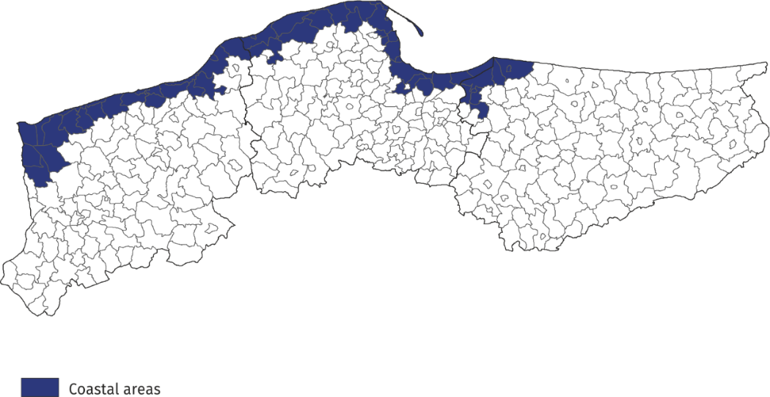
Map 1. Coastal gminas

Tourist accommodation establishments in coastal areas
Accommodation establishments in coastal areas is typically seasonal in nature. As of the end of July 2020, 2,502 tourist accommodation establishments operated in these areas, i.e. almost 1/4 of all establishments in Poland. The vast majority of them (almost 70%) operated on a seasonal basis (the percentage of seasonal establishments in Poland was less than
45% of rooms for guests, more than 40% of complexes of tourist cottages and holiday youth centres, and 1/3 of camping sites and tent camp sites.
Compared to the previous year, the number of accommodation establishments in coastal areas decreased by 198, i.e. by 7.3%, and decreases were recorded for all types of establishments, which was undoubtedly influenced by the COVID 19 pandemic.
The structure of accommodation establishments in coastal areas is fundamentally different from the structure of establishments in total in Poland. rooms for guests prevail - at the end of July this year there were 967 of them and they accounted for 38.6% of all establishments in these areas. There were numerous holiday centres - 492 (19.7%) and complexes of tourist cottages - 231 (9.2%). Hotels accounted for 9.0% of tourist accommodation establishments in coastal areas (24.3% in Poland) and there were 225 of such establishments there.
Chart 1. Tourist accommodation establishments in coastal areas in 2020 – as of 31 July
At the end of July 2020, tourist accommodation establishments located in coastal gminas had 218.5 thousand bed places, which accounted for 28.2% of the total number of bed places in accommodation establishments in Poland, and it was 7.3 thousand less than a year ago (3.2%). However, not all types of accommodation establishments recorded a decrease in the number of bed places – their number increased, among other things, in tent camp sites (by 6.7%), complexes of tourist cottages (by 6.2%), hotels (by 0.7%) and holiday centres (by 0.5%), compared to the same period last year.

Chart 2. Bed places in coastal areas in 2020 – as of 31 July
The largest number of bed places was offered by holiday centres - 73.8 thousand, i.e. 33.8% of the total number of bed places in the area. Hotels had 35.3 thousand (i.e. 16.2%) places prepared for tourists, while rooms for guest had 24.8 thousand (11.4%). Among other types of establishments, 14.5 thousand bed places were available for tourists in complexes of tourist cottages, and 12.7 thousand in camping sites.
Establishments in coastal areas are larger than the average in Poland. One establishment functioning in coastal areas had an average of 87 places (75 places in the country).
In 2020, the density index of the accommodation establishments in coastal areas was 28 places per 1 square kilometre of area (in the country - less than 3).

Tourists accommodated in tourist accommodation establishments
Tourists accommodated in establishments in coastal areas during the holiday period constituted 25.9% of all tourists accommodated in the whole country during that period
The effect of the COVID-19 pandemic is that in 2020, starting from March, the tourist traffic is much smaller compared to previous years. At the same time, during the holiday season of this year (July and August), the coastal areas were more popular than the year before. The establishments located in gminas of coastal areas were visited by 1.5 million tourists in that period, i.e. 25.9% of persons accommodated at tourist establishments throughout the country, while in the same period of 2019 this percentage was 21.3%. More tourists were accommodated in August this year - 833.4 thousand and it was 19.3% more than in July this year (698.5 thousand). Compared to the same period of 2019, the number of tourists accommodated in July and August was 256 thousand (14.3%) lower - 21.5% lower in July and 7.1% lower in August.
Nearly 1/3 of tourists (471.3 thousand) staying in these areas were accommodated in hotels. A large number of tourists chose to stay in holiday centres - 367.5 thousand (24.0%), and in rooms for guest - 156.1 thousand (10.2%).
Among the total number of tourists accommodated in tourist accommodation establishments 87.0% (1.3 million) were domestic tourists, and 13.0% (0.2 million) were foreign tourists. In relation to the same period of 2019, the number of domestic tourists was lower by 7.4%, while the number of foreign tourists decreased by 42.9%.
Chart 3. Tourists accommodated in coastal areas in July-August

In July and August 2020, as in previous years, the majority of foreign tourists accommodated in coastal areas were from Germany. During this period, 159.0 thousand of them arrived, but their share in the total number of foreign tourists was much higher than the year before and amounted to 79.9% - in the same period of 2019 they accounted for 58.7% of the total number of foreign tourists. The share of guests from other countries did not exceed 3%; most of them were Czechs (5.5 thousand), British (4.4 thousand) and Swedes (3.9 thousand), who constituted, respectively, 2.8%, 2.2% and 2.0% of the total number of foreign tourists accommodated in coastal areas.
Overnight stays provided at tourist accommodation establishments
Overnight stays provided in July and August in coastal areas accounted for 36.9% of all overnight stays in Poland during this period
A total of 7.3 million overnight stays were provided for tourists staying in coastal areas in July and August this year, which accounted for 36.9% of all overnight stays provided at tourist accommodation establishments in Poland during that period. In the same period last year, the share was 3.2 percentage points lower.
This year significantly more overnight stays were provided to tourists in August - 4.0 million, i.e. 18.4% more than in July (3.3 million). Compared to the same period in 2019, the total number of overnight stays provided in July and August this year was 18.9% lower (i.e. 1.7 million) - 27.0% lower in July (1.2 million), and 10.4% lower in August (0.5 million).
On average, 5 overnight stays were provided for tourists during their holiday trips, while the average length of a tourist stay in Poland during that period was just over 3 nights.
In the period July-August 2020, 6.5 million overnight stays were provided for domestic tourists (15.2% less than in July and August last year) and they accounted for 88.6% of the total number of overnight stays in coastal areas and 35.9% of the total number of overnight stays provided for domestic tourists in the same period in Poland. A total of 831.6 thousand overnight stays were provided for foreign tourists, which was 39.2% less than in the previous year. Most overnight stays were provided to tourists from countries neighbouring Poland, i.e. Germany (698.8 thousand - 84.0% of overnight stays of foreign tourists), Czechia (20.7 thousand - 2.5%) and Ukraine (18.5 thousand - 2.2%).
Chart 4. Overnight stays provided tourist accommodation establishments in coastal areas in July-August
Occupancy rate of bed places in tourist accommodation establishments
The occupancy rate of bed places in coastal gminas was higher than the national average and amounted to 49.6% in July and 58.5% in August
During the holiday season (July, August), places in tourist accommodation establishments located in coastal gminas are usually better occupied than in other areas of the country. In addition, in recent years the degree of occupation of accommodation establishments, both for the country and in coastal areas, was higher in July than in August. This year, however, during the holidays, the places in tourist accommodation establishments were better occupied in August than in July. In coastal gminas, the occupancy rate of bed places in August this year was 58.5%, and in July 49.6%, while the average for the whole country was 44.5% and 38.3% respectively. In the corresponding months of 2019, the ratio was higher - in July in coastal gminas it was 65.3%, in the country 51.8%, and in August 64.1% and 53.2% respectively.
Between 400 thousand and 600 thousand overnight stays were provided in 4 gminas: Mielno - 573.5 thousand, Rewal - 549.6 thousand, Władysławowo - 489.0 thousand and Świnoujście - 465.4 thousand. Around 300 thousand overnight stays were recorded in tourist accommodation establishments in the following gminas: Łeba, Dziwnów, Ustronie Morskie.

Chart 4. Tourism in coastal areas in comparison with the country in July-August 2020

Occupancy of tourist accommodation establishments in gminas located in coastal areas in July and August 2020
In the period July-August, the largest number of overnight stays in coastal gminas was provided in Kołobrzeg
In coastal areas, in July and August, the largest number of overnight stays was provided in establishments located in Kołobrzeg - 729.9 thousand, which accounted for 1/10 of all overnight stays provided in the area. Over 128 thousand tourists were accommodated in them. This means that during the 2 months of the summer holidays there were 278 tourists and 1579 overnight stays per 100 inhabitants of the city.
Large tourist traffic was also recorded in Gdansk, where over 645 thousand overnight stays were provided for 221 thousand tourists between July and August. There were 47 tourists and 137 overnight stays per 100 inhabitants of the city.

Table 1. Tourist accommodation establishments and its occupancy in the period July-August in 2019 and 2020
Specification | Tourist accommodation establishments | Bed places |  | Tourists |  | Overnight stays provided
Specification | as of 31 July |  | per 1 sq km of area | total | of which foreign tourists | total | of which for foreign tourists
 | 2019
Poland | 11 251 | 825 522 | 2.6 | 8 379 110 | 1 761 028 | 26 654 373 | 4 471 309
Coastal area | 2 700 | 225 779 | 28.5 | 1 787 683 | 348 418 | 8 988 377 | 1 367 546
Other area | 8 551 | 599 743 | 2.0 | 6 591 427 | 1 412 610 | 17 665 996 | 3 103 763
 | 2020
Poland | 10 291 | 775 282 | 2.5 | 5 919 976 | 598 953 | 19 768 413 | 1 780 307
Coastal area | 2 502 | 218 470 | 28.1 | 1 531 901 | 198 946 | 7 292 701 | 831 593
Other area | 7 789 | 556 812 | 1.8 | 4 388 075 | 400 007 | 12 475 712 | 948 714

In total, 60% of tourist traffic from coastal areas was concentrated in these 9 gminas, both in terms of the number of tourists accommodated and the number of overnight stays.

Table 2. Occupancy of tourist accommodation establishments in selected coastal gminas in July and August 2020
Gmina | Overnight stays provided |  |  | Tourists accommodated
Gmina | in thousand | July-August 2019=100 | in percentages | in thousand | July-August 2019=100
Coastal area – | 7 292.7 | 81.1 | 100.0 | 1 531.9 | 85.7
Kołobrzeg  (urban gmina) | 729.9 | 81.0 | 10.0 | 128.1 | 87.4
Gdańsk | 645.1 | 81.1 | 8.8 | 220.7 | 77.5
Mielno | 573.5 | 84.6 | 7.9 | 98.7 | 92.1
Rewal | 549.6 | 80.6 | 7.5 | 97.1 | 87.4
Władysławowo | 489.0 | 78.8 | 6.7 | 98.0 | 83.0
Świnoujście | 465.4 | 86.4 | 6.4 | 117.2 | 99.5
Łeba | 311.9 | 76.4 | 4.3 | 60.2 | 83.2
Dziwnów | 294.9 | 71.6 | 4.0 | 50.4 | 77.7
Ustronie Morskie | 291.8 | 93.1 | 4.0 | 52.1 | 97.9
Międzyzdroje | 262.5 | 88.7 | 3.6 | 56.3 | 90.0

When quoting Statistics Poland data, please provide information: “Source of data: Statistics Poland”, and when publishing calculations made on data published by Statistics Poland, please provide information: “Own study based on Statistics Poland data”

Prepared by:  Statistical Office in Rzeszów  Director Marek Cierpiał-Wolan  Office: tel. (+48 17) 853 52 10 | Issued by:  The Spokeperson for the President  of Statistics Poland  Karolina Banaszek  Mobile: (+48) 695 255 011

Press Office  Office: tel. (+48 22) 608 34 91, 608 38 04  e-mail: obslugaprasowa@stat.gov.pl |  | www.stat.gov.pl/en/
 |  | @StatPoland
 |  | @GlownyUrzadStatystyczny

Related information
Occupancy of tourist accommodation establishments in Poland in July and August 2020
Occupancy of tourist accommodation establishments in Poland in June and July 2020
Occupancy of tourist accommodation establishments in Poland in May and June 2020
Occupancy of tourist accommodation establishments in Poland in April and May 2020
Occupancy of tourist accommodation establishments in the first quarter of 2020
Occupancy of tourist accommodation establishments in Poland in March and April 2020
Tourism in Poland in the face of COVID-19 pandemic
Tourism in 2019

Data available in databases
Local Data Bank

Terms used in official statistics
Tourist
Tourist accommodation establishment
Bed places in tourist accommodation establishments
Nights spent (overnight stays) in tourist accommodation establishments.
Duration of the stay
Occupancy rate of bed places or rooms

According to the Eurostat methodology, coastal areas are classified on the basis of the distance of a given gmina from the sea: if a gmina borders on the sea, it is, as a rule, a coastal gmina; if a gmina does not border on the sea but 50% of its area is within 10 km from the sea, it is also considered a coastal gmina. In Poland, in agreement with Eurostat, the following gminas: Słupsk (rural gmina), Główczyce, Gniewino, Pruszcz Gdański (rural gmina), Cedry Wielkie, Koszalin (urban gmina) and Sianów (urban-rural gmina), are additionally considered to be coastal gminas. The list of coastal gminas is included in Annex 4 of the Methodological report "Tourist accommodation statistics" available on the website https://stat.gov.pl/obszary-tematyczne/kultura-turystyka-sport/turystyka/zeszyt-metodologiczny-statystyka-turystycznej-bazy-noclegowej,15,1.html

