Occupancy of tourist accommodation establishments in 2019
(data concern tourist accommodation establishments with 10 or more bed places)
In 2019, 35.7 million tourists were accommodated in tourist accommodation establishments, with 93.3 million nights spent. Compared to 2018, it was more by 5.2% and 5.0%, respectively. The occupancy rate of bed places in all tourist accommodation establishments in 2019 ammounted to 40.6% and was higher by 0.5 percentage point compared to the previous year.
 93.3mln
nights spent in tourists accommodation establishments

5.2%
Increase in the number of tourists accommodated compared to 2018

Tourist accommodation establishments
As of 31 July 2019, 11,251 tourist accommodation establishments were operating in Poland, of which 4,229 hotels and similar establishments and 7,022 other accommodation establishments.
In July 2019, in Poland there were 11.3 thousand tourist accommodation establishments
Among hotels and similar establishments, the most numerous group, as in previous years, were hotels – 2,635 (43 more than in 2018) and other hotel establishments, which include hotels, motels, boarding houses, which were not given any category, and facilities providing hotel services– including guest houses and inns. At the end of July 2019 there were 1,064 such establishments, i.e. by 0.7% more than in 2018.
In the group of other accommodation establishments, rooms for guests and private lodgings were the most numerous – 2,418 establishments (i.e. by 5.5% more than a year earlier) and holiday centres – 1,095 establishments - which in 2019 recorded a slight decrease compared to the previous year (by 1.3%).
Map 1. Tourist accommodation establishments density rate by voivodship in 2019
As of 31 July
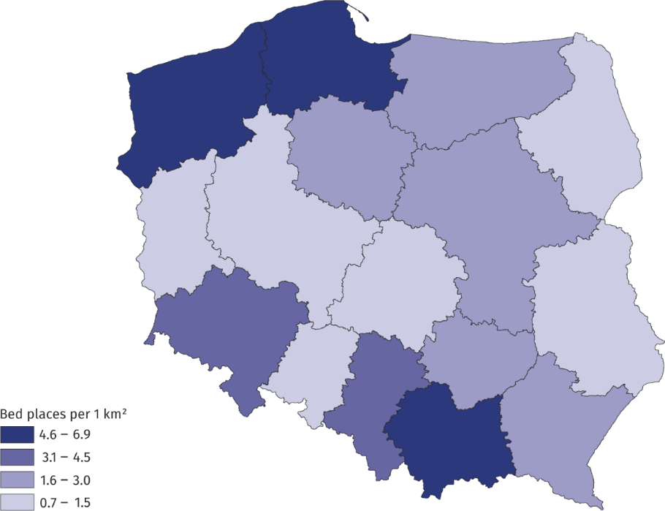
In 2019, tourist accommodation establishments offered 825.5 thousand bed places, of which 70% were available to tourists all year round. In relation to the previous year, the number of bed places increased by 26.8 thousand (i.e. by 3.4%). Tourist accommodation establishments density rate measured by the number of bed places per 1 km² of area was similar to that of the previous year and amounted to 2.6.
On average, one tourist accommodation establishment had 73 bed places (72 a year before). As in 2018, the largest number of bed places was offered by hotels (286.2 thousand) and holiday centres (125.3 thousand).
The largest resources of tourist accommodation establishments are located in Zachodniopomorskie, Pomorskie and Małopolskie Voivodships, which in 2019 offered 145.4, 119.5 and 104.9 thousand bed places for tourists respectively, with the vast majority (over 90%) of bed places in Małopolskie Voivodship being all-year-round bed places, and seasonal bed places prevailing in two others voivodships.

Tourists in tourist accommodation establishments
In 2019, 2/3 of total tourists accommodated stayed in hotels

In 2019, 35.7 million tourists stayed in tourist accommodation establishments, which was 1.8 million more (5.2%) than in the previous year.
Over 27 million tourists were accommodated in hotels and similar establishments, including the most (23.5 million) staying in hotels (22.1 million a year before). In other tourist accommodation establishments 8.4 million tourists were accommodated, with the most people using typically holiday establishments, such as holiday centres - almost 2 million tourists. Training-recreational centres as well as rooms for guests were also very popular. In each of these types of accommodation over 1 million tourists stayed overnight. In health establishments almost 900 thousand people were accommodated in 2019.
The largest number of tourists stayed in tourist accommodation establishments located in Małopolskie and Mazowieckie (over 5.5 million in each) as well as in Dolnośląskie (almost 4 million) Voivodships. Compared to 2018, an increase in the number of tourists was recorded in all voivodships; the number of tourists increased the most in Dolnośląskie, Małopolskie and Podlaskie Voivodships (about 8% in each).
Among persons staying in tourist accommodation establishments in 2019, foreign tourists accounted for 21%, as in the year before, and there were 7.5 million of them. The largest number of foreign tourists stayed in Małopolskie and Mazowieckie Voivodships (over 1.5 million in each), constituting almost 1/3 of the total number of tourists visiting these voivodships. In the total number of foreign tourists using the accommodation establishments the most numerous groups included tourists from Germany (1.9 million), United Kingdom (605 thousand), Ukraine (556 thousand) and the United States (374 thousand). Among the remaining countries, the largest number of tourists came from Russia (290 thousand), Italy (264 thousand), Israel (256 thousand) and France (232 thousand).
In Poland, most tourists (almost 1/4) use tourist accommodation establishments in the summer months, with the highest seasonality of tourist traffic observed in the coastal voivodships
(Pomorskie and Zachodniopomorskie) - the number of tourists accommodated in these voivodships in the so-called high season (July, August) is almost 4 times higher than in the months with the lowest rate of occupancy.
Chart 1. Tourists in tourist accommodation establishments by month in 2019
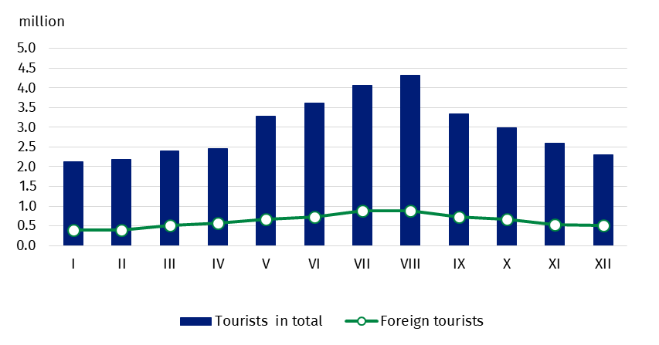
Map 2. Tourist traffic intensity rate by voivodship in 2019
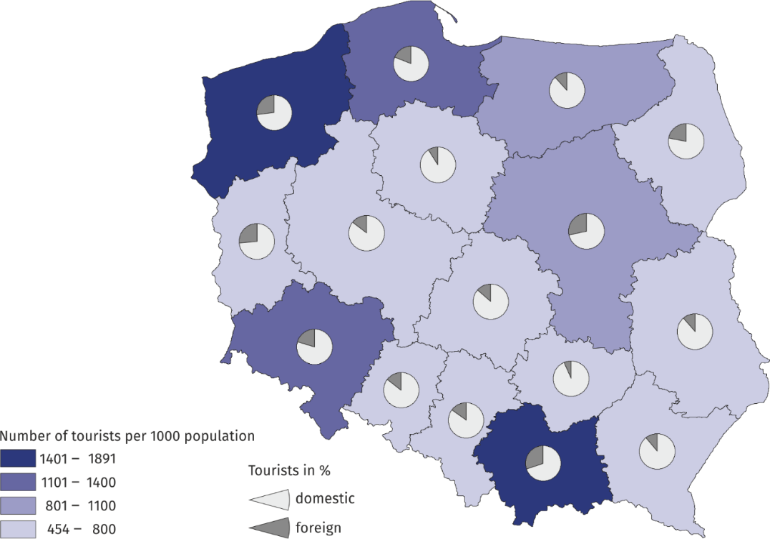

Nights spent
In 2019, tourist accommodation establishments recorded 93.3 million nights spent (by 5.0% more than in 2018), including those for foreign tourists - 18.7 million (by 5.3% more than in the previous year). Most nights spent were provided to tourists staying in hotels (48%), holiday centres and health establishments (approx. 11% in each).
In 2019, 18.7 million overnight stays were provided to foreign tourists

As in previous years, also in 2019, the largest number of overnight stays was recorded in Zachodniopomorskie (16.1 million) and Małopolskie (14.9 million) Voivodships. Nights spent in these two voivodships constituted 1/3 of the total nights spent in Poland.
Nights spent in the summer season (July and August) 2019 accounted for 28.6% of all nights spent in 2019 and it was by 0.9 percentage point less than last year.
Nights spent by foreign tourists in 2019 in tourist accommodation establishments constituted, as in the year before, 20.0% of the total number of nights spent.
Foreign tourists most often chose hotels as their accommodation, where they spent 13.2 million overnight stays (5.0% more than in 2018).
An average duration of stay of tourists in tourist accommodation establishments in 2019 was similar for domestic and foreign tourists. On average, domestic tourists spent 2.6 nights and foreign ones 2.5. In 2019, tourists stayed the longest in Zachodniopomorskie Voivodship (5 nights) and the shortest in Mazowieckie and Wielkopolskie Voivodships (less than 2 nights).
Chart 2. Nights spent in tourist accommodation establishments by month in 2019
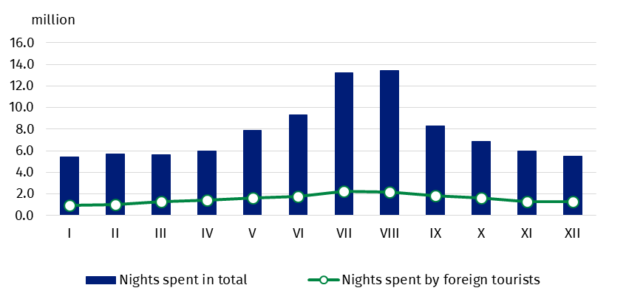
Table 1. Occupancy of tourist accommodation establishments by type of accommodation in 2019
Type of establishment | Tourists accommodated |  | Nights spent |  | Occupancy rate of bed places (in %)
Type of establishment | total | of which  foreign  tourists | total | of which by foreign  tourists | Occupancy rate of bed places (in %)
Type of establishment | in thousand |  |  |  | Occupancy rate of bed places (in %)
TOTAL | 35 668.1 | 7 470.5 | 93 342.7 | 18 683.6 | 40.6
Hotels and similar  establishments | 27 222.9 | 6 582.5 | 53 717.1 | 15 089.7 | 41.7
hotels | 23 511.6 | 6 014.1 | 44 848.2 | 13 203.2 | 44.1
motels | 225.3 | 31.9 | 357.2 | 39.7 | 25.4
boarding houses | 6 41.0 | 59.0 | 1 711.3 | 156.6 | 30.9
other hotel  establishments | 2 845.0 | 477.6 | 6 800.5 | 1 690.1 | 33.5
Other establishments | 8 445.2 | 888.1 | 39 625.6 | 3 593.9 | 39.1
excursion hostels | 95.6 | 5.2 | 283.5 | 20.4 | 29.1
shelters | 193.6 | 5.4 | 296.3 | 7.4 | 29.4
youth hostels | 81.1 | 13.5 | 194.2 | 45.1 | 31.0
school youth hostels | 310.8 | 34.8 | 851.5 | 136.8 | 19.3
holiday centres | 1 898.2 | 105.5 | 10 336.2 | 601.5 | 41.1
holiday youth centres | 140.0 | 0.8 | 879.9 | 8.6 | 49.3
training-recreational centres | 1 095.5 | 36.7 | 3 847.1 | 164.5 | 32.5
creative arts centres | 42.3 | 2.1 | 141.3 | 7.6 | 26.8
complexes of tourist cottages | 388.3 | 19.9 | 1 488.1 | 75.3 | 30.3
camping sites | 313.0 | 115.0 | 955.1 | 305.0 | 27.3
tent camp sites | 102.7 | 14.0 | 325.5 | 37.8 | 17.3
hostels | 804.7 | 266.5 | 1 795.4 | 675.4 | 46.9
health establishments | 874.3 | 49.1 | 11 102.4 | 425.1 | 79.6
rooms for guests | 1 012.6 | 103.1 | 3 537.3 | 390.8 | 26.8
agrotourism lodgings | 156.6 | 8.7 | 571.0 | 48.3 | 15.7
other not classified | 935.9 | 107.7 | 3 020.9 | 644.5 | 30.0

Map 3. Nights spent per 100 population and average duration of stay by voivodship in 2019

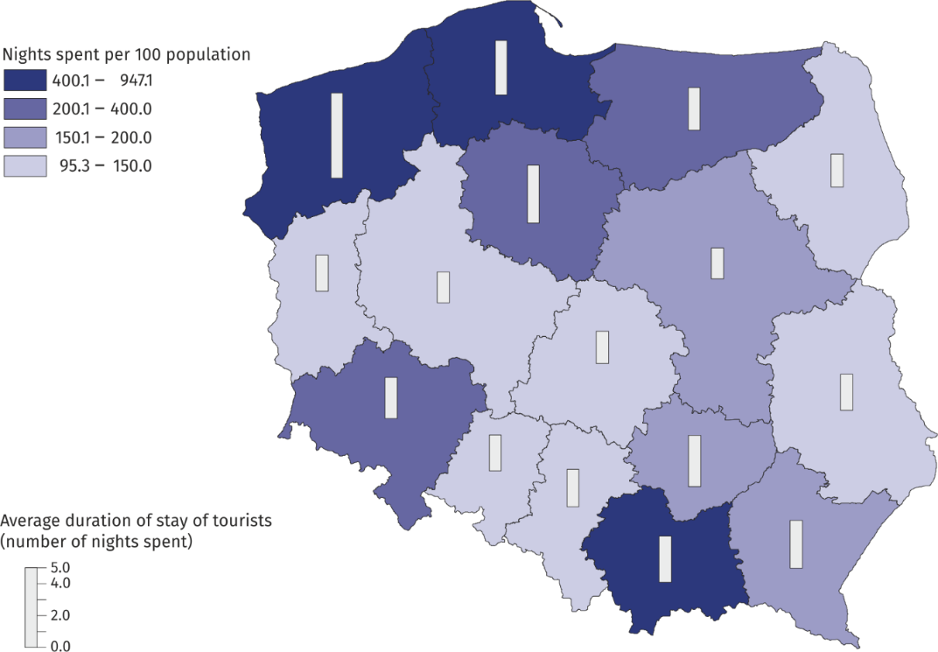

Table 2. Occupancy of tourist accommodation establishments by voivodship in 2019
In 2019, the most overnight stays were provided in: Zachodniopomorskie
(16.1 million) and Małopolskie (14.9 million) Voivodships

VOIVODSHIPS | Tourists accommodated |  |  |  | Nights spent |  |  | Occupancy rate of bed places (in %)
VOIVODSHIPS | total |  | of which  foreign  tourists |  | total |  | of which by foreign  tourists | Occupancy rate of bed places (in %)
VOIVODSHIPS | in thousand |  |  |  |  |  |  | Occupancy rate of bed places (in %)
POLSKA | 35 668.1 | 7 470.5 |  | 93 342.7 |  | 18 683.6 |  | 40.6
Dolnośląskie | 3 932.3 | 796.1 |  | 9 617.9 |  | 1 640.5 |  | 39.4
Kujawsko-Pomorskie | 1 358.7 | 121.3 |  | 4 570.1 |  | 306.0 |  | 45.7
Lubelskie | 1 146.1 | 129.9 |  | 2 381.0 |  | 220.6 |  | 31.8
Lubuskie | 720.8 | 190.3 |  | 1 480.0 |  | 322.6 |  | 29.7
Łódzkie | 1 423.6 | 192.9 |  | 2 726.7 |  | 508.0 |  | 35.1
Małopolskie | 5 597.5 | 1 684.2 |  | 14 855.5 |  | 4 105.1 |  | 43.0
Mazowieckie | 5 536.2 | 1570.6 |  | 9 709.9 |  | 3 133.0 |  | 44.0
Opolskie | 447.0 | 65.2 |  | 938.2 |  | 128.5 |  | 32.5
Podkarpackie | 1 297.0 | 144.1 |  | 3 602.1 |  | 279.1 |  | 34.8
Podlaskie | 688.5 | 151.8 |  | 1 315.5 |  | 207.1 |  | 30.6
Pomorskie | 3 238.7 | 615.7 |  | 10 333.3 |  | 1 659.8 |  | 43.1
Śląskie | 2 903.2 | 430.7 |  | 6 520.3 |  | 966.1 |  | 38.0
Świętokrzyskie | 656.3 | 43.1 |  | 1 940.1 |  | 121.2 |  | 33.7
Warmińsko-Mazurskie | 1 377.5 | 164.7 |  | 3 379.5 |  | 395.4 |  | 31.8
Wielkopolskie | 2 133.2 | 307.0 |  | 3 887.8 |  | 651.2 |  | 31.0
Zachodniopomorskie | 3 211.5 | 862.9 |  | 16 084.7 |  | 4 039.7 |  | 51.5

Occupancy rate of bed places
The highest occupancy rate of bed places was recorded in health establishments – 79.6%
In 2019, the total occupancy rate of bed places in tourist accommodation establishments amounted to 40.6% (in 2018 - 40.1%). The highest rate was recorded in the summer months: in July - 51.8%, in August - 53.2%. As in the previous year, the most occupied bed places were recorded in health establishments (79.6%), holiday youth centres (49.3%), hostels (46.9%) and hotels (44.1%). Among the voivodships, the highest values of the rate were observed in the following voivodships: Zachodniopomorskie (51.5%), Kujawsko-Pomorskie (45.7%) and Mazowieckie (44.0%), while the lowest use of bed places was recorded in Lubuskie and Podlaskie Voivodships (about 30%).

Chart 3. Occupancy rate of bed places by month in 2019
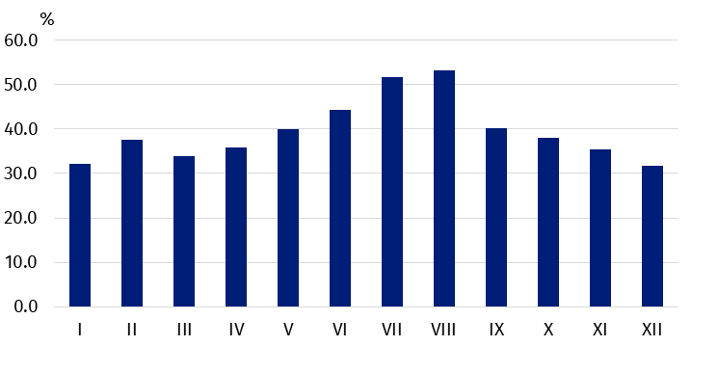

Prepared by:  Statistical Office in Rzeszów  Director Marek Cierpiał-Wolan  Office: tel. (+48 17) 853 52 10 | Issued by:  The Spokesperson for the President  of Statistics Poland  Karolina Banaszek  Mobile: (+48) 695 255 011

Press Office  Office: tel. (+48 22) 608 34 91, 608 38 04  e-mail: obslugaprasowa@stat.gov.pl |  | www.stat.gov.pl/en/
 |  | @StatPoland
 |  | @GlownyUrzadStatystyczny

Related information
Tourism in 2018
Data available in databases
Local Data Bank

Terms used in official statistics
Tourist
Tourist accommodation establishment
Bed places in tourist accommodation establishments
Nights spent (overnight stays) in tourist accommodation establishments.
Duration of stay
Occupancy rate of bed places or rooms

Hotels, motels, boarding houses and other hotel establishments.
Excursion hostels, shelters, youth hostels, school youth hostels, holiday centres, holiday youth centres, training-recreational centres, creative arts centres, complexes of tourist cottages, camping sites, tent camp sites, hostels, health establishments, rooms for guests (private lodgings), agrotourism lodgings, other not classified.
Hotel services include daily bed, room and sanitary cleaning, among other things.

