Residential construction in the period I-XI of 2018

In the period of eleven months of 2018 there were more dwellings completed than the year before. The number of dwellings for which permits have been granted or which have been registered with a construction project and the number of dwellings in which construction has begun also increased.
100,5
Lorem ipsum dolor sit amet, consectetur adipiscing elit
102.5
Index number of dwellings completed
Number of dwellings completed increased by 2.5% y/y in the period I-XI 2018
According to preliminary data, in the period January-November of 2018, 163.8 thous. dwellings were completed, i.e. by 2.5% more than the year before. Investors of two main forms of construction on the housing market, i.e. developers and private investors completed respectively 98.2 thous. dwellings (by 4.4% more than in the corresponding period of the previous year) and 60.0 thous. dwellings (i.e. by 1.2% less). The share of these forms of construction amounted to 96.5% of the total number of dwellings completed in the period of eleven months of 2018 (of which developers built 59.9% and private investors 36.6% of dwellings). More dwellings, in comparison with January-November of 2017, were completed in the cooperative construction (2.5 thous. dwellings against 2.0 thous.). In other forms of construction (the public building society, the municipal and the company construction) altogether 3.2 thous. dwellings were completed, i.e. by 3.2% more than the year before.
Average useful floor area of
a dwelling in the period
I-XI 2018 was 91.0 sq m
Total useful floor area of dwellings completed in the period of eleven months amounted to 14.9 m. sq m, i.e. by 0.6% more than in the corresponding period of previous year. During that time the average useful floor area of 1 dwelling decreased by 1.8 sq m to the level of 91.0 sq m.
Number of dwellings for which permits have been granted or which have been registered with a construction project increased by 2.9% y/y in the period I-XI 2018
In the period of eleven months of 2018 permits and registrations with a construction project have been granted for construction of 237.7 thous. dwellings, i.e. by 2.9% more than in the corresponding period of previous year. Permits for construction of the biggest number of dwellings were given to investors in the form of construction for sale or rent (146.9 thous.) and to private investors (85.8 thous.). Altogether the share for these forms of construction amounted to 97.9% of the total number of dwellings (of which developers 61.8% and private investors 36.1%). More dwellings for which permits have been granted or which have been registered with a construction project were noticed in the cooperative construction (1.5 thous. dwellings against 1.4 thous.) while for other forms of construction less than the year before (3.5 thous. dwellings against 4,8 thous.).
Number of dwellings in which construction has begun increased by 8.8% y/y in the period I-XI 2018
In January-November of 2018 the number of dwellings in which construction has begun was 210.8 thous., i.e. by 8.8% more than in the corresponding period of previous year. Developers have started construction of 123.7 thous. dwellings, private investors 82.4 thous. dwellings,
i.e. altogether 97.8% of total number of dwellings (of which developers 58.7% and private investors 39.1%). Less dwellings in which construction has begun (in the corresponding period of previous year) were noticed in the cooperative construction (2.2 thous. dwellings against
2.5 thous.) and in other forms of construction (2.6 thous. dwellings against 3.2 thous.).

Chart 1. Construction activity in the scope of construction of dwellings
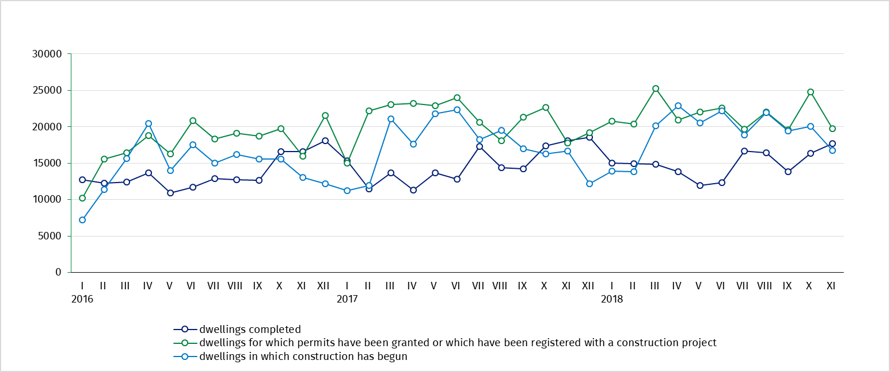

Table 1. Residential construction results

Forms of construction | 2018
Forms of construction | XI |  |  | I-XI
Forms of construction | Number of dwellings | XI  2017=100 | X  2018=100 | Number of dwellings | I-XI  2017=100
Dwellings completed
Total | 17 668 | 97.5 | 108.1 | 163 845 | 102.5
Private | 5 716 | 93.9 | 95.2 | 59 952 | 98.8
For sale or rent | 10 932 | 95.2 | 115.5 | 98 185 | 104.4
Cooperatives | 350 | more than  2-fold | 81.0 | 2 540 | 128.2
Others | 670 | 155.1 | 151.6 | 3 168 | 103.2
Dwellings for which permits have been granted or which have been registered
with a construction project
Total | 19 748 | 111.1 | 79.7 | 237 747 | 102.9
Private | 6 469 | x | 79.2 | 85 836 | x^{c}
For sale or rent | 13 101 | x^{c} | 80.7 | 146 870 | x^{c}
Cooperatives | 35 | 16.7 | 31.0 | 1 496 | 104.9
Others^{b} | 143 | 27.6 | 55.0 | 3 545 | 73.3
Dwellings in which construction has begun
Total | 16 792 | 100.7 | 83.7 | 210 816 | 108.8
Private | 5 383 | x^{c} | 71.7 | 82 357 | x^{c}
For sale or rent | 11 093 | x^{c} | 90.8 | 123 654 | x^{c}
Cooperatives | 236 | 120.4 | 357.6 | 2 242 | 89.3
Others^{b} | 80 | 16.5 | 29.2 | 2 563 | 81.0

Prepared by:  Statistical Office in Lublin  Zofia Kurlej  Tel: 81 533 2301  e-mail: Z.Kurlej@stat.gov.pl | Dissemination:  The Spokeperson for the President  of the Statistic Poland  Karolina Dawidziuk  Tel: 22 608 3475, 22 608 3009  e-mail: rzecznik@stat.gov.pl

Press Office  tel.: +48 22 608 34 91, +48 22 608 38 04  faks: +48 22 608 38 86  e-mail: obslugaprasowa@stat.gov.pl |  | www.stat.gov.pl
 |  | @GUS_STAT
 |  | @GlownyUrzadStatystyczny

Related information
Statistical Bulletin No 10/2018

Socio-economic situation of the country in October 2018
Construction results in 2017
Housing construction I-III quarter 2018
Data available in databases
Knowledge Databases Construction
Local Data Bank
Terms used in official statistics
Dwellings for which permits have been granted
Dwellings in which construction has begun
Dwellings completed

Reported data – subject to change upon developing quarterly reports
The public building society, municipal and company construction
Since January 2018 data regarding the effects of „the private construction” concern only dwellings realized for the investor’s own needs; dwellings for sale or rent provided by individual investors (included into this form of construction so far) have been included into the form of construction “for sale or rent”, therefore, indices in relation to the corresponding period of the previous year will be presented starting from January 2019.

