Residential construction ^{a)} in the period I-X of 2018
Residential construction
In the period of first ten months of 2018 there were more dwellings completed than the year before. The number of dwellings for which permits have been granted or which have been registered with a construction project and the number of dwellings in which construction has begun also increased.
100,5
Lorem ipsum dolor sit amet, consectetur adipiscing elit
103.1
Index number of dwellings completed
Number of dwellings completed increased by 3.1% y/y in the period I-X 2018
According to preliminary data, in the period January-October of 2018, 146.0 thous. dwellings were completed, i.e. by 3.1% more than the year before. Investors of two main forms of construction on the housing market, i.e. developers and private investors completed respectively 86.9 thous. dwellings and 54.6 thous. dwellings, i.e. by 5.2% and 0.1% more than in the corresponding period of the previous year. The share of these forms of construction amounted to 96.9% of the total number of dwellings completed in the period of ten months of 2018 (of which developers 59.5% and private investors 37.4%). More dwellings, in comparison with January-October of 2017, were also completed in the cooperative construction (2.1 thous. dwellings against 1.9 thous.) whereas less dwellings in other forms of construction (the public building society, the municipal and the company construction)
2.4 thous. dwellings, i.e. by 7.1% less than the year before.
Total useful floor area of dwellings completed in the period of first ten months amounted to 13.4 m. sq m, i.e. by 1.3% more than in the corresponding period of previous year. During that time the average floor area of 1 dwelling decreased by 1.5 sq m to the level of 91.8 sq m.
Average floor area of
a dwelling in the period of I-X 2018 was 91.8 sq m
In the period of ten months of 2018 permits and registrations with a construction project have been granted for construction of 218.0 thous. dwellings, i.e. by 2.2% more than in the corresponding period of previous year. Permits for construction of the biggest number of dwellings were given to investors in the form of construction for sale or rent (133.8 thous.) and to private investors (79.4 thous.). Altogether the share for these forms of construction amounted to 97.8% of the total number of dwellings in the period I-X of 2018 (of which developers 61.4% and private investors 36.4%). More dwellings for which permits have been granted or which have been registered with a construction project were noticed in the cooperative construction (1.5 thous. dwellings against 1.2 thous.) while for other forms of construction 3.4 thous. dwellings, i.e. by 21.3% less than the year before.
Number of dwellings for which permits have been granted or which have been registered with a construction project increased by 2.2% y/y in the period I-X 2018
In January-October of 2018 the number of dwellings in which construction has begun was
194.0 thous., i.e. by 9.5% more than in the corresponding period of previous year. Developers have started construction of 112.6 thous. dwellings, private investors 77.0 thous. dwellings,
i.e. altogether 97.7% of total number of dwellings (of which developers 58.0% and private investors 39.7%). Less dwellings in which construction has begun (in the corresponding period of previous year) were noticed in the cooperative construction (2.0 thous. dwellings against
2.3 thous.) and in other forms of construction (2.5 thous. dwellings against 2.7 thous.).
Number of dwellings in which construction has begun increased by 9.5% y/y in the period I-X 2018

- Reported data – subject to change upon developing quarterly reports

Chart 1. Construction activity in the scope of construction of dwellings
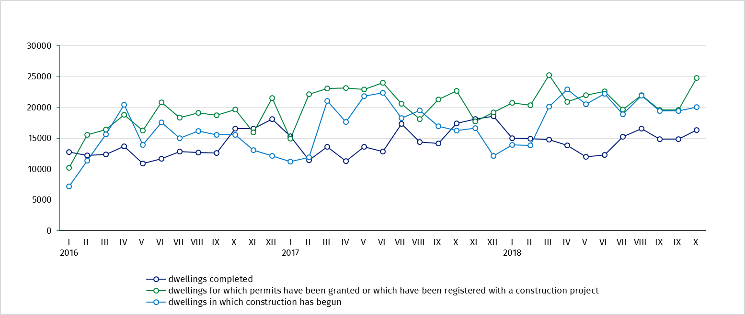

Table 1. Residential construction results ^{b)}
Residential construction
results
Forms of construction | 2018
Forms of construction | X |  |  | I-X
Forms of construction | Number of dwellings | X  2017=100 | IX  2018=100 | Number of dwellings | I-X  2017=100
Dwellings completed
Total | 16 344 | 93.9 | 109.9 | 146 016 | 103.1
Private | 6 006 | 98.9 | 118.0 | 54 625 | 100.1
For sale or rent | 9 464 | 89.9 | 106.0 | 86 887 | 105.2
Cooperatives | 432 | 135.8 | 129.3 | 2 055 | 110.8
Others^{c)} | 442 | 89.8 | 85.0 | 2 449 | 92.9
Dwellings for which permits have been granted or which have been registered
with a construction project
Total | 24 773 | 109.2 | 126.3 | 217 999 | 102.2
Private | 8 172 | x ^{d)} | 107.3 | 79 367 | x ^{d)}
For sale or rent | 16 228 | x ^{d)} | 145.8 | 133 769 | x ^{d)}
Cooperatives | 113 | more than 100- fold | 113.0 | 1 461 | 120.1
Others^{c)} | 260 | 63.9 | 33.9 | 3 402 | 78.7
Dwellings in which construction has begun
Total | 20 063 | 123.3 | 103.1 | 194 024 | 109.5
Private | 7 506 | x ^{d)} | 95.6 | 76 974 | x ^{d)}
For sale or rent | 12 217 | x ^{d)} | 108.8 | 112 561 | x ^{d)}
Cooperatives | 66 | 62.3 | 28.6 | 2 006 | 86.7
Others^{c)} | 274 | 85.6 | 183.9 | 2 483 | 92.6

^{b)} Since January of 2018 data regarding the effects of „the private construction” concern only dwellings realized for the investor’s own needs; dwellings for sale or rent (included into this form of construction so far) have been included into the form of construction “for sale or rent”. ^{c)} The public building society, municipal and company construction. ^{d)} According to the revised scope of forms of construction, indices in relation to the corresponding period of the previous year will be presented from January of 2019.

Prepared by:  Statistical Office in Lublin  Zofia Kurlej  Tel: 81 533 2301  e-mail: Z.Kurlej@stat.gov.pl | Dissemination:  The Spokeperson for the President  of the Statistic Poland  Karolina Dawidziuk  Tel: 22 608 3475, 22 608 3009  e-mail: rzecznik@stat.gov.pl

Press Office  tel.: +48 22 608 34 91, +48 22 608 38 04  faks: +48 22 608 38 86  e-mail: obslugaprasowa@stat.gov.pl |  | www.stat.gov.pl
 |  | @GUS_STAT
 |  | @GlownyUrzadStatystyczny

Related information
Statistical Bulletin No 9/2018

Socio-economic situation of the country - I-III Quarter 2018
Construction results in 2017
Housing construction I-II quarter 2018
Data available in databases
Knowledge Databases Construction
Local Data Bank
Terms used in official statistics
Dwellings for which permits have been granted
Dwellings in which construction has begun
Dwellings completed

