Residential construction ^{a)} in the period I-VIII of 2018
Residential construction
In the period of first eight months of 2018 there were more dwellings completed than the year before. The number of dwellings for which permits have been granted or which have been registered with a construction project and the number of dwellings in which construction has begun also increased.
100,5
Lorem ipsum dolor sit amet, consectetur adipiscing elit
104.3
Index number of dwellings completed
The number of dwellings completed increased by 4.3% y/y in the period I-VIII 2018
According to preliminary data, in the period January-August of 2018, 114802 dwellings were completed, i.e. by 4.3% more than the year before. Among two main forms of constructions on the housing market better results were recorded by developers who completed 68495 dwellings and private investors 43531 dwellings (respectively by 8.1% and 0.2% more than in the corresponding period of the previous year). The share of these forms of construction amounted to 97.6% of the total number of dwellings completed in the period of eight months of 2018 (of which developers 59.7% and private investors 37.9%). Less dwellings, in comparison with January-August of 2017, were completed by the housing cooperatives (1289 dwellings against 1357) and in the public building society construction (651 dwellings against 1093), whereas more dwellings in the municipal construction (751 dwellings against 701) and in the company construction (85 dwellings against 62).
Total useful floor area of dwellings completed in the period of first eight months amounted to 10.6 m. sq m, i.e. by 2.0% more than in the corresponding period of the previous year. During that time the average floor area of 1 dwelling decreased by 2.1 sq m to the level of 92,2 sq m.
The average floor area of
1 dwelling in the period of
I-VIII 2018 was 92.2 sq m
In the period of eight months of 2018 permits and registrations with a construction project have been granted for construction of 173670 dwellings i.e. by 2.7% more than in the corresponding period of the previous year. Permits for construction of the biggest number of dwellings were given to investors in the form of construction for sale or rent (106298) and to private investors (63748). Altogether the share for these forms of construction amounted to 97.9% of the total number of dwellings in the period I-VIII of 2018 (of which developers 61.2% and private investors 36.7%). More dwellings for which permits have been granted or which have been registered with a construction project were noticed in the cooperative construction (1248 dwellings against 1133) while for other forms of construction (the public building society, the municipal and the company construction) 2376 dwellings, i.e. by 25.8% less than the year before.
Number of dwellings for which permits have been granted or which have been registered with a construction project increased by 2.7% y/y in the period I-VIII 2018
In January-August of 2018 the number of dwellings in which construction has begun was 154495, i.e. by 7.4% more than in the corresponding period of the previous year. The developers have started construction of 89113 dwellings, private investors 61613 dwellings, i.e. altogether 97.6% of total number of dwellings (of which developers 57.7% and private investors 39.9%). More dwellings in which construction has begun (in the corresponding period of the previous year) were noticed in the cooperative construction (1709 dwellings against 1641) and for other forms of construction (2060 dwellings against 1759).
The number of dwellings in which construction has begun increased by 7.4% y/y in the period I-VII 2018

- Reported data – subject to change upon developing quarterly reports

Chart 1. Construction activity in the scope of construction of dwellings

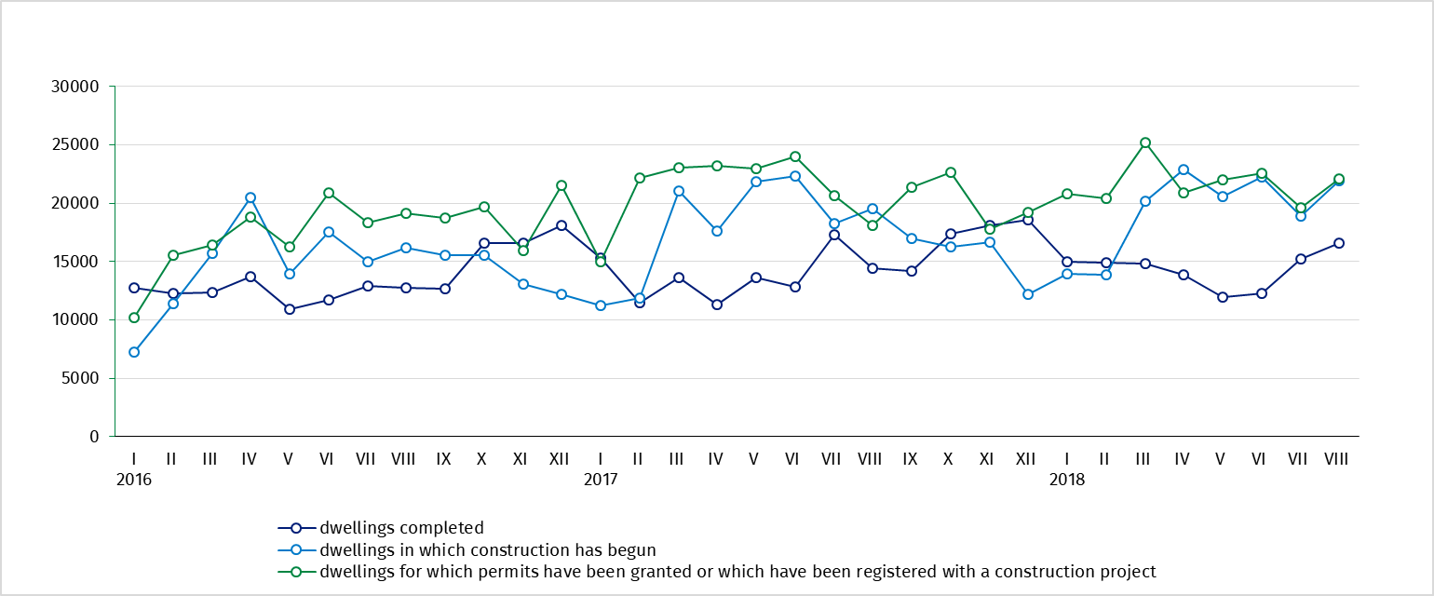

Table 1. Residential construction results ^{b)}
Residential construction
results
Forms of construction | 2018
Forms of construction | VIII |  |  | I-VIII
Forms of construction | Numer of dwellings | VIII  2017=100 | VII  2018=100 | Number of dwellings | I-VIII  2017=100
Dwellings completed
Total | 16593 | 115.2 | 108.8 | 114802 | 104.3
Private | 5307 | 99.7 | 96.2 | 43531 | 100.2
For sale or rent | 10801 | 130.7 | 113.1 | 68495 | 108.1
Cooperative | 208 | 46.7 | more than  2-fold | 1289 | 95.0
Others^{c)} | 277 | 75.5 | more than  2-fold | 1487 | 80.1
Dwellings for which permits have been granted or which have been registered
with a construction project
Total | 22074 | 121.9 | 112.3 | 173670 | 102.7
Private | 8490 | x ^{d)} | 97.0 | 63748 | x ^{d)}
For sale or rent | 13255 | x ^{d)} | 122.9 | 106298 | x ^{d)}
Cooperative | 170 | 180.9 | more than  3-fold | 1248 | 110.2
Others^{c)} | 159 | 41.5 | more than  2-fold | 2376 | 74.2
Dwellings in which construction has begun
Total | 21929 | 112.2 | 116.0 | 154495 | 107.4
Private | 8275 | x ^{d)} | 96.4 | 61613 | x ^{d)}
For sale or rent | 13234 | x ^{d)} | 139.1 | 89113 | x ^{d)}
Cooperative | 126 | 29.3 | 35.2 | 1709 | 104.1
Others^{c)} | 294 | 77.4 | 67.0 | 2060 | 117.1

b) Since January of 2018 data regarding the effects of „the individual construction” concern only dwellings realized for the investor’s own needs; dwellings for sale or rent (included into this form of construction so far) have been included into the form of “construction designated for sale or rent”. c) The company, municipal and public building society construction. d) According to the revised scope of forms of construction, indices in relation to the corresponding period of the previous year will be presented from January of 2019.

Prepared by:  Statistical Office in Lublin  Zofia Kurlej  Tel: 81 533 2301  e-mail: Z.Kurlej@stat.gov.pl | Dissemination:  The Spokeperson for the President  of the Statistic Poland  Karolina Dawidziuk  Tel: 22 608 3475, 22 608 3009  e-mail: rzecznik@stat.gov.pl

Press Office  tel.: +48 22 608 34 91, +48 22 608 38 04  faks: +48 22 608 38 86  e-mail: obslugaprasowa@stat.gov.pl |  | www.stat.gov.pl
 |  | @GUS_STAT
 |  | @GlownyUrzadStatystyczny

Related information
Statistical Bulletin No 7/2018

Socio-economic situation of the country in July 2018
Construction results in 2017
Housing construction I-II quarter 2018
Data available in databases
Knowledge Databases Construction
Local Data Bank
Terms used in official statistics
Dwellings for which permits have been granted
Dwellings in which construction has begun
Dwelling completed

