Residential construction ^{a)} in the period I-VI of 2018
Residential construction
In the period of first six months of 2018 there were more dwellings completed than the year before. The number of dwellings for which permits have been granted or which have been registered with a construction project and the number of dwellings in which construction has begun also increased.
100,5
Lorem ipsum dolor sit amet, consectetur adipiscing elit
106,3
Index number of dwellings completed
The number of dwellings completed increased by 6.3% y/y in the period I-VI 2018
According to preliminary data, in the period January-June of 2018, 83217 dwellings were completed, i.e. by 6.3% more than the year before. Among two main forms of constructions on the housing market better results were recorded by developers who completed 48159 dwellings, i.e. by 8.9% more than in the corresponding period of previous year and private investors – 32955 dwellings, i.e. by 1.1% more. The share of these forms of construction amounted to 97.5% of the total number of dwellings completed in a period of six months of 2018 (of which developers – 57.9% and private investors – 39.6%). More dwellings, in comparison with January-June of 2017, were also completed by the housing cooperatives (1007 dwellings against 802), in the public building society construction 533 dwellings (against 199 dwellings the year before), in the municipal construction 490 dwellings (against 436), in the company construction 73 dwelling (against 20).
In January-June of 2018 permits and registrations with a construction project have been granted for construction of 132285 dwellings i.e. by 1.4% more than in the corresponding period of previous year. Permits for construction of the biggest number of dwellings were given to investors in the form of construction for sale or rent - 82607 dwellings and to private investors - 46503 dwellings. Housing cooperatives were given permits for 1026 dwellings (against 869 dwellings the year before) while other investors (the public building society, the municipal and company construction) - 2149 dwellings, i.e. by 4,1% more than the year before.
Dwellings for which permits have been granted or which have been registered with a construction project increased by 1.4% y/y in the period I-VI 2018
The number of dwellings in which construction has begun increased in the period of six months of 2018 to 113666 dwellings, i.e. by 7.2%. The developers have started construction of 66363 dwellings, private investors - 44751 dwellings, the housing cooperatives - 1225 dwellings (against 1060 dwellings in January-June of 2017) and other investors - 1327 dwellings (against 1249 dwellings the year before).
The number of dwellings in which construction has begun increased by 7.2% y/y in the period I-VI 2018

- Reported data – subject to change upon developing quarterly reports

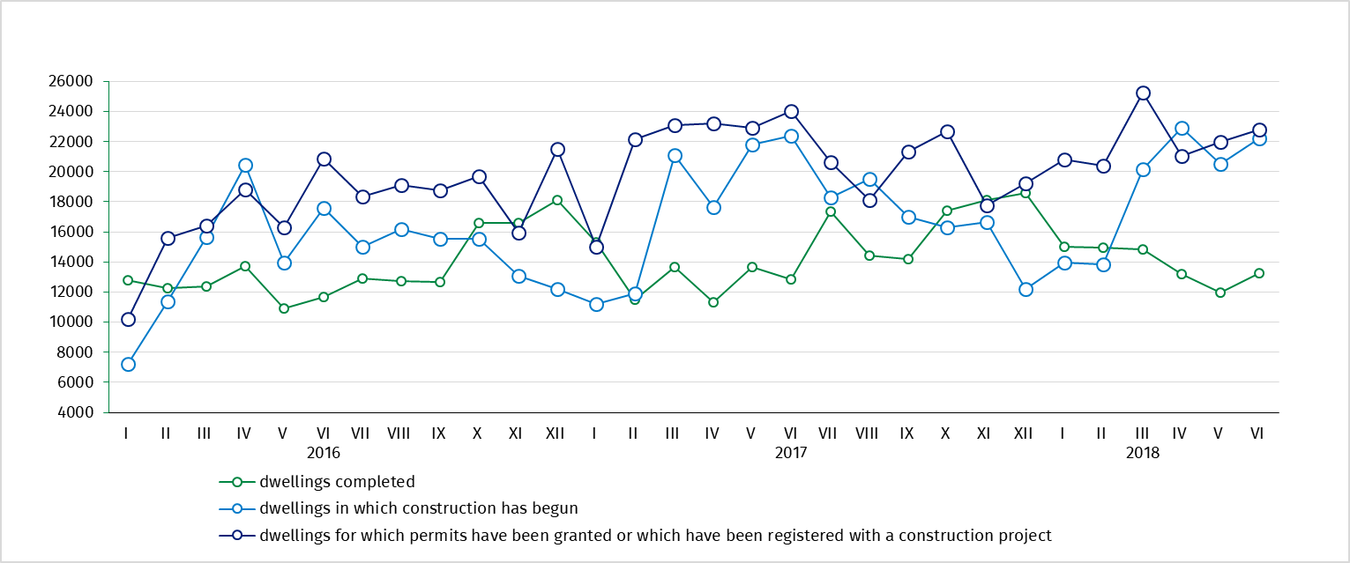
Chart 1. Construction activity in the scope of construction of dwellings

Table 1. Residential construction results ^{b)}
Residential construction
results
Forms of construction | 2018
Forms of construction | VI |  |  | I-VI
Forms of construction | numbers | VI  2017=100 | V  2018=100 | numbers | I-VI  2017=100
Dwellings completed
Total | 13275 | 103,3 | 111,0 | 83217 | 106,3
Private | 5073 | 104,3 | 103,2 | 32955 | 101,1
For sale or rent | 7932 | 101,5 | 117,9 | 48159 | 108,9
Cooperative | 110 | more than  2-fold | 56,7 | 1007 | 125,6
Others^{c)} | 160 | 140,4 | 130,1 | 1096 | 167,3
Dwellings in which construction has begun
Total | 22228 | 99,4 | 108,2 | 113666 | 107,2
Private | 8543 | X ^{d)} | 91,0 | 44751 | X ^{d)}
For sale or rent | 12926 | X ^{d)} | 122,4 | 66363 | X ^{d)}
Cooperative | 284 | more than  2-fold | 104,0 | 1225 | 115,6
Others^{c)} | 475 | 153,7 | 153,7 | 1327 | 106,2
Dwellings for which permits have been granted or which have been registered
with a construction project
Total | 22807 | 94,9 | 103,7 | 132285 | 101,4
Private | 8922 | X ^{d)} | 102,4 | 46503 | X ^{d)}
For sale or rent | 13391 | X ^{d)} | 103,1 | 82607 | X ^{d)}
Cooperative | 377 | more than  3-fold | 163,2 | 1026 | 118,1
Others^{c)} | 117 | 37,7 | 164,8 | 2149 | 104,1

b) Since January of 2018 data regarding the effects of „the individual construction” concern only dwellings realized for the investor’s own needs; dwellings for sale or rent (included into this form of construction so far) have been included into the form of “construction designated for sale or rent” .c) The company, municipal and public building society construction. d) According to the revised scope of forms of construction, indices in relation to the corresponding period of the previous year will be presented from January of 2019.

Prepared by:  Statistical Office in Lublin  Zofia Kurlej  Tel: 81 533 2301  e-mail: Z.Kurlej@stat.gov.pl | Dissemination:  The Spokeperson for the President  of the Statistic Poland  Karolina Dawidziuk  Tel: 22 608 3475, 22 608 3009  e-mail: rzecznik@stat.gov.pl

Press Office  tel.: +48 22 608 34 91, +48 22 608 38 04  faks: +48 22 608 38 86  e-mail: obslugaprasowa@stat.gov.pl |  | www.stat.gov.pl
 |  | @GUS_STAT
 |  | @GlownyUrzadStatystyczny

Related information
Statistical Bulletin No 5/2018
Information on socio-economic situation of the country in May 2018
Construction – Activity results in 2016
Housing construction I quarter 2018
Data available in databases
Knowledge Databases Construction
Local Data Bank
Terms used in official statistics
Dwellings for which permits have been granted
Dwellings in which construction has begun
Dwelling completed

