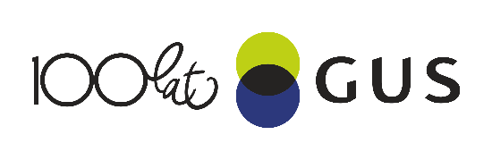
18.06.2018 r.
NEWS RELEASES
Residential construction ^{a)} in the period I-V of 2018
Residential construction
In the period of first five months of 2018 there were more dwellings completed than the year before. The number of dwellings for which permits have been granted or which have been registered with a construction project and the number of dwellings in which construction has begun also increased.
100,5
Lorem ipsum dolor sit amet, consectetur adipiscing elit
9106.9
An increase in the number of dwellings completed
The number of dwellings completed increased by 6.9% y/y in the period I-V 2018
According to preliminary data, in the period January-May of 2018, 69942 dwellings were completed, i.e. by 6.9% more than the year before (when an increase was noted by 5.5%). Among two main forms of constructions in the housing market better results were recorded by developers who completed 40227 dwellings, i.e. by 10.4% more than the year before (when an increase was recorded by 8.7%) and private investors – 27882 dwellings, i.e. by 0.6% more (against an increase by 3.5% the year before ). The share of these forms of construction amounted to 97.4% of the total number of dwellings completed in January-May of 2018 (of which developers – 57.5% and private investors – 39.9%). More dwellings, in comparison with January-May of 2017, were completed by the housing cooperatives (897 dwellings against 748), in the public building society construction 384 dwellings (against 199 dwellings the year before), in the municipal construction 480 dwellings (against 327), in the company construction 72 dwelling (against 15).
The number of permits increased by 2.9% y/y in the period I-V 2018

In January-May of 2018 permits and registrations with a construction project have been granted for construction of 109478 dwellings i.e. by 2.9% more than in January-May of 2017 (when an increase was noted by 37.7%). Permits for construction of the biggest number of dwellings were given to investors in the form construction for sale or rent - 69216 dwellings and to private investors - 37581 dwellings. Housing cooperatives were given permits for 649 dwellings (against 744 dwellings the year before) while other investors (the public building society, the municipal and company construction) - 2032 dwellings, i.e. by 15,8% more than the year before.
The number of dwellings in which construction has begun increased by 9.3% y/y in the period I-V 2018
–
The number of dwellings in which construction has begun increased in the period of five months of 2018 to 91438 dwellings, i.e. by 9.3% (against an increase by 21,7% the year before). The developers have started construction of 53437 dwellings, private investors - 36208 dwellings, the housing cooperatives - 941 dwellings (against 943 dwellings in January-May of 2017) and other investors - 852 dwellings (against 940 dwellings the year before).

- Residence data – subject to change upon developing quarterly reports

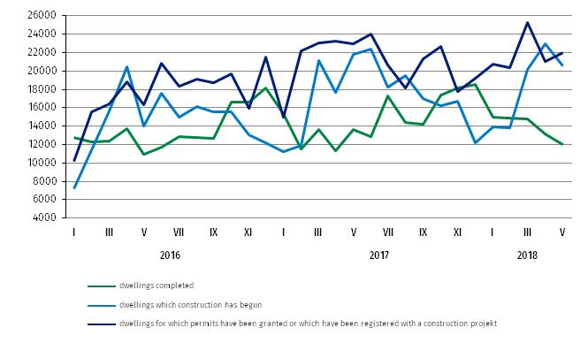
Chart 1. Construction activity in the scope of construction of dwellings

Table 1. Residential construction results ^{b)}
Residential construction results
Forms of construction | 2018
Forms of construction | V |  |  | I-V
Forms of construction | number | V 2017=100 | IV 2018=100 | number | I-V 2017=100
Dwellings completed
Total | 11958 | 87.7 | 90.7 | 69942 | 106.9
Private | 4914 | 93.8 | 100.2 | 27882 | 100.6
For sale or rent | 6727 | 82.1 | 86.1 | 40227 | 110.4
Cooperative | 194 | 114.8 | 91.5 | 897 | 119.9
Rest ^{c)} | 123 | more than 3-fold | 47.9 | 936 | 173.0
Dwellings in which construction has begun
Total | 20536 | 94.1 | 89.6 | 91438 | 109.3
Private | 9390 | X ^{d)} | 88.0 | 36208 | X ^{d)}
For sale or rent | 10564 | X ^{d)} | 87.0 | 53437 | X ^{d)}
Cooperative | 273 | 175.0 | more than 4-fold | 941 | 99.8
Rest ^{c)} | 309 | 178.6 | nearly 7-fold | 852 | 90.6
Dwellings for which permits have been granted or which have been registered
with a construction project
Total | 22003 | 95.9 | 104.6 | 109478 | 102.9
Private | 8711 | x ^{d)} | 102.8 | 37581 | x ^{d)}
For sale or rent | 12990 | x ^{d)} | 105.5 | 69216 | x ^{d)}
Cooperative | 231 | 7-fold | more than 2-fold | 649 | 87.2
Rest ^{c)} | 71 | 41.0 | 48.0 | 2032 | 115.8

b) Since January of 2018 data regarding the effects of „the individual construction” concern only dwellings realized for the investor’s own needs; dwellings for sale or rent (included into this form of construction so far) have been included into the form of “construction designated for sale or rent” .c) The company, municipal and public building society construction. d) According to the revised scope of forms of construction, indices in relation to the corresponding period of the previous year will be presented from January of 2019.

Prepared by:  Departament Produkcji  Janusz Kobylarz  Tel: 22 6083767  e-mail: J.Kobylarz@stat.gov.pl | Issued by:  The Spokeperson for the President  of the Statistic Poland  Tel: 22 608 3475, 22 608 3009  e-mail: rzecznik@stat.gov.pl

Press Office  tel.: +48 22 608 34 91, +48 22 608 38 04  faks: +48 22 608 38 86  e-mail: obslugaprasowa@stat.gov.pl |  | www.stat.gov.pl
 |  | @StatPoland
 |  | @GlownyUrzadStatystyczny

Related information
Statistical Bulletin No 4/2018
Information on socio-economic situation of the country in April 2018
Construction – Activity results in 2017
Housing construction I quarter 2018
Data available in databases
Knowledge Databases Construction
Local Data Bank
Terms used in official statistics
Dwellings for which permits have been granted
Dwellings in which construction has begun
Dwelling completed

