Active enterprises in the third quarter of 2025

In the third quarter of 2025, there were 2 875 994 active enterprises in Poland. With regard to the kind of economic activity, the largest population were enterprises from section trade; repair of motor vehicles (17.2% of total). The largest number of active enterprises had their registered offices in the Mazowieckie voivodship (20.1% of total).
4.9%
Increase in the number of active enterprises in the third quarter of 2025 compared to the corresponding period of the previous year

Basic information on active enterprises
The share of micro entities increased year-on-year to 95.9% of active enterprises

In the third quarter of 2025, compared to the same period in 2024, the number of active enterprises increased by 4.9%. Micro entities (with up to 9 persons employed) accounted for 95.9% of all active enterprises, and compared to the third quarter of 2024, their number increased by 5.2%. Small enterprises (with the number of persons employed from 10 to 49), medium (with 50 to 249 persons employed) and large (with 250 or more persons employed) accounted for 3.4%, 0.6%, and 0.1% of all active enterprises, respectively. Differently than in the case of micro entities, number of small enterprises decreased by 0.5%, medium enterprises by 1.0% and large enterprises by 3 entities, compared to the third quarter of 2024.

Table 1. Number of active enterprises by the number of persons employed
Quarter | Active enterprises
Quarter | total | by the number of persons employed
Quarter | total | up to 9 persons | 10-49 | 50-249 | 250 and more persons
Q3 2025 | 2 875 994 | 2 757 202 | 97 170 | 17 439 | 4 183
Q3 2024 | 2 741 329 | 2 621 869 | 97 666 | 17 608 | 4 186
In the third quarter of 2025, the largest number of enterprises conducting activity was observed in sections: trade; repair of motor vehicles (17.2%) and professional, scientific and technical activities (13.8%)

Active enterprises by kind of economic activity
In the third quarter of 2025, the largest of enterprises conducted activity in sections: trade; repair of motor vehicles (17.2%) of all active enterprises), construction (15.2%), and professional, scientific and technical activities (13.8%). The smallest share was accounted to enterprises in the section mining and quarrying (0.1%) and energy generation and supply (0.3%).
Compared to the same period of 2024, the largest increase in the number of active enterprises was observed in the sections: education (17.8%), administration and support activities (15.9%), and arts, entertainment and recreation activities (9.2%).
In the population of large entities, the largest share was held by enterprises in the manufacturing (43.1%). Among micro entities, the largest share was recorded, as for all enterprises, in the sections: trade; repair of motor vehicles (17.0%), construction (15.3%), and professional, scientific, and technical activities (14.1%).
Chart 1. Number of active enterprises

Table 2. Number of active enterprises by size classes and NACE Rev. 2 section in the third quarter of 2025
Specification | Active enterprises
Specification | total | by the number of persons employed
Specification | total | up to 9 persons | 10-49 | 50-249 | 250 and more persons
Total | 2 875 994 | 2 757 202 | 97 170 | 17 439 | 4 183
Agriculture, forestry, hunting and fishing | 25 881 | 23 670 | 1 749 | 445 | 17
Mining and quarrying | 2 483 | 2 024 | 319 | 106 | 34
Manufacturing | 238 459 | 209 369 | 21 199 | 6 090 | 1 801
Energy generation and supply | 9 178 | 8 638 | 322 | 169 | 49
Water supply; sewage and waste management | 8 401 | 6 370 | 1 284 | 648 | 99
Construction | 437 295 | 421 992 | 14 008 | 1 174 | 121
Trade; repair of motor vehicles | 494 680 | 469 277 | 21 773 | 3 103 | 527
Transportation and storage | 168 448 | 157 002 | 9 783 | 1 362 | 301
Accomodation and catering | 83 879 | 78 704 | 4 759 | 338 | 78
Information and communication | 236 478 | 233 106 | 2 531 | 631 | 210
Financial and insurance activities | 57 985 | 56 307 | 1 083 | 460 | 135
Real estate activities | 77 559 | 75 118 | 2 011 | 398 | 32
Professional, scientific and technical activities | 395 482 | 389 317 | 5 181 | 741 | 243
Administrative and support service activities | 128 332 | 123 468 | 3 632 | 890 | 342
Education | 83 518 | 80 869 | 2 315 | 306 | 28
Human health and social work activities | 246 327 | 241 667 | 4 062 | 458 | 140
Arts, entertainment and recreation activities | 32 696 | 32 242 | 380 | 62 | 12
Other service activities | 148 913 | 148 062 | 779 | 58 | 14

Active enterprises by registered office
In the third quarter of 2025, the largest number of active enterprises (according to the place of registered offices) was in the Mazowieckie (20.1% of all active enterprises), and also many active enterprises operated in the Wielkopolskie (10.3%), the Śląskie (10.2%) and the Małopolskie (10.0%) voivodships. The smallest number of enterprises were located in the Opolskie voivodship (1.9% of all active enterprises).
Compared to the same period of 2024, the largest increase in the number of active enterprises was recorded in the Mazowieckie (5.9%), Małopolskie (5.7%), and Pomorskie (5.5%) voivodships, the smallest was in the Zachodniopomorskie voivodship (3.7%), the Warmińsko-Mazurskie (3.5%), and the Podlaskie (3.6%) voivodships.
In the population of large entities, the largest share was held by enterprises based in the Mazowieckie (26.9%), Śląskie (12.1%), and Wielkopolskie (11.1%) voivodships. In the population of microenterprises, the highest percentage of entities was recorded in the Mazowieckie (20.2%), Wielkopolskie (10.2%), Śląskie (10.2%), and Małopolskie (10.0%) voivodships.
In the powiats that are not cities with powiat status, the largest number of active enterprises was located in the powiats: poznański (47 450 entities), piaseczyński (27 216), krakowski (25 519), wołominski (24 029), pruszkowski (20 573), wrocławski (19 705). The number of active enterprises did not exceed 1000 entities in the following powiats: gołdapski (987), węgorzewski (957) and sejneński (935).
In relation to the third quarter of 2024, the largest increase in the number of active enterprises, greater than for the entire country (i.e. 4.9%) was observed in 77 powiats that are not cities with powiat status. The largest increase (above 7.0%) was recorded in the following powiats: legionowski, pruszkowski, wrocławski, grodziski, średzki and zwoleński. A decrease in the number of active enterprises was observed in the powiats: węgrowski, krasnostawski and pyrzycki.
In the third quarter of 2025, the highest number of active enterprises per 1000 population was observed in the Mazowieckie (104.9), Pomorskie (85.2), Wielkopolskie (85.0), Małopolskie (83.8), and Dolnośląskie (82.1) voivodships. In contrast, the lowest number was observed in the Podkarpackie voivodship (57.1).

Chart 2. Structure of active enterprises by voivodships in the third quarter of 2025

Table 3. Number of active enterprises by size classes and voivodships in the third quarter of 2025
Specification | Active enterprises
Specification | total | by the number of persons employed
Specification | total | up to 9 persons | 10-49 | 50-249 | 250 and more persons
Total | 2 875 994 | 2 757 202 | 97 170 | 17 439 | 4 183
Dolnośląskie | 235 362 | 227 014 | 6 671 | 1 304 | 373
Kujawsko-Pomorskie | 126 206 | 120 516 | 4 667 | 852 | 171
Lubelskie | 116 071 | 111 254 | 4 107 | 615 | 95
Lubuskie | 66 826 | 64 044 | 2 251 | 441 | 90
Łódzkie | 164 410 | 157 145 | 6 042 | 1 017 | 206
Małopolskie | 287 522 | 276 021 | 9 627 | 1 522 | 352
Mazowieckie | 578 017 | 555 840 | 17 596 | 3 457 | 1 124
Opolskie | 55 085 | 52 504 | 2 103 | 393 | 85
Podkarpackie | 117 819 | 112 388 | 4 493 | 780 | 158
Podlaskie | 69 851 | 67 050 | 2 300 | 437 | 64
Pomorskie | 201 071 | 193 350 | 6 358 | 1 120 | 243
Śląskie | 294 724 | 280 936 | 11 289 | 1 992 | 507
Świętokrzyskie | 68 274 | 65 458 | 2 369 | 375 | 72
Warmińsko-Mazurskie | 77 619 | 74 521 | 2 549 | 474 | 75
Wielkopolskie | 295 688 | 281 970 | 11 257 | 1 998 | 463
Zachodniopomorskie | 121 449 | 117 191 | 3 491 | 662 | 105

Map 1. Number of active enterprises by powiats in the third quarter of 2025
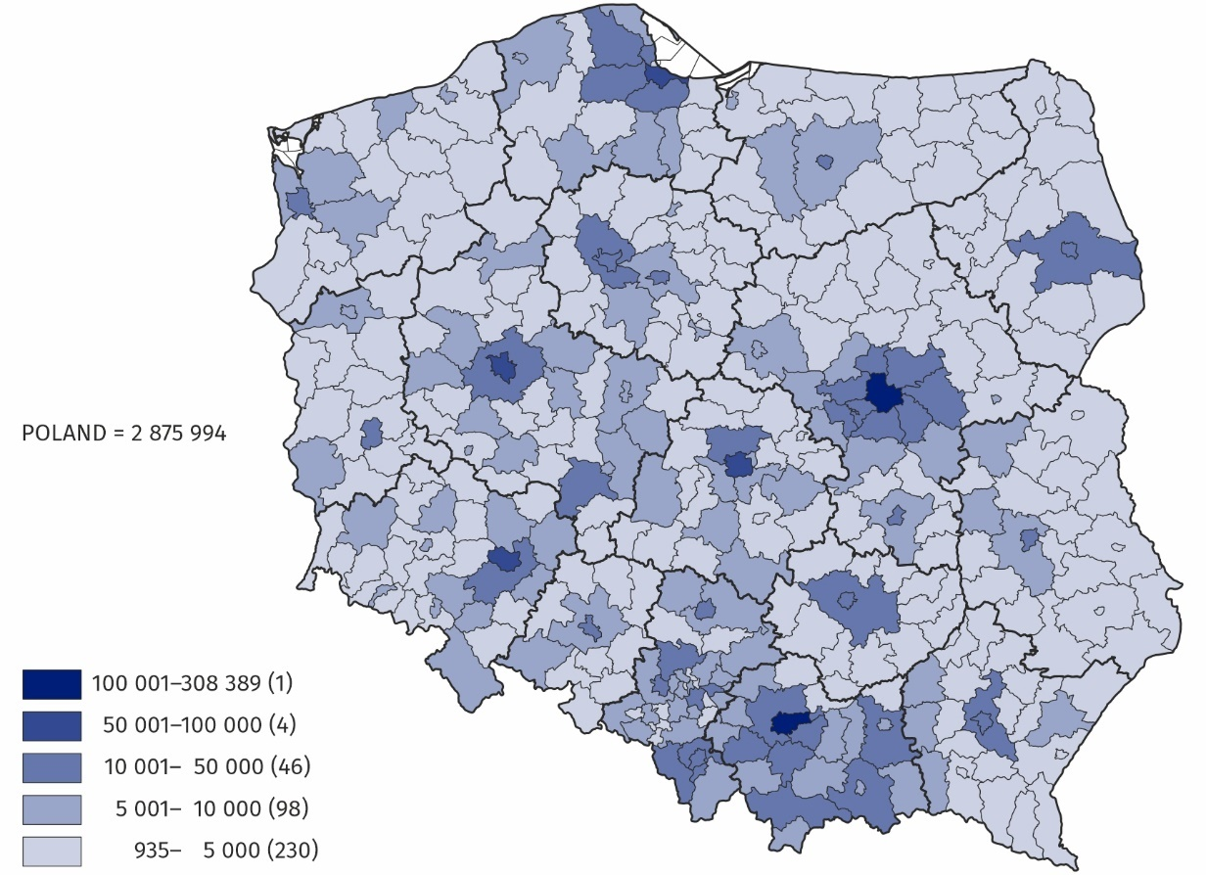

The data presented in this news release concern active enterprises (understood as a one legal unit) regardless of the size class by number of persons employed and the kind of accounting record kept. The data include entities of the national economy which are market producers, for which the predominant activity is classified according to the NACE Rev. 2 to section A (excluding indywidual agricultural holdings), B, C, D, E, F, G, H, I, J, K, L, M, N, P, Q, R, S (excluding division 94).
The enterprises method was used for preparing the data, and this method involves taking entire enterprises as the basic for grouping data according to clasifications and territorial divisions.
Code | Full name | Abbreviation
A* | Agriculture, forestry, hunting and fishing | –
B | Mining and quarrying | –
C | Manufacturing | –
D | Electricity, gas, steam, hot water and air conditioning manufacturing and supply | Energy generation and supply
E | Water supply; sewerage, waste management and remediation activities | Water supply; sewage and waste management
F | Construction | –
G | Wholesale and retail trade; repair of motor vehicles including motorcycles | Trade; repair of motor vehicles
H | Transportation and storage | –
I | Accommodation and food service activities | Accommodation and catering
J | Information and communication | –
K | Financial and insurance activities | –
L | Real estate activities | –
M | Professional, scientific and technical activities | –
N | Administrative and support service activities | –
P | Education | –
Q | Human health and social work activities | –
R | Arts, entertainment and recreation activities | –
S** | Other service activities | –
An enterprise is considered to have been active in the quarter if it conducted economic activity at least in one month of that quarter (regardless of the number of days of activity conduted).
In this news release, abbreviated names of some sections of NACE Rev. 2 were used; the list of letter symbols of the section (code), full names and abbreviated names is as follows:

* Section A– excluding indywidual agricultural holdings
** Section S – excluding division 94 Activities of membership organisations

An integral part of this news release are tables in XLSX format (downloadable files) with a set of tables presenting data in detailed breakdown, including by NACE Rev. 2 groups and by powiats.

In case of quoting Statistics Poland data, please provide information: “Source of data: Sta-tistics Poland”, and in case of publishing calculations made on data published by Statistics Poland, please include the following disclaimer: “Own study based on figures from Statistics Poland”.

Prepared by:  Enterprise Department  Director Katarzyna Walkowska-Macias  Phone: (+48 22) 608 31 25 | Issued by:  Press Office  Mobile: (+48) 695 255 032  Phone: (+48 22) 608 38 04, (+48 22) 449 41 45,  (+48 22) 608 30 09  e-mail: obslugaprasowa@stat.gov.pl

stat.gov.pl/en/

@StatPoland

@GlownyUrzadStatystyczny

gus_stat

glownyurzadstatystycznygus

glownyurzadstatystyczny

Related publications
Enterprises active in the second quarter of 2025
Enterprises active in the first quarter of 2025
Enterprises active in the fourth quarter of 2024

