Producer price indices for business services in the third quarter of 2025

In the third quarter of 2025, the producer prices for business services increased compared to the previous quarter by 0.8% and compared to the third quarter of 2024 - by 3.7%.
3.7%
Increase in producer prices for business services compared to the third quarter of 2024

Table 1. Producer price indices for business services
SPECIFICATION | 3 quarter 2025 |  |  | 1-3 quarter 2025
SPECIFICATION | 2 quarter 2025=100 | 4 quarter 2024=100 | 3 quarter 2024=100 | 1-3 quarter 2024=100
Total | 100.8 | 103.1 | 103.7 | 103.7
Publishing activities | 99.6 | 100.4 | 102.5 | 103.3
Motion picture, video and television programme production, sound recording and music publishing activities | 100.1 | 102.2 | 103.8 | 104.9
Programming and broadcasting activities | 111.2 | 102.0 | 102.4 | 99.0
Computer programming, consultancy and related activities | 100.8 | 102.5 | 103.4 | 103.6
Information service activities | 101.7 | 105.0 | 105.3 | 104.4
Real estate activities | 100.7 | 104.1 | 104.4 | 104.7
Legal and accounting activities | 101.1 | 103.7 | 104.5 | 104.6
Management consultancy activities | 100.3 | 103.0 | 103.4 | 104.0
Architectural and engineering activities; technical testing and analysis | 100.3 | 102.0 | 102.3 | 102.3
Advertising and market research | 101.0 | 101.2 | 102.2 | 102.5
Other professional, scientific and technical activities | 101.6 | 103.3 | 105.0 | 104.7
SPECIFICATION | 3 quarter 2025 |  |  | 1-3 quarter 2025
SPECIFICATION | 2 quarter 2025=100 | 4 quarter 2024=100 | 3 quarter 2024=100 | 1-3 quarter 2024=100
Rental and leasing activities | 99.8 | 101.0 | 101.0 | 100.5
Employment activities | 101.2 | 104.9 | 105.5 | 105.0
Travel agency, tour operator and other reservation service and related activities | 102.1 | 101.7 | 98.7 | 99.3
Security and investigation activities | 100.1 | 107.0 | 107.4 | 107.6
Services to buildings and landscape activities | 100.0 | 103.7 | 104.2 | 105.1
Office administrative, office support and other business support activities | 99.7 | 102.8 | 103.9 | 104.5

In the third quarter of 2025 the highest increase of prices compared to the previous quarter was recorded in programming and broadcasting activities (by 11.2%). Next, there was noticed the rise of prices in travel agency, tour operator and other reservation service and related activities (by 2.1%), information service activities (by 1.7%) and other professional, scientific and technical activities (by 1.6%). The lowest growths in prices were noticed in the case of motion picture, video and television programme production, sound recording and music publishing activities and security and investigation activities (by 0.1% each).
In the 3th quarter of 2025, the highest increase of prices compared to the previous quarter was recorded in programming and broadcasting activities
Prices of services to buildings and landscape activities remained at the same level as in the second quarter of 2025.
Price decrease compared to the previous quarter were recorded in publishing activities (by 0.4%), office administrative, office support and other business support activities (by 0.3%) and rental and leasing activities (by 0.2%).
Compared to the third quarter of 2024, the highest increase of service prices occurred in security and investigation activities (by 7.4%), employment activities (by 5.5%), information service activities (by 5.3%) and other professional, scientific and technical activities (by 5.0%). The lowest increase of prices were noticed in the case of rental and leasing activities (by 1.0%), advertising and market research (by 2.2%), architectural and engineering activities; technical testing and analysis (by 2.3%), programming and broadcasting activities (by 2.4%) and publishing activities (by 2.5%).
Price decerase compared to the third quarter of 2024 year occurred in travel agency, tour operator reservation service and related activities (by 1.3%).

Chart 1. Producer price changes of business services in 2021-2025 (the previous quarter = 100)
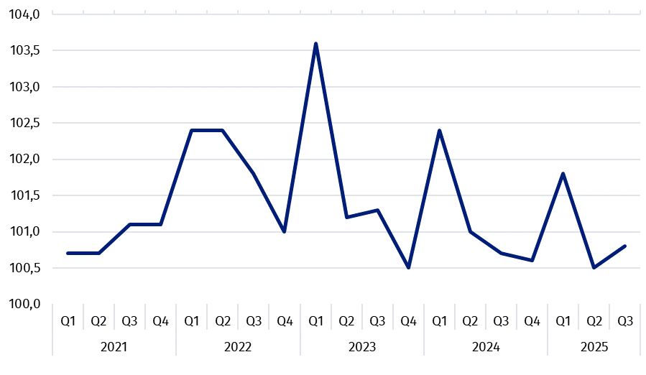

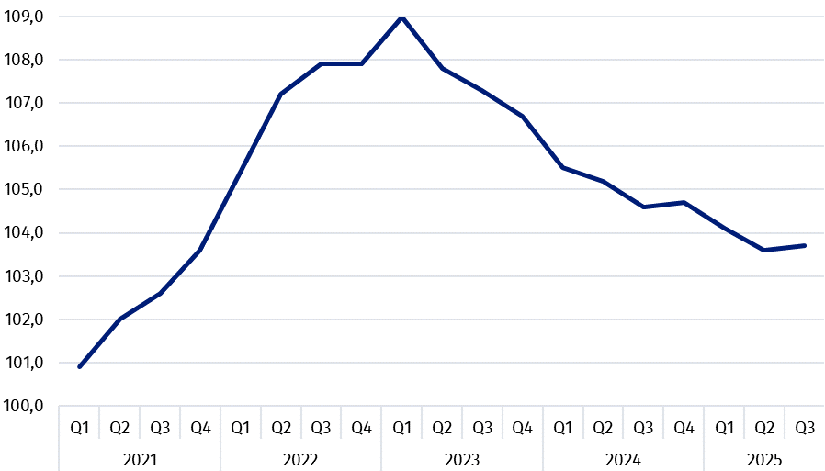
Chart 2. Producer price changes of business services in 2021-2025 (corresponding period of the previous year = 100)

In case of quoting Statistics Poland data, please provide information: “Source of data: Statistics Poland”, and in case of publishing calculations made on data published by Statistics Poland, please include the following disclaimer: “Own study based on figures from Statistics Poland”.

Prepared by:  Trade and Services Department  Director Ewa Adach-Stankiewicz  Phone: (+48 22) 608 31 24 | Issued by:  Press Office  Mobile +48 695 255 032  Phone +48 22 608 38 04, +48 22 449 41 45,  +48 22 608 30 09  e-mail: obslugaprasowa@stat.gov.pl

www.stat.gov.pl/en/

@StatPoland

@GlownyUrzadStatystyczny

gus_stat

glownyurzadstatystycznygus

glownyurzadstatystyczny
Related information
News releases

Prices in the national economy

Data available in databases
Knowledge Databases
Prices indices (Topics: Prices, Trade)

Terms used inn official statistics
Producer price indices for business services

,² Producer price indices for business services are presented using a weighting system prepared based on turnover in 2021.

