Financial results of cultural institutions in the period January–September 2025 (preliminary data)

In the first three quarters of 2025, cultural institutions recorded a 12.4% increase in total revenues and a 11.5% increase in total costs, compared to the same period of the previous year. At the same time, investment outlays decreased by 10.2%.
12.4%
Increase in total revenues y/y
Total revenues of cultural institutions in the period January–September of 2025 amounted to PLN 13,509.1 million and were higher by 12.4% compared to the previous year. In the structure of revenues, 92.8% were net revenues from the sale of products, goods and materials, 6.9% – other operating revenues and 0.3% – financial revenues. The share of Mazowieckie Voivodship in the total revenue of cultural institutions was 24.9% and was the highest among all voivodships.
The average total revenues per one cultural institution amounted to PLN 2,870.6 thousand. The highest total revenues per institution were achieved by cultural institutions in Mazowieckie Voivodship (PLN 5,160.9 thousand), and the lowest – in Lubelskie Voivodship (PLN 1,402.6 thousand). Total revenues of local government cultural institutions amounted to PLN 11,037.8 million (81.7%), while those of national cultural institutions amounted to PLN 2,471.3 million (18.3%). The revenues of entities conducting operation of art facilities had the largest share in the total revenues of cultural institutions – 41.4%.
Total revenues of local government cultural institutions accounted for 81.7% of total revenues
The total costs of cultural institutions in the period under review amounted to PLN 12,584.1 million and were 11.5% higher than those incurred a year earlier. In the cost structure, operating costs accounted for 99.0%. Over 24% of all costs were the total costs of cultural institutions from Mazowieckie Voivodship. Entities conducting operation of arts facilities had the largest share in total revenues of all cultural institutions – 41.5%.
The gross financial result of cultural institutions amounted to PLN 925.0 million (gross profit – PLN 991.2 million, and gross loss – PLN 66.2 million). The net financial result of cultural institutions amounted to PLN 923.4 million (compared to PLN 736.5 million a year ago), with an increase in net profit by 22.8% and a decrease in net loss by 4.7%.
Table 1. Financial results of cultural institutions
The net financial result of cultural institutions in the first three quarters of 2025 amounted to PLN 923.4 million
Specification | 01–09 2024 | 01–09 2025
Specification | in PLN million |  | 01–09 2024=100
Total revenues | 12,020.9 | 13,509.1 | 112.4
Total costs | 11,282.9 | 12,584.1 | 111.5
Gross financial result | 738.0 | 925.0 | 125.3
Net financial result | 736.5 | 923.4 | 125.4
Net profit | 806.1 | 989.8 | 122.8
Net loss | 69.7 | 66.4 | 95.3
Investment outlays | 1,126.2 | 1,011.1 | 89.8
Outlays on intangible fixed assets | 15.4 | 19.2 | 124.8
In the period January–September of 2025, investment outlays incurred by cultural institutions amounted to PLN 1,011.1 million and were 10.2% lower than a year earlier. Over 43% of total investment outlays of cultural institutions were total investment outlays of entities located in Mazowieckie Voivodship.
Investment outlays incurred by local government cultural institutions amounted to PLN 629.3 million, i.e. 62.2% of the total amount of investment outlays.

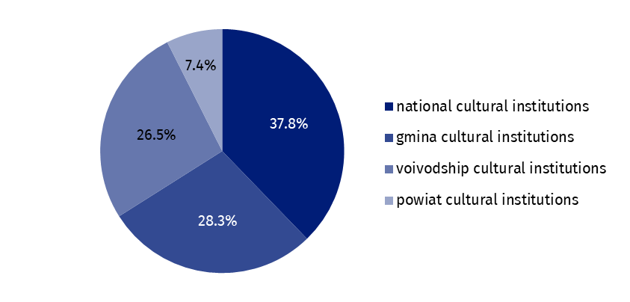
Chart 1. Investment outlays of cultural institutions by legal forms in the period

January–September 2025
In the first three quarters of 2025, outlays incurred by cultural institutions on intangible fixed assets increased by 24.8% compared to the same period of the previous year and amounted to PLN 19.2 million. Over 49% of the total outlays on intangible fixed assets was incurred by institutions from Mazowieckie Voivodship.
Table 2. Total revenues and total costs of cultural institutions by selected divisions and classes of PKD 2007 in the period January–September 2025
The largest share in the total revenues of cultural institutions had the revenues of entities conducting operation of art facilities – 41.4%
Specification | Number of cultural institutions | Total  revenues | Total costs
Specification | Number of cultural institutions | in PLN million
Grand total | 4,706 | 13,509.1 | 12,584.1
local government units property | 4,630 | 11,037.8 | 10,401.6
government property | 76 | 2,471.3 | 2,182.5
of which:
creative, arts and entertainment activities | 2,341 | 8,136.1 | 7,690.5
of which:
performing arts activities | 152 | 2,410.9 | 2,335.4
operation of arts facilities | 2,180 | 5,586.1 | 5,227.5
libraries, archives, museums and other cultural activities | 2,359 | 5,210.7 | 4,747.3
of which:
libraries and archives activities | 1,956 | 2,216.5 | 2,053.7
museums activities | 395 | 2,916.7 | 2,620.5
Data presented in this study come from the survey on the F-01/dk form Quarterly report on the finances of cultural institutions. Information on the survey methodology can be found in the Methodological report. Culture Statistics.
In the case of quoting data from the Statistics Poland, please provide information: "Statistics Poland data source", and in the case of publishing calculations made on data published by the Statistics Poland, please provide information: "Own study based on Statistics Poland data".

Prepared by:  Statistical Office in Kraków  Director Agnieszka Szlubowska  Phone: (+48 12) 420 40 50 | Issued by:  Press Office  Mobile: (+48) 695 255 032  Phone: (+48 22) 608 38 04, (+48 22) 449 41 45,  (+48 22) 608 30 09  e-mail: obslugaprasowa@stat.gov.pl

stat.gov.pl/en/

@StatPoland

@GlownyUrzadStatystyczny

gus_stat

glownyurzadstatystycznygus

glownyurzadstatystyczny
Related information
Financial results of cultural institutions in the first half of 2025 (preliminary data)
Methodological report. Culture statistics
Terms used in official statistics
Total revenues
Total costs
Gross financial result
Net financial result
Investment outlays
Outlays on intangible fixed assets
Cultural institution

