Persons performing work only under contracts
of mandate and related contracts in Poland in June 2025
On the last day of June 2025, 1 451.3 thousand persons in Poland were performing work only under contracts of mandate and related contracts, i.e. 5.0% more than in June 2024. Compared with March 2025, their number increased by 4.0%.
1.5 million
number of persons performing work only under contracts of mandate and related contracts in Poland as at 30 June 2025
The data presented in this study refer to persons performing work only under contracts of mandate together with contracts of a related nature, i.e. agency agreements, service contracts, nanny agreements, appointment letters and contracts with members of supervisory boards. The information presented is part of experimental work aimed at determining the number of persons performing work only under civil law contracts.
On the last day of June 2025, men accounted for 51.1% of all persons performing work only under contracts of mandate and related contracts

Among persons performing work only under contracts of mandate and related contracts, men constitute the majority. At the end of June 2025, their share was 51.1%, which was 0.4 percentage points (pp) higher than a year earlier and 0.3 pp lower than at the end of March 2025.
Compared with June 2024, both the number of women and the number of men performing work only under contracts of mandate and related contracts increased, by 4.1% and 5.9%, respectively. Compared with 31 March 2025, their number also increased, by 4.7% and 3.4%, respectively.
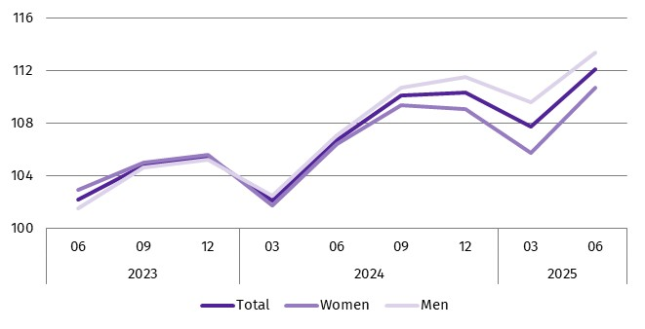
Chart 1. Indices of the number of persons performing work only under contracts of mandate and related contracts
(03 2023 = 100)

At the end of June 2025, the median age of persons performing work only under contracts of mandate and related contracts was 42.0 years, unchanged from June 2024.
In June 2025 – as in previous months – the largest number of persons performing work only under contracts of mandate and related contracts were in the Administrative and support service activities section, which includes, inter alia, the activities of employment agencies providing placement services. As at 30 June 2025, the number of such persons was 311.9 thousand, i.e. 21.5% of the total number of persons performing work only under such contracts. This share was 0.7 pp lower than at the end of June 2024 and 0.3 pp lower than at the end of March 2025.
The second largest section in terms of the number of persons performing work only under contracts of mandate and related contracts was Trade; repair of motor vehicles^{Δ}, which accounted for 10.6% of all contractors, 0.5 pp fewer than a year earlier and 0.1 pp fewer than in March 2025.
Chart 2. Persons performing work only under contracts of mandate and related contracts by sex and PKD 2007/NACE Rev. 2 section in June 2025
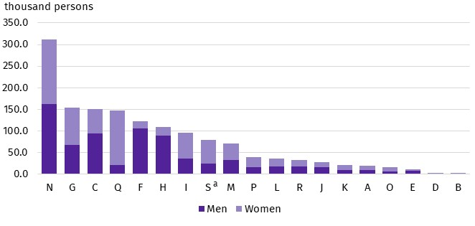
As at the end of the month
One in five persons performing contracts of mandate and related contracts was related to the Administrative and support service activities section
a Data for the Other service activities (S) section also cover persons performing work only under contracts of mandate and related contracts in the Activities of households as employers; undifferentiated goods- and services-producing activities of households for own use (T) and Activities of extraterritorial organisations and bodies (U) sections.
On the last day of June 2025, the largest number of persons performing work only under contracts of mandate and related contracts lived in the Warszawski stołeczny region and the Śląskie region – 191.8 thousand and 171.0 thousand persons, respectively, which accounted for 13.2% and 11.8% of the total number of persons performing work only under such contracts. The regions with the lowest numbers of contractors were Opolskie and Świętokrzyskie, where 30.3 thousand and 29.6 thousand contractors lived, respectively (which accounted for 2.1% and 2.0% of the total number of persons performing work only under contracts of mandate and related contracts). Compared with June 2024, these shares remained at a similar level.

Chart 3. Persons performing work only under contracts of mandate and related contracts by place of residenceª and sex in June 2025
As at 30 June 2025, 17.8 thousand persons performing work only under contracts of mandate and related contracts lived abroad
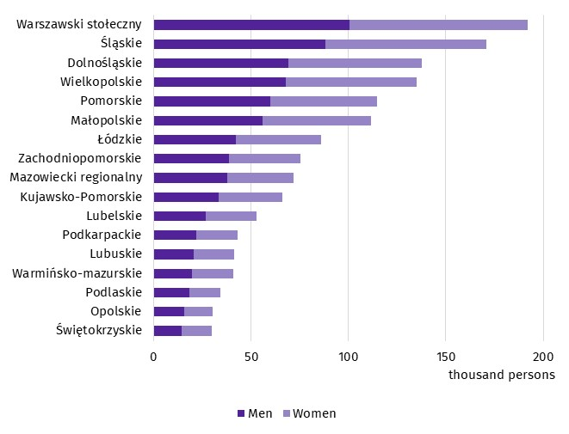
As at the end of the month
a Data by statistical region; excluding persons performing only contracts of mandate and related contracts living abroad.
Methodological notes
The source of the presented data is administrative registers. The population under study includes persons performing work only under contracts of mandate, together with contracts of a related nature, to which the provisions of the Civil Code apply and which involve the obligation to be covered by social and/or health insurance with the Social Insurance Institution (ZUS), i.e. agency agreements, service contracts, nanny agreements, appointment letters and contracts with members of supervisory boards. According to the provisions of the Civil Code, in Poland, contracts of mandate and related contracts can be concluded by persons aged 13 or over. The population under study does not include persons working under contracts to perform a specified task or persons performing harvest assistance contracts (farmer's helpers). It also does not include persons performing work under contracts of mandate and related contracts who have concluded such a contract with their own employer or with another entity but to the benefit of their own employer, or who are secondary school pupils or students under the age of 26.
In this publication symbols and abbreviated names of PKD 2007/NACE Rev. 2 sections were used marking abbreviations with a ‘Δ’ symbol. The full names can be found in the list of PKD 2007/NACE Rev. 2 sections below.
Full names of PKD 2007/NACE Rev. 2 sections:
A – Agriculture, forestry and fishing;
B – Mining and quarrying;
C – Manufacturing;
D – Electricity, gas, steam and air conditioning supply;
E – Water supply; sewerage, waste management and remediation activities;
F – Construction;
G – Wholesale and retail trade; repair of motor vehicles and motorcycles;
H – Transportation and storage;
I – Accommodation and food service activities;
J – Information and communication;
K – Financial and insurance activities;
L – Real estate activities;
M – Professional, scientific and technical activities;
N – Administrative and support service activities;
O – Public administration and defence; compulsory social security;
P – Education;
Q – Human health and social work activities;
R – Arts, entertainment and recreation;
S – Other service activities;
T – Activities of households as employers; undifferentiated goods- and services-producing activities of households for own use;
U – Extraterritorial organisations and bodies.
Data for the Other service activities (S) section also cover persons performing work under contracts of mandate and related contracts in the Activities of households as employers; undifferentiated goods- and services-producing activities of households for own use (T) and Activities of extraterritorial organisations and bodies (U) sections.
When quoting Statistics Poland data, please provide the information: ‘Source of data: Statistics Poland’, and when publishing calculations made on data published by Statistics Poland, please include the following disclaimer: ‘Own study based on figures from Statistics Poland’.

Prepared by:  Statistical Office in Bydgoszcz  Acting Director Katarzyna Klamrowska  Phone: (+48 52) 366 93 90 | Issued by:  Press Office  Mobile phone: +48 695 255 032  Landline phones: +48 22 608 38 04, +48 22 449 41 45, +48 22 608 30 09  e-mail: obslugaprasowa@stat.gov.pl

stat.gov.pl/en/

@StatPoland

@GlownyUrzadStatystyczny

gus_stat

glownyurzadstatystycznygus

glownyurzadstatystyczny
Related information
Methodological report. Employment in the national economy
Methodological report. Employment in the national economy according to administrative data sources
Employed persons in the national economy in Poland in June 2025
Terms used in official statistics
Employed persons in the national economy

