Activities of non-governmental organizations in 2024
In 2024, there were 113.1 thousand non-governmental organizations operating in Poland, associated 7.6 million people. They created 169.8 thousand full-time equivalent jobs, which was 1.5% of the average employment in the national economy. In connection with the autumn floods, the organizations provided support to 4.3 million people, donating material and financial assistance worth PLN 723.4 million.
7.7%
Increase in the number of non-governmental organizations compared to 2023

Active non-governmental organizations
The most numerous group of non-governmental organizations were typical associations and social organizations (29.0%)
In 2024, there were 113.1 thousand non-governmental organizations operating in Poland (7.7% more than in 2023). The most numerous group were typical associations and social organizations (29.0%), followed by foundations (19.8%) and sports associations (17.8%). Rural housewives clubs (15.3%) and volunteer fire brigades (13.1%) also had a significant share. The smallest group was business associations, farmers organizations (1.1%). 9.9 thousand entities had the status of public benefit organizations. In turn, 0.8 thousand non-governmental organizations had the status of social enterprises.

Chart 1. Number of non-governmental organizations

Chart 2. Non-governmental organizations by type in 2024
In addition to organizations with legal personality, there were also organizations without legal personality, but with legal capacity. According to data provided by county offices and city offices with county rights, in 2024 there were 12.4 thousand ordinary associations registered in Poland. Furthermore, according to a study by the Institute of Catholic Church Statistics, in 2023 there were 51.7 thousand parish-based organizations of the Catholic Church operating in the country.

Map 1. Non-governmental organizations by voivodeships and regions in 2024

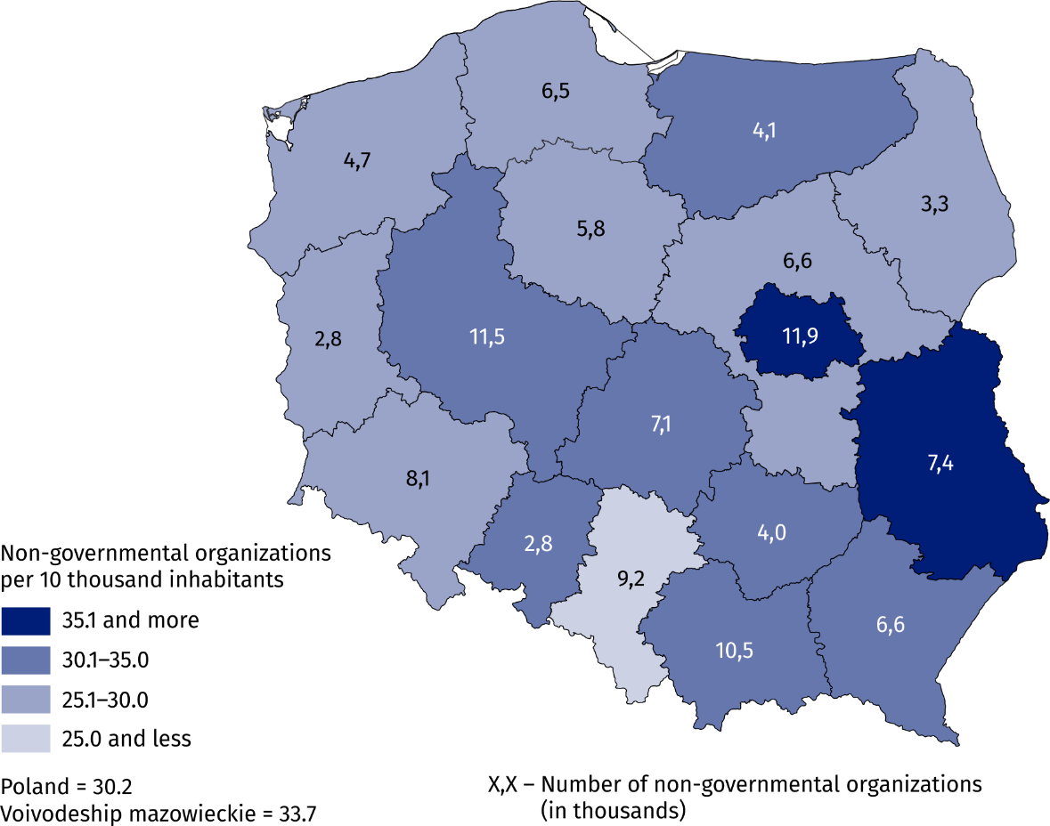
Population as of December 31, 2024.

Field of statutory activity
In 2024, the largest percentage of non-governmental organizations operated in the field of sports, tourism, recreation, hobbies (26.8%)
Non-governmental organizations carried out diverse and comprehensive activities. In 2024, the largest percentage of organizations indicated sport, tourism, recreation and hobbies as their main area of activity (26.8%). The share of organizations operating in the areas of culture and arts (13.7%), rescue services (13.4%), and local social and economic development (10.8%) was relatively high. The smallest number of organizations operated in the areas of employment assistance (1.3%).
In 2024, significant changes were observed in the structure of non-governmental organizations' activities. The number of rural housewives clubs increased by 36.6% compared to 2023, which translated into a 2.0 percentage point increase in the share of organizations operating mainly in the area of local development. The share of organizations operating in this field exceeded the share of organizations dealing mainly with social services and education and research by 2.2 percentage points and 1.1 percentage points, respectively.

Chart 3. Non-governmental organizations by the main field of statutory activity in 2024
Most non-governmental organizations (70.6%) conducted only unpaid statutory activities. The remaining 29.4% of organizations declared that they conducted paid statutory activities or economic activities, with 4.0% of organizations conducting both forms of activity simultaneously.

People associated with non-governmental organizations
The number of people associated with non-governmental organizations increased by 4.9% compared to 2022
At the end of 2024, non-governmental organizations had a total of 7.6 million natural persons, i.e., 4.9% more than in 2022. Most people were members of typical associations and social organizations (59.0%). Sports associations were also numerous, integrating 22.0% of members. One organization had an average of 67 people, with half of the organizations declaring no more than 20 members.

Chart 4. Membership of natural personsª by type of organization in 2024

Status as of December 31
a For foundations and other organizations that do not associate natural persons, the number of members of collegial bodies (management board, council, etc.) has been taken into account.

Labour resources
More than half of non-governmental organizations (61.3%) did not employ paid employees, basing their activities solely on volunteer work. Among organizations that did employ paid employees, a larger proportion employed people on the basis of civil law contracts (25.1%) than on the basis of employment contracts (13.6%).

Chart 5. Non-governmental organizations by paid employees in 2024
95.4% of organizations declared that they used volunteer work. The highest percentage of organizations using volunteer work was recorded in rural housewives clubs (98.8%) and the lowest in faith-based charities (54.6%). In total, 3.2 million people were involved in social activities for organizations in 2024 (3.4% more than in 2023), of which 51.1% were women. One organization used the work of an average of 29 people, with half of the organizations using no more than 10 people.
In 2024, 3.2 million people performed volunteer work for non-governmental organizations

Chart 6. Percentage of non-governmental organizations benefiting from work of volunteers and with personnel employed on the basis of employment contract by type of organization in 2024

At the end of 2024, 214.3 thousand people were employed by non-governmental organizations on the basis of an employment contract (14.3% more than in 2023), of which 177.1 thousand were employed full-time. Women accounted for 77.1% of employees hired on the basis of an employment contract. The average number of employees in organizations employing people was 14, and the median was 3.
As of December 31, 2024, persons employed in non-governmental organizations under an employment contract accounted for 1.2% of the total number of persons employed in the national economy, and their share in employment based on an employment contract was 1.6%. The average employment in non-governmental organizations in 2024 was 169.8 thousand full-time jobs, which corresponded to 1.5% of the average employment based on employment contract in the national economy.

Revenues
Revenues of non-governmental organizations in 2024 amounted to PLN 57.5 billion
In 2024, the revenues of non-governmental organizations amounted to PLN 57.5 billion (12.7% more than in 2023). The two largest groups of entities – typical associations and social organizations and foundations – generated a total of PLN 41.6 billion, which accounted for 72.4% of the total revenue of non-governmental organizations. The average revenue per non-governmental organization was PLN 508.4 thousand. The highest average revenue was recorded by faith-based charities – PLN 3 390.8 thousand, and the lowest by rural housewives clubs – PLN 17.0 thousand.

Chart 7. Revenues of non-governmental organizations by sources of revenues in 2024
More than half of the revenues (60.5%) of non-governmental organizations came from non-market sources. This category was dominated by public funds, which accounted for 45.7% of total revenues, including subsidies from local government administration – 22.6%. The share of revenues from market sources amounted to 32.4%, of which 18.9% came from paid statutory activities and 11.0% from economic activities. Membership dues and other forms of financing accounted for a total of 7.1% of the revenues of non-governmental organizations.

Involvement in help due to the flood (september–december 2024)
Due to the flood, 14.3 thousand non-governmental organizations undertook additional support activities
Between september and december 2024, 14.3 thousand non-governmental organizations (12.6% of the total) undertook additional support activities due to the flood in Poland and abroad. The highest level of involvement in support activities was recorded among volunteer fire brigades (39.6%), followed by hunting clubs (31.4%). Among the voivodeships, a particularly high proportion of organizations involved in support activities was recorded in the Opolskie (30.1%) and Dolnośląskie (21.1%) voivodeships.
Among the organizations located in the voivodeships most affected by the flood (Dolnośląskie, Lubuskie, Małopolskie, Opolskie and Śląskie), 0.6 thousand entities (1.8%) temporarily ceased their activities, on average for a period of two months. The highest percentage of organizations that did not operate due to the flood situation was recorded in the Opolskie voivodeship (4.2%).

Chart 8. Percentage of non-governmental organizations involved in help due to the flood
The main recipients of help provided by non-governmental organizations were natural persons – 68.2% of organizations directed their help to them. In total, they provided support to approximately 4.3 million recipients, with the same person being included multiple times by different non-governmental organizations.
The organizations also supported other non-governmental organizations – associations, foundations, church organizations and similar entities (21.5%), as well as local government or local administration bodies (17.8%) and health care, education, social assistance and other social service providers (5.1%).
One of the key forms of support was the donation of goods, declared by 61.8% of organizations. The estimated value of the donated goods amounted to PLN 349.5 million. Financial resources were donated by 16.5% of organizations, and the total value of this form of support amounted to PLN 373.9 million.
In addition, organizations carried out rescue operations (18.6%), performed renovation-construction, cleaning and tidying work (13.4%) and provided food (9.0%) and transportation (7.6%).

Methodological notes
The news releases was prepared on the basis of preliminary results of the survey “Non-governmental organizations and faith-based charities”, conducted annually by the Statistics Poland, alternately on SOF-1/SOF-4s and SOF-5 forms. The survey covered: associations and similar organizations, foundations, faith-based charities conducting social activities and rural housewives clubs (SOF-1 form), as well as business associations and farmers organizations (SOF-4s form).
Due to a change in the survey methodology, professional associations were surveyed every four years as part of a separate survey entitled “Social dialogue partners – employers' organizations and trade unions”.
The term “non-governmental organizations” has replaced the term “non-profit organizations” used in previous editions of the news releases, which is less commonly used in Poland. The term “non-governmental organizations” can be used interchangeably with the term “social economy organizations.”
Membership in non-governmental organizations is reviewed every two years.
The selection of units for the study conducted using the SOF-1 form was two-stage. In the first stage, purposive sampling was used, while in the second stage, stratified sampling was used within each voivodeship and legal form. The survey conducted using the SOF-4s form was full survey, which means that all business associations and farmers organizations selected from the survey, were included in the survey file. In total, 32.4 thousand non-governmental organizations were required to report using the SOF-1 and SOF-4s forms. Completed reports were submitted by 77.6% of entities, while 14.4% declared that they did not conduct any statutory activities in 2024. 4.4% of organizations refused to participate in the survey, while 3.6% of entities could not be contacted.
Detailed information on the selection of units for the files and the method of constructing analytical weights enabling the generalization of results is contained in the methodological notebook “Non-profit organizations: associations, foundations, business and professional associations and faith-based charities”.
A survey of parish-based organizations of the Catholic Church was conducted in 2024 by the Institute of Catholic Church Statistics. It has been conducted every five years since 1999. The study involves collecting, as part of parish reporting, basic information about organizations operating in all parishes and pastoral centers in Poland.
When quoting Statistics Poland data, please provide the information: “Source of data: Statistics Poland”, and when publishing calculations made on data published by Statistics Poland, please include the following disclaimer: “Own study based on figures from Statistics Poland”.
Prepared by:  Social Surveys and Labour Market Department  Director Agnieszka Zgierska, PhD  Phone: (+48 22) 608 30 15  Statistical Office in Kraków  Director Agnieszka Szlubowska | Issued by:  Press Office  Mobile: (+48) 695 255 032  Phone: (+48 22) 608 38 04, (+48 22) 449 41 45,  (+48 22) 608 30 09  e-mail: obslugaprasowa@stat.gov.pl
Phone: (+48 12) 420 40 50 |   stat.gov.pl/en/
Phone: (+48 12) 420 40 50 |   @StatPoland
Phone: (+48 12) 420 40 50 |   @GlownyUrzadStatystyczny

gus_stat

glownyurzadstatystycznygus

glownyurzadstatystyczny
Related information
Management and integration activities of social economy entities in 2023
Cooperation of social economy entities in 2023
Non-governmental organizations as social economy entities in 2019–2023
The non-profit sector in 2022
Methodological report. Non-profit organizations: associations, foundations, business and professional associations and faith-based charities
Data available in databases
Local Data Bank Social economy
Knowledge Databases Social economy
Terms used inn official statistics
Non-governmental organisation
Public benefit organisation
Volunteering

The presented community of non-governmental organizations differs from that presented in the news releases “Activities of associations and similar organizations, foundations, faith-based charities, business and professional associations in 2022 – preliminary results” as it does not include professional associations.
In this study, associations and other social organizations, excluding sports associations, sports unions, volunteer fire brigades and hunting clubs, were defined as “typical.”
An ordinary association is a simplified form of association without legal personality. It may be established by at least three persons and operates on the basis of its rules and regulations and an entry in the register kept by the starosta relevant for the association's registered office (cf. The Act of 7 April 1989 – Law on Associations, Journal of Laws 2020, item 2261, articles 40-43).
Volunteer work or volunteering, is work performed voluntarily and without remuneration, both by members of an organization and by non-members.
Data on the number of people working and employed on the basis of an employment contract in the national economy as of December 31, according to: Concise Statistical Yearbook of Poland 2025, Statistics Poland, Warsaw, p. 114.
Data on average employment according to: Concise Statistical Yearbook of Poland 2025, Statistics Poland, Warsaw, p. 117.

