Index of sold production of industry in November 2025¹
In November 2025, sold production of industry was by 1.1% lower than in November 2024 (when a decrease was recorded by 1.3%), whereas in comparison with October 2025, it decreased by 9.3%. In the period January-November of 2025, sold production of industry was by 2.5% higher than in the corresponding period of 2024 (which saw an increase by 0.5%).
A significant decrease in sold production compared to October 2025 was caused by the reduced number of working days and the base effect
1.1%
Decrease in sold production of industry compared to November 2024

After seasonal adjustment, sold production of industry slightly increased per year
After eliminating the seasonal factors, in November 2025 sold production of industry reached the level higher by 0.8% than in the corresponding month of 2024 and by 1.6% lower than in October 2025.
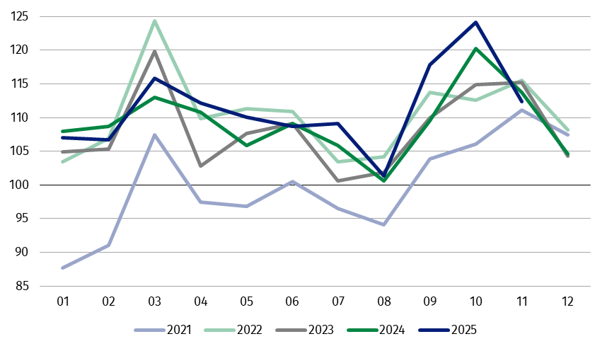
Chart 1. Sold production of industry (monthly average of 2021=100)
The highest y/y decrease was recorded in the production of energy, while an increase – in the production of capital goods

In November 2025, among the main industrial groupings there was a decrease per year in the production of energy – by 9.4%, durable consumer goods – by 8.2% and intermediate goods – by 1.9%. An increase was observed in the production of capital goods – by 3.7% and slight in non-durable consumer goods – by 0.2%.

1 Preliminary data; comprise enterprises with 10 or more persons employed.

Table 1. Index of sold production of industry ª (constant prices)
SPECIFICATION | 2025
SPECIFICATION | 10 | 11 | 10 | 11 | 01-11 | 10 | 11
SPECIFICATION | previous month =100 |  | corresponding period of previous year = 100 |  |  | monthly average  of 2021 =100
INDUSTRY | 105.5* | 90.7 | 103.3* | 98.9 | 102.5 | 124.1* | 112.4
Mining and quarrying | 112.3* | 94.1 | 104.0* | 104.8 | 97.5 | 118.7* | 111.7
Manufacturing | 104.6 | 89.5 | 103.3* | 98.6 | 102.8 | 124.9* | 111.0
Electricity, gas, steam and air conditioning supply | 123.0* | 110.1 | 101.2* | 97.9 | 98.3 | 115.9* | 129.1
Water supply; sewerage waste management and remediation activities | 103.6* | 93.9 | 105.9* | 103.2 | 104.0 | 126.2* | 118.5
a Data including final information on production and prices in October and preliminary data in November.
* Data revised.
The share in total industry of sold production of divisions which recorded a decrease per year amounted to 48.1%
According to the preliminary data, in November 2025 a decrease in sold production (in constant prices), compared to November 2024, was reported in 19 (out of 34) industry divisions, among others in manufacture of electrical equipment – by 7.6%, manufacture of furniture – by 7.3%, manufacture of computer, electronic and optical products – by 6.6%, manufacture of paper and paper products and manufacture of chemicals and chemical products – by 4.8% each, in repair and installation of machinery and equipment – by 3.2%, in manufacture of rubber and plastic products – by 2.4%.
An increase in sold production of industry, compared to November 2024, was recorded in 15 divisions, among others in manufacture of machinery and equipment – by 12.0%, in waste collection, treatment and disposal activities; materials recovery – by 10.3%, in manufacture of beverages – by 4.9%, manufacture of motor vehicles, trailers and semi-trailers and manufacture of food products – by 2.5% each.
Chart 2. Index of sold production of industry by selected NACE divisions (constant
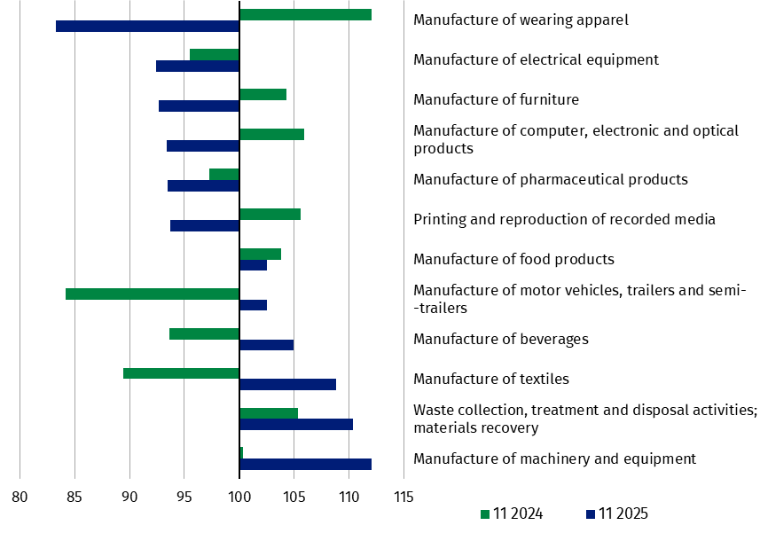
prices; corresponding period of previous year = 100)
In November 2025, a decrease in sold production (in constant prices), compared to October 2025, was recorded in 30 (out of 34) industry divisions, among others in manufacture of other non-metallic mineral products – by 17.4%, manufacture of products of wood, cork, straw and wicker – by 16.7%, manufacture of electrical equipment – by 15.5%, manufacture of other transport equipment – by 13.7%, manufacture of rubber and plastic products – by 12.4%, manufacture of computer, electronic and optical products – by 12.2%, manufacture of chemicals and chemical products – by 11.8%, manufacture of furniture – by 10.8%, manufacture of paper and paper products – by 10.3%.
The share in total industry of sold production of divisions which recorded a decrease compared to October 2025 amounted to 88.5%

An increase in sold production of industry, compared to the previous month, was recorded in 4 divisions, among others in electricity, gas, steam and air conditioning supply – by 10.1%, in manufacture of beverages – by 2.8%.
Chart 3. Index of sold production of industry by selected NACE divisions (constant
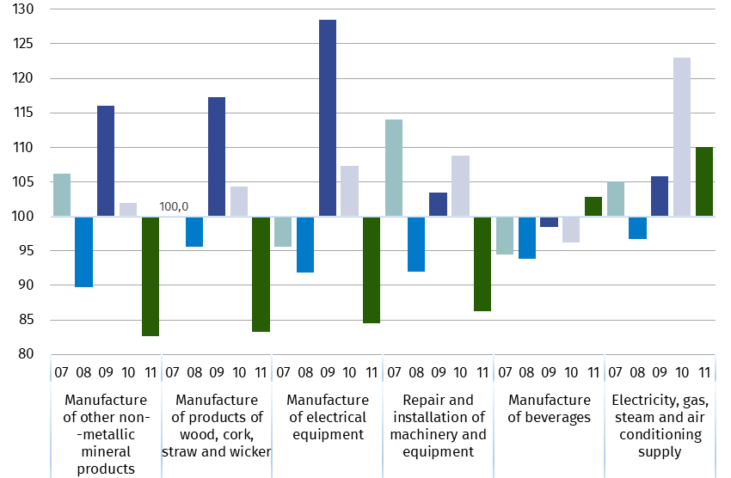
prices; previous month=100)

Data presented in this news release concern entities with 10 or more persons employed, conducting economic activity classified according to the Polish Classification of Activities (PKD 20027) to Industry, i.e. to the following sections: ‘Mining and quarrying’, ‘Manufacturing’, ‘Electricity, gas, steam and air conditioning supply’, ‘Water supply; sewerage, waste management and remediation activities’.
Statistical unit, according to which the presented data are compiled, is a legal unit. Methodology of compiling data on sold production of industry is presented in the methodological report Industrial production surveys.

In addition, for the needs of European statistics, data on industrial production are also compiled according to the kind-of-activity unit (KAU). The concept of the kind-of-activity unit is presented in the methodological report Short-term statistics by European concept of the Kind-of-activity unit.

In case of quoting Statistics Poland data, please provide information: “Source of data: Statistics Poland”, and in case of publishing calculations made on data published by Statistics Poland, please include the following disclaimer: “Own study based on figures from Statistics Poland”.
Prepared by:  Enterprises Department  Director Katarzyna Walkowska-Macias  Phone: (+48 22) 608 31 25 | Issued by:  Press Office  Mobile +48 695 255 032  Phone +48 22 608 38 04, +48 22 449 41 45,  +48 22 608 30 09  e-mail: obslugaprasowa@stat.gov.pl

stat.gov.pl

@GUS_STAT

@GlownyUrzadStatystyczny

gus_stat

glownyurzadstatystycznygus

glownyurzadstatystyczny

Related information
Statistical Bulletin
Socio-economic situation of the country
Methodological report. Industrial production surveys

Data available in databases
Knowledge Database - Industry
Macroeconomic Data Bank
Macroeconomic indicators
Local Data Bank

Terms used in official statistics
Sold production of industry
Seasonally un-adjustedindex of sold production of industry
Seasonally adjustedindex of sold production of industry
Production of capital goods
Production of non-durable consumer goods
Production of durable consumer goods
Production of intermediate goods
Production of goods related to energy

