Energy consumption in households in 2024
Households in Poland had a significant share in gross inland energy consumption (excluding motor fuels). Average electricity consumption in households in 2024 increased by 23,6% compared to 2002.
20.3%
Share of households in gross
inland energy consumption

Structure of household energy consumption
In 2024 in Poland share of households in gross inland energy consumption (excluding motor fuels) amounted to 20.3%. On average, households used approximately 22.8 GJ of energy
per 1 inhabitant, which placed Poland at the European average level of 21.3 GJ/1 inhabitant.
In the structure of energy consumption in households in Poland, most relevant were solid fuels, mainly hard coal (which is an exception in the European Union) and fuel wood. They were most frequently used for space heating (by 30.6% of households). These fuels were used also for water heating (21.7% of households) and much less for cooking (1.2%).
District heating (44.3%) and solid fuels (39.4%) played a key role in space heating
Table 1. Structure of energy consumption in households by type of use (in %)
Specification | 2015 | 2018 | 2021 | 2024
Space heating | 65,5 | 65,1 | 65,1 | 62,6
Water heating | 16,2 | 16,6 | 17,3 | 18,0
Cooking | 8,5 | 8,5 | 8,5 | 10,0
Lighting (including electrical equipment) | 9,8 | 9,8 | 9,0 | 10,6
A highly relevant energy carrier is district heating, which was used for space heating in
44.9% of all dwellings, mainly in cities where it was the predominating commodity (64.3%). Moreover 37.8% of households, i.e. 77.9% of all district heating consumers, obtained heated water from the district installation.
62.6% of the energy consumed by households was used for space heating. The share of energy used for space heating decreased by 2.9 p.p. compared to 2015
Natural gas was used in 53.3% of households, but 24.5% of consumers used it only for cooking, and only 20.7% for space heating. This structure of gas consumption was the result of the long-standing practice of installing gas networks in multi-family buildings for the sole purpose of cooking meals. In contrast, liquid gas was used by 27.8% of households, almost entirely for cooking (26.8%).
Fuel wood was used by 17.2% of households. It was usually burnt in the same boilers and
stoves as hard coal, either together with coal or interchangeably. Apart from fuel wood,
households also used other types of biomass, though they were far less common than wood.
Electricity was commonly used by households, mainly for lighting as well as power supply for electrical appliances and electronic devices. The use of electricity for heating
purposes was insignificant (7.0%), due to high prices and availability of cheaper
substitutes. Electricity was also used for cooking and space heating, usually on a secondary basis, whereas its use for water heating was common mainly in those areas which
did not have access to the heating or gas network.
Table 2: Share of households using various energy carriers for space heating (in %)
Specification | 2015 | 2018 | 2021 | 2024
Electricity | 4,5 | 5,1 | 5,5 | 7,0
District heat | 41,7 | 40,4 | 52,2 | 44,3
Natural gas | 10,1 | 14,0 | 14,6 | 20,7
LPG | 0,3 | 0,5 | 0,8 | 1,2
Heating oil | 0,4 | 0,5 | 0,3 | 0,2
Hard coal | 40,4 | 36,5 | 20,9 | 17,1
Lignite | 1,1 | 0,5 | 0,4 | 1,0
Coke | 0,8 | 0,6 | 0,2 | 0,3
Fuel wood | 41,7 | 28,8 | 20,7 | 17,1
Other types of biomass | 3,0 | 1,3 | 2,3 | 3,9
Solar energy | 0,15 | 0,13 | 0,40 | 0,4
Heat pumps | 0,07 | 0,28 | 0,69 | 2,4

Appliances for space and water heating
In dwellings equipped with central heating boilers (for solid fuels or natural gas), double-function boilers were most frequent present (27.5%) and used simultaneously for water heating. Single-function boilers were less popular (18.8%), though still more common than fireplaces (2.0%).

Chart 1: Space heating by heating techniques in 2024
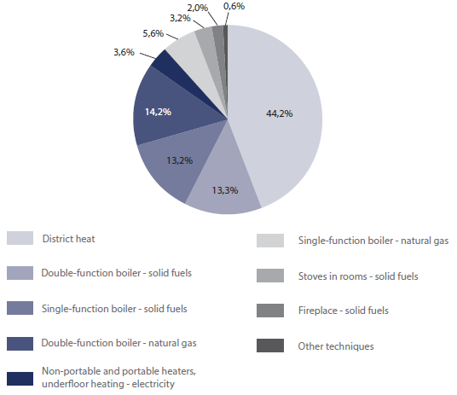
The most common way to obtain hot water was through a district heating installation
(37.8% of households), a significant share constituted also electric boilers or water heaters (19.4%) as well as bathroom heaters for natural gas (14.6%), while double-function boilers or water heaters for solid fuels were used in 14,9% of households and for natural gas in 11.8%.
Chart 2: Water heating by heating techniques in 2024
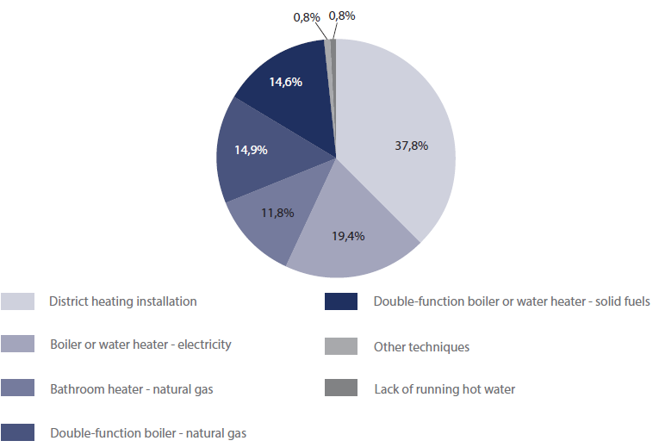

Households equippedwith energy-consuming appliances
Most households were well-equipped with basic energy-consuming devices, both those which satisfied the principal heating needs and those which improved the living comfort of inhabitants. A vast majority of households owned the most important electric appliances, such as TV sets (82.9%), automatic washing machines (86.3%), combined fridge-freezers (81.1%).
Energy poverty
Between 2012 and 2024, four measures of energy poverty showed a downward trend: Low Income, High Costs (LIHC), The ability to pay bills on time (Bills), Building with a leaking roof (Leaks), Insufficient thermal comfort (Thermal), meanwhile, Twice The Median of Energy Expenditure (2M) continued its upward trend. The highest value was recorded for Double Median of Energy Expenditures (2M), according to which in 2024, 20.1 % of households were characterised by energy poverty according to this measure, which means an increase
(by 0.6 percentage points) compared to 2012. The second of the objective indicators - High Costs, Low Income (LIHC), decreased from 11.1 % in 2012 to 9.1% in 2024, with a temporary increase recorded in 2020–2022.
Subjective indicators, which also relate to the severity of energy poverty, include The ability to pay bills on time(Bills) - only a negligible number (0.7% in 2024) of households were unable to pay their bills on time which is a decrease of 2.9 p.p. compared to 2015.
Two indicators related to the technical and functional qualities of the buildings (Leaks, Thermal) show clear improvement. In 2024, 3.5% households lived in buildings with leaking roofs, and 4.7% experienced insufficient thermal comfort. This represents a decrease of
7.0 percentage points (Leaks) and 8.4 percentage points (Thermal) compared to 2012.
Chart 3. Energy poverty
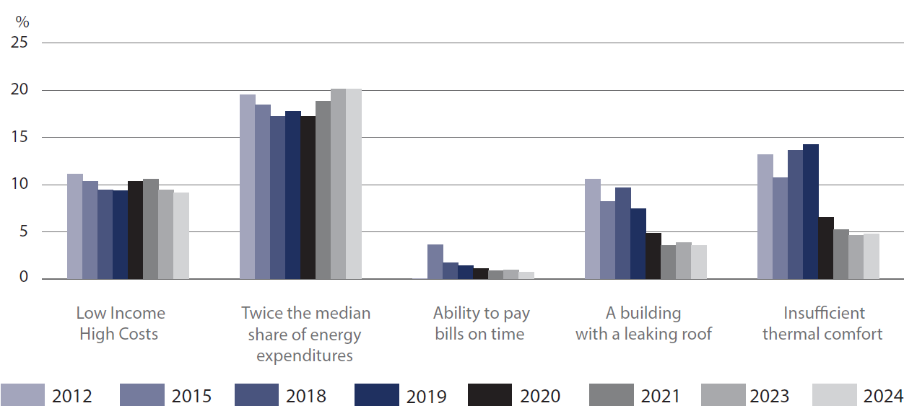

When quoting Statistics Poland data, please provide information: “Source of data: Statistics Poland”, and when publishing calculations made on data published by Statistics Poland, please provide information: “Own study based on Statistics Poland data”

Prepared by:  Statistical Office in Rzeszów  Director Teresa Krzemińska  Phone: (+48) 17 853 52 10,  (+48) 17 853 52 19 | Issued by:  Press Office  Mobile: (+48) 695 255 032  Phone: (+48 22) 608 38 04, (+48 22) 449 41 45,  (+48 22) 608 30 09  e-mail: obslugaprasowa@stat.gov.pl

stat.gov.pl/en/

@StatPoland

@GlownyUrzadStatystyczny

gus_stat

glownyurzadstatystycznygus

glownyurzadstatystyczny
Related information
Energy statistics
Energy efficiency in Poland 2013-2023
Data available in databases
Knowledge Database – Energy statistcs
Poland macroeconomic indicators
Macroeconomic Data Bank
Terms used inn official statistics
Primary energy
Derived energy
Energy consumption

Relative numbers were calculated on the basis of absolute data expressed with greater precision than given in the tables.

