Index of Services Production in October 2025
According to preliminary data, in October 2025 services production was higher by 5.6% than a year before (at that time, it was recorded an increase of 5.4%), and in relation to September 2025 increased by 1.4%.
5.6%
Increase in services production, compared with October 2024

Index of services production is the indicator measuring monthly changes in the volume of service production that is turnover in constant prices obtained on the market by service enterprises. The results apply to entities with 10 and more employees, which as their core activity provide services in the field of: transport and warehousing, accommodation and catering services, information technologies, data processing and other service activities in the field of information, real estate services, accounting activities, management, architecture and engineering, technical research and analysis, advertising and market research, rental and leasing, employment, tourism organisers, detective and security activities, maintaining order and cleaning inside and outside buildings of all types, and administrative office services.
After elimination of the impact of seasonal effects, in October 2025, services production was higher by 6.1% than in the corresponding month of the previous year, and in relation to September 2025 increased by 0.2%. Compared to monthly average production of services in 2021, services production increased by 28.1%.
After seasonal adjustment, the year-to-year increase in services production in October 2025 amounted to 6.1%

Chart 1. Services production (constant prices; monthly average 2021=100)
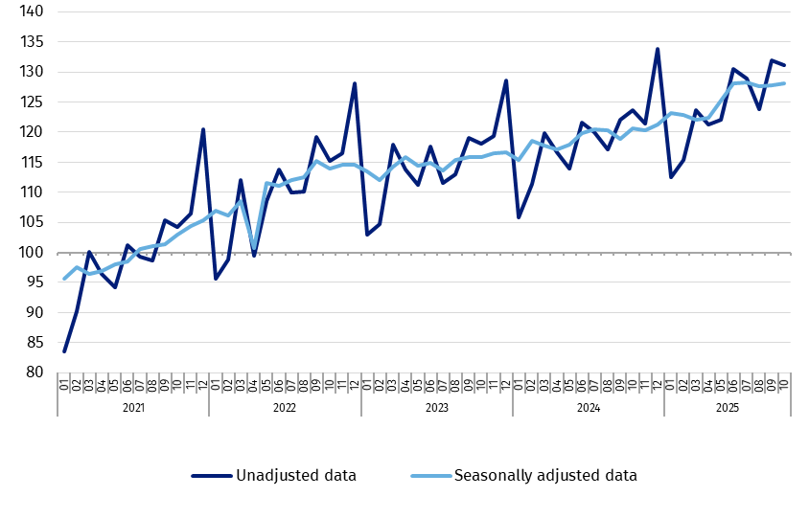

Chart 2. Services production (constant prices; monthly average 2021=100; unadjusted data)

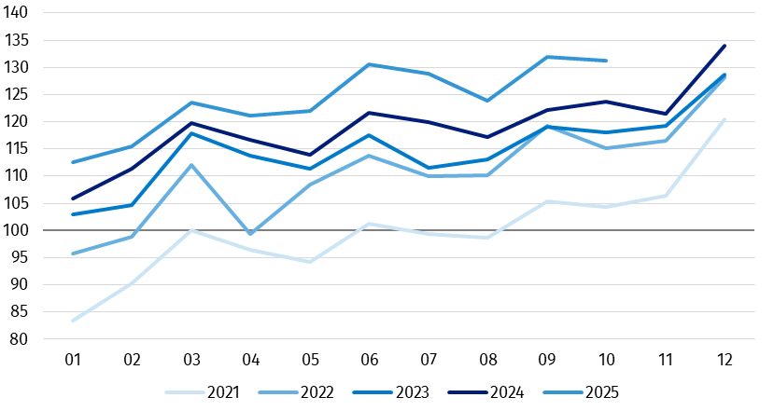

Specification | 09 2025 | 10 2025 | 09 2025 | 10 2025 | 09 2025 | 10 2025
Specification | previous  month=100 |  | corresponding month of the previous year=100 |  | monthly average 2021=100
TOTAL SERVICES | 106.9 | 101.4 | 107.5 | 105.6 | 131.9 | 131.2
Transportation and storage | 103.7* | 106.1 | 106.2* | 104.9 | 118.0* | 124.5
Accommodation and food service activities | 95.2 | 98.8 | 106.8 | 107.6 | 158.2 | 156.1
Information and communication | 110.3* | 99.1 | 109.3* | 105.6 | 145.5* | 142.1
Real estate activities | 102.9 | 99.8 | 101.9 | 102.5 | 110.1 | 110.4
Professional, scientific and technical activities | 114.0* | 97.8 | 109.6* | 110.0 | 139.1* | 136.2
Administrative and support service activities | 102.6* | 102.6 | 101.0* | 103.6 | 119.5* | 121.1

Table 1. Dynamics of services production (constant prices; unadjusted data)

* Data revised.
According to the preliminary data, in sections with the largest share in the total index, i.e. in Section J Information and communication and in Section H Transportation and storage, in October 2025, there was recorded an increase of 5.6% and 4.9%, respectively.

On the level of divisions, the highest increase of services production in comparison with October 2024 was recorded in the field of advertising and market research – of 28.3%, as well as in information service activities – of 20.6%.
The largest decrease in services production occurred in other professional, scientific and technical activities – of 11.8%, and in architectural and engineering activities, technical testing and analysis – of 8.9%.

Chart 3. Dynamics of services production in selected PKD 2007 divisions (constant prices; corresponding month of the previous year=100; unadjusted data)

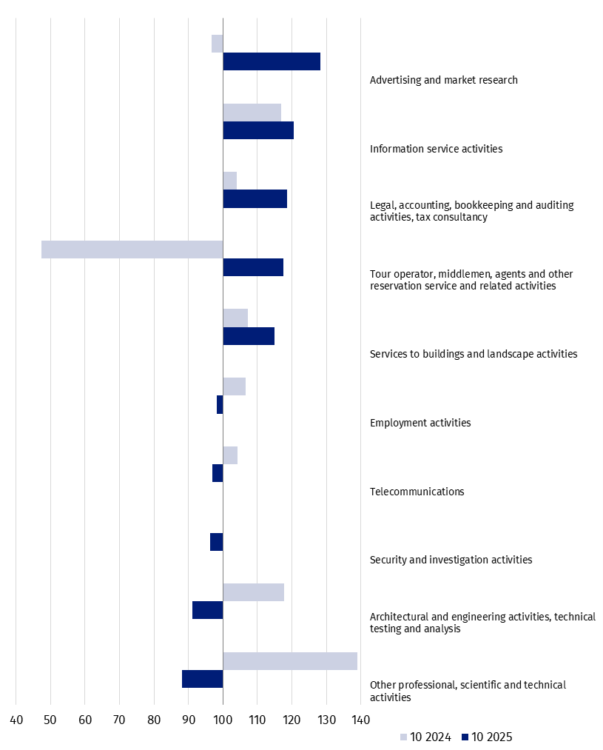

Compared to the previous month, in October 2025, total services production increased by 1.4%. In Section J Information and communication a decrease of 0.9% was observed, while in Section H Transportation and storage – an increase of 6.1%.
On the level of divisions the largest increase compared with September 2025 was observed in public and licence programmes broadcasting – of 11.7%, and Information service activities – of 7.4%.
The highest decrease was observed in tour operator, middlemen, agents and other reservation service and related activities – of 39.9%, and in motion picture, video and television programme production, sound recording and music publishing activities– of 10.3%.

Chart 4. Dynamics of services production in selected PKD 2007 divisions (constant prices; previous month=100; unadjusted data)²

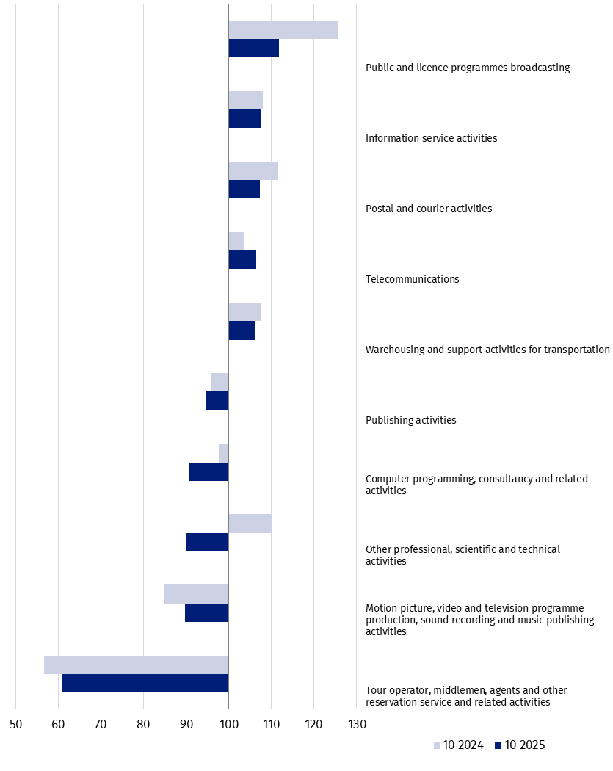

Methodological note
In accordance with the Commission Implementing Regulation (EU) 2020/1197 of 30 July 2020 laying down technical specifications and arrangements pursuant to Regulation (EU) 2019/2152 of the European Parliament and of the Council on European business statistics repealing 10 legal acts in the field of business statistics, the aggregate "Production of services" includes the following service activities according to the Polish Classification of Activities (PKD 2007):
- section H Transportation and storage;
- section I Accommodation and food service activities;
- section J Information and communication;
- section L Real estate activities;
- section M Professional, scientific and technical activities excluding activities of head offices and holding companies, excluding financial holding companies (M70.1), scientific research and development (M72), and veterinary activities (M75);
- section N Administrative and support service activities.
Index of services production was developed based on the data from the following sources:
- DG-1 Report on economic activity;
- SP Annual enterprise survey;
- Survey on prices of consumer goods and services;
- Survey on services producer prices;
- Survey on prices of residential premises.
Due to the current methodology for developing the total index of services production, and index of services production for different levels of aggregation (PKD 2007 divisions and sections), it is not recommended to calculate the indexes in relation to the previous month and the corresponding month of the previous year based on the provided indicators in relation to the monthly average of annual base year (2021=100). Due to the use of the weighting system, the indicators will differ. The methodology for calculating the index of services production is consistent with the guidelines of the OECD manual "Compilation Manual for an Index of Services Production".
The data concern service entities with 10 or more employees. The basic statistical unit for which the above data was developed is the "legal unit". The definitions of statistical units, including the "legal unit", was specified in Council Regulation (EEC) 696/93 of 15 March 1993 on the statistical units for the observation and analysis of the production system in the Community.

When quoting Statistics Poland data, please provide the information: “Source of data: Statistics Poland”, and when publishing calculations made on data published by Statistics Poland, please include the following disclaimer: “Own study based on figures from Statistics Poland”.
Prepared by:  Prices and Services Department  Director Ewa Adach-Stankiewicz  Phone: (+48 22) 608 31 24 | Issued by:  Press Office  Mobile: (+48) 695 255 032  Phone: (+48 22) 608 38 04, (+48 22) 449 41 45,  (+48 22) 608 30 09  e-mail: obslugaprasowa@stat.gov.pl

stat.gov.pl/en/

@StatPoland

@GlownyUrzadStatystyczny

gus_stat

glownyurzadstatystycznygus

glownyurzadstatystyczny
Related information
Index of Services Production in September 2025

Data available in databases
Knowledge Databases – Internal market – Services
Macroeconomic Data Bank – Monthly – Business services

Terms used in official statistics
Production of services

Professional, scientific and technical activities, excluding activities of head offices and holding companies, excluding financial holding companies (M70.1), scientific research and development (M72), and veterinary activities (M75).
Dynamics for all activities covered by the survey are presented in the enclosed XLSX file featuring charts. Dynamics of service production regarding water transport and air transport were not published due to statistical confidentiality.

