Index numbers of construction and assembly
production in December 2025
According to preliminary data construction and assembly production (in constant prices) carried out domestically was in December 2025 higher by 4.5% than in the same period of 2024 and higher by 36.2% compared to November 2025.
4.5%
Increase of construction and assembly production
compared to December 2024

After seasonally adjusted, the decrease was noted in construction and assembly production of 0.1% an annual

In December 2025, after eliminating the seasonal factors, construction and assembly production reached the level by 0.1% lower than in the corresponding month of the previous year and higher by 5.1% in comparison to November 2025.
Chart 1. Index numbers of construction and assembly production (constant prices; average monthly base 2021=100) ª
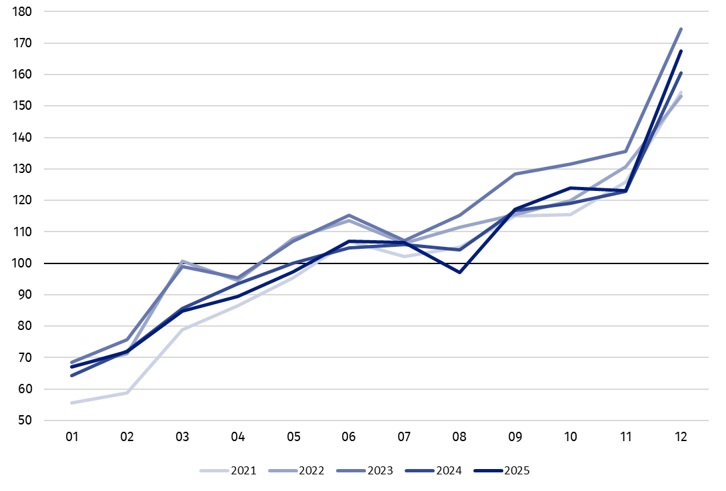
ª Preliminary data for December 2025.

The increase in construction and assembly production in December 2025 (in constant prices), compared to the average monthly value of 2021, was 67.6%.

Table 1. Index numbers of construction and assembly production (constant prices) ª
Specification | 12 2025 |  | 01‒12 2025
Specification | 11 2025=100 | 12 2024=100 | 01‒12 2024=100
CONSTRUCTION | 136.2 | 104.5 | 100.7
Construction of buildings ^{Δ} | 121.1 | 113.3 | 97.9
Civil engineering works ^{Δ} | 150.1 | 92.8 | 96.9
Specialised construction activities | 130.6 | 123.0 | 110.4
ª Data including final information on production and prices in November and preliminary data in December 2025.
^{Δ} Abbreviated form according to PKD 2007.

Construction and assembly production in December 2025 for entities performing specialised construction activities increased of 23.0% an annual, for entities dealing mainly with construction of buildings of 13.3%. The decrease was noted in entities whose basic type of activity was civil engineering of 7.2%.
In December 2025 compared to November 2025, an increase in the sales of construction and assembly production was noted in entities dealing mainly with civil engineering works of 50.1%, in entities performing specialised construction activities of 30.6% and in whose basic type of activity was construction of buildings of 21.1%.
In 2025 the construction and assembly production increased by 0.7%
In 2025, in relation to the same period of the previous year, an increase in the sales of construction and assembly production was noted of 0.7%. The increase was observed in entities performing specialised construction activities of 10.4%, whereas decreases were noted in entities dealing mainly with civil engineering works of 3.1% and whose basic type of activity was construction of buildings of 2.1%.
Analyzing the value of construction and assembly production in December 2025 in terms of construction works (investment and restoration works) were observed:
In December 2025 was noted an increase for restoration works of 5.2% and for investment works of 4.2% an annual
- an annual increase for restoration works by 5.2% and for investment works by 4.2% (in December 2024, a decrease for restoration and for investment of 8.0%),
- compared to November 2025, an increase for investment works by 42.1% and an increase by 24.0% for restoration works.
In 2025, in relation to the same period of the previous year, an increase in the sales of construction and assembly production were noted for investment works by 1.2% and a decrease for restoration works by 0.7% (in 2024, a decrease for investment works of 8.3% and for works restoration works of 6.1%).

In case of quoting Statistics Poland data, please provide information: “Source of data: Statistics Poland” and in case of publishing calculations made on data published by Statistics Poland, please include the following disclaimer: “Own study based on figures from Statistics Poland”.

Prepared by:  Statistical Office in Lublin  Director Krzysztof Markowski, Ph.D.  Phone: (+48) 695 255 301 | Issued by:  Press Office  Mobile: (+48) 695 255 032  Phone: (+48 22) 608 38 04, (+48 22) 449 41 45,  (+48 22) 608 30 09  e-mail: obslugaprasowa@stat.gov.pl

stat.gov.pl/en/

@StatPoland

@GlownyUrzadStatystyczny

gus_stat

glownyurzadstatystycznygus

glownyurzadstatystyczny
Related information
Statistical Bulletin
Socio-economic situation of the country
Data available in databases
Knowledge Database - Construction
Macroeconomic Data Bank
Macroeconomic indicators
Local Data Bank

Terms used in official statistics
Sale of construction and assembly production
Seasonally unadjusted index of sale of construction and assembly production in constant prices
Seasonally adjusted index of sale of construction and assembly production
Sale of construction works with an investment character
Sale of construction works with a restoration character and other works

Preliminary data; comprise enterprises employing over 9 persons, whose the main type of activity is included in the section F “Construction” in accordance with the Polish Classification of Activities (PKD 2007).

