Pig population as of December 2025
According to preliminary data, the population of pigs in December 2025 was 9 225.2 thousand heads showing an increase of 1.6% compared to the analogical period last year. The increased in numbers occurred in all production-use groups except fattening pigs.
1.6%
Increase in pig population in December 2025 y/y
The population of pigs in December 2025 was 9 225.2 thousand heads. The largest change in the herd structure was observed in fattening pigs. Their share decreased by 1.0 pp. compared to December 2024

At the beginning of December 2025, the pig population amounted to 9 225.2 thousand heads and was higher by 147 thousand heads (by 1.6%) than the state recorded in the analogical period of 2024, and compared with the number of pigs in June 2025 – higher by 101.7 thousands heads, i.e. by 1.1%.

Table 1. Pig population in thousands heads in December 2025
Specification | 12 2025 | 12 2024=100 | 06 2025=100
Pigs | 9 225.2 | 101.6 | 101.1
Piglets, less than 20 kg | 1 841.2 | 103.4 | 96.1
Pigs, from 20 kg to less than 50 kg | 2 712.7 | 103.7 | 106.2
Fattening pigs, 50 kg and over | 4 043.7 | 99.3 | 100.4
Breeding pigs 50 kg and over | 627.6 | 102.9 | 100.5
of which: total breeding sows | 618.2 | 103.1 | 100.6
of which: covered sows | 427.9 | 104.0 | 101.2

The herd of sows for breeding increased compared to December 2024 by 18.5 thousand heads (by 3.1%) to the level of 618.2 thousand heads, including the number of covered sows increased by 16.5 (by 4.0%) to 472.9 thousand heads. Compared to June 2025, the number of sows for breeding increased by 3.7 thousand heads (by 0.6%), including covered sows increased by 5.2 thousand heads, i.e. by 1.2%.

In the structure of the total pig herd, the share of individual production-use groups
The largest share in the herd structure was the population of fattening pigs - 43.8%
in December 2025 was:
- piglets, less than 20 kg – 20.0%,
- pigs, from 20 kg to less than 50 kg – 29.4%,
- fattening pigs, 50 kg and over – 43.8%,
- breeding pigs, 50 kg and over – 6.8%,
of which:
- total number of breeding sows – 6.8%,
- of which covered sows – 6.7%.

Chart 1. Pigs and sows population in December 2020-2025

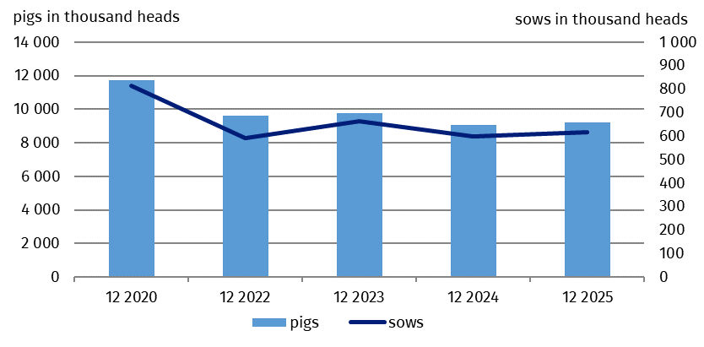
Compared to the structure of the pig population recorded at the beginning of December 2024, the proportion of pigs, from 20 kg to less than 50 kg (by 0.6 pp.), piglets (by 0.3 pp.) and breeding pigs (by 0.1 pp.) was increased in 2025. On the other hand, the proportion of fattening pigs 50 kg and over (by 1.0 pp.) was decreased in 2025.
Chart 2. Pig population structure in December 2024 and 2025 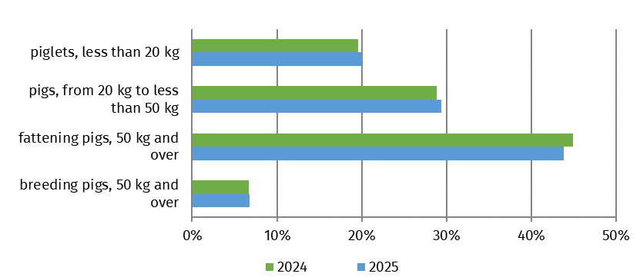

In the period from January to November 2025 (according to preliminary data) the import of live pigs amounted to 8 034.5 thousand heads and was by 3.2% higher than in the analogical period of the previous year, including the import of piglets and pigs weighing from 20 kg to 50 kg increased by 4.0%. The average weight of one imported pig during this period was 32.6 kg compared to 32.5 kg in 2024.
From January 1 to November 30 2025, pig import increased by 3.2% compared to the analogical period of the previous year
The largest shares in the national pig population were recorded in the following voivodeships: Wielkopolskie (24.9%), Mazowieckie (17.5%), Łódzkie (11.8%), Kujawsko-pomorskie (9.2%) and Pomorskie (9.0%). The lowest shares of pig population were recorded in voivodeships: Podkarpackie (0.8%), Lubuskie (0.9%) and Małopolskie (1.1%).
In December 2025, the purchase price of pigs for slaughter (PLN 5.22 per kg) was by 5.8% lower than in the previous month, and decreased by 16.7% year-on-year.
African swine fever (ASF) continues to be at risk. In the first half of 2025, the General Veterinary Inspectorate registered 18 outbreaks of ASF in pigs, the disease affected 19 265 animals.
Additional table on pig population by voivodeships is available in Excel file.

When quoting Statistics Poland data, please provide the information: “Source of data: Statistics Poland”, and when publishing calculations made on data published by Statistics Poland, please include the following disclaimer: “Own study based on figures from Statistics Poland”.
Prepared by:  Agriculture and Environment Department  Director Marta Wojciechowska  Phone: (+48 22) 608 31 28 | Issued by:  Press Office  Mobile: (+48) 695 255 032  Phone: (+48 22) 608 38 04, (+48 22) 449 41 45,  (+48 22) 608 30 09  e-mail: obslugaprasowa@stat.gov.pl
 | stat.gov.pl/en/
 | @StatPoland
 | @GlownyUrzadStatystyczny
 | gus_stat
 | glownyurzadstatystycznygus
 | glownyurzadstatystyczny
Related information
Farm animals in 2024
Data available in databases
Local Data Bank
Terms used in official statistics
Pigs

Preliminary generalised results of a representative survey of pig population and pig production comprising: - all holdings of legal persons and unincorporated entities, - selected individual holdings (30 thousand holdings - sample of approximately 2.0%).

