Price indices of residential premises
in the first quarter of 2025

In the first quarter of 2025 prices of residential premises in Poland compared to the previous quarter, increased by 0.7%. On the primary market the increase was 0.9%, while on the secondary market it was 0.5%. Compared to the corresponding quarter of 2024, prices of residential premises increased by 6.6% (of which on the primary market
– by 7.0% and on the secondary market – by 6.2%).
6.6%
Increase in prices of residential premises compared to the 1st quarter of 2024

Table 1. Price indices of residential premises in the first quarter of 2025
Specification | Q1 2025
Specification | Q4 2024=100 | Q1 2024=100 | 2015=100
Total | 100.7 | 106.6 | 213.2
Primary market | 100.9 | 107.0 | 202.3
Secondary market | 100.5 | 106.2 | 221.3
Chart 1. Weighting system used in the compilations of price indices of residential premises
in 2025
For compiling price indices
of residential premises
in 2025, the primary market
is assigned a weight of 46.3% and the secondary market
53.7%
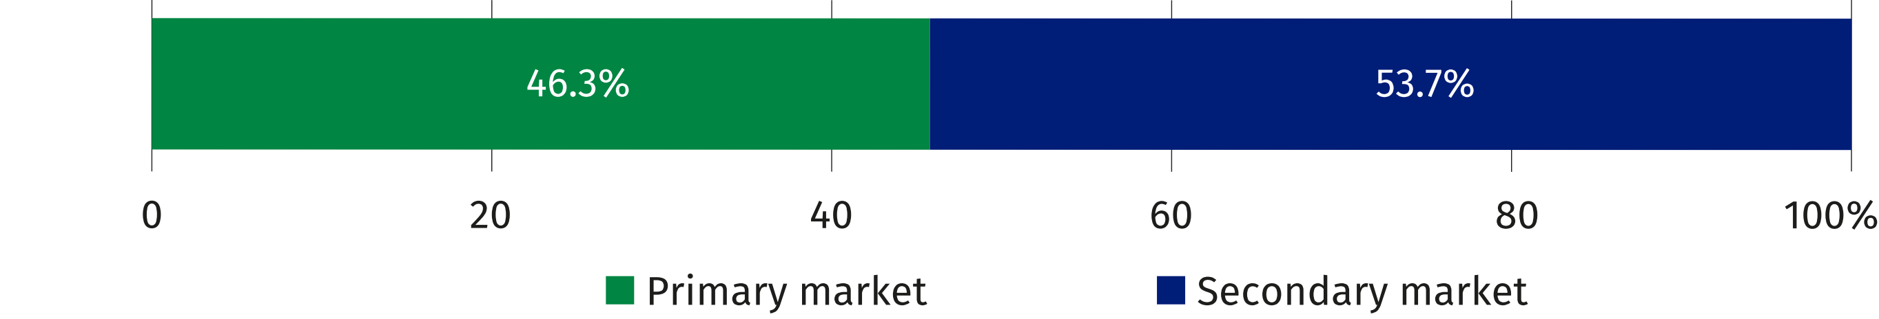

Chart 2. Changes in prices of residential premises compared to the previous quarter
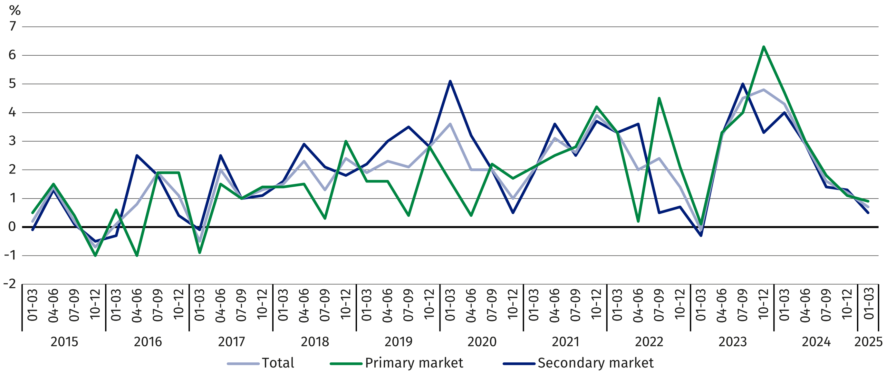

Chart 3. Changes in prices of residential premises compared to the corresponding
quarter of the previous year
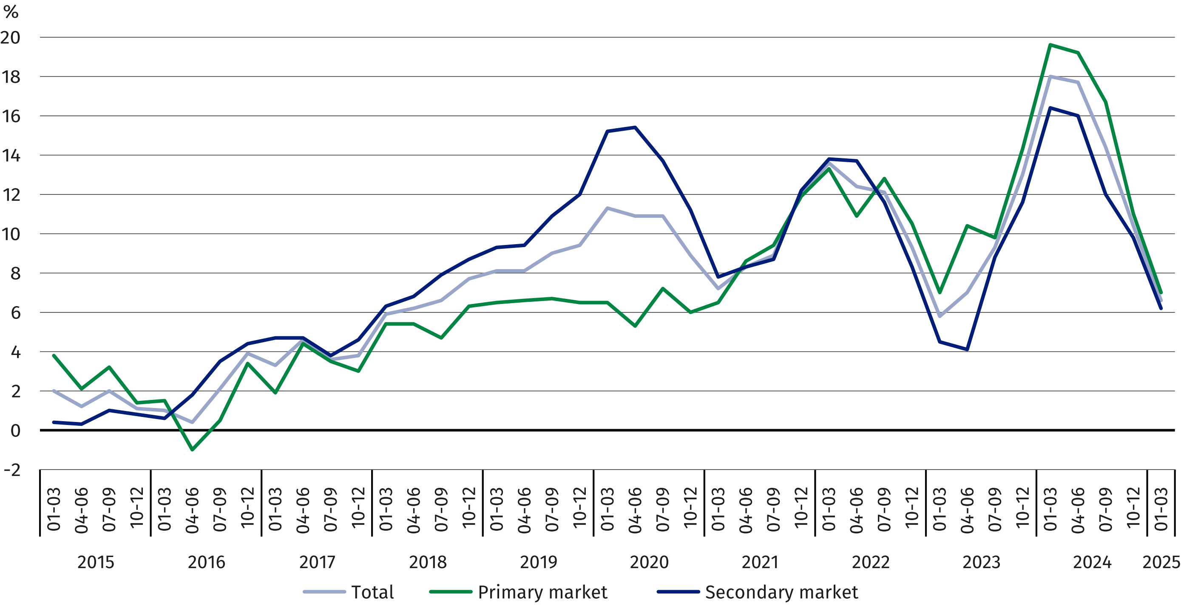

Chart 4. Changes in prices of residential premises compared to 2015
In the first quarter of 2025 prices of residential premises were
by 113.2% higher compared
to the average price for 2015
(of which on the primary market – by 102.3% and on the secon-dary market – by 121.3%)

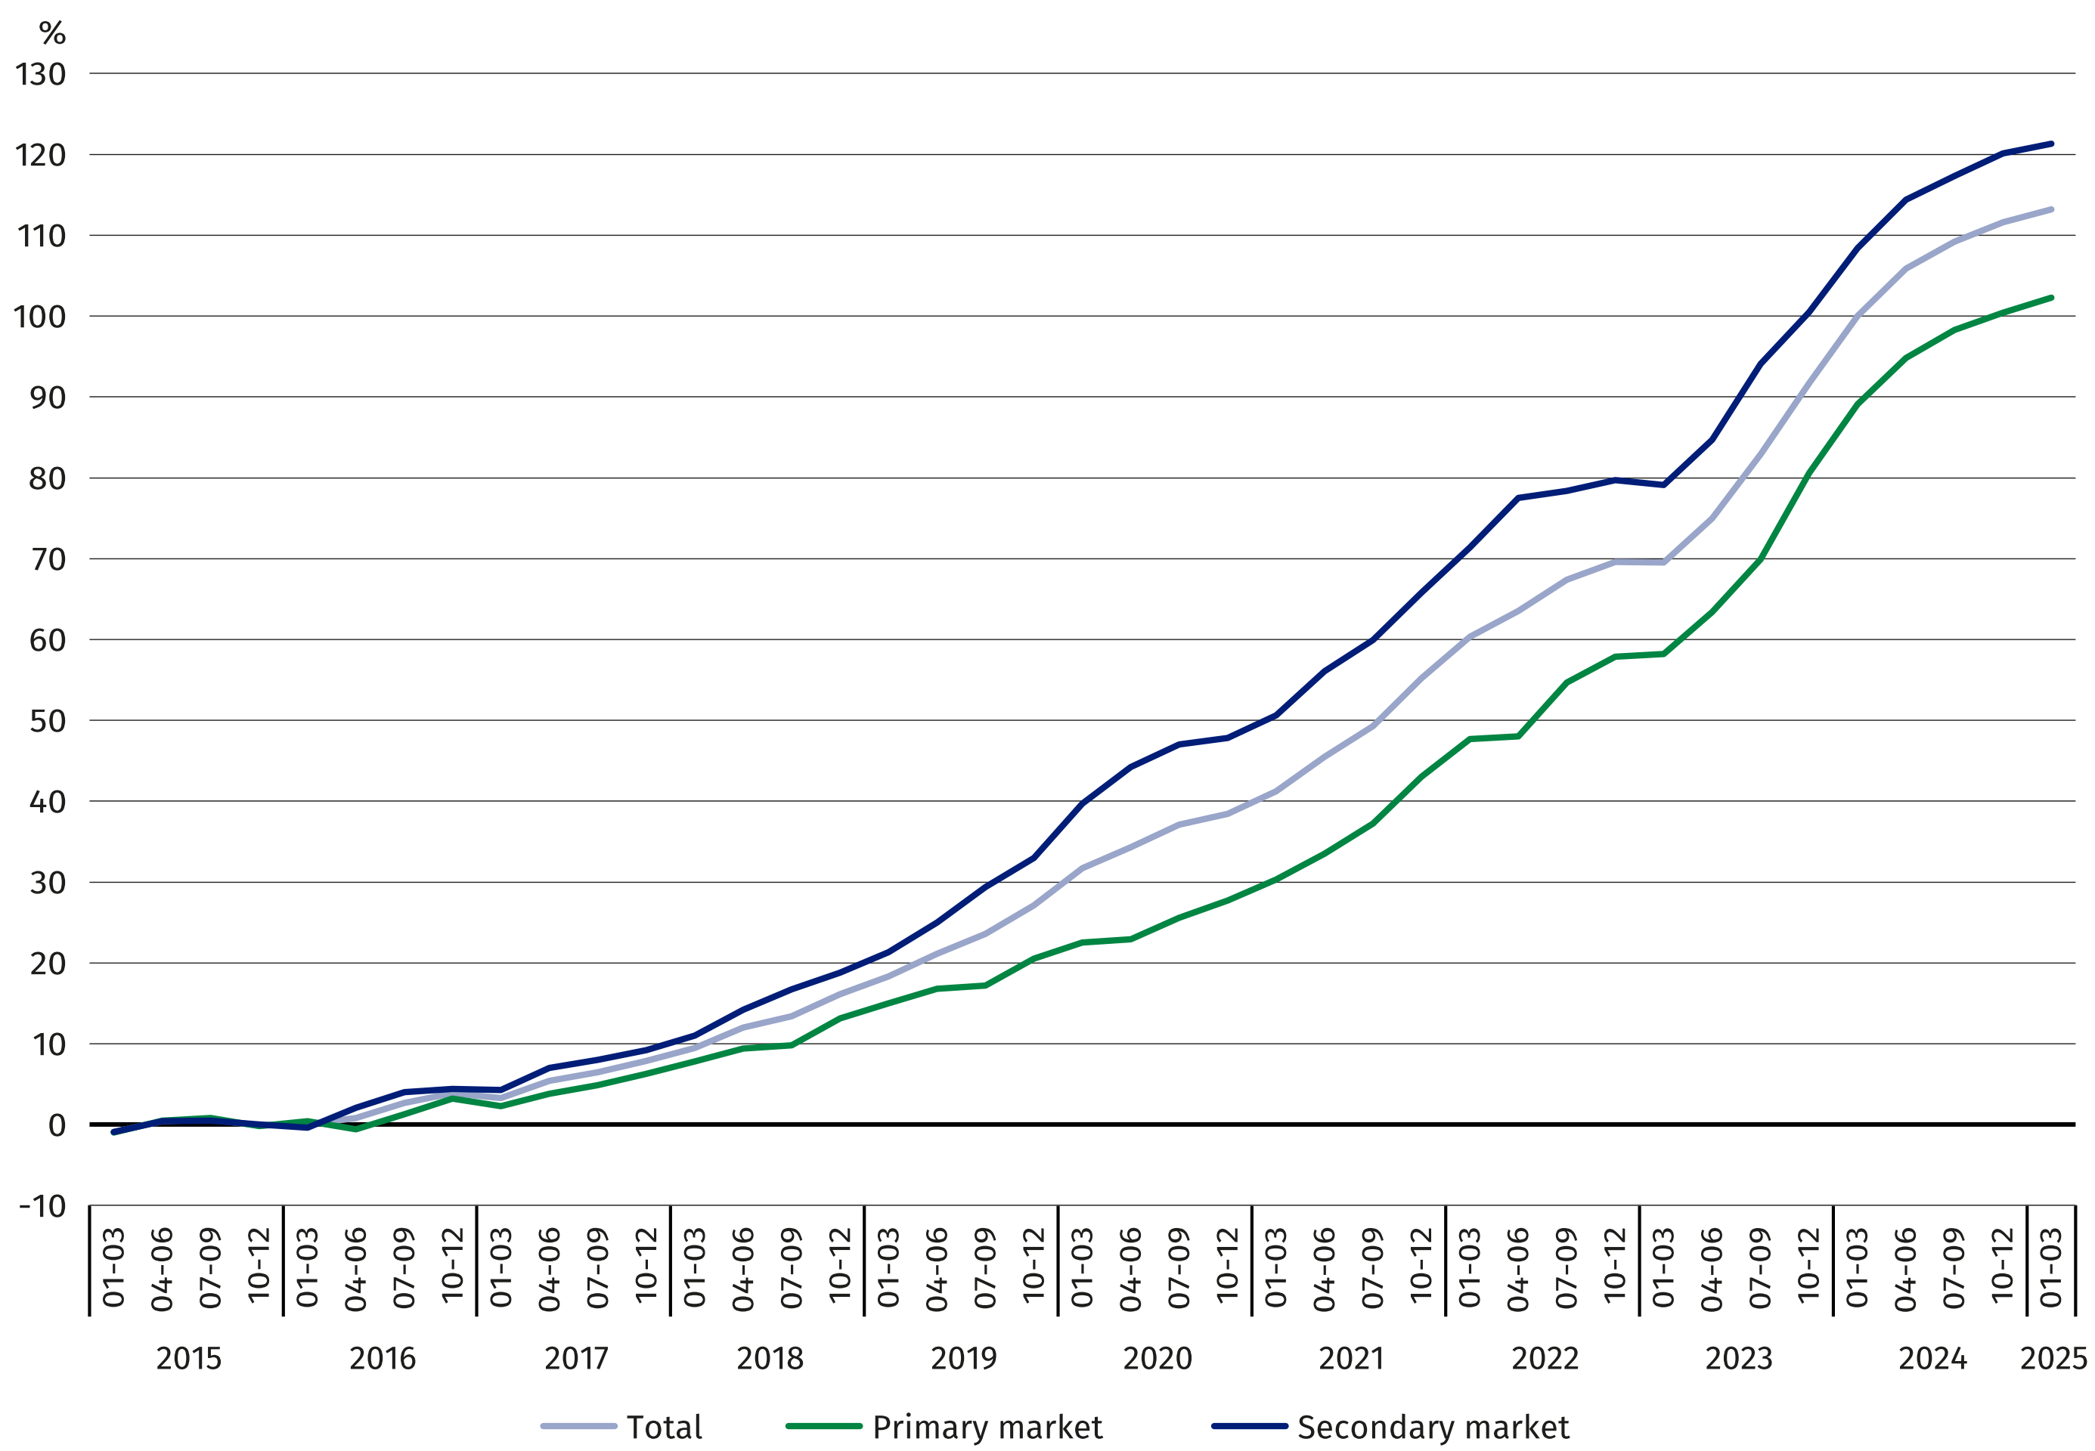

Table 2. Price indices of residential premises by voivodships in the first quarter of 2025
In the first quarter of 2025, the highest increase in prices
of residential premises,
compared to the previous
quarter, was recorded in both the Mazowieckie Voivodship
(by 2.0%); a decrease was
recorded in two voivodships: the Małopolskie Voivodship
– by 0.3% and Śląskie Voivodship – by 0.2%
Specification | Q1 2025
Specification | Q4 2024=100 | Q1 2024=100
Poland | 100.7 | 106.6
Dolnośląskie | 100.0 | 108.2
Kujawsko-pomorskie | 100.3 | 107.7
Lubelskie | 101.4 | 109.1
Lubuskie | 100.5 | 104.8
Łódzkie | 100.2 | 104.3
Małopolskie | 99.7 | 102.9
Mazowieckie | 102.0 | 106.5
Opolskie | 100.2 | 105.4
Podkarpackie | 100.8 | 104.1
Podlaskie | 100.7 | 112.5
Pomorskie | 100.7 | 108.0
Śląskie | 99.8 | 109.0
Świętokrzyskie | 100.3 | 106.6
Warmińsko-mazurskie | 101.3 | 102.6
Wielkopolskie | 100.4 | 107.9
Zachodniopomorskie | 100.2 | 102.1
In case of quoting Statistics Poland data, please provide information: “Source of data: Statistics Poland”, and in case of publishing calculations made on data published by Statistics
Poland, please include the following disclaimer: “Own study based on figures from Statistics Poland”.

Prepared by:  Statistical Office in Szczecin  Deputy Director Katarzyna Dmitrowicz-Życka  Phone: 91 459 77 00 | Issued by:  Press Office  Mobile: (+48) 695 255 032  Phone: (+48 22) 608 38 04, (+48 22) 449 41 45,  (+48 22) 608 30 09  e-mail: obslugaprasowa@stat.gov.pl

www.stat.gov.pl/en/

@StatPoland

@GlownyUrzadStatystyczny

gus_stat

glownyurzadstatystycznygus

glownyurzadstatystyczny
Related information
Price indices of residential premises by voivodships
Price of one square meter of usable floor space of a residential building in the first quarter of 2025
Real estate sales in 2023
Data available in databases
Knowledge Databases (DBW) – Economy – Prices – Real estate prices
Local Data Bank – Real estate market
Terms used in official statistics
Real estate turnover
Real Estate Price Register
Premises
Price indices of residential premises

