Consumer price indices in January 2026
(preliminary data)
Final data for January 2026 will be published 13.03.2026
2.2%
price increase compared with January 2025
According to preliminary data, in January 2026 consumer prices increased by 2.2% compared with the corresponding month of the previous year. As related to the previous month consumer prices increased by 0.6%.

Table 1. Consumer price indices in January 2026 (preliminary dataª)
Specification | 01 2026ª
Specification | 01 2025=100 | 12 2025=100
Total | 102.2 | 100.6
Food and non-alcoholic beverages | 102.4 | 101.3
Alcoholic beverages and tobacco | 107.0 | 100.7
Dwelling | 102.9 | 101.3
of which:
electricity, gas and other fuels | 103.4 | 101.9
Transport | 94.1 | 97.9
of which:
fuels for personal transport equipment | 92.9 | 97.6
NOTE: Starting with data for 2026, the CPI is calculated according to the international COICOP 2018 classification. Current information on the implementation of the classification is available on the Statistics Poland website: Current information on inflation.

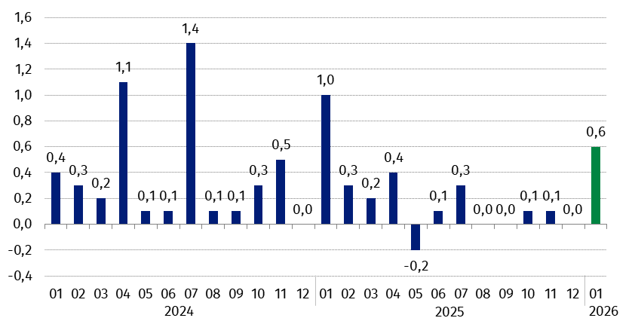
Chart 1. Changes in consumer prices as related to the previous month (in %)
2026

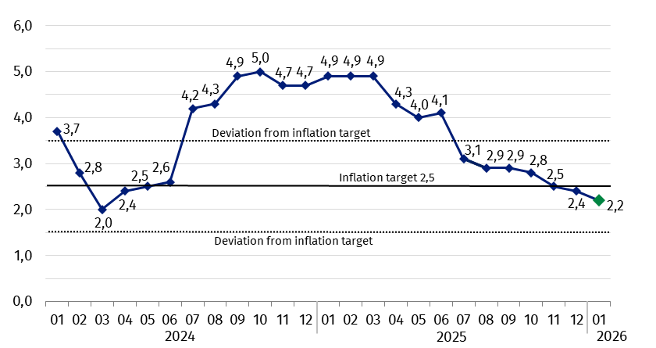
Chart 2. Changes in consumer prices^{b} as related to the corresponding period of the previous year (in %)
According to preliminary data in January 2026 the consumer price index was within the deviations from inflation target determined by the Monetary Policy Council (2.5% +/- 1 pp)

Chart 3. Weighting system used in the compilations of consumer price indices in 2025
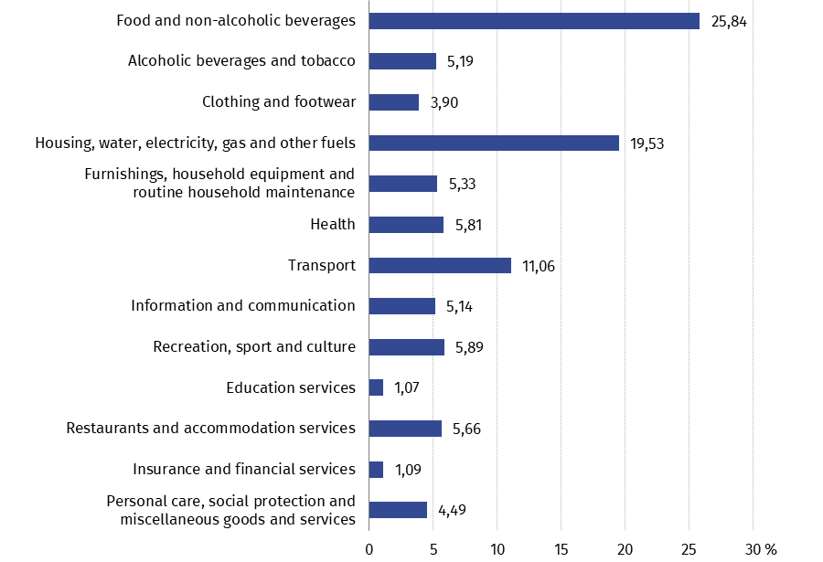
In case of quoting Statistics Poland data. please provide information: “Source of data: Statistics Poland”. and in case of publishing calculations made on data published by Statistics Poland. please include the following disclaimer: “Own study based on figures from Statistics Poland”.
Prepared by:  Prices and Services Department  Director Ewa Adach-Stankiewicz  Phone: (+48 22) 608 31 24 | Issued by:  Press Office  Mobile (+48) 695 255 032  Phone (+48 22) 608 38 04  (+48 22) 608 30 09  (+48 22) 449 41 45  e-mail: obslugaprasowa@stat.gov.pl

stat.gov.pl/en/

@StatPoland

@GlownyUrzadStatystyczny

gus_stat

glownyurzadstatystycznygus

glownyurzadstatystyczny
Related information
Communications and Announcements
News releases
Information on the implementation of the COICOP 2018 classification with 2026 data
Data available in databases
Knowledge Database Prices
Macroeconomic Data Bank
Local Data Bank
Price indices (Topics: Prices. Trade)
Prices (Topics: Prices. Trade)
Terms used in official statistics
Price index of consumer goods and services
Retail price

Data is preliminary and is presented in a narrower scope. It is calculated based on the structure of households’ expenditure (excluding own consumption) from 2024.
Final data with the exception of the preliminary data for January 2026.
Structure of households’ expenditure (excluding own consumption) from 2024 according to COICOP 2018 classification.

