Construction and assembly production in January 2026
Construction and assembly production results in January 2026 were significantly impacted by exceptionally unfavorable weather conditions.
A significant decrease in production compared to December 2025 occurred particularly in activities related to civil engineering (including road and bridge construction), which are most dependent on weather conditions.
According to preliminary data construction and assembly production (in constant prices) carried out domestically was in January 2026 lower by 12.8% than in the same period of 2025 and lower by 65.2% compared to December 2025.
12.8%
Decrease of construction and assembly production
compared to January 2025

In January 2026, after eliminating the seasonal factors, construction and assembly production reached the level by 10.8% lower than in the corresponding month of the previous year and lower by 8.9% in comparison to December 2025.
Chart 1. Construction and assembly production (constant prices; average monthly base 2021=100)ª
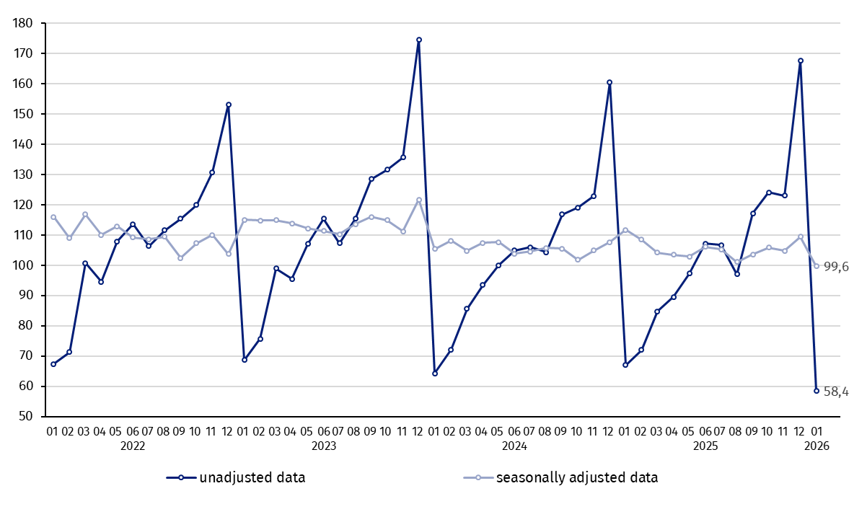
ª Preliminary data for January 2026.

The decrease in construction and assembly production in January 2026 (in constant prices), compared to the average monthly value of 2021, was 41.6%.

Table 1. Construction and assembly production (constant prices) ª
Specification | 01 2026
Specification | 12 2025=100 | 01 2025=100
CONSTRUCTION | 34.8 | 87.2
Construction of buildings ^{Δ} | 45.7 | 81.6
Civil engineering works ^{Δ} | 25.1 | 92.5
Specialised construction activities | 41.6 | 88.1
ª Data including final information on production and prices in December 2025 and preliminary data in January 2026.
^{Δ} Abbreviated form according to PKD 2007.

Construction and assembly production in January 2026 decreased for entities dealing mainly with construction of buildings of 18.4% an annual, for entities performing specialised construction activities of 11.9% and in entities whose basic type of activity was civil engineering of 7.5%.
In January 2026 compared to December 2025, decreases in the sales of construction and assembly production were noted in entities dealing mainly with civil engineering works of 74.9%, in entities performing specialised construction activities of 58.4% and in whose basic type of activity was construction of buildings of 54.3%.

Analyzing the value of construction and assembly production in January 2026 in terms of construction works (investment and restoration works) were observed:
In January 2026 was noted a decrease for restoration works of 28.3% and for investment works of 3.9% an annual
- an annual decrease for restoration works by 28.3% and for investment works by 3.9% (in January 2025, increases for restoration and for investment of 2.8% and 5.0% respectively),
- compared to December 2025, a decrease for investment works by 65.5% and by 64.3% for restoration works.

In case of quoting Statistics Poland data, please provide information: “Source of data: Statistics Poland” and in case of publishing calculations made on data published by Statistics Poland, please include the following disclaimer: “Own study based on figures from Statistics Poland”.

Prepared by:  Statistical Office in Lublin  Director Krzysztof Markowski, Ph.D.  Phone: (+48) 695 255 301 | Issued by:  Press Office  Mobile: (+48) 695 255 032  Phone: (+48 22) 608 38 04, (+48 22) 449 41 45,  (+48 22) 608 30 09  e-mail: obslugaprasowa@stat.gov.pl

stat.gov.pl/en/

@StatPoland

@GlownyUrzadStatystyczny

gus_stat

glownyurzadstatystycznygus

glownyurzadstatystyczny
Related information
Statistical Bulletin
Socio-economic situation of the country
Data available in databases
Knowledge Database - Construction
Macroeconomic Data Bank
Macroeconomic indicators
Local Data Bank

Terms used in official statistics
Sale of construction and assembly production
Seasonally unadjusted index of sale of construction and assembly production in constant prices
Seasonally adjusted index of sale of construction and assembly production
Sale of construction works with an investment character
Sale of construction works with a restoration character and other works

Preliminary data; comprise enterprises employing over 9 persons, whose the main type of activity is included in the section F “Construction” in accordance with the Polish Classification of Activities (PKD 2007).

