Retail sales in January 2026
In January 2026 retail sales at constant prices were by 4.4% higher than the year before (against an increase of 4.9 in January 2025).
4.4%
An increase compared with
the corresponding month of the previous year
Compared with December 2025, there was a decrease by 17.8% in retail sales.

Retail sales seasonally adjusted
In January 2026, an increase of 5.1% in retail sales seasonally adjusted was recorded in comparison with January 2025
After eliminating the seasonal factors, in January 2026 retail sales at constant prices were by 5.1% higher than in the corresponding month of 2025 and increased by 0.5% compared with December 2025.
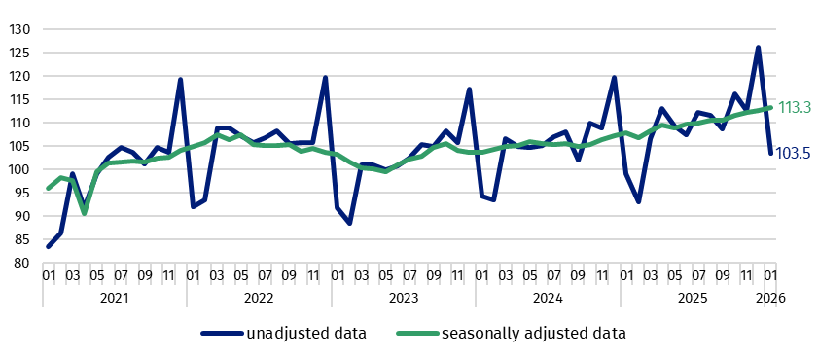
Chart 1. Retail sales (constant prices, monthly average 2021=100)

Chart 2. Retail sales (constant prices, corresponding period of previous year=100)
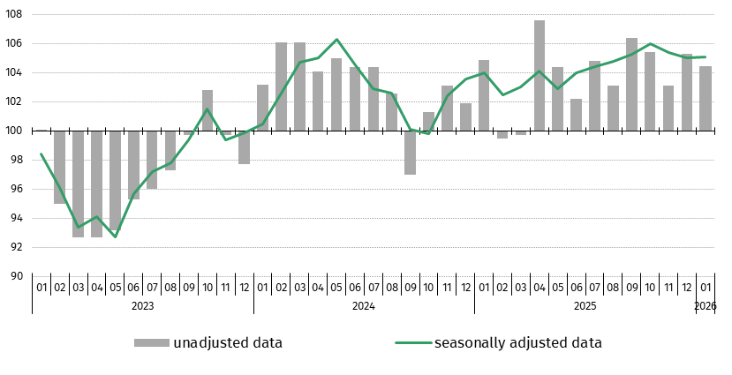

Retail sales of goods by predominant type of enterprise activity
In January 2026, an increase in retail sales y/y was recorded in most groups
In January 2026, retail sales (at constant prices) compared with the corresponding period of 2025 increased significantly in the groups: “textiles, clothing, footwear” (by 17.6%), “furniture, radio, TV and household appliances” (by 10.5%), “pharmaceuticals, cosmetics, orthopaedic equipment” (by 9.6%) and “newspapers, books, other sale in specialized stores” (by 8.1%).
In the group with the highest share in “total” retail sales - “food, beverages and tobacco products” an increase in sales of 4.2% was observed. Among presented groups a decrease in sales was noted in the group “motor vehicles, motorcycles, parts” (by 4.5%).
In January 2026, the value of retail sales via Internet at current prices was by 10.9% higher than a year ago, and the share of sales via Internet in “total” sales increased from 9.1% to 9.7%. Among the presented groups with a significant share of sales via Internet an increase in share was reported by enterprises from groups “furniture, radio, TV and household appliances” (from 18.1% a year ago to 19.3%) and “newspapers, books, other sale in specialized stores” (respectively from 19.9% to 20.7%). On the other hand a decrease in share was shown by units from the group “textiles, clothing, footwear” (from 29.0% to 26.3%).
Chart 3. Retail sales of goods in January 2026 by groups (constant prices, corresponding period of previous year=100
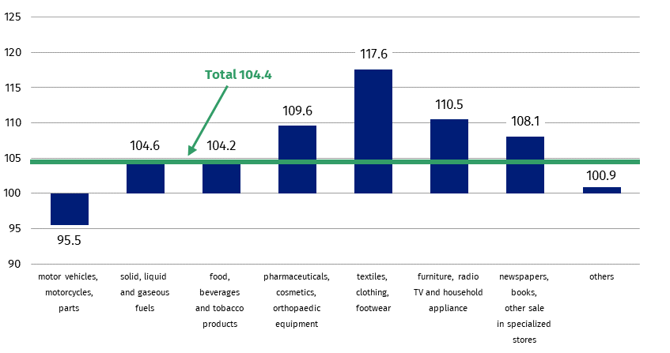

Table 1. Index numbers and structure of retail sales
Specification | Constant prices |  | Current prices
Specification | 01 2026 |  | 01 2026
Specification | 12 2025=100 | 01 2025=100 | 12 2025=100 | 01 2025=100 | Structure  in %
Total | 82.2 | 104.4 | 82.1 | 103.9 | 100.0
of which:
Motor vehicles, motorcycles, parts | 78.6 | 95.5 | 78.2 | 89.5 | 7.5
Solid, liquid and gaseous fuels | 89.5 | 104.6 | 88.1 | 99.0 | 12.0
Food, beverages and tobacco products | 83.3 | 104.2 | 84.3 | 107.5 | 26.7
Other retail sale in non-specialized stores | . | . | . | . | .
Pharmaceuticals, cosmetics, orthopaedic equipment | 87.4 | 109.6 | 88.1 | 111.6 | 8.9
Textiles, clothing, footwear | 84.4 | 117.6 | 81.2 | 114.7 | 6.0
Furniture, radio, TV and household appliances | 77.0 | 110.5 | 77.2 | 109.0 | 7.9
Newspapers, books, other sale in specialized stores | 60.0 | 108.1 | 60.4 | 108.8 | 3.6
Others | 80.3 | 100.9 | 80.3 | 101.5 | 9.3
(.) Data not available, classified data (statistical confidentiality) or providing data impossible or purposeless
Methodological notes
The data presented in this news release concerns trade and non-trade enterprises employing more than 9 persons. Groups of enterprises were created on the basis of the Polish Classification of Activities (PKD 2007) and a given enterprise is included to a specific category by predominating kind of activity and according to its present organizational status in mentioned period. The recorded changes of rise or fall of the dynamics of retail sales in particular groups of enterprises activity may result from a change in the predominating kind of activity and organisational changes (e.g. a merger of enterprises). This does not have impact on the dynamics of the total retail sales.
The adjusted data for 2021-2025 has been corrected compared to the data presented in the previous news releases.
The published monthly information on trade activity, in addition to retail sales, also includes data on the volume of sales by kind-of-activity unit (KAU), which is compiled for the needs of European statistics. The volume of sales (constant prices 2021=100) includes divisions and groups of Section G according to PKD 2007 - "Wholesale and retail trade; repair of motor vehicles and motorcycles”. The data is disseminated on the website of the Statistics Poland: Knowledge Databases - Short-Term Statistics data by KAU

When quoting Statistics Poland data, please provide the information: “Source of data: Statistics Poland”, and when publishing calculations made on data published by Statistics Poland, please include the following disclaimer: “Own study based on figures from Statistics Poland”.

Prepared by:  Prices and Services Statistics Department  Director Ewa Adach-Stankiewicz  Phone: (+48 22) 608 31 24, (+48) 695 255 067 | Issued by:  Press Office  Mobile: (+48) 695 255 032  Phone: (+48 22) 608 38 04, (+48 22) 449 41 45,  (+48 22) 608 30 09  e-mail: obslugaprasowa@stat.gov.pl

stat.gov.pl/en/

@StatPoland

@GlownyUrzadStatystyczny

gus_stat

glownyurzadstatystycznygus

glownyurzadstatystyczny
Related information
Internal market in 2024
Socio-economic situation of the country
Statistical Bulletin
Data available in databases
Knowledge Database - Internal market
Local Data Bank
Macroeconomic Data Bank
Terms used in official statistics
Retail sales of goods
Kind-of-activity unit

Preliminary data
The volume of sales is defined as turnover in trade deflated by price index i.e. turnover at constant prices (2021=100).

