Prices of agricultural products in January 2026
Procurement prices of basic agricultural products decreased in January 2026 both in comparison with the previous month (by 4.5%) and compared to the corresponding period of 2025 (by 8.4%).
8.4%
decrease in procurement prices of basic agricultural products in comparison with January 2025

Chart 1. Changes in procurement prices of basic agricultural products in relation to the previous month
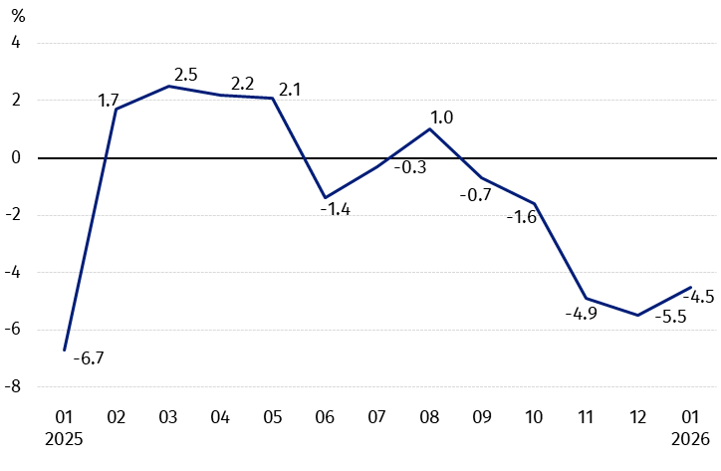
In January 2026, in comparison with December 2025, the procurement prices of basic agricultural products decreased except for wheat and rye

Chart 2. Changes in procurement prices of basic agricultural products in relation to the corresponding month of the previous year
Procurement prices of basic agricultural products, except for cattle and poultry for slaughter, were lower in January 2026 than those recorded in January 2025

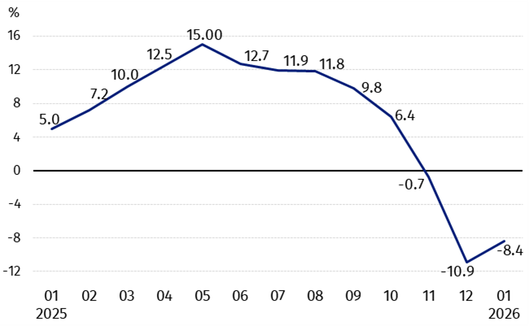

Procurement prices and marketplace prices received by farmers
In January 2026, the majority of cereal grain were sold at the higher procurement prices than in the previous month, while the prices of animals for slaughter were lower. At marketplaces, there was more paid for the most agricultural products except for rye and maize. At the both markets, prices of wheat, triticale and potatoes increased.
Compared to the corresponding month of 2025, in January 2026 there was recorded the decrease in prices of the agricultural products both in procurement and at the marketplaces, except for cattle and poultry for slaughter in procurement.
Table 1. Prices of agricultural products (excluding VAT) in January 2026
Specification | Procurement prices |  |  | Marketplaces prices
Specification | 01 2026
Specification | in zloty | 12 2025 =100 | 01 2025 =100 | in zloty | 12 2025 =100 | 01 2025 =100
Cereal grain – per dt
Wheat | 74.91 | 101.5 | 81.9 | 104.46 | 100.5 | 92.6
Rye | 61.27 | 101.2 | 87.8 | 79.12 | 96.9 | 91.5
Barley | 75.23 | 99.7 | 90.2 | 100.87 | 101.3 | 94.1
Triticale | 70.24 | 104.2 | 87.3 | 91.55 | 101.4 | 95.4
Oat | 55.32 | 86,0 | 67.8 | 89.27 | 100.2 | 88.7
Maize | 73.81 | 117.8 | 88,0 | 115.12 | 97.1 | 96.2
Potatoes – per dt | 81.96 | 146.8 | 74.4 | 179.34 | 103.4 | 84.6
Animals for slaughter – per kg
Cattle (excl. calves) | 15.31 | 93.9 | 126.8 | 12.07 | 101.5 | 99.7
of which young cattle | 15.72 | 91.7 | 127.1 | . | . | .
Pigs | 4.75 | 91.1 | 82.8 | . | . | .
Poultry | 5.68 | 97.8 | 102.2 | . | . | .
Cows’ milk – per hl | 188.86 | 94.8 | 82.3 | . | . | .
Data on procurement prices were calculated on the basis of information on value and quantity of procurement by legal persons and independent organizational entities without legal personality (without natural persons).
Indices of procurement prices and prices received by farmers at marketplaces were calculated on the basis of absolute data expressed with more precision than in the tables.

Prices of major agricultural products in January 2026
In January 2026, PLN 74.91 was paid per dt of wheat in procurement, i.e. 1.5% more than in the previous month, but 18.1% less than a year ago. At the marketplaces, the price of wheat (PLN 104.46 per dt) increased by 0.5% in comparison with December 2025, but it decreased by 7.4% compared to January 2025.
The procurement price of rye (PLN 61.27 per dt) was higher by 1.2% in comparison with December 2025, but it was lower by 12.2% than in January 2025. The price of rye at the marketplace (PLN 79.12 per dt) decreased both on a monthly basis (by 3.1%) and on an annual basis (by 8.5%).
In January 2026, PLN 81.96 was paid per dt of potatoes in procurement, i.e 46.8% more than in the previous month, but 25.6% less than in the corresponding period of 2025. At the marketplaces, the price of potatoes (PLN 179.34 per dt) increased by 3.4% in comparison with December 2025, but it decreased by 15.4% compared to January 2025.
The procurement price of cattle of slaughter (PLN 15.31 per kg) was lower by 6.1% on a monthly basis, but it was higher by 26.8% on an annual basis. At the marketplaces, cattle for slaughter (PLN 12.07 per kg) were sold more expensive compared to December 2025 (by 1.5%), but cheaper in comparison with January last year (by 0.3%).
In January 2026, PLN 4.75 was paid per kg of pigs for slaughter in procurement, i.e. 8.9% less than a month ago and 17.2% less than a year ago.
The procurement price of poultry for slaughter (PLN 5.68 per kg) decreased by 2.2% in the comparison with December 2025, while the price increased by 2.2% compared to January last year.
PLN 188.86 was paid in procurement per hl of cows’ milk, i.e. 5.2% less than in the previous month and 17.7% less than a year ago.

Chart 3. Procurement and marketplaces prices of wheat and rye

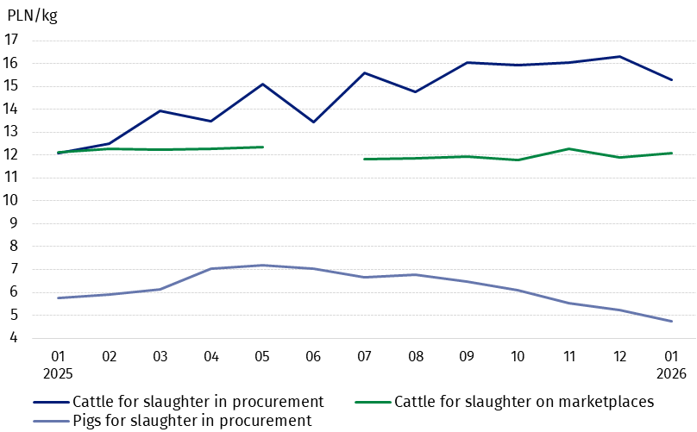

Chart 4. Procurement and marketplaces prices of potatoes

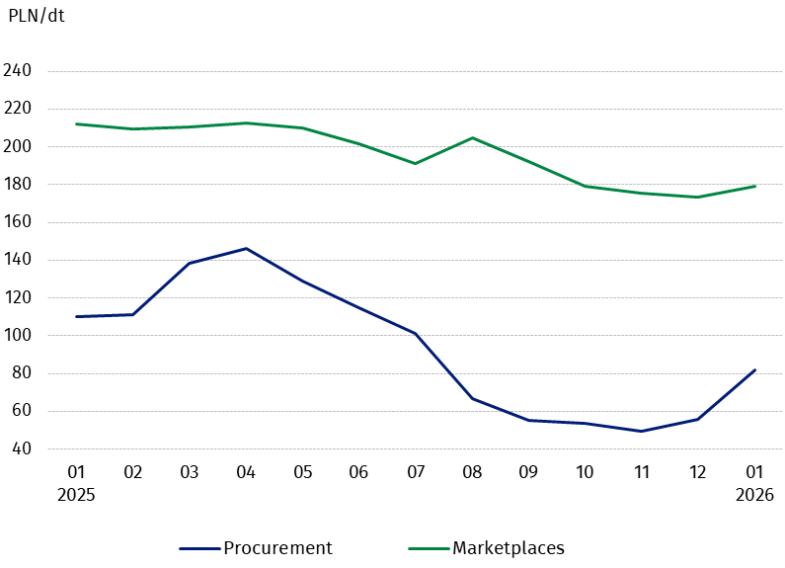

Chart 5. Procurement and marketplaces prices of cattle for slaughter and procurement prices of pigs for slaughter
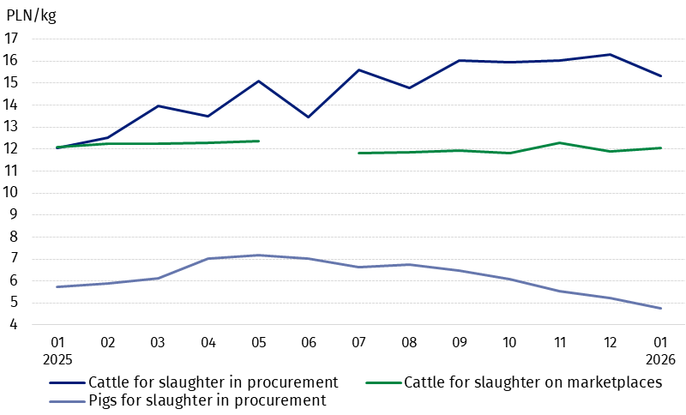

Chart 6. Procurement prices of poultry for slaughter and cows’ milk
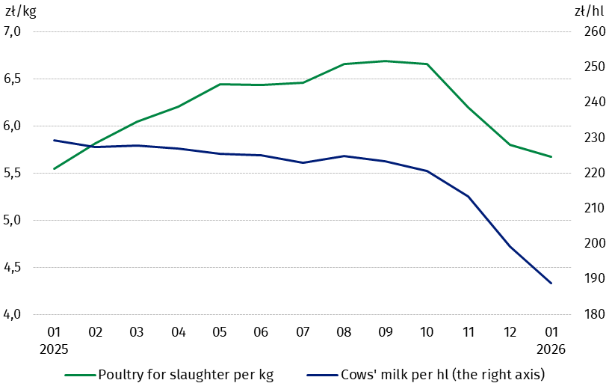

The differentiation of the level of prices of basic agricultural products in particular voivodships is presented in Table 2 for procurement prices and in Table 3 for prices obtained by farmers at the marketplaces (Excel sheet).

In case of quoting Statistics Poland data, please provide information: “Source of data: Statistics Poland”, and in case of publishing calculations made on data published by Statistics Poland, please include the following disclaimer: “Own study based on figures from Statistics Poland”.

Prepared by:  Prices and Services Department  Director Ewa Adach-Stankiewicz  Phone: (+48 22) 608 31 24 | Issued by:  Press Office  Mobile: (+48) 695 255 032  Phone: (+48 22) 608 38 04, (+48 22) 449 41 45.  (+48 22) 608 30 09  e-mail: obslugaprasowa@stat.gov.pl

stat.gov.pl/en/

@StatPoland

@GlownyUrzadStatystyczny

gus_stat

glownyurzadstatystycznygus

glownyurzadstatystyczny
Related information
Socio-economic situation of the country in 2025
Procurement and prices of agricultural products in 2025

Data available in databases
BDL – Prices - Prices in agriculture
Knowledge Databases – Economy - Prices – Producer prices - Agricultural prices

Terms used in official statistics
Procurement of agricultural products
Procurement prices
Marketplace
Marketplace prices

Wheat and rye grain, animals for slaughter: cattle, pigs and poultry, cow's milk
Procurement prices – excluding sowing seed.
Procurement prices – total (of which: edible early kinds, seed, edible late, industrial, of which starch). Marketplaces prices – edible excluding early kinds.
Marketplaces prices – average weighted price of cattle for slaughter calculated with the adoption of the structure of procurement quantity of young cattle and cows for slaughter.
In June 2025, the price of cattle for slaughter at marketplaces was classified as a statistical confidentiality due to the low number of quotations.

