Employed, unemployed and economically inactive persons (preliminary results of the Polish Labour Force Survey in the fourth quarter of 2025)

In the fourth quarter of 2025, economically active persons accounted for 59.0% of the population aged 15-89. This share remained unchanged compared to the third quarter of 2025, but increased by 0.5 pp. compared to the same period of the previous year.
59.0%
Activity rate of persons
aged 15-89

Economic activity of the population aged 15-89 by the LFS
In the fourth quarter of 2025, the number of economically active persons aged 15-89 amounted to 17 912 thousand, of which: 17 346 thousand constituted employed persons, while 567 thousand – the unemployed. The population of economically inactive persons in this age group comprised 12 456 thousand persons.
The economically active population remained at a similar level compared to the third quarter of 2025, but increased compared to the fourth quarter of 2024.

Population of economically active persons remained at similar level compared to the third quarter of 2025 (in the fourth quarter of 2025, the number of economically active persons was lower by 11 thousand, i.e. by 0.1%), while it increased compared to the fourth quarter of 2024 (by 170 thousand, i.e. by 1.0%).
Chart 1. Structure of the population aged 15-89 by status on the labour market in the fourth quarter of 2025
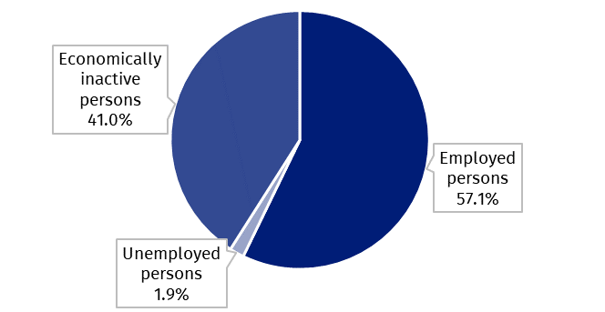

The activity rate for the population aged 15-89 was 59.0% and remained unchanged compared to the third quarter of 2025, but increased compared to the fourth quarter of 2024 (by 0.5 pp.). The indicator was higher for men than for women – in the fourth quarter of 2025: 65.8% versus 52.7% (respective values for persons at the working age were 82.5% for the total population of that age: 84.9% for men and 79.7% for women). Corresponding indicators for urban and rural residents accounted respectively for: 59.2% and 58.7% (at the working age: 84.3% and 79.9%).
The indicator describing the relation of not working persons to the number of employed persons was higher than in the third quarter of 2025, but lower than in the fourth quarter of 2024
Within the scope of population aged 15-89, the ratio of the number of not working persons (unemployed and economically inactive) to the employed persons slightly increased compared to the previous quarter with a simultaneous decrease in this ratio compared to the fourth quarter of 2024. In the fourth quarter of 2025, there were 751 unemployed or economically inactive persons aged 15-89 per 1 000 employed persons (in the third quarter of 2025 – 749 persons and in the fourth quarter of 2024 – 760 persons).
In the fourth quarter of 2025, employed persons accounted for 57.1% of the population aged
15-89. The employment rate was slightly lower than noted in the third quarter of 2025 (by 0.1 pp.) but higher than recorded in the fourth quarter of 2024 (by 0.3 pp.).
57.1%
Employment rate
of persons aged 15-89

Employed persons aged 15-89 by the LFS
In the fourth quarter of 2025, population of employed persons aged 15-89 amounted to 17 346 thousand persons and remained at a similar level compared to the third quarter of 2025 (a decrease by 15 thousand, i.e. by 0.1%), while compared to the fourth quarter of 2024 it increased by 99 thousand i.e. by 0.6%.
The number of working-age persons in the fourth quarter of 2025 amounted to 16 466 thousand. Compared to the third quarter of 2025, there was a decrease in this group of persons – by 39 thousand, i.e. by 0.2%, while compared to the fourth quarter of 2024 – a slightly increase by 17 thousand, i.e. by 0.1%.
Chart 2. Employed persons and employment rate of persons aged 15-89 and at the
working age
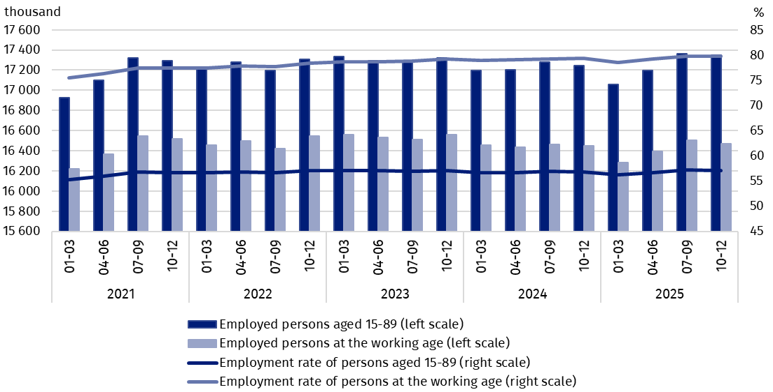
The size of the working population changes throughout the year i.e. due to the seasonality of certain types of work

In the fourth quarter of 2025, in the population of employed persons, taking into account division by sex, men still predominated constituting 53.7% (i.e. 9 309 thousand persons) of this group. Regarding the place of residence, there were more employed persons living in urban areas (60.4%, i.e. 10 483 thousand), which is a direct consequence of the higher population in urban than rural areas.
Chart 3 presents the directions and magnitude of changes in the population of employed persons aged 15-89 compared to the previous quarter and the same quarter of the previous year, depending on sex and place of residence of the employed persons.
Chart 3. Changes in the number of employed persons aged 15-89 between the 4th quarter of 2025 and the 3rd quarter of 2025 as well as the 4th quarter of 2024
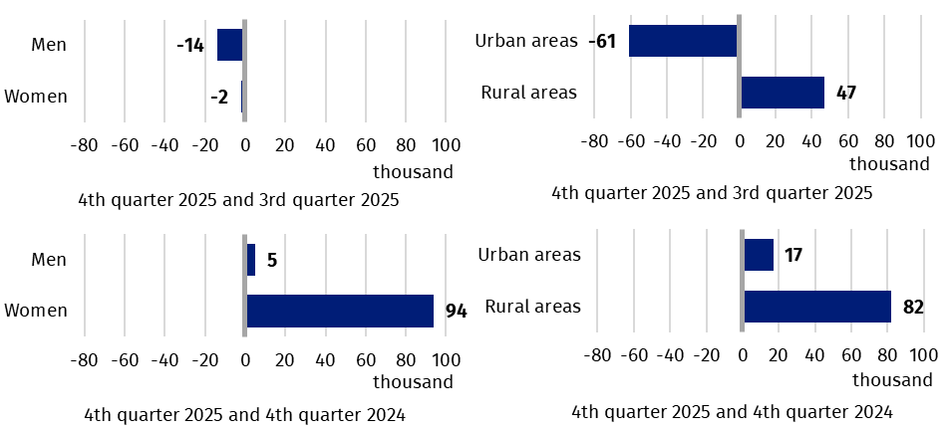
In the fourth quarter of 2025, the total employment rate amounted to 57.1% and was insignificantly lower than noted in the third quarter of 2025 – by 0.1 pp., and higher than in the fourth quarter of 2024 – by 0.3 pp.
Chart 4 presents changes in the employment rate for the population aged 15-89 compared to the previous quarter and the same quarter of the previous year, depending on sex and place of residence of the employed persons.
Chart 4. Changes in the employment rate of persons aged 15-89 between the 4th quarter of 2025 and the 3rd quarter of 2025 as well as the 4th quarter of 2024
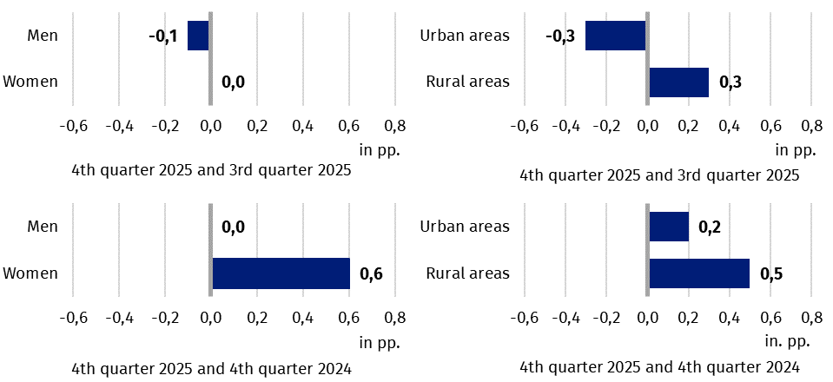
The LFS results indicate, among other things, that in the fourth quarter of 2025:
The number of full-time employed persons was slightly lower than in the third quarter of 2025 and in the fourth quarter of 2024
- 16 056 thousand persons (i.e. 92.6%) performed full-time work, while 1 289 thousand (i.e. 7.4%) were employed part-time,
- in the private sector worked 13 115 thousand persons, which constituted 75.6% of all employed persons, and 4 230 thousand persons worked in the public sector – 24.4% of all employed persons,
- the average number of hours worked in the reference week in the main job amounted to 37.8 hours,
- a vast majority of employees employed in public companies/institutions or by a private employer performed their work on the basis of the contract for an indefinite period (84.0%, i.e. 11 817 thousand persons),
- the sections where the most people worked were: Manufacturing – 19.0% of all employed persons (3 300 thousand persons); Trade; repair of motor vehicles^{Δ} – 12.9% (2 237 thousand), Education – 8.1% (1 419 thousand) and Construction – 7.5% (1 308 thousand).
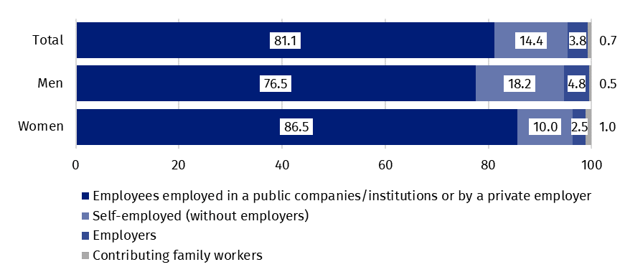
Chart 5. Structure of employed persons aged 15-89 by employment status in the main job in the fourth quarter of 2025 (in %)

In the fourth quarter of 2025, unemployed persons accounted for 3.2% of the economically active population aged 15-89. The unemployment rate was higher compared to the previous quarter (by 0.1 pp.) as well as the fourth quarter of 2024 (by 0.4 pp.).
3.2%
Unemployment rate of persons aged 15-89

Unemployed persons aged 15-74 by the LFS
In the fourth quarter of 2025, the size of the unemployed population aged 15-74 (featured by the international criteria used in the LFS) amounted to 567 thousand and was slightly higher than in the third quarter of 2025 – by 0,9% (increase by 5 thousand persons), and markedly higher than in the fourth quarter of 2024 – by 14.5% (increase by 72 thousand).
The number of unemployed persons was slightly higher than recorded in the previous quarter, but significantly higher than in the corresponding period of the previous year.
Chart 6. Unemployed persons aged 15-74 and unemployment rate of persons aged 15-89
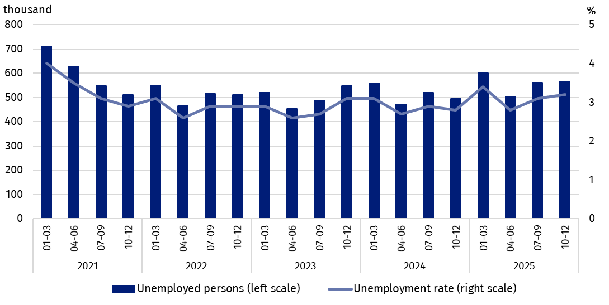
In the fourth quarter of 2025, the population of unemployed men was slightly higher than the population of unemployed women (284 thousand unemployed men versus 282 thousand unemployed women). The number of unemployed persons living in urban areas was 329 thousand and in rural areas 237 thousand.
Chart 7 presents the directions and magnitude of changes in the unemployed persons population depending on sex and place of residence.
Chart 7. Changes in the number of unemployed persons aged 15-74 between the 4th quarter of 2025 and the 3rd quarter of 2025 as well as the 4th quarter of 2024
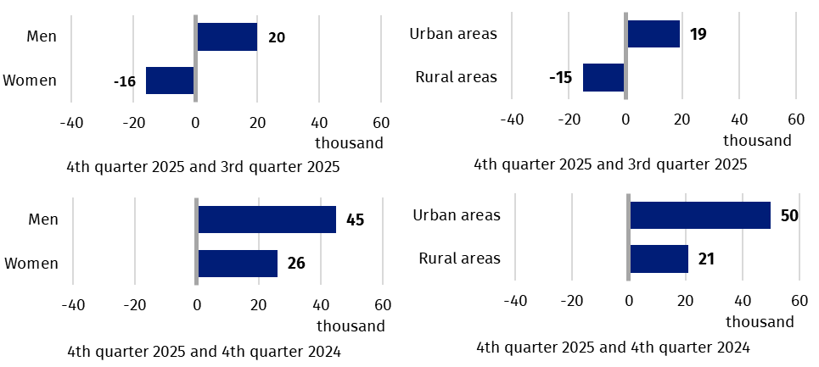
In the fourth quarter of 2025, the unemployment rate according to the LFS amounted to 3.2% and was slightly higher than noted in the third quarter of 2025 (by 0.1 pp.), and slightly higher than observed in the fourth quarter of 2024 (by 0.4 pp.).
Chart 8 presents changes in the intensity of unemployment by sex and place of residence of unemployed persons.
Chart 8. Changes in the unemployment rate of persons aged 15-89 between the 4th quarter of 2025 and the 3rd quarter of 2025 as well as the 4th quarter of 2024
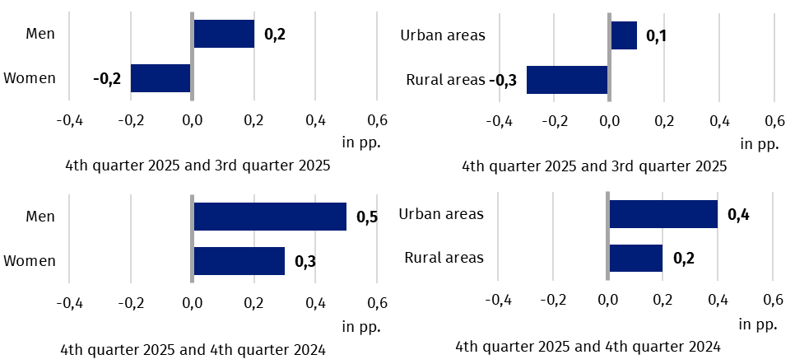
Changes in unemployment rate are also noticeable when taking into account the division of population by age groups. The highest unemployment rate was recorded for the youngest age group, i.e. in the age group 15-24 years – 11.4%. Significantly lower unemployment rates were observed in other age groups. The unemployment rate was 3.5% for persons aged
25-34, 2.4% for aged 35-44, and 2.5% in group of persons in non-mobile age (45-59/64).
The unemployment rate for persons of post-working age (60/65-89 years) cannot be presented due to the high random sampling error of the indicator (resulting from the low number of unemployed persons in this age group, less than 10 thousand, i.e. below the data reliability threshold adopted in polish LFS).
As in previous periods, the highest unemployment rate was observed among the youngest persons, i.e. aged 15-24
Persons with tertiary education are still in the best situation – the unemployment rate in this group is the lowest – in the fourth quarter of 2025 it was 1.7%. For the subpopulation of persons with post-secondary and technical secondary or secondary sectoral vocational education, unemployment rate was 3.0% and for those with general secondary education– 3.8%. Among persons with basic vocational or basic sectoral vocational education the unemployment rate in the analysed quarter was 4.7%. However, the highest unemployment rate – 12.2% concerned the population with the lowest level of education, i.e., with lower secondary education or less.
To the greatest extent, unemployment affected persons with the lowest level of education

Each unemployed person was classified into one of four categories separated due to the reason of inflow to unemployment. The largest population of unemployed were those who lost their job, i.e. persons who left their last job in the last 3 months not on their own initiative (42.0%, i.e. 238 thousand persons). The share of unemployed intending to return to work after a break (lasting longer than 3 months) was 26.6% (i.e. 151 thousand), but among women this share was higher than among men and amounted to 30.2% and 23.2%, respectively. The share of unemployed who resigned from work on their own initiative was 16.1% (i.e. 91 thousand persons) and unemployed persons who were looking for their first job 15.3% (i.e. 87 thousand) of the entire unemployed population.

Chart 9. Structure of unemployed persons by the source of inflow to unemployment in the fourth quarter of 2025 (in %)
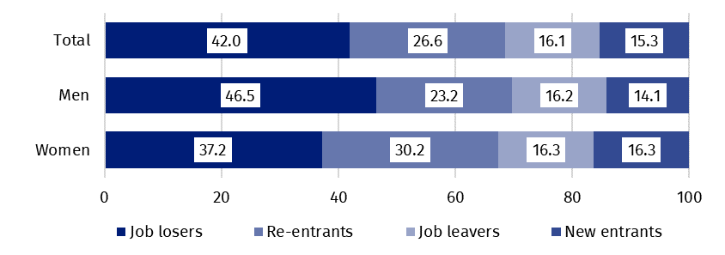
The average duration of job search by unemployed persons in the fourth quarter of 2025 was 8.6 months
In the fourth quarter of 2025, unemployed persons had been looking for a job 8.6 months on average (in the previous quarter and in the fourth quarter of 2024 it was 7.9 and 8.4 months respectively). Persons who were seeking a job for the longest duration were the ones aged
55-74 (an average 10.3 months), while the shortest job search duration was observed for the youngest persons i.e. aged 15-19 (5.5 months).

41.0%
The share of economically
inactive persons in the total number of the population aged 15–89

In the fourth quarter of 2025, economically inactive persons accounted for 41.0% of the total number of population aged 15-89. The indicator remained unchanged compared to the previous quarter, but was lower than in the fourth quarter of 2024 by 0.6 pp.

Economically inactive persons aged 15-89 by the LFS
The number of economically inactive persons remained at a similar level to the third quarter of 2025, but was lower than in the fourth quarter of 2024.
In the fourth quarter of 2025, population of economically inactive persons aged 15-89 amounted to 12 456 thousand and did not change significantly compared to the third quarter of 2025 (increase by 16 thousand persons i.e. by 0.1%), while a decrease was recorded compared to the fourth quarter of 2024 – by 154 thousand i.e. by 1.2%.
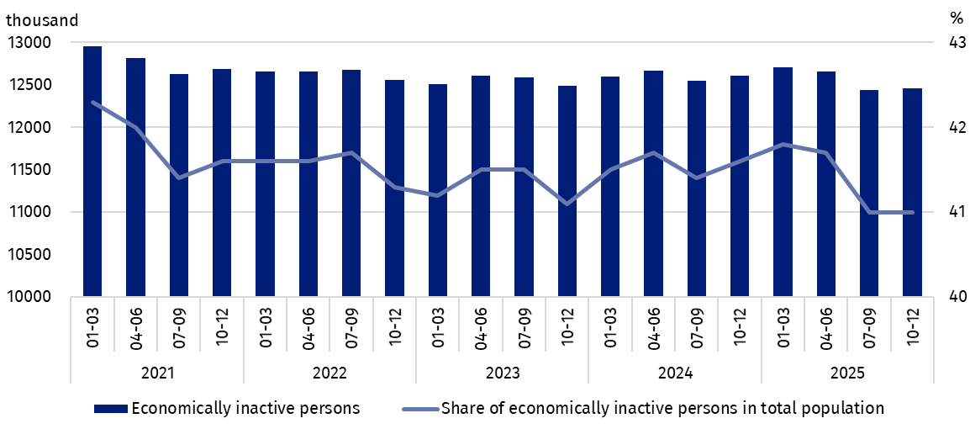
Chart 10. Economically inactive persons and the share of economically inactive persons in population aged 15-89
Over half of the population of economically inactive persons in the analysed age group constituted women – their share was 60.0% (7 478 thousand). Economically inactive women accounted for 47.3% of all women aged 15-89, while analogous indicator for men was 34.2%. A majority of economically inactive persons constituted urban residents (59.9%, i.e. 7 455 thousand) than rural residents, which is connected with a higher population in urban than in rural areas. The share of economically inactive persons in the analysed age group among all urban residents was at the level of 40.8% and among rural residents amounted to 41.3%.
Chart 11 presents changes in the economically inactive population depending on sex and place of residence.
Chart 11. Changes in the number of economically inactive persons aged 15-89 between the 4th quarter of 2025 and the 3rd quarter of 2025 as well as the 4th quarter of 2024
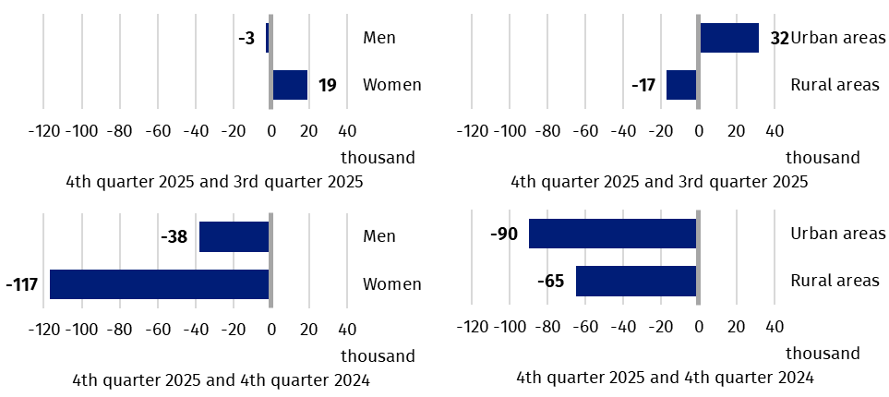
The economically inactive population is a specific one in respect to the labour market resources. Its scope includes persons who have not entered the labour market yet (including the majority of the youth still participating in education) and persons who have definitely left the labour market or will never enter the labour market (some retirees, pensioners, persons who earn their living from other sources than work), but also persons who entered the labour market, then partially deactivated and who will want to re-enter the labour market after a break.
Chart 12. Structure of economically inactive persons aged 15-74 by sex and reasons for inactivity in the fourth quarter of 2025 (in %)
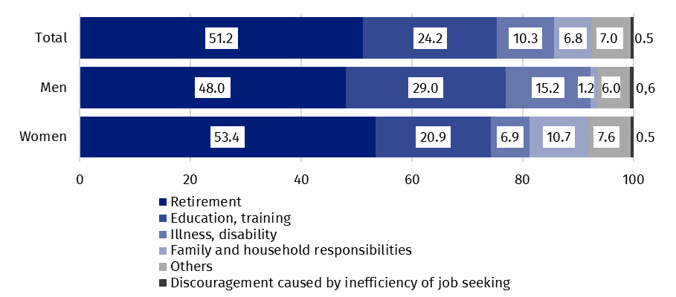
In the fourth quarter of 2025, over half of the economically inactive persons aged 15-74 numbering 9 671 thousand (the reason for inactivity was determined for this age group) constituted retirees (51.2%), while the second largest group were pupils and students (24.2%). It is worth noting that education and training as well as illness and disability were more often the reasons for inactivity among men (respectively 29.0% and 15.2%) than among women (respectively 20.9% and 6.9%). On the other hand, family responsibilities were much more often the reason for inactivity among women (10.7%) than men (1.2%).
Family and households responsibilities were much more often the reason for women's economic inactivity
Education and training were the most often reason for economic inactivity of persons at the working age
Among the economically inactive of working age (3 620 thousand persons) the most often reasons for inactivity were: education and training – 32.5%, illness and disability – 23.7% and family responsibilities – 17.3%. Retirement as the reason for inactivity on the labour market indicated 8.3% persons at the working age, while persons discouraged with unsuccessful job search constituted 1.3% of this group.

Methodological notes

The presented news release was prepared on the basis of the generalised results of the sample survey Badanie Aktywności Ekonomicznej Ludności/BAEL (Eng.: Labour Force Survey/PL-LFS).
Badanie Aktywności Ekonomicznej Ludności has been carried out in Poland quarterly since May 1992 and it has been improved in accordance with the International Labour Organization and Eurostat recommendations.
From the first quarter of 2021 onwards, the base of the EU-LFS methodology are definitions of the employed, the unemployed and economically inactive persons in accordance with the Resolution concerning statistics of work, employment and labour underutilization adopted in 2013 on the 19th International Conference of Labour Statisticians in Geneva (19th ICLS) and recommended by the International Labour Organization (ILO) for the use in all countries.
The survey object is the situation in terms of economic activity of the population, i.e. the fact of performing work, being unemployed or economically inactive persons in the reference week. In the European Union, the implementation of the provisions of the above mentioned Resolution was carried out through introduction of new legal acts. From 2021 onwards,
EU-LFS has been one of the key surveys embraced by the framework regulation for social statistics (the so-called IESS FR). Accompanying IESS FR implementing regulations in the domain of the labour force specify the range of the core survey and module surveys, determine survey organisation and define in detail particular populations specified according to the status of persons in the labour market.
Since the fourth quarter of 2023, generalization of the survey results over the general population has been carried out with the use of the data on resident population in Poland living in households coming from the balances, for which the basis (initial base) are the results of the Population and Housing Census of 31 March 2021 (by the third quarter of 2023, the results were generalised over the general population using population data from the balances, for which the basis were the results of the National Census 2011). The component data (births, deaths and migrations) come from administrative registers. The data published in this news release and in the attached tables for the period from the first quarter of 2021 to the third quarter of 2023 have been recalculated in accordance with the new basis for generalizing results and are therefore comparable.
In the fourth quarter of 2025, the data on the resident population as of the state on 30 September 2025 were used to generalise the survey results. The number of resident population aged 15-89 years living in households obtained after generalisation of the results of the survey is lower by about 488 thousand (persons living in institutional households and homeless persons) from the estimated number of resident population as of the state on 30 September 2025.
In the fourth quarter of 2025, the Labour Force Survey covered 27.0 thousand households, including 19.0 thousand households in urban areas. In each of the sampled households, persons at the age 15-89 years were surveyed, which gave a sample of 45.7 thousand persons, of whom 29.7 thousand persons were urban residents. The response rate was 63.8%.
More information on the methodology used in the survey can be found in the Methodological report and detailed survey results can be found in the tables available on Statistics Poland website at:
https://stat.gov.pl/en/topics/labour-market/yearbook-of-labour/methodological-report-labour-force-survey,8,2.html
https://stat.gov.pl/en/topics/labour-market/working-unemployed-economically-inactive-by-lfs/labour-force-survey-in-poland-quarter-32025,2,59.html

In the case of quoting Statistics Poland data, please provide information: ‘Source of data: Statistics Poland’, and in the case of publishing calculations made on data published by Statistics Poland, please provide information: ‘Own work based on Statistics Poland data.’

Prepared by:  Labour Market and Human Capital Department  Director Agnieszka Zgierska, PhD  Phone: (+48 22) 608 34 99 | Issued by:  Press Office  Mobile +48 695 255 032  Phone +48 22 608 38 04, +48 22 449 41 45,  +48 22 608 30 09  e-mail: obslugaprasowa@stat.gov.pl

www.stat.gov.pl/en/

@StatPoland

@GlownyUrzadStatystyczny

gus_stat

glownyurzadstatystycznygus

glownyurzadstatystyczny
Related information
Methodological report. Labour Force Survey
Labour Force Survey in Poland
Other publications containing the results of LFS and its module surveys
stat.gov.pl → Topics → Labour Market
Data available in databases
Strateg → Topics → Labour Market
Local Data Bank → labour Market
Terms used in official statistics
Economic activity by LFS
Economically active population by LFS
Employed persons by LFS
Unemployed persons by LFS
Economically inactive population according to the LFS

Activity rate by LFS
Employment rate by LFS
Unemployment rate by LFS

The LFS results refer to the resident population i.e. staying or intending to stay in the country’s territory for at least 12 months, living in households. Generalisation of the survey results over the general population has been carried out with the use of the data on resident population in Poland, coming from the balances, for which the basis (initial base) are the results of the Population and Housing Census 2021/National Census 2021. Data for the period from the first quarter of 2021 to the third quarter of 2023 was recalculated in line with the new generalisation basis. See methodological notes at the end of this news release.
Men aged 18-64 and women aged 18-59.
The Δ sign indicates that the categories of applied classification of the kind of activity (NACE Rev. 2) are presented in an abbreviated form.
See methodological notes at the end of this news release.
LFS results are presented as an average value in the analysed period, in this case – an average in a quarter (unlike, for example, in the case of data on registered unemployment, where data are most often presented as of the end of the period).
Men aged 45-64 and women aged 45-59.
Men aged 65-89 and women aged 60-89.
The average duration of job search is the period, counted in months, during which unemployed persons are actively looking for a job (this includes the last uninterrupted period of job search).
Regulation (EU) 2019/1700 of the European Parliament and of the Council of 10 October 2019 establishing a common framework for European statistics relating to persons and households, based on data at individual level collected from samples.

