Culture Satellite Account in 2021
2.8%
Contribution of the area of culture to the creation of gross value added in 2021

The gross value added generated by the area of culture in 2021 amounted to PLN 63.2 billion, which was PLN 4.1 billion higher than in 2020. Two domains, Advertising and Audio-visual arts and multimedia, dominated most transactions within the culture satellite account.
In 2021, the area of culture saw lower growth in the value of main transactions in comparison to the national economy. The value of gross output in the area of culture reached PLN 138.2 billion and increased by 7.4% in comparison to 2020. The value of intermediate consumption amounted to PLN 75.0 billion, while the gross value added, representing the difference between the gross output and the intermediate consumption, amounted to PLN 63.2 billion (an increase of 7.7% and 7.0% respectively compared to the previous year). The compensation of employees increased by 2.5% on an annual basis to PLN 26.7 billion. The gross operating surplus, representing the difference between the gross value added and the compensation of employees and the other taxes on production, less other subsidies on production, amounted to PLN 37.0 billion (2.9% less than in 2020). The other subsidies on production decreased significantly (by PLN 4.5 billion compared to 2020), which may be related to a reduction in financial support granted to many entities in 2020 in connection with the announcement of an epidemic threat in Poland (COVID-19).
Table 1. Main transactions in the culture satellite account
Transactions | 2020 | 2021
Transactions | in PLN million,  current prices |  | 2020=100
Gross output | 128,694.5 | 138,205.5 | 107.4
Intermediate consumption | 69,600.9 | 74,989.7 | 107.7
Value added, gross | 59,093.6 | 63,215.8 | 107.0
Compensation of employees | 26,080.1 | 26,727.4 | 102.5
Operating surplus, gross | 38,115.5 | 37,003.2 | 97.1
In 2021, the value of gross output generated by the area of culture accounted for 2.6% of the gross output of the entire national economy (0.2 p.p. less compared to 2020), while the share of gross value added amounted to 2.8% (0.1 p.p. less than in 2020). The contribution of area of culture to the creation of gross operating surplus in the economy amounted to 3.0% (0.3 p.p. less in comparison to 2020).
The share of gross value added of the area of culture in the national economy decreased by 0.1 p.p. compared to 2020
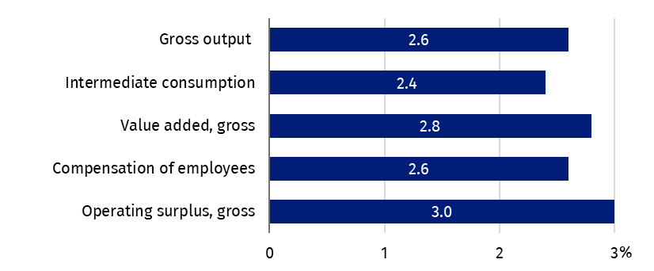
Chart 1. The share of area of culture in the national economy by main transactions in 2021
In 2021, the largest share in the value of gross output in the area of culture was recorded in Advertising domain – 25.7%. A significant contribution, amounting to 20.2%, was recorded in Audio-visual arts and multimedia domain. These two domains also dominated in other transactions, such as intermediate consumption (31.4% and 22.3%, respectively), gross value added (19.0% and 17.6%, respectively) and gross operating surplus (22.2% and 19.7%, respectively).
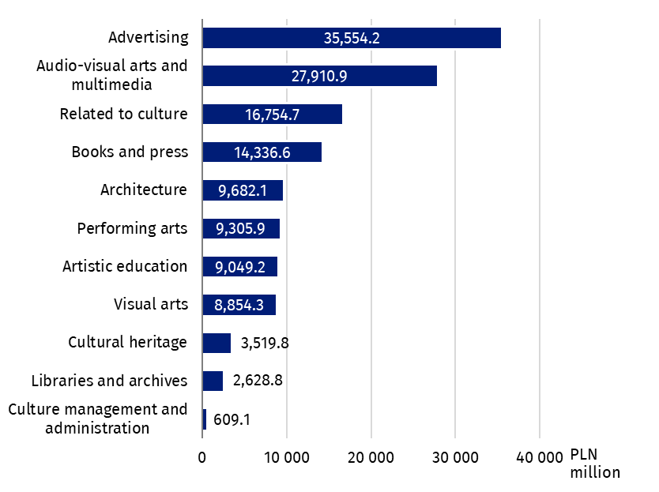
Chart 2. The gross output by cultural domains in 2021
Three domains: Advertising, Audio-visual arts and multimedia, and Related to culture, together generated 58.0% of the gross output of the area of culture
Domains Related to culture and Books and press had also significant share (in gross output 12.1% and 10.4%, respectively; in gross value added 10.3% and 12.5%, respectively). In case of gross operating surplus, apart from domains: Advertising, Audio-visual arts and multimedia and Books and press (22.2%, 19.7% and 12.9% respectively), the contribution of Architecture and Visual arts domains was also significant (11.8% and 11.5% respectively).
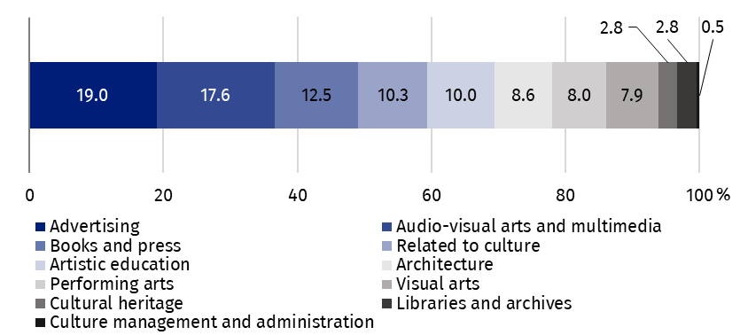
Chart 3. The gross value added by cultural domains in 2021
Two domains accounted for the largest share in compensation of employees – Advertising and Artistic education (14.9% each).
The highest compensation of employees was observed in the following domains: Advertising and Artistic education (PLN 4.0 billion each)
In terms of other taxes on production Audio-visual arts and multimedia domain dominated (54.6%), while Artistic education accounted for the largest share in other subsidies on production (34.9%).
During analysed year the gross capital formation in the area of culture amounted to PLN 6,687.1 million. As in 2020, the highest value of gross capital formation was noticed in Architecture domain (PLN 3,309.5 million).
The final consumption expenditure in the area of culture amounted to PLN 55,770.4 million (PLN 5,423.2 million more than in 2020). Audio-visual arts and multimedia accounted for almost half of the final consumption expenditure (PLN 26,231.2 million).
The final consumption by households accounted for 66.3% of the final consumption expenditure and increased by 11.8% compared to 2020. The highest amount of this consumption was recorded in Audio-visual arts and multimedia domain (PLN 23,639.7 million, i.e. 2,702.7 million more than in 2020).
In the general government sector (31.1% of total final consumption expenditures), the highest value of consumption was recorded in Performing arts (PLN 5,397.9 million, i.e. PLN 427.5 million more than in 2020).
In the sector of non-profit institutions serving households, which are related to culture, final consumption expenditure amounted to PLN 1,425.5 million (PLN 95.2 million more than in 2020). The highest value of final consumption expenditure, as in the general government sector, was recorded in Performing arts domain (PLN 401.7 million, i.e. PLN 73.8 million more than in 2020).
In 2021, a positive balance of PLN 3,399.5 million (PLN 2,036.2 million less than in 2020) was recorded in foreign trade in cultural and creative goods and services. The positive foreign trade balance was mainly influenced by two domains: Books and press (balance of PLN 4,070.9 million) and Advertising (balance of PLN 2,002.1 million). Exports increased by 8.7% compared to 2020. The largest share in exports of cultural and creative goods and services was observed in the Advertising domain (39.3%). Audio-visual arts and multimedia (29.6%) and Books and press (26.7%) also had a large share in exports. The value of imports of cultural and creative goods and services increased by 20.7% compared to 2020. The same domains prevailed in imports as in exports: Audio-visual arts and multimedia (42.9% of all imports of the area of culture), Advertising (36.7%) and Books and press (14.3%).
Methodological notes
The Culture Satellite Account allows to measure the share of cultural entities in generation of gross domestic product. The scope of the area of culture encompasses the activities of state and local government cultural institutions, non-governmental organisations operating in the area of culture and entities classified as cultural and creative industries. Information on the methodological solutions used can be found in the "Report on methodological work. Culture Satellite Account" (hyperlink available on the last page).
Cultural Satellite Account for 2021 was developed based on data from before the introduction of the benchmarking revision in national accounts carried out in 2024 and covering the years 1995–2022.
In the case of quoting data from the Statistics Poland, please provide information: "Statistics Poland data source", and in the case of publishing calculations made on data published by the Statistics Poland, please provide information: "Own study based on Statistics Poland data".

Prepared by:  Statistical Office in Kraków  Director Agnieszka Szlubowska  Phone: (+48 12) 420 40 50 | Issued by:  Press Office  Mobile: (+48) 695 255 032  Phone: (+48 22) 608 38 04, (+48 22) 449 41 45,  (+48 22) 608 30 09  e-mail: obslugaprasowa@stat.gov.pl

stat.gov.pl/en/

@StatPoland

@GlownyUrzadStatystyczny

gus_stat

glownyurzadstatystycznygus

glownyurzadstatystyczny
Related information
Report on methodological work. Culture Satellite Account (PL version only)
Culture satellite account for 2020
Cultural and creative industries in 2017–2021
Cultural and creative industries in 2023
Culture and national heritage in 2024
Terms used inn official statistics
Gross capital formation
Exports of goods and services
Imports of goods and services
Compensation of employees
Operating surplus, gross
Output
Gross Domestic Product (GDP)
Final consumption expenditure
Value added, gross
Intermediate consumption

Gross capital formation measures the increase in wealth, including, in value terms, gross fixed capital formation, the increase in tangible current assets, and the acquisition of valuable assets less their disposal.

